[](http://www.comsol.com/)

Ex3 6 room3D heat

|  |  |
| --- | --- |
| Date | Nov 24, 2013 11:54:59 AM |

Contents

1. Global

1.1. Definitions

2. Model 1

2.1. Definitions

2.2. Geometry 1

2.3. Laminar Flow

2.4. Heat Transfer in Fluids

2.5. Heat Transfer in Fluids 2

2.6. Heat Transfer in Fluids 3

2.7. Heat Transfer in Fluids 1

2.8. Heat Transfer in Fluids 2a

2.9. Heat Transfer in Fluids 3a

2.10. Mesh 1

3. Study 1

3.1. Stationary

3.2. Solver Configurations

4. Study 2

4.1. Stationary

4.2. Solver Configurations

5. Study 3

5.1. Parametric Sweep

5.2. Stationary

5.3. Solver Configurations

6. Study 4

6.1. Time Dependent

6.2. Solver Configurations

7. Results

7.1. Data Sets

7.2. Derived Values

7.3. Tables

7.4. Plot Groups

1. Global

|  |  |
| --- | --- |
| Date | Oct 27, 2013 1:07:41 PM |

Global settings

|  |  |
| --- | --- |
| Name | Ex3 6 room3D heat.mph |
| Path | /Users/gilliam/Desktop/collect_15/research_15/geo_reg_mono_eugenio/Mono_1_15/Comsol_EX_GitHub/Chapter3/Chap3Ex6_Heat_3D_room/Ex3_6_room3D_heat.mph |
| Program | COMSOL 4.3b (Build: 189) |

Used products

|  |
| --- |
| COMSOL Multiphysics |

* 1. Definitions
     1. Parameters 1

Parameters

| **Name** | **Expression** | **Value** | **Description** |
| --- | --- | --- | --- |
| H | 2. [m] | 2.0000 m |  |
| L | 4 [m] | 4.0000 m |  |
| l | 0.2 [m] | 0.20000 m |  |
| mesh_size | l/2 | 0.10000 m |  |
| rho | 1 [kg/m^3] | 1.0000 kg/m³ |  |
| mu | 0.001 [Pa*s] | 0.0010000 Pa·s |  |
| K | 0.001 [W/(m*K)] | 0.0010000 W/(m·K) |  |
| Bin | 20 [K] | 20.000 K |  |
| d | 5[K] | 5.0000 K |  |
| Tr | 25[K] | 25.000 K |  |
| cp | 1 [J/(kg*K)] | 1.0000 J/(kg·K) |  |
| k | 0 | 0.0000 |  |
| Mr | 22 [K] | 22.000 K |  |
| Ar | 3 [K] | 3.0000 K |  |
| Md | 5 [K] | 5.0000 K |  |
| Ad | 10 [K] | 10.000 K |  |
| hour | 3600 [s] | 3600.0 s |  |
| day | 24*hour | 86400 s |  |
| alpha0 | 0 | 0.0000 |  |
| alpha1 | 2*pi/day | 7.2722E-5 1/s |  |

* + 1. Functions

#### Analytic 1

|  |  |
| --- | --- |
| Function name | alpha |
| Function type | Analytic |

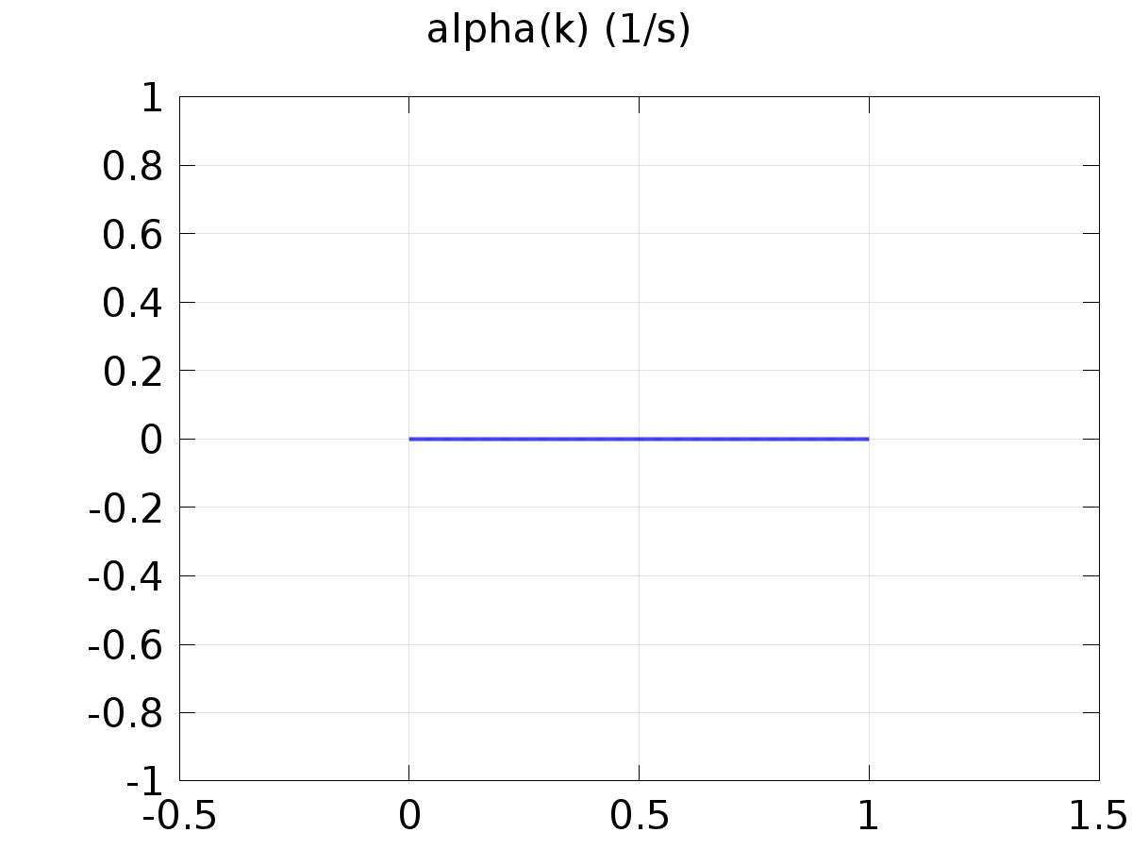

Analytic 1

Definition

| **Description** | **Value** |
| --- | --- |
| Expression | alpha0*(k==0) + alpha0*(k==1) + alpha1*(k==2) + alpha1*(k==3) |
| Arguments | k |

Units

| **Description** | **Value** |
| --- | --- |
| Function | 1/s |

#### Analytic 3

|  |  |
| --- | --- |
| Function name | Trc |
| Function type | Analytic |

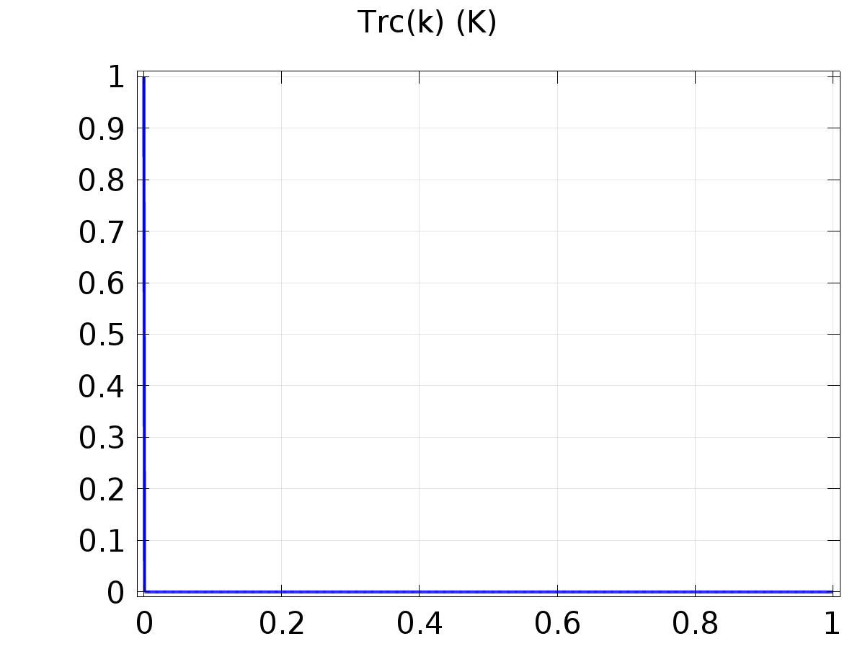

Analytic 3

Definition

| **Description** | **Value** |
| --- | --- |
| Expression | 1*(k==0) + 0*(k==1) + 0*(k==2) + 0*(k==3) |
| Arguments | k |

Units

| **Description** | **Value** |
| --- | --- |
| Function | K |

#### Analytic 2

|  |  |
| --- | --- |
| Function name | Trs |
| Function type | Analytic |

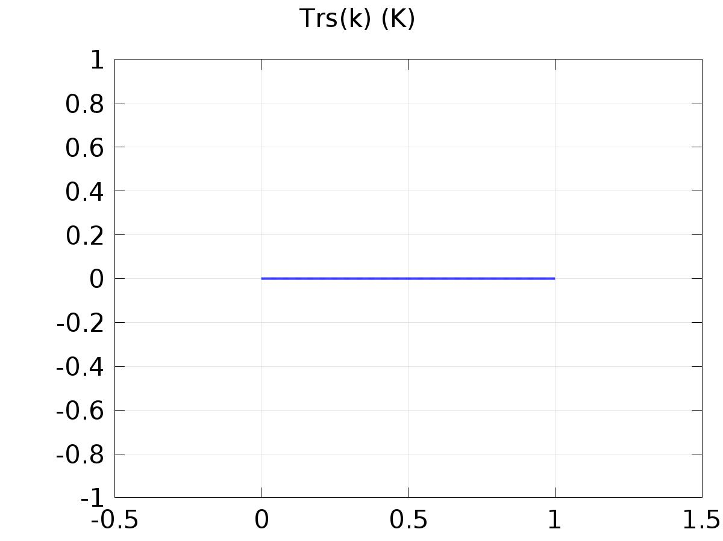

Analytic 2

Definition

| **Description** | **Value** |
| --- | --- |
| Expression | 0*(k==0) + 0*(k==1) + 1*(k==2) + 0*(k==3) |
| Arguments | k |

Units

| **Description** | **Value** |
| --- | --- |
| Function | K |

#### Analytic 5

|  |  |
| --- | --- |
| Function name | dc |
| Function type | Analytic |

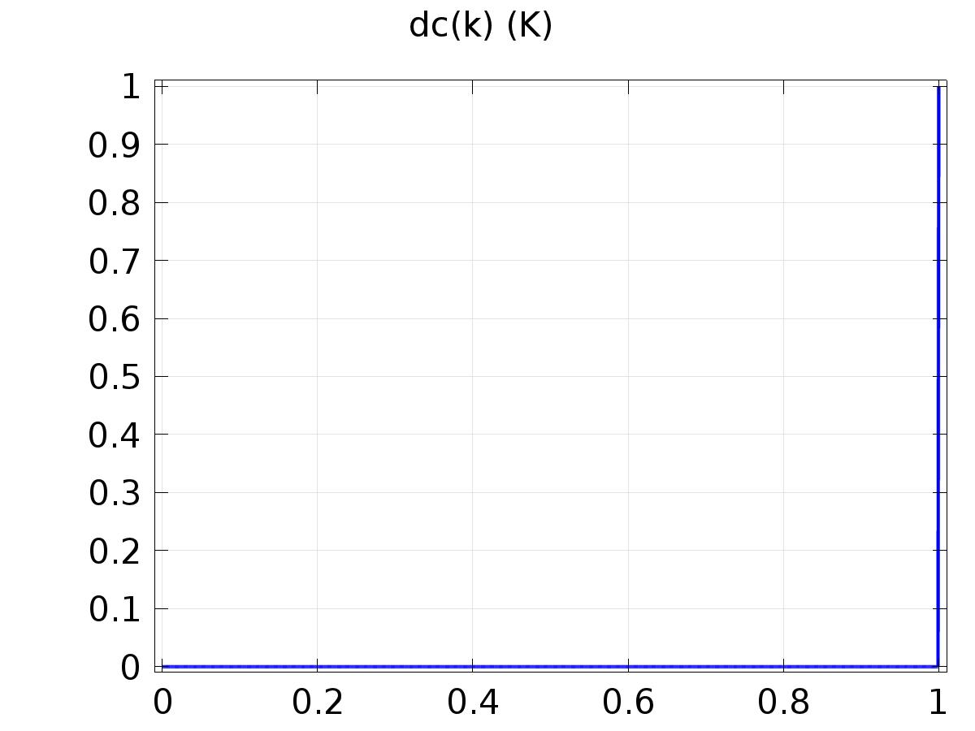

Analytic 5

Definition

| **Description** | **Value** |
| --- | --- |
| Expression | 0*(k==0) + 1*(k==1) + 0*(k==2) + 0*(k==3) |
| Arguments | k |

Units

| **Description** | **Value** |
| --- | --- |
| Function | K |

#### Analytic 4

|  |  |
| --- | --- |
| Function name | ds |
| Function type | Analytic |

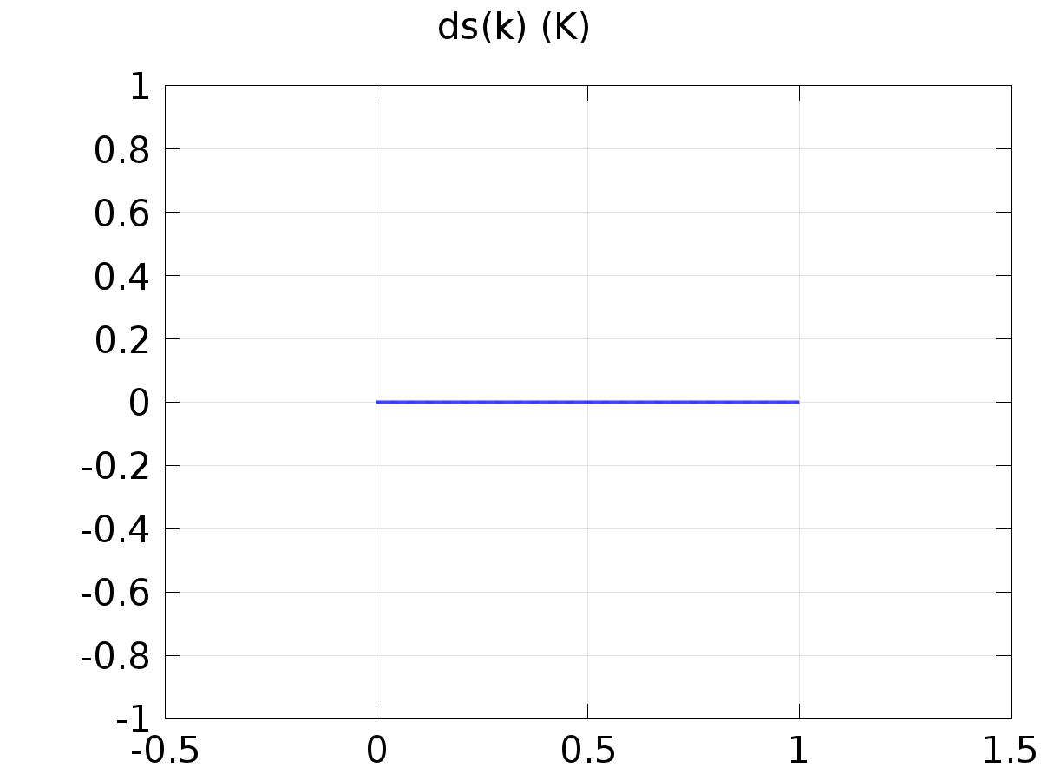

Analytic 4

Definition

| **Description** | **Value** |
| --- | --- |
| Expression | 0*(k==0) + 0*(k==1) + 0*(k==2) + 1*(k==3) |
| Arguments | k |

Units

| **Description** | **Value** |
| --- | --- |
| Function | K |

1. Model 1

Component settings

|  |  |
| --- | --- |
| Unit system | SI |

* 1. Definitions
     1. Variables

#### Variables 1a

Selection

|  |  |
| --- | --- |
| Geometric entity level | Entire model |

| **Name** | **Expression** | **Description** |
| --- | --- | --- |
| G | C(X_T) |  |
| Gammac | (Trc(k) - C(z1t_T))/G |  |
| Gammas | (Trs(k) - C(z2t_T))/G |  |
| yrc | C(z1_T) |  |
| yrs | C(z2_T) |  |
| Gamma | Gamma_Mr*Mr + Gamma_Md*Md + Gammas_Ar*Ar*sin(alpha1*t) + Gammac_Ar*Ar*cos(alpha1*t) + Gammas_Ad*Ad*sin(alpha1*t) + Gammac_Ad*Ad*cos(alpha1*t) |  |
| d | Md + Ad*sin(alpha1*t) |  |
| yr | Mr + Ar*sin(alpha1*t) |  |
| e | C(T) - yr |  |

#### Variables 2a

Selection

|  |  |
| --- | --- |
| Geometric entity level | Entire model |

| **Name** | **Expression** | **Description** |
| --- | --- | --- |
| Gamma_Mr | 0.0521069562089497 |  |
| Gamma_Md | -0.0021069031814109533 |  |
| Gammac_Ar | 5.876345035388123E-4 |  |
| Gammas_Ar | 0.05210588514401548 |  |
| Gammac_Ad | -4.561019279789624E-6 |  |
| Gammas_Ad | -0.0021068993670703994 |  |

* + 1. Probes

#### Global Variable Probe 1

|  |  |
| --- | --- |
| Probe type | Global variable probe |

#### Global Variable Probe 2

|  |  |
| --- | --- |
| Probe type | Global variable probe |

#### Global Variable Probe 3

|  |  |
| --- | --- |
| Probe type | Global variable probe |

#### Global Variable Probe 4

|  |  |
| --- | --- |
| Probe type | Global variable probe |

* + 1. Component Couplings

#### Average 1

|  |  |
| --- | --- |
| Coupling type | Average |
| Operator name | C |

Source selection

|  |  |
| --- | --- |
| Geometric entity level | Boundary |
| Selection | Boundary 120 |

* + 1. Coordinate Systems

#### Boundary System 1

|  |  |
| --- | --- |
| Coordinate system type | Boundary system |
| Tag | sys1 |

Coordinate names

| **First (t1)** | **Second (t2)** | **Third (n)** |
| --- | --- | --- |
| t1 | t2 | n |

Settings

| **Description** | **Value** |
| --- | --- |
| Create first tangent direction from | Global Cartesian |

* 1. Geometry 1

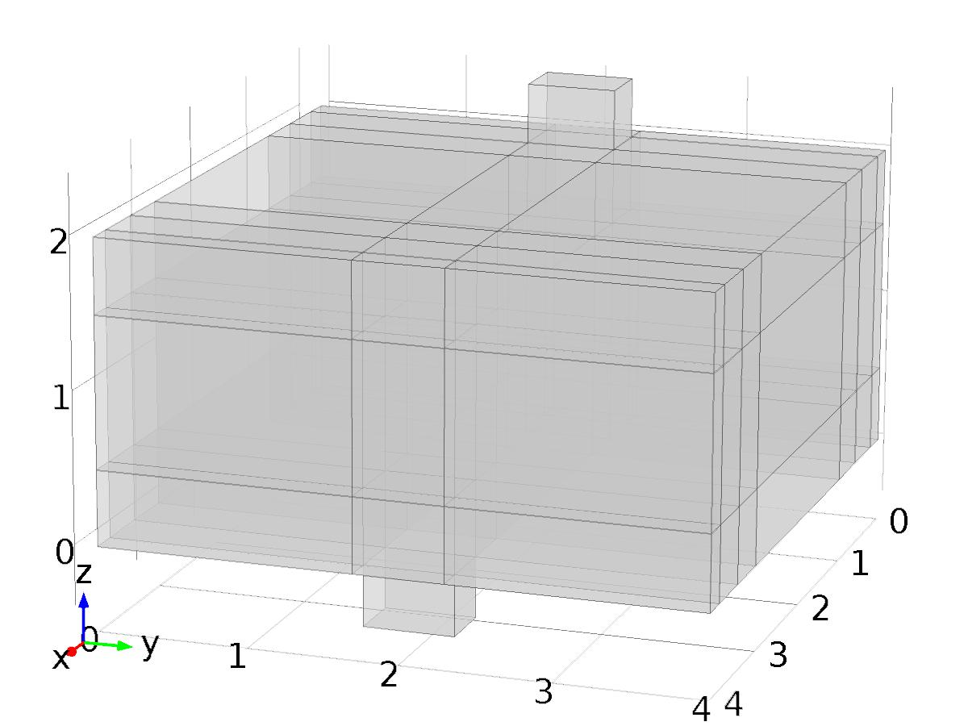

Geometry 1

Units

|  |  |
| --- | --- |
| Length unit | m |
| Angular unit | deg |

Geometry statistics

| **Description** | **Value** |
| --- | --- |
| Space dimension | 3 |
| Number of domains | 65 |
| Number of boundaries | 250 |
| Number of edges | 320 |
| Number of vertices | 136 |

* + 1. Block 1 (blk1)

Position

| **Description** | **Value** |
| --- | --- |
| Position | {0, 0, 0} |

Axis

| **Description** | **Value** |
| --- | --- |
| Axis type | z - axis |

Size and shape

| **Description** | **Value** |
| --- | --- |
| Width | L |
| Depth | L |
| Height | H |

Layers

| **Description** | **Value** |
| --- | --- |
| Layers |  |

* + 1. Block 2 (blk2)

Position

| **Description** | **Value** |
| --- | --- |
| Position | {2*l, L/2, H/2} |
| Base | Center |

Axis

| **Description** | **Value** |
| --- | --- |
| Axis type | z - axis |

Size and shape

| **Description** | **Value** |
| --- | --- |
| Width | 2*l |
| Depth | L |
| Height | H |

Layers

| **Description** | **Value** |
| --- | --- |
| Layers |  |

* + 1. Block 3 (blk3)

Position

| **Description** | **Value** |
| --- | --- |
| Position | {L/2, L/2, H/2} |
| Base | Center |

Axis

| **Description** | **Value** |
| --- | --- |
| Axis type | z - axis |

Size and shape

| **Description** | **Value** |
| --- | --- |
| Width | L |
| Depth | 3*l |
| Height | H |

Layers

| **Description** | **Value** |
| --- | --- |
| Layers |  |

* + 1. Block 4 (blk4)

Position

| **Description** | **Value** |
| --- | --- |
| Position | {L - 2*l, L/2, H/2} |
| Base | Center |

Axis

| **Description** | **Value** |
| --- | --- |
| Axis type | z - axis |

Size and shape

| **Description** | **Value** |
| --- | --- |
| Width | 2*l |
| Depth | L |
| Height | H |

Layers

| **Description** | **Value** |
| --- | --- |
| Layers |  |

* + 1. Block 5 (blk5)

Position

| **Description** | **Value** |
| --- | --- |
| Position | {L/2, L/2, H/2} |
| Base | Center |

Axis

| **Description** | **Value** |
| --- | --- |
| Axis type | z - axis |

Size and shape

| **Description** | **Value** |
| --- | --- |
| Width | 10*l |
| Depth | L |
| Height | H |

Layers

| **Description** | **Value** |
| --- | --- |
| Layers |  |

* + 1. Block 6 (blk6)

Position

| **Description** | **Value** |
| --- | --- |
| Position | {L/2, L/2, H/2} |
| Base | Center |

Axis

| **Description** | **Value** |
| --- | --- |
| Axis type | z - axis |

Size and shape

| **Description** | **Value** |
| --- | --- |
| Width | L |
| Depth | L |
| Height | 5*l |

Layers

| **Description** | **Value** |
| --- | --- |
| Layers |  |

* + 1. Block 7 (blk7)

Position

| **Description** | **Value** |
| --- | --- |
| Position | {2*l, L/2, H + l} |
| Base | Center |

Axis

| **Description** | **Value** |
| --- | --- |
| Axis type | z - axis |

Size and shape

| **Description** | **Value** |
| --- | --- |
| Width | 2*l |
| Depth | 3*l |
| Height | 2*l |

Layers

| **Description** | **Value** |
| --- | --- |
| Layers |  |

* + 1. Block 8 (blk8)

Position

| **Description** | **Value** |
| --- | --- |
| Position | {L - 2*l, L/2, -l} |
| Base | Center |

Axis

| **Description** | **Value** |
| --- | --- |
| Axis type | z - axis |

Size and shape

| **Description** | **Value** |
| --- | --- |
| Width | 2*l |
| Depth | 3*l |
| Height | 2*l |

Layers

| **Description** | **Value** |
| --- | --- |
| Layers |  |

* 1. Laminar Flow

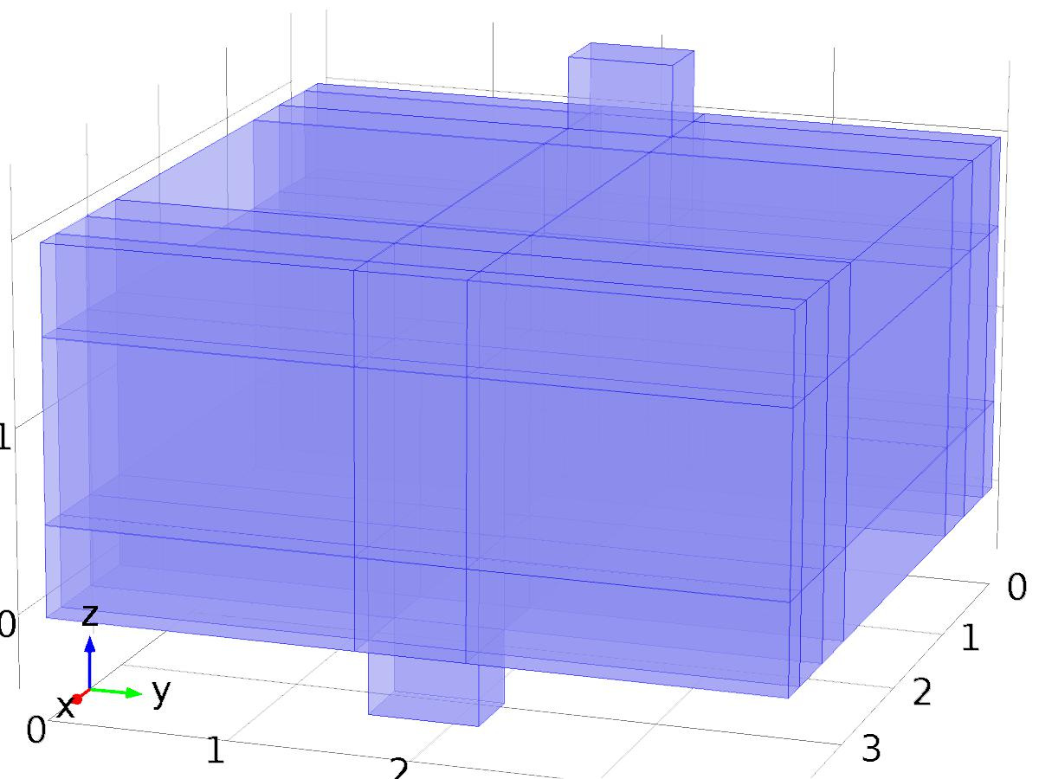

Laminar Flow

Selection

|  |  |
| --- | --- |
| Geometric entity level | Domain |
| Selection | Domains 1–65 |

Equations









Settings

| **Description** | **Value** |
| --- | --- |
| Discretization of fluids | P1 + P1 |
| Value type when using splitting of complex variables | {Real, Real, Real, Real, Real, Real, Real, Real, Real, Real, Real} |
| Isotropic diffusion | Off |
| Compressibility | Incompressible flow |
| Turbulence model type | None |
| Reference pressure level | 1[atm] |
| Use pseudo time stepping for stationary equation form | Off |
| Local CFL number | 1.3^min(niterCMP, 9) + if(niterCMP>=25, 9*1.3^min(niterCMP - 25, 9), 0) + if(niterCMP>=45, 90*1.3^min(niterCMP - 45, 9), 0) |
| Streamline diffusion | On |
| Crosswind diffusion | On |

Used products

|  |
| --- |
| COMSOL Multiphysics |

Variables

| **Name** | **Expression** | **Unit** | **Description** | **Selection** |
| --- | --- | --- | --- | --- |
| NavierStokes.dz | 1 | m | Thickness | Domains 1–65 |
| NavierStokes.pref | 1[atm] | Pa | Reference pressure level | Domains 1–65 |
| NavierStokes.pA | p+NavierStokes.pref | Pa | Absolute pressure | Domains 1–65 |
| NavierStokes.nx | nx | 1 | Normal vector, x component | Boundaries 6, 9, 12, 15–16, 18–19, 22, 25–26, 28–29, 34, 37, 39–40, 42, 44–45, 47–52, 55, 57–58, 60–65, 71, 74, 76–77, 79, 81–82, 84–89, 92–93, 95–100, 105, 108, 110–111, 113, 115–116, 118–123, 125–126, 128–133, 138, 141, 143–144, 146, 148–149, 151–156, 158–159, 161–166, 171, 174, 176–177, 179, 184–192, 195–196, 198–203, 208, 211, 213–214, 216, 219–220, 222–227, 229–230, 232–237 |
| NavierStokes.ny | ny | 1 | Normal vector, y component | Boundaries 6, 9, 12, 15–16, 18–19, 22, 25–26, 28–29, 34, 37, 39–40, 42, 44–45, 47–52, 55, 57–58, 60–65, 71, 74, 76–77, 79, 81–82, 84–89, 92–93, 95–100, 105, 108, 110–111, 113, 115–116, 118–123, 125–126, 128–133, 138, 141, 143–144, 146, 148–149, 151–156, 158–159, 161–166, 171, 174, 176–177, 179, 184–192, 195–196, 198–203, 208, 211, 213–214, 216, 219–220, 222–227, 229–230, 232–237 |
| NavierStokes.nz | nz | 1 | Normal vector, z component | Boundaries 6, 9, 12, 15–16, 18–19, 22, 25–26, 28–29, 34, 37, 39–40, 42, 44–45, 47–52, 55, 57–58, 60–65, 71, 74, 76–77, 79, 81–82, 84–89, 92–93, 95–100, 105, 108, 110–111, 113, 115–116, 118–123, 125–126, 128–133, 138, 141, 143–144, 146, 148–149, 151–156, 158–159, 161–166, 171, 174, 176–177, 179, 184–192, 195–196, 198–203, 208, 211, 213–214, 216, 219–220, 222–227, 229–230, 232–237 |
| NavierStokes.nx | dnx | 1 | Normal vector, x component | Boundaries 1–5, 7–8, 10–11, 13–14, 17, 20–21, 23–24, 27, 30–33, 35–36, 38, 41, 43, 46, 53–54, 56, 59, 66–70, 72–73, 75, 78, 80, 83, 90–91, 94, 101–104, 106–107, 109, 112, 114, 117, 124, 127, 134–137, 139–140, 142, 145, 147, 150, 157, 160, 167–170, 172–173, 175, 178, 180–183, 193–194, 197, 204–207, 209–210, 212, 215, 217–218, 221, 228, 231, 238–250 |
| NavierStokes.ny | dny | 1 | Normal vector, y component | Boundaries 1–5, 7–8, 10–11, 13–14, 17, 20–21, 23–24, 27, 30–33, 35–36, 38, 41, 43, 46, 53–54, 56, 59, 66–70, 72–73, 75, 78, 80, 83, 90–91, 94, 101–104, 106–107, 109, 112, 114, 117, 124, 127, 134–137, 139–140, 142, 145, 147, 150, 157, 160, 167–170, 172–173, 175, 178, 180–183, 193–194, 197, 204–207, 209–210, 212, 215, 217–218, 221, 228, 231, 238–250 |
| NavierStokes.nz | dnz | 1 | Normal vector, z component | Boundaries 1–5, 7–8, 10–11, 13–14, 17, 20–21, 23–24, 27, 30–33, 35–36, 38, 41, 43, 46, 53–54, 56, 59, 66–70, 72–73, 75, 78, 80, 83, 90–91, 94, 101–104, 106–107, 109, 112, 114, 117, 124, 127, 134–137, 139–140, 142, 145, 147, 150, 157, 160, 167–170, 172–173, 175, 178, 180–183, 193–194, 197, 204–207, 209–210, 212, 215, 217–218, 221, 228, 231, 238–250 |
| NavierStokes.nxmesh | root.nxmesh | 1 | Normal vector, x component | Boundaries 6, 9, 12, 15–16, 18–19, 22, 25–26, 28–29, 34, 37, 39–40, 42, 44–45, 47–52, 55, 57–58, 60–65, 71, 74, 76–77, 79, 81–82, 84–89, 92–93, 95–100, 105, 108, 110–111, 113, 115–116, 118–123, 125–126, 128–133, 138, 141, 143–144, 146, 148–149, 151–156, 158–159, 161–166, 171, 174, 176–177, 179, 184–192, 195–196, 198–203, 208, 211, 213–214, 216, 219–220, 222–227, 229–230, 232–237 |
| NavierStokes.nymesh | root.nymesh | 1 | Normal vector, y component | Boundaries 6, 9, 12, 15–16, 18–19, 22, 25–26, 28–29, 34, 37, 39–40, 42, 44–45, 47–52, 55, 57–58, 60–65, 71, 74, 76–77, 79, 81–82, 84–89, 92–93, 95–100, 105, 108, 110–111, 113, 115–116, 118–123, 125–126, 128–133, 138, 141, 143–144, 146, 148–149, 151–156, 158–159, 161–166, 171, 174, 176–177, 179, 184–192, 195–196, 198–203, 208, 211, 213–214, 216, 219–220, 222–227, 229–230, 232–237 |
| NavierStokes.nzmesh | root.nzmesh | 1 | Normal vector, z component | Boundaries 6, 9, 12, 15–16, 18–19, 22, 25–26, 28–29, 34, 37, 39–40, 42, 44–45, 47–52, 55, 57–58, 60–65, 71, 74, 76–77, 79, 81–82, 84–89, 92–93, 95–100, 105, 108, 110–111, 113, 115–116, 118–123, 125–126, 128–133, 138, 141, 143–144, 146, 148–149, 151–156, 158–159, 161–166, 171, 174, 176–177, 179, 184–192, 195–196, 198–203, 208, 211, 213–214, 216, 219–220, 222–227, 229–230, 232–237 |
| NavierStokes.nxmesh | root.dnxmesh | 1 | Normal vector, x component | Boundaries 1–5, 7–8, 10–11, 13–14, 17, 20–21, 23–24, 27, 30–33, 35–36, 38, 41, 43, 46, 53–54, 56, 59, 66–70, 72–73, 75, 78, 80, 83, 90–91, 94, 101–104, 106–107, 109, 112, 114, 117, 124, 127, 134–137, 139–140, 142, 145, 147, 150, 157, 160, 167–170, 172–173, 175, 178, 180–183, 193–194, 197, 204–207, 209–210, 212, 215, 217–218, 221, 228, 231, 238–250 |
| NavierStokes.nymesh | root.dnymesh | 1 | Normal vector, y component | Boundaries 1–5, 7–8, 10–11, 13–14, 17, 20–21, 23–24, 27, 30–33, 35–36, 38, 41, 43, 46, 53–54, 56, 59, 66–70, 72–73, 75, 78, 80, 83, 90–91, 94, 101–104, 106–107, 109, 112, 114, 117, 124, 127, 134–137, 139–140, 142, 145, 147, 150, 157, 160, 167–170, 172–173, 175, 178, 180–183, 193–194, 197, 204–207, 209–210, 212, 215, 217–218, 221, 228, 231, 238–250 |
| NavierStokes.nzmesh | root.dnzmesh | 1 | Normal vector, z component | Boundaries 1–5, 7–8, 10–11, 13–14, 17, 20–21, 23–24, 27, 30–33, 35–36, 38, 41, 43, 46, 53–54, 56, 59, 66–70, 72–73, 75, 78, 80, 83, 90–91, 94, 101–104, 106–107, 109, 112, 114, 117, 124, 127, 134–137, 139–140, 142, 145, 147, 150, 157, 160, 167–170, 172–173, 175, 178, 180–183, 193–194, 197, 204–207, 209–210, 212, 215, 217–218, 221, 228, 231, 238–250 |

* + 1. Fluid Properties 1



Fluid Properties 1

Selection

|  |  |
| --- | --- |
| Geometric entity level | Domain |
| Selection | Domains 1–65 |

Equations

Settings

| **Description** | **Value** |
| --- | --- |
| Density | User defined |
| Density | rho |
| Dynamic viscosity | User defined |
| Dynamic viscosity | mu |

#### Variables

| **Name** | **Expression** | **Unit** | **Description** | **Selection** |
| --- | --- | --- | --- | --- |
| NavierStokes.rho | rho | kg/m^3 | Density | Domains 1–65 |
| NavierStokes.mu | mu | Pa*s | Dynamic viscosity | Domains 1–65 |
| NavierStokes.sr | sqrt(0.5*(4*ux^2+2*(uy+vx)^2+2*(uz+wx)^2+4*vy^2+2*(vz+wy)^2+4*wz^2)+eps) | 1/s | Shear rate | Domains 1–65 |
| NavierStokes.divu | ux+vy+wz | 1/s | Divergence of velocity field | Domains 1–65 |
| NavierStokes.Fx | 0 | N/m^3 | Volume force, x component | Domains 1–65 |
| NavierStokes.Fy | 0 | N/m^3 | Volume force, y component | Domains 1–65 |
| NavierStokes.Fz | 0 | N/m^3 | Volume force, z component | Domains 1–65 |
| NavierStokes.U | sqrt(u^2+v^2+w^2) | m/s | Velocity magnitude | Domains 1–65 |
| NavierStokes.vorticityx | wy-vz | 1/s | Vorticity field, x component | Domains 1–65 |
| NavierStokes.vorticityy | -wx+uz | 1/s | Vorticity field, y component | Domains 1–65 |
| NavierStokes.vorticityz | vx-uy | 1/s | Vorticity field, z component | Domains 1–65 |
| NavierStokes.vort_magn | sqrt(NavierStokes.vorticityx^2+NavierStokes.vorticityy^2+NavierStokes.vorticityz^2) | 1/s | Vorticity magnitude | Domains 1–65 |
| NavierStokes.cellRe | 0.25*NavierStokes.rho*sqrt(emetric(u,v,w)/emetric2)/NavierStokes.mu | 1 | Cell Reynolds number | Domains 1–65 |
| NavierStokes.nu | NavierStokes.mu/NavierStokes.rho | m^2/s | Kinematic viscosity | Domains 1–65 |
| NavierStokes.betaT | 0 | 1/Pa | Isothermal compressibility coefficient | Domains 1–65 |
| NavierStokes.mu_eff | NavierStokes.mu+NavierStokes.muT | Pa*s | Dynamic viscosity | Domains 1–65 |
| NavierStokes.muT | 0 | Pa*s | Turbulent dynamic viscosity | Domains 1–65 |
| NavierStokes.T_stressx | NavierStokes.K_stressx-p*NavierStokes.nxmesh | N/m^2 | Total stress, x component | Boundaries 1–250 |
| NavierStokes.T_stressy | NavierStokes.K_stressy-p*NavierStokes.nymesh | N/m^2 | Total stress, y component | Boundaries 1–250 |
| NavierStokes.T_stressz | NavierStokes.K_stressz-p*NavierStokes.nzmesh | N/m^2 | Total stress, z component | Boundaries 1–250 |
| NavierStokes.K_stressx | NavierStokes.mu_eff*(2*ux*NavierStokes.nxmesh+(uy+vx)*NavierStokes.nymesh+(uz+wx)*NavierStokes.nzmesh) | N/m^2 | Viscous stress, x component | Boundaries 1–250 |
| NavierStokes.K_stressy | NavierStokes.mu_eff*((vx+uy)*NavierStokes.nxmesh+2*vy*NavierStokes.nymesh+(vz+wy)*NavierStokes.nzmesh) | N/m^2 | Viscous stress, y component | Boundaries 1–250 |
| NavierStokes.K_stressz | NavierStokes.mu_eff*((wx+uz)*NavierStokes.nxmesh+(wy+vz)*NavierStokes.nymesh+2*wz*NavierStokes.nzmesh) | N/m^2 | Viscous stress, z component | Boundaries 1–250 |
| NavierStokes.K_stress_tensorxx | 2*NavierStokes.mu_eff*ux | N/m^2 | Viscous stress tensor, xx component | Domains 1–65 |
| NavierStokes.K_stress_tensoryx | NavierStokes.mu_eff*(vx+uy) | N/m^2 | Viscous stress tensor, yx component | Domains 1–65 |
| NavierStokes.K_stress_tensorzx | NavierStokes.mu_eff*(wx+uz) | N/m^2 | Viscous stress tensor, zx component | Domains 1–65 |
| NavierStokes.K_stress_tensorxy | NavierStokes.mu_eff*(uy+vx) | N/m^2 | Viscous stress tensor, xy component | Domains 1–65 |
| NavierStokes.K_stress_tensoryy | 2*NavierStokes.mu_eff*vy | N/m^2 | Viscous stress tensor, yy component | Domains 1–65 |
| NavierStokes.K_stress_tensorzy | NavierStokes.mu_eff*(wy+vz) | N/m^2 | Viscous stress tensor, zy component | Domains 1–65 |
| NavierStokes.K_stress_tensorxz | NavierStokes.mu_eff*(uz+wx) | N/m^2 | Viscous stress tensor, xz component | Domains 1–65 |
| NavierStokes.K_stress_tensoryz | NavierStokes.mu_eff*(vz+wy) | N/m^2 | Viscous stress tensor, yz component | Domains 1–65 |
| NavierStokes.K_stress_tensorzz | 2*NavierStokes.mu_eff*wz | N/m^2 | Viscous stress tensor, zz component | Domains 1–65 |
| NavierStokes.K_stress_tensor_testxx | 2*NavierStokes.mu_eff*test(ux) | N/m^2 | Viscous stress tensor test, xx component | Domains 1–65 |
| NavierStokes.K_stress_tensor_testyx | NavierStokes.mu_eff*(test(vx)+test(uy)) | N/m^2 | Viscous stress tensor test, yx component | Domains 1–65 |
| NavierStokes.K_stress_tensor_testzx | NavierStokes.mu_eff*(test(wx)+test(uz)) | N/m^2 | Viscous stress tensor test, zx component | Domains 1–65 |
| NavierStokes.K_stress_tensor_testxy | NavierStokes.mu_eff*(test(uy)+test(vx)) | N/m^2 | Viscous stress tensor test, xy component | Domains 1–65 |
| NavierStokes.K_stress_tensor_testyy | 2*NavierStokes.mu_eff*test(vy) | N/m^2 | Viscous stress tensor test, yy component | Domains 1–65 |
| NavierStokes.K_stress_tensor_testzy | NavierStokes.mu_eff*(test(wy)+test(vz)) | N/m^2 | Viscous stress tensor test, zy component | Domains 1–65 |
| NavierStokes.K_stress_tensor_testxz | NavierStokes.mu_eff*(test(uz)+test(wx)) | N/m^2 | Viscous stress tensor test, xz component | Domains 1–65 |
| NavierStokes.K_stress_tensor_testyz | NavierStokes.mu_eff*(test(vz)+test(wy)) | N/m^2 | Viscous stress tensor test, yz component | Domains 1–65 |
| NavierStokes.K_stress_tensor_testzz | 2*NavierStokes.mu_eff*test(wz) | N/m^2 | Viscous stress tensor test, zz component | Domains 1–65 |
| NavierStokes.upwind_helpx | u | m/s | Upwind term, x component | Domains 1–65 |
| NavierStokes.upwind_helpy | v | m/s | Upwind term, y component | Domains 1–65 |
| NavierStokes.upwind_helpz | w | m/s | Upwind term, z component | Domains 1–65 |
| NavierStokes.tau_vdxx | 2*NavierStokes.mu*ux | Pa | Strain rate, xx component | Domains 1–65 |
| NavierStokes.tau_vdyx | NavierStokes.mu*(vx+uy) | Pa | Strain rate, yx component | Domains 1–65 |
| NavierStokes.tau_vdzx | NavierStokes.mu*(wx+uz) | Pa | Strain rate, zx component | Domains 1–65 |
| NavierStokes.tau_vdxy | NavierStokes.mu*(uy+vx) | Pa | Strain rate, xy component | Domains 1–65 |
| NavierStokes.tau_vdyy | 2*NavierStokes.mu*vy | Pa | Strain rate, yy component | Domains 1–65 |
| NavierStokes.tau_vdzy | NavierStokes.mu*(wy+vz) | Pa | Strain rate, zy component | Domains 1–65 |
| NavierStokes.tau_vdxz | NavierStokes.mu*(uz+wx) | Pa | Strain rate, xz component | Domains 1–65 |
| NavierStokes.tau_vdyz | NavierStokes.mu*(vz+wy) | Pa | Strain rate, yz component | Domains 1–65 |
| NavierStokes.tau_vdzz | 2*NavierStokes.mu*wz | Pa | Strain rate, zz component | Domains 1–65 |
| NavierStokes.Qvd | NavierStokes.tau_vdxx*ux+NavierStokes.tau_vdxy*uy+NavierStokes.tau_vdxz*uz+NavierStokes.tau_vdyx*vx+NavierStokes.tau_vdyy*vy+NavierStokes.tau_vdyz*vz+NavierStokes.tau_vdzx*wx+NavierStokes.tau_vdzy*wy+NavierStokes.tau_vdzz*wz | W/m^3 | Viscous dissipation | Domains 1–65 |
| NavierStokes.res_u | px+NavierStokes.rho*u*ux+NavierStokes.rho*v*uy+NavierStokes.rho*w*uz-(d(2*ux,x)+d(uy+vx,y)+d(uz+wx,z))*NavierStokes.mu-NavierStokes.Fx | N/m^3 | Equation residual | Domains 1–65 |
| NavierStokes.res_v | NavierStokes.rho*u*vx+py+NavierStokes.rho*v*vy+NavierStokes.rho*w*vz-(d(vx+uy,x)+d(2*vy,y)+d(vz+wy,z))*NavierStokes.mu-NavierStokes.Fy | N/m^3 | Equation residual | Domains 1–65 |
| NavierStokes.res_w | NavierStokes.rho*u*wx+NavierStokes.rho*v*wy+pz+NavierStokes.rho*w*wz-(d(wx+uz,x)+d(wy+vz,y)+d(2*wz,z))*NavierStokes.mu-NavierStokes.Fz | N/m^3 | Equation residual | Domains 1–65 |
| NavierStokes.res_p | NavierStokes.rho*NavierStokes.divu | kg/(m^3*s) | Pressure equation residual | Domains 1–65 |

#### Shape functions

| **Name** | **Shape function** | **Unit** | **Description** | **Shape frame** | **Selection** |
| --- | --- | --- | --- | --- | --- |
| u | Lagrange (Linear) | m/s | Velocity field, x component | Material | Domains 1–65 |
| v | Lagrange (Linear) | m/s | Velocity field, y component | Material | Domains 1–65 |
| w | Lagrange (Linear) | m/s | Velocity field, z component | Material | Domains 1–65 |
| p | Lagrange (Linear) | Pa | Pressure | Material | Domains 1–65 |

#### Weak expressions

| **Weak expression** | **Integration frame** | **Selection** |
| --- | --- | --- |
| (p-NavierStokes.K_stress_tensorxx)*test(ux)-NavierStokes.K_stress_tensorxy*test(uy)-NavierStokes.K_stress_tensorxz*test(uz)-NavierStokes.K_stress_tensoryx*test(vx)+(p-NavierStokes.K_stress_tensoryy)*test(vy)-NavierStokes.K_stress_tensoryz*test(vz)-NavierStokes.K_stress_tensorzx*test(wx)-NavierStokes.K_stress_tensorzy*test(wy)+(p-NavierStokes.K_stress_tensorzz)*test(wz) | Material | Domains 1–65 |
| NavierStokes.Fx*test(u)+NavierStokes.Fy*test(v)+NavierStokes.Fz*test(w) | Material | Domains 1–65 |
| NavierStokes.rho*(-(ux*u+uy*v+uz*w)*test(u)-(vx*u+vy*v+vz*w)*test(v)-(wx*u+wy*v+wz*w)*test(w)) | Material | Domains 1–65 |
| -NavierStokes.rho*NavierStokes.divu*test(p) | Material | Domains 1–65 |
| NavierStokes.streamlinens | Material | Domains 1–65 |
| NavierStokes.crosswindns | Material | Domains 1–65 |

* + 1. Wall 1

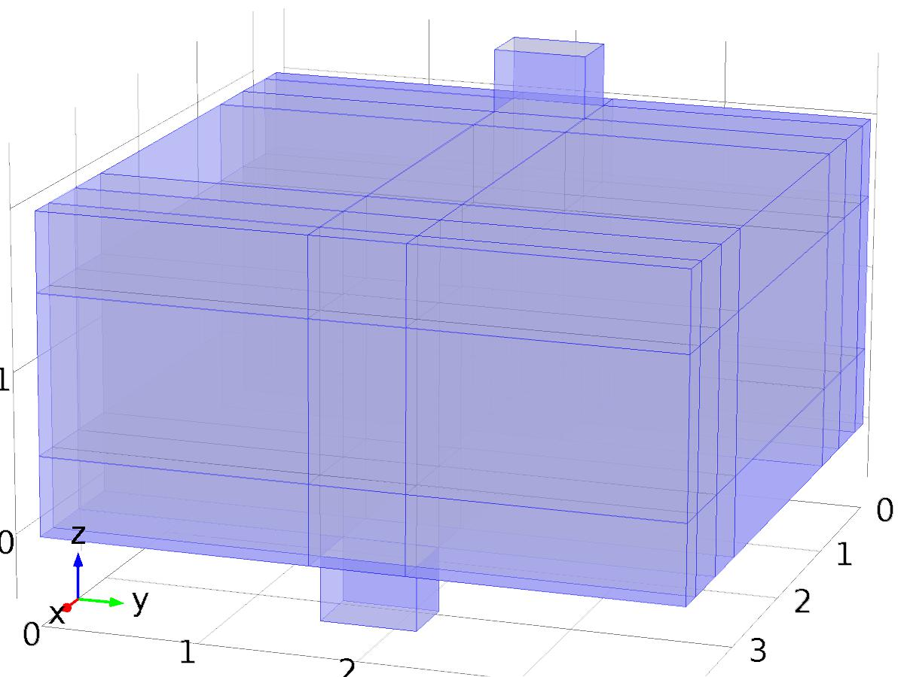

Wall 1

Selection

|  |  |
| --- | --- |
| Geometric entity level | Boundary |
| Selection | Boundaries 1–5, 7–8, 10–11, 13–14, 17, 20–21, 23–24, 27, 30–33, 35–36, 38, 41, 43, 46, 53–54, 59, 66–70, 72–73, 75, 78, 80, 83, 90–91, 94, 101–104, 106–107, 109, 112, 114, 117, 124, 127, 134–137, 139–140, 142, 145, 147, 150, 157, 160, 167–170, 172–173, 175, 178, 180–182, 193–194, 197, 204–207, 209–210, 212, 215, 217–218, 221, 228, 231, 238–250 |

Equations

Settings

| **Description** | **Value** |
| --- | --- |
| Boundary condition | No slip |
| Apply reaction terms on | Individual dependent variables |
| Use weak constraints | Off |
| Constraint method | Elemental |

#### Variables

| **Name** | **Expression** | **Unit** | **Description** | **Selection** |
| --- | --- | --- | --- | --- |
| NavierStokes.ubndx | 0 | m/s | Velocity at boundary, x component | Boundaries 1–5, 7–8, 10–11, 13–14, 17, 20–21, 23–24, 27, 30–33, 35–36, 38, 41, 43, 46, 53–54, 59, 66–70, 72–73, 75, 78, 80, 83, 90–91, 94, 101–104, 106–107, 109, 112, 114, 117, 124, 127, 134–137, 139–140, 142, 145, 147, 150, 157, 160, 167–170, 172–173, 175, 178, 180–182, 193–194, 197, 204–207, 209–210, 212, 215, 217–218, 221, 228, 231, 238–250 |
| NavierStokes.ubndy | 0 | m/s | Velocity at boundary, y component | Boundaries 1–5, 7–8, 10–11, 13–14, 17, 20–21, 23–24, 27, 30–33, 35–36, 38, 41, 43, 46, 53–54, 59, 66–70, 72–73, 75, 78, 80, 83, 90–91, 94, 101–104, 106–107, 109, 112, 114, 117, 124, 127, 134–137, 139–140, 142, 145, 147, 150, 157, 160, 167–170, 172–173, 175, 178, 180–182, 193–194, 197, 204–207, 209–210, 212, 215, 217–218, 221, 228, 231, 238–250 |
| NavierStokes.ubndz | 0 | m/s | Velocity at boundary, z component | Boundaries 1–5, 7–8, 10–11, 13–14, 17, 20–21, 23–24, 27, 30–33, 35–36, 38, 41, 43, 46, 53–54, 59, 66–70, 72–73, 75, 78, 80, 83, 90–91, 94, 101–104, 106–107, 109, 112, 114, 117, 124, 127, 134–137, 139–140, 142, 145, 147, 150, 157, 160, 167–170, 172–173, 175, 178, 180–182, 193–194, 197, 204–207, 209–210, 212, 215, 217–218, 221, 228, 231, 238–250 |

#### Shape functions

| **Constraint** | **Constraint force** | **Shape function** | **Selection** |
| --- | --- | --- | --- |
| -u+NavierStokes.ubndx | test(-u) | Lagrange (Linear) | Boundaries 1–5, 7–8, 10–11, 13–14, 17, 20–21, 23–24, 27, 30–33, 35–36, 38, 41, 43, 46, 53–54, 59, 66–70, 72–73, 75, 78, 80, 83, 90–91, 94, 101–104, 106–107, 109, 112, 114, 117, 124, 127, 134–137, 139–140, 142, 145, 147, 150, 157, 160, 167–170, 172–173, 175, 178, 180–182, 193–194, 197, 204–207, 209–210, 212, 215, 217–218, 221, 228, 231, 238–250 |
| -v+NavierStokes.ubndy | test(-v) | Lagrange (Linear) | Boundaries 1–5, 7–8, 10–11, 13–14, 17, 20–21, 23–24, 27, 30–33, 35–36, 38, 41, 43, 46, 53–54, 59, 66–70, 72–73, 75, 78, 80, 83, 90–91, 94, 101–104, 106–107, 109, 112, 114, 117, 124, 127, 134–137, 139–140, 142, 145, 147, 150, 157, 160, 167–170, 172–173, 175, 178, 180–182, 193–194, 197, 204–207, 209–210, 212, 215, 217–218, 221, 228, 231, 238–250 |
| -w+NavierStokes.ubndz | test(-w) | Lagrange (Linear) | Boundaries 1–5, 7–8, 10–11, 13–14, 17, 20–21, 23–24, 27, 30–33, 35–36, 38, 41, 43, 46, 53–54, 59, 66–70, 72–73, 75, 78, 80, 83, 90–91, 94, 101–104, 106–107, 109, 112, 114, 117, 124, 127, 134–137, 139–140, 142, 145, 147, 150, 157, 160, 167–170, 172–173, 175, 178, 180–182, 193–194, 197, 204–207, 209–210, 212, 215, 217–218, 221, 228, 231, 238–250 |

* + 1. Initial Values 1



Initial Values 1

Selection

|  |  |
| --- | --- |
| Geometric entity level | Domain |
| Selection | Domains 1–65 |

Settings

| **Description** | **Value** |
| --- | --- |
| Velocity field | {0, 0, 0} |
| Pressure | 0 |
| Turbulent kinetic energy | spf.kinit |
| Turbulent dissipation rate | spf.epinit |
| Specific dissipation rate | spf.omInit |
| Reciprocal wall distance | spf.G0 |
| Undamped turbulent kinematic viscosity | spf.nutildeinit |

* + 1. Inlet 1

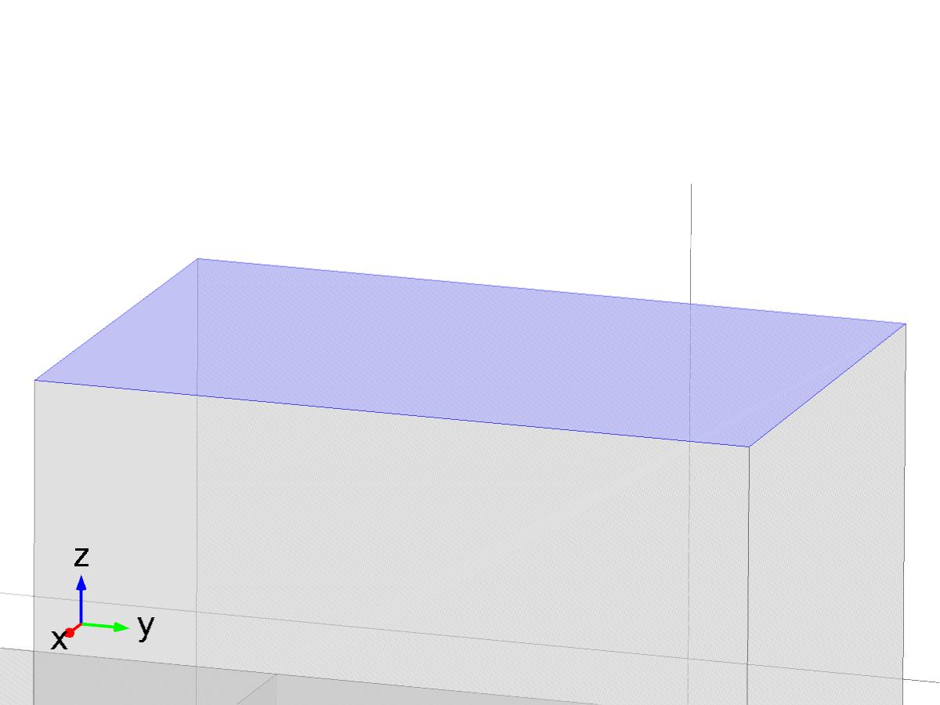

Inlet 1

Selection

|  |  |
| --- | --- |
| Geometric entity level | Boundary |
| Selection | Boundary 56 |

Equations

Settings

| **Description** | **Value** |
| --- | --- |
| Use weak constraints | Off |
| Boundary condition | Normal stress |
| Pressure | 10 |
| Normal stress | 1 |
| Normal inflow velocity | 0.1 |
| Velocity field, x component | 0 |
| Velocity field, y component | 0 |
| Velocity field, z component | 0.1 |
| Turbulent intensity | 0.05 |
| Turbulence length scale | 0.01[m] |
| Turbulent kinetic energy | 0.005[m^2/s^2] |
| Turbulent dissipation rate | 0.005[m^2/s^3] |
| Specific dissipation rate | 20[1/s] |
| Undamped turbulent kinematic viscosity | 3*spf.nu |
| Constraint method | Elemental |

#### Variables

| **Name** | **Expression** | **Unit** | **Description** | **Selection** |
| --- | --- | --- | --- | --- |
| NavierStokes.f0 | 1 | N/m^2 | Normal stress | Boundary 56 |

#### Weak expressions

| **Weak expression** | **Integration frame** | **Selection** |
| --- | --- | --- |
| -NavierStokes.f0*(test(u)*NavierStokes.nxmesh+test(v)*NavierStokes.nymesh+test(w)*NavierStokes.nzmesh) | Material | Boundary 56 |

* + 1. Outlet 1

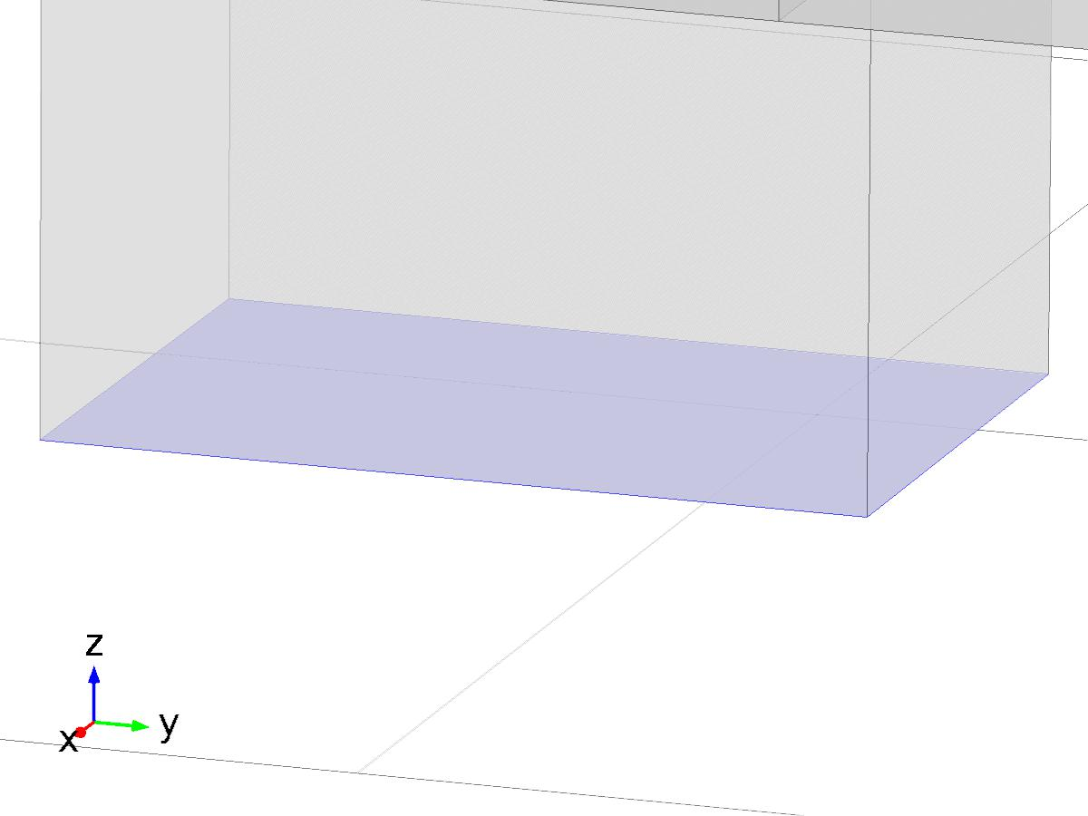

Outlet 1

Selection

|  |  |
| --- | --- |
| Geometric entity level | Boundary |
| Selection | Boundary 183 |

Equations

Settings

| **Description** | **Value** |
| --- | --- |
| Use weak constraints | Off |
| Boundary condition | Normal stress |
| Normal stress | 0 |
| Constraint method | Elemental |

#### Variables

| **Name** | **Expression** | **Unit** | **Description** | **Selection** |
| --- | --- | --- | --- | --- |
| NavierStokes.f0 | 0 | N/m^2 | Normal stress | Boundary 183 |

#### Weak expressions

| **Weak expression** | **Integration frame** | **Selection** |
| --- | --- | --- |
| -NavierStokes.f0*(test(u)*NavierStokes.nxmesh+test(v)*NavierStokes.nymesh+test(w)*NavierStokes.nzmesh) | Material | Boundary 183 |

* 1. Heat Transfer in Fluids

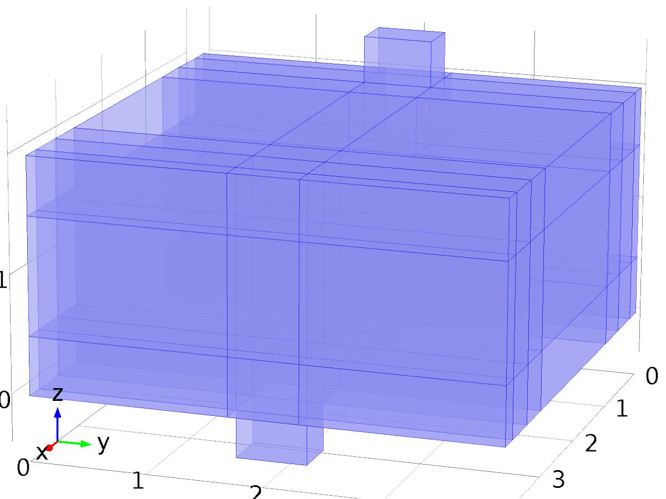

Heat Transfer in Fluids

Selection

|  |  |
| --- | --- |
| Geometric entity level | Domain |
| Selection | Domains 1–65 |

Equations





Settings

| **Description** | **Value** |
| --- | --- |
| Temperature | Linear |
| Compute boundary fluxes | On |
| Apply smoothing to boundary fluxes | On |
| Value type when using splitting of complex variables | Real |
| Streamline diffusion | On |
| Crosswind diffusion | On |
| Lower gradient limit | (0.01[K])/ht.helem |
| Isotropic diffusion | Off |

Used products

|  |
| --- |
| COMSOL Multiphysics |

Variables

| **Name** | **Expression** | **Unit** | **Description** | **Selection** |
| --- | --- | --- | --- | --- |
| X_T.q0 | 0 | W/m^2 | Inward heat flux | Boundaries 1–250 |
| X_T.Tu | X_T | K | Temperature | Boundaries 1–250 |
| X_T.Td | X_T | K | Temperature | Boundaries 1–250 |
| X_T.opaqueLayer | 1 |  | Thin layer opacity | Boundaries 1–250 |
| X_T.Tvar | X_T | K | Temperature | Domains 1–65 |
| X_T.d | 1 | 1 | Thickness | Domains 1–65 |
| X_T.nx | nx | 1 | Normal vector, x component | Boundaries 6, 9, 12, 15–16, 18–19, 22, 25–26, 28–29, 34, 37, 39–40, 42, 44–45, 47–52, 55, 57–58, 60–65, 71, 74, 76–77, 79, 81–82, 84–89, 92–93, 95–100, 105, 108, 110–111, 113, 115–116, 118–123, 125–126, 128–133, 138, 141, 143–144, 146, 148–149, 151–156, 158–159, 161–166, 171, 174, 176–177, 179, 184–192, 195–196, 198–203, 208, 211, 213–214, 216, 219–220, 222–227, 229–230, 232–237 |
| X_T.ny | ny | 1 | Normal vector, y component | Boundaries 6, 9, 12, 15–16, 18–19, 22, 25–26, 28–29, 34, 37, 39–40, 42, 44–45, 47–52, 55, 57–58, 60–65, 71, 74, 76–77, 79, 81–82, 84–89, 92–93, 95–100, 105, 108, 110–111, 113, 115–116, 118–123, 125–126, 128–133, 138, 141, 143–144, 146, 148–149, 151–156, 158–159, 161–166, 171, 174, 176–177, 179, 184–192, 195–196, 198–203, 208, 211, 213–214, 216, 219–220, 222–227, 229–230, 232–237 |
| X_T.nz | nz | 1 | Normal vector, z component | Boundaries 6, 9, 12, 15–16, 18–19, 22, 25–26, 28–29, 34, 37, 39–40, 42, 44–45, 47–52, 55, 57–58, 60–65, 71, 74, 76–77, 79, 81–82, 84–89, 92–93, 95–100, 105, 108, 110–111, 113, 115–116, 118–123, 125–126, 128–133, 138, 141, 143–144, 146, 148–149, 151–156, 158–159, 161–166, 171, 174, 176–177, 179, 184–192, 195–196, 198–203, 208, 211, 213–214, 216, 219–220, 222–227, 229–230, 232–237 |
| X_T.nx | dnx | 1 | Normal vector, x component | Boundaries 1–5, 7–8, 10–11, 13–14, 17, 20–21, 23–24, 27, 30–33, 35–36, 38, 41, 43, 46, 53–54, 56, 59, 66–70, 72–73, 75, 78, 80, 83, 90–91, 94, 101–104, 106–107, 109, 112, 114, 117, 124, 127, 134–137, 139–140, 142, 145, 147, 150, 157, 160, 167–170, 172–173, 175, 178, 180–183, 193–194, 197, 204–207, 209–210, 212, 215, 217–218, 221, 228, 231, 238–250 |
| X_T.ny | dny | 1 | Normal vector, y component | Boundaries 1–5, 7–8, 10–11, 13–14, 17, 20–21, 23–24, 27, 30–33, 35–36, 38, 41, 43, 46, 53–54, 56, 59, 66–70, 72–73, 75, 78, 80, 83, 90–91, 94, 101–104, 106–107, 109, 112, 114, 117, 124, 127, 134–137, 139–140, 142, 145, 147, 150, 157, 160, 167–170, 172–173, 175, 178, 180–183, 193–194, 197, 204–207, 209–210, 212, 215, 217–218, 221, 228, 231, 238–250 |
| X_T.nz | dnz | 1 | Normal vector, z component | Boundaries 1–5, 7–8, 10–11, 13–14, 17, 20–21, 23–24, 27, 30–33, 35–36, 38, 41, 43, 46, 53–54, 56, 59, 66–70, 72–73, 75, 78, 80, 83, 90–91, 94, 101–104, 106–107, 109, 112, 114, 117, 124, 127, 134–137, 139–140, 142, 145, 147, 150, 157, 160, 167–170, 172–173, 175, 178, 180–183, 193–194, 197, 204–207, 209–210, 212, 215, 217–218, 221, 228, 231, 238–250 |
| X_T.nxmesh | root.nxmesh | 1 | Normal vector (mesh), x component | Boundaries 6, 9, 12, 15–16, 18–19, 22, 25–26, 28–29, 34, 37, 39–40, 42, 44–45, 47–52, 55, 57–58, 60–65, 71, 74, 76–77, 79, 81–82, 84–89, 92–93, 95–100, 105, 108, 110–111, 113, 115–116, 118–123, 125–126, 128–133, 138, 141, 143–144, 146, 148–149, 151–156, 158–159, 161–166, 171, 174, 176–177, 179, 184–192, 195–196, 198–203, 208, 211, 213–214, 216, 219–220, 222–227, 229–230, 232–237 |
| X_T.nymesh | root.nymesh | 1 | Normal vector (mesh), y component | Boundaries 6, 9, 12, 15–16, 18–19, 22, 25–26, 28–29, 34, 37, 39–40, 42, 44–45, 47–52, 55, 57–58, 60–65, 71, 74, 76–77, 79, 81–82, 84–89, 92–93, 95–100, 105, 108, 110–111, 113, 115–116, 118–123, 125–126, 128–133, 138, 141, 143–144, 146, 148–149, 151–156, 158–159, 161–166, 171, 174, 176–177, 179, 184–192, 195–196, 198–203, 208, 211, 213–214, 216, 219–220, 222–227, 229–230, 232–237 |
| X_T.nzmesh | root.nzmesh | 1 | Normal vector (mesh), z component | Boundaries 6, 9, 12, 15–16, 18–19, 22, 25–26, 28–29, 34, 37, 39–40, 42, 44–45, 47–52, 55, 57–58, 60–65, 71, 74, 76–77, 79, 81–82, 84–89, 92–93, 95–100, 105, 108, 110–111, 113, 115–116, 118–123, 125–126, 128–133, 138, 141, 143–144, 146, 148–149, 151–156, 158–159, 161–166, 171, 174, 176–177, 179, 184–192, 195–196, 198–203, 208, 211, 213–214, 216, 219–220, 222–227, 229–230, 232–237 |
| X_T.nxmesh | root.dnxmesh | 1 | Normal vector (mesh), x component | Boundaries 1–5, 7–8, 10–11, 13–14, 17, 20–21, 23–24, 27, 30–33, 35–36, 38, 41, 43, 46, 53–54, 56, 59, 66–70, 72–73, 75, 78, 80, 83, 90–91, 94, 101–104, 106–107, 109, 112, 114, 117, 124, 127, 134–137, 139–140, 142, 145, 147, 150, 157, 160, 167–170, 172–173, 175, 178, 180–183, 193–194, 197, 204–207, 209–210, 212, 215, 217–218, 221, 228, 231, 238–250 |
| X_T.nymesh | root.dnymesh | 1 | Normal vector (mesh), y component | Boundaries 1–5, 7–8, 10–11, 13–14, 17, 20–21, 23–24, 27, 30–33, 35–36, 38, 41, 43, 46, 53–54, 56, 59, 66–70, 72–73, 75, 78, 80, 83, 90–91, 94, 101–104, 106–107, 109, 112, 114, 117, 124, 127, 134–137, 139–140, 142, 145, 147, 150, 157, 160, 167–170, 172–173, 175, 178, 180–183, 193–194, 197, 204–207, 209–210, 212, 215, 217–218, 221, 228, 231, 238–250 |
| X_T.nzmesh | root.dnzmesh | 1 | Normal vector (mesh), z component | Boundaries 1–5, 7–8, 10–11, 13–14, 17, 20–21, 23–24, 27, 30–33, 35–36, 38, 41, 43, 46, 53–54, 56, 59, 66–70, 72–73, 75, 78, 80, 83, 90–91, 94, 101–104, 106–107, 109, 112, 114, 117, 124, 127, 134–137, 139–140, 142, 145, 147, 150, 157, 160, 167–170, 172–173, 175, 178, 180–183, 193–194, 197, 204–207, 209–210, 212, 215, 217–218, 221, 228, 231, 238–250 |
| X_T.dnx | dnx | 1 | Normal vector down direction, x component | Boundaries 1–250 |
| X_T.dny | dny | 1 | Normal vector down direction, y component | Boundaries 1–250 |
| X_T.dnz | dnz | 1 | Normal vector down direction, z component | Boundaries 1–250 |
| X_T.unx | unx | 1 | Normal vector up direction, x component | Boundaries 1–250 |
| X_T.uny | uny | 1 | Normal vector up direction, y component | Boundaries 1–250 |
| X_T.unz | unz | 1 | Normal vector up direction, z component | Boundaries 1–250 |
| X_T.dEiInt | X_T.intDom(d(X_T.rho*X_T.Ei,t)*X_T.varIntSpa) | W | Total accumulated heat rate | Global |
| X_T.dEi0Int | X_T.intDom(d(X_T.rho*X_T.Ei0,t)*X_T.varIntSpa) | W | Total accumulated energy rate | Global |
| X_T.ntfluxInt | X_T.intExtBnd(X_T.ntflux*X_T.varIntSpa) | W | Total net heat rate | Global |
| X_T.ntefluxInt | X_T.intExtBnd(X_T.nteflux*X_T.varIntSpa) | W | Total net energy rate | Global |
| X_T.QInt | X_T.intDom(X_T.Qtot*X_T.varIntSpa)-X_T.intIntBnd((X_T.ndflux_u+X_T.ndflux_d)*X_T.varIntSpa) | W | Total heat source | Global |
| X_T.WnsInt | 0 | W | Total work source | Global |
| X_T.WInt | 0 | W | Total work source | Global |

* + 1. Heat Transfer in Fluids 1



Heat Transfer in Fluids 1

Selection

|  |  |
| --- | --- |
| Geometric entity level | Domain |
| Selection | Domains 1–65 |

Equations

Settings

| **Description** | **Value** |
| --- | --- |
| Fluid type | Gas/Liquid |
| Thermal conductivity | User defined |
| Thermal conductivity | {{K, 0, 0}, {0, K, 0}, {0, 0, K}} |
| Density | User defined |
| Density | rho |
| Heat capacity at constant pressure | User defined |
| Heat capacity at constant pressure | cp |
| Ratio of specific heats | User defined |
| Ratio of specific heats | 1 |
| Equivalent conductivity for convection | Off |

#### Variables

| **Name** | **Expression** | **Unit** | **Description** | **Selection** |
| --- | --- | --- | --- | --- |
| domflux.X_Tx | -X_T.k_effxx*X_Tx-X_T.k_effxy*X_Ty-X_T.k_effxz*X_Tz | W/m^2 | Domain flux, x component | Domains 1–65 |
| domflux.X_Ty | -X_T.k_effyx*X_Tx-X_T.k_effyy*X_Ty-X_T.k_effyz*X_Tz | W/m^2 | Domain flux, y component | Domains 1–65 |
| domflux.X_Tz | -X_T.k_effzx*X_Tx-X_T.k_effzy*X_Ty-X_T.k_effzz*X_Tz | W/m^2 | Domain flux, z component | Domains 1–65 |
| X_T.WnsInt | X_T.fluid1.intDom(X_T.pA*(d(X_T.ux,x)+d(X_T.uy,y)+d(X_T.uz,z))*X_T.fluid1.varIntSpa) | W | Total work source | Global |
| X_T.kxx | K | W/(m*K) | Thermal conductivity, xx component | Domains 1–65 |
| X_T.kyx | 0 | W/(m*K) | Thermal conductivity, yx component | Domains 1–65 |
| X_T.kzx | 0 | W/(m*K) | Thermal conductivity, zx component | Domains 1–65 |
| X_T.kxy | 0 | W/(m*K) | Thermal conductivity, xy component | Domains 1–65 |
| X_T.kyy | K | W/(m*K) | Thermal conductivity, yy component | Domains 1–65 |
| X_T.kzy | 0 | W/(m*K) | Thermal conductivity, zy component | Domains 1–65 |
| X_T.kxz | 0 | W/(m*K) | Thermal conductivity, xz component | Domains 1–65 |
| X_T.kyz | 0 | W/(m*K) | Thermal conductivity, yz component | Domains 1–65 |
| X_T.kzz | K | W/(m*K) | Thermal conductivity, zz component | Domains 1–65 |
| X_T.rho | material.rho | kg/m^3 | Density | Domains 1–65 |
| X_T.Cp | cp | J/(kg*K) | Heat capacity at constant pressure | Domains 1–65 |
| X_T.gamma | 1 | 1 | Ratio of specific heats | Domains 1–65 |
| X_T.fluid1.pRef | model.input.pRef | Pa | Reference pressure level | Domains 1–65 |
| X_T.T | model.input.minput_temperature | K | Temperature | Domains 1–65 |
| X_T.alphap | -d(X_T.rho,X_T)/(X_T.rho+eps) | 1/K | Isobaric compressibility coefficient | Domains 1–65 |
| X_T.pA | model.input.minput_pressure | Pa | Absolute pressure | Domains 1–65 |
| X_T.gradTmag | sqrt(X_T.gradTx^2+X_T.gradTy^2+X_T.gradTz^2) | K/m | Temperature gradient magnitude | Domains 1–65 |
| X_T.kmean | (X_T.k_effxx+X_T.k_effyy+X_T.k_effzz)/3 | W/(m*K) | Mean effective thermal conductivity | Domains 1–65 |
| X_T.Q | 0 | W/m^3 | Heat source | Domains 1–65 |
| X_T.qs | 0 | W/(m^3*K) | Production/absorption coefficient | Domains 1–65 |
| X_T.Qmet | 0 | W/m^3 | Metabolic heat source | Domains 1–65 |
| X_T.Qtot | 0 | W/m^3 | Total heat source | Domains 1–65 |
| X_T.rhoInt | subst(X_T.rho,root.mod1.X_T.fluid1.minput_pressure,X_T.pA) | kg/m^3 | Density for integration | Domains 1–65 |
| X_T.CpInt | subst(X_T.Cp,root.mod1.X_T.fluid1.minput_pressure,X_T.pA) | J/(kg*K) | Specific heat capacity for integration | Domains 1–65 |
| X_T.gammaInt | subst(X_T.gamma,root.mod1.X_T.fluid1.minput_pressure,X_T.pA) | 1 | Ratio of specific heats for integration | Domains 1–65 |
| X_T.TRef | 298.15[K] | K | Reference temperature | Domains 1–65 |
| X_T.pRef | X_T.fluid1.pRef | Pa | Reference pressure level | Domains 1–65 |
| X_T.HRef | 0 | J/kg | Reference enthalpy | Domains 1–65 |
| X_T.DeltaH | integrate((1+X_T*d(X_T.rhoInt,X_T)/X_T.rhoInt)/X_T.rhoInt,X_T.pA,X_T.pRef,X_T.pA)+integrate(subst(X_T.CpInt,X_T.pA,X_T.pRef),X_T,X_T.TRef,X_T) | J/kg | Sensible enthalpy | Domains 1–65 |
| X_T.H | X_T.HRef+X_T.DeltaH | J/kg | Enthalpy | Domains 1–65 |
| X_T.H0 | X_T.H+0.5*(X_T.ux^2+X_T.uy^2+X_T.uz^2) | J/kg | Total enthalpy | Domains 1–65 |
| X_T.Ei | X_T.H-X_T.pA/X_T.rho | J/kg | Internal energy | Domains 1–65 |
| X_T.Ei0 | X_T.Ei+0.5*(X_T.ux^2+X_T.uy^2+X_T.uz^2) | J/kg | Total internal energy | Domains 1–65 |
| X_T.Qbtot | 0 | W/m^2 | Total boundary heat source | Boundaries 1–250 |
| X_T.k_effxx | X_T.kxx | W/(m*K) | Effective thermal conductivity, xx component | Domains 1–65 |
| X_T.k_effyx | X_T.kyx | W/(m*K) | Effective thermal conductivity, yx component | Domains 1–65 |
| X_T.k_effzx | X_T.kzx | W/(m*K) | Effective thermal conductivity, zx component | Domains 1–65 |
| X_T.k_effxy | X_T.kxy | W/(m*K) | Effective thermal conductivity, xy component | Domains 1–65 |
| X_T.k_effyy | X_T.kyy | W/(m*K) | Effective thermal conductivity, yy component | Domains 1–65 |
| X_T.k_effzy | X_T.kzy | W/(m*K) | Effective thermal conductivity, zy component | Domains 1–65 |
| X_T.k_effxz | X_T.kxz | W/(m*K) | Effective thermal conductivity, xz component | Domains 1–65 |
| X_T.k_effyz | X_T.kyz | W/(m*K) | Effective thermal conductivity, yz component | Domains 1–65 |
| X_T.k_effzz | X_T.kzz | W/(m*K) | Effective thermal conductivity, zz component | Domains 1–65 |
| X_T.C_eff | X_T.rho*X_T.Cp | J/(m^3*K) | Effective volumetric heat capacity | Domains 1–65 |
| X_T.ux | model.input.minput_velocity1 | m/s | Velocity field, x component | Domains 1–65 |
| X_T.uy | model.input.minput_velocity2 | m/s | Velocity field, y component | Domains 1–65 |
| X_T.uz | model.input.minput_velocity3 | m/s | Velocity field, z component | Domains 1–65 |
| X_T.gradTx | X_Tx | K/m | Temperature gradient, x component | Domains 1–65 |
| X_T.gradTy | X_Ty | K/m | Temperature gradient, y component | Domains 1–65 |
| X_T.gradTz | X_Tz | K/m | Temperature gradient, z component | Domains 1–65 |
| X_T.Qltot | 0 | W/m | Total line heat source | Edges 1–320 |
| X_T.Qptot | 0 | W | Total point heat source | Points 1–136 |
| X_T.alphaTdxx | X_T.k_effxx/X_T.C_eff | m^2/s | Thermal diffusivity, xx component | Domains 1–65 |
| X_T.alphaTdyx | X_T.k_effyx/X_T.C_eff | m^2/s | Thermal diffusivity, yx component | Domains 1–65 |
| X_T.alphaTdzx | X_T.k_effzx/X_T.C_eff | m^2/s | Thermal diffusivity, zx component | Domains 1–65 |
| X_T.alphaTdxy | X_T.k_effxy/X_T.C_eff | m^2/s | Thermal diffusivity, xy component | Domains 1–65 |
| X_T.alphaTdyy | X_T.k_effyy/X_T.C_eff | m^2/s | Thermal diffusivity, yy component | Domains 1–65 |
| X_T.alphaTdzy | X_T.k_effzy/X_T.C_eff | m^2/s | Thermal diffusivity, zy component | Domains 1–65 |
| X_T.alphaTdxz | X_T.k_effxz/X_T.C_eff | m^2/s | Thermal diffusivity, xz component | Domains 1–65 |
| X_T.alphaTdyz | X_T.k_effyz/X_T.C_eff | m^2/s | Thermal diffusivity, yz component | Domains 1–65 |
| X_T.alphaTdzz | X_T.k_effzz/X_T.C_eff | m^2/s | Thermal diffusivity, zz component | Domains 1–65 |
| X_T.alphaTdMean | X_T.kmean/X_T.C_eff | m^2/s | Mean thermal diffusivity | Domains 1–65 |
| X_T.dfluxx | -X_T.k_effxx*X_Tx-X_T.k_effxy*X_Ty-X_T.k_effxz*X_Tz | W/m^2 | Conductive heat flux, x component | Domains 1–65 |
| X_T.dfluxy | -X_T.k_effyx*X_Tx-X_T.k_effyy*X_Ty-X_T.k_effyz*X_Tz | W/m^2 | Conductive heat flux, y component | Domains 1–65 |
| X_T.dfluxz | -X_T.k_effzx*X_Tx-X_T.k_effzy*X_Ty-X_T.k_effzz*X_Tz | W/m^2 | Conductive heat flux, z component | Domains 1–65 |
| X_T.dfluxMag | sqrt(X_T.dfluxx^2+X_T.dfluxy^2+X_T.dfluxz^2) | W/m^2 | Conductive heat flux magnitude | Domains 1–65 |
| X_T.trlfluxx | 0 | W/m^2 | Translational heat flux, x component | Domains 1–65 |
| X_T.trlfluxy | 0 | W/m^2 | Translational heat flux, y component | Domains 1–65 |
| X_T.trlfluxz | 0 | W/m^2 | Translational heat flux, z component | Domains 1–65 |
| X_T.trlfluxMag | sqrt(X_T.trlfluxx^2+X_T.trlfluxy^2+X_T.trlfluxz^2) | W/m^2 | Translational heat flux magnitude | Domains 1–65 |
| X_T.cfluxx | X_T.rho*X_T.ux*X_T.Ei | W/m^2 | Convective heat flux, x component | Domains 1–65 |
| X_T.cfluxy | X_T.rho*X_T.uy*X_T.Ei | W/m^2 | Convective heat flux, y component | Domains 1–65 |
| X_T.cfluxz | X_T.rho*X_T.uz*X_T.Ei | W/m^2 | Convective heat flux, z component | Domains 1–65 |
| X_T.cfluxMag | sqrt(X_T.cfluxx^2+X_T.cfluxy^2+X_T.cfluxz^2) | W/m^2 | Convective heat flux magnitude | Domains 1–65 |
| X_T.tfluxx | X_T.dfluxx+X_T.trlfluxx+X_T.cfluxx | W/m^2 | Total heat flux, x component | Domains 1–65 |
| X_T.tfluxy | X_T.dfluxy+X_T.trlfluxy+X_T.cfluxy | W/m^2 | Total heat flux, y component | Domains 1–65 |
| X_T.tfluxz | X_T.dfluxz+X_T.trlfluxz+X_T.cfluxz | W/m^2 | Total heat flux, z component | Domains 1–65 |
| X_T.tfluxMag | sqrt(X_T.tfluxx^2+X_T.tfluxy^2+X_T.tfluxz^2) | W/m^2 | Total heat flux magnitude | Domains 1–65 |
| X_T.tefluxx | X_T.dfluxx+X_T.rho*X_T.ux*X_T.H0 | W/m^2 | Total energy flux, x component | Domains 1–65 |
| X_T.tefluxy | X_T.dfluxy+X_T.rho*X_T.uy*X_T.H0 | W/m^2 | Total energy flux, y component | Domains 1–65 |
| X_T.tefluxz | X_T.dfluxz+X_T.rho*X_T.uz*X_T.H0 | W/m^2 | Total energy flux, z component | Domains 1–65 |
| X_T.tefluxMag | sqrt(X_T.tefluxx^2+X_T.tefluxy^2+X_T.tefluxz^2) | W/m^2 | Total energy flux magnitude | Domains 1–65 |
| X_T.rflux | 0 | W/m^2 | Radiative heat flux | Boundaries 1–250 |
| X_T.chflux | 0 | W/m^2 | Boundary convective heat flux | Boundaries 1–250 |
| X_T.ntrlflux | mean(X_T.trlfluxx)*X_T.nx+mean(X_T.trlfluxy)*X_T.ny+mean(X_T.trlfluxz)*X_T.nz | W/m^2 | Normal translational heat flux | Boundaries 1–250 |
| X_T.ntrlflux_u | up(X_T.trlfluxx)*X_T.unx+up(X_T.trlfluxy)*X_T.uny+up(X_T.trlfluxz)*X_T.unz | W/m^2 | Internal normal translational heat flux, upside | Boundaries 6, 9, 12, 15–16, 18–19, 22, 25–26, 28–29, 34, 37, 39–40, 42, 44–45, 47–52, 55, 57–58, 60–65, 71, 74, 76–77, 79, 81–82, 84–89, 92–93, 95–100, 105, 108, 110–111, 113, 115–116, 118–123, 125–126, 128–133, 138, 141, 143–144, 146, 148–149, 151–156, 158–159, 161–166, 171, 174, 176–177, 179, 184–192, 195–196, 198–203, 208, 211, 213–214, 216, 219–220, 222–227, 229–230, 232–237 |
| X_T.ntrlflux_d | down(X_T.trlfluxx)*X_T.dnx+down(X_T.trlfluxy)*X_T.dny+down(X_T.trlfluxz)*X_T.dnz | W/m^2 | Internal normal translational heat flux, downside | Boundaries 6, 9, 12, 15–16, 18–19, 22, 25–26, 28–29, 34, 37, 39–40, 42, 44–45, 47–52, 55, 57–58, 60–65, 71, 74, 76–77, 79, 81–82, 84–89, 92–93, 95–100, 105, 108, 110–111, 113, 115–116, 118–123, 125–126, 128–133, 138, 141, 143–144, 146, 148–149, 151–156, 158–159, 161–166, 171, 174, 176–177, 179, 184–192, 195–196, 198–203, 208, 211, 213–214, 216, 219–220, 222–227, 229–230, 232–237 |
| X_T.ncflux | mean(X_T.cfluxx)*X_T.nx+mean(X_T.cfluxy)*X_T.ny+mean(X_T.cfluxz)*X_T.nz | W/m^2 | Normal convective heat flux | Boundaries 1–250 |
| X_T.ncflux_u | up(X_T.cfluxx)*X_T.unx+up(X_T.cfluxy)*X_T.uny+up(X_T.cfluxz)*X_T.unz | W/m^2 | Internal normal convective heat flux, upside | Boundaries 6, 9, 12, 15–16, 18–19, 22, 25–26, 28–29, 34, 37, 39–40, 42, 44–45, 47–52, 55, 57–58, 60–65, 71, 74, 76–77, 79, 81–82, 84–89, 92–93, 95–100, 105, 108, 110–111, 113, 115–116, 118–123, 125–126, 128–133, 138, 141, 143–144, 146, 148–149, 151–156, 158–159, 161–166, 171, 174, 176–177, 179, 184–192, 195–196, 198–203, 208, 211, 213–214, 216, 219–220, 222–227, 229–230, 232–237 |
| X_T.ncflux_d | down(X_T.cfluxx)*X_T.dnx+down(X_T.cfluxy)*X_T.dny+down(X_T.cfluxz)*X_T.dnz | W/m^2 | Internal normal convective heat flux, downside | Boundaries 6, 9, 12, 15–16, 18–19, 22, 25–26, 28–29, 34, 37, 39–40, 42, 44–45, 47–52, 55, 57–58, 60–65, 71, 74, 76–77, 79, 81–82, 84–89, 92–93, 95–100, 105, 108, 110–111, 113, 115–116, 118–123, 125–126, 128–133, 138, 141, 143–144, 146, 148–149, 151–156, 158–159, 161–166, 171, 174, 176–177, 179, 184–192, 195–196, 198–203, 208, 211, 213–214, 216, 219–220, 222–227, 229–230, 232–237 |
| X_T.ndflux | -dflux_spatial(X_T) | W/m^2 | Normal conductive heat flux | Boundaries 1–5, 7–8, 10–11, 13–14, 17, 20–21, 23–24, 27, 30–33, 35–36, 38, 41, 43, 46, 53–54, 56, 59, 66–70, 72–73, 75, 78, 80, 83, 90–91, 94, 101–104, 106–107, 109, 112, 114, 117, 124, 127, 134–137, 139–140, 142, 145, 147, 150, 157, 160, 167–170, 172–173, 175, 178, 180–183, 193–194, 197, 204–207, 209–210, 212, 215, 217–218, 221, 228, 231, 238–250 |
| X_T.ndflux | 0.5*(uflux_spatial(X_T)-dflux_spatial(X_T)) | W/m^2 | Normal conductive heat flux | Boundaries 6, 9, 12, 15–16, 18–19, 22, 25–26, 28–29, 34, 37, 39–40, 42, 44–45, 47–52, 55, 57–58, 60–65, 71, 74, 76–77, 79, 81–82, 84–89, 92–93, 95–100, 105, 108, 110–111, 113, 115–116, 118–123, 125–126, 128–133, 138, 141, 143–144, 146, 148–149, 151–156, 158–159, 161–166, 171, 174, 176–177, 179, 184–192, 195–196, 198–203, 208, 211, 213–214, 216, 219–220, 222–227, 229–230, 232–237 |
| X_T.ndflux_u | -uflux_spatial(X_T) | W/m^2 | Internal normal conductive heat flux, upside | Boundaries 6, 9, 12, 15–16, 18–19, 22, 25–26, 28–29, 34, 37, 39–40, 42, 44–45, 47–52, 55, 57–58, 60–65, 71, 74, 76–77, 79, 81–82, 84–89, 92–93, 95–100, 105, 108, 110–111, 113, 115–116, 118–123, 125–126, 128–133, 138, 141, 143–144, 146, 148–149, 151–156, 158–159, 161–166, 171, 174, 176–177, 179, 184–192, 195–196, 198–203, 208, 211, 213–214, 216, 219–220, 222–227, 229–230, 232–237 |
| X_T.ndflux_d | -dflux_spatial(X_T) | W/m^2 | Internal normal conductive heat flux, downside | Boundaries 6, 9, 12, 15–16, 18–19, 22, 25–26, 28–29, 34, 37, 39–40, 42, 44–45, 47–52, 55, 57–58, 60–65, 71, 74, 76–77, 79, 81–82, 84–89, 92–93, 95–100, 105, 108, 110–111, 113, 115–116, 118–123, 125–126, 128–133, 138, 141, 143–144, 146, 148–149, 151–156, 158–159, 161–166, 171, 174, 176–177, 179, 184–192, 195–196, 198–203, 208, 211, 213–214, 216, 219–220, 222–227, 229–230, 232–237 |
| X_T.ntflux | X_T.ndflux+X_T.ntrlflux+X_T.ncflux | W/m^2 | Normal total heat flux | Boundaries 1–250 |
| X_T.ntflux_u | X_T.ndflux_u+X_T.ntrlflux_u+X_T.ncflux_u | W/m^2 | Internal normal total flux, upside | Boundaries 6, 9, 12, 15–16, 18–19, 22, 25–26, 28–29, 34, 37, 39–40, 42, 44–45, 47–52, 55, 57–58, 60–65, 71, 74, 76–77, 79, 81–82, 84–89, 92–93, 95–100, 105, 108, 110–111, 113, 115–116, 118–123, 125–126, 128–133, 138, 141, 143–144, 146, 148–149, 151–156, 158–159, 161–166, 171, 174, 176–177, 179, 184–192, 195–196, 198–203, 208, 211, 213–214, 216, 219–220, 222–227, 229–230, 232–237 |
| X_T.ntflux_d | X_T.ndflux_d+X_T.ntrlflux_d+X_T.ncflux_d | W/m^2 | Internal normal total flux, downside | Boundaries 6, 9, 12, 15–16, 18–19, 22, 25–26, 28–29, 34, 37, 39–40, 42, 44–45, 47–52, 55, 57–58, 60–65, 71, 74, 76–77, 79, 81–82, 84–89, 92–93, 95–100, 105, 108, 110–111, 113, 115–116, 118–123, 125–126, 128–133, 138, 141, 143–144, 146, 148–149, 151–156, 158–159, 161–166, 171, 174, 176–177, 179, 184–192, 195–196, 198–203, 208, 211, 213–214, 216, 219–220, 222–227, 229–230, 232–237 |
| X_T.nteflux | mean(X_T.tefluxx)*X_T.nx+mean(X_T.tefluxy)*X_T.ny+mean(X_T.tefluxz)*X_T.nz-mean(X_T.dfluxx)*X_T.nx-mean(X_T.dfluxy)*X_T.ny-mean(X_T.dfluxz)*X_T.nz+X_T.ndflux | W/m^2 | Normal total energy flux | Boundaries 1–250 |
| X_T.nteflux_u | up(X_T.tefluxx)*X_T.unx+up(X_T.tefluxy)*X_T.uny+up(X_T.tefluxz)*X_T.unz-up(X_T.dfluxx)*X_T.unx-up(X_T.dfluxy)*X_T.uny-up(X_T.dfluxz)*X_T.unz+X_T.ndflux_u | W/m^2 | Internal normal total energy flux, upside | Boundaries 6, 9, 12, 15–16, 18–19, 22, 25–26, 28–29, 34, 37, 39–40, 42, 44–45, 47–52, 55, 57–58, 60–65, 71, 74, 76–77, 79, 81–82, 84–89, 92–93, 95–100, 105, 108, 110–111, 113, 115–116, 118–123, 125–126, 128–133, 138, 141, 143–144, 146, 148–149, 151–156, 158–159, 161–166, 171, 174, 176–177, 179, 184–192, 195–196, 198–203, 208, 211, 213–214, 216, 219–220, 222–227, 229–230, 232–237 |
| X_T.nteflux_d | down(X_T.tefluxx)*X_T.dnx+down(X_T.tefluxy)*X_T.dny+down(X_T.tefluxz)*X_T.dnz-down(X_T.dfluxx)*X_T.dnx-down(X_T.dfluxy)*X_T.dny-down(X_T.dfluxz)*X_T.dnz+X_T.ndflux_d | W/m^2 | Internal normal total energy flux, downside | Boundaries 6, 9, 12, 15–16, 18–19, 22, 25–26, 28–29, 34, 37, 39–40, 42, 44–45, 47–52, 55, 57–58, 60–65, 71, 74, 76–77, 79, 81–82, 84–89, 92–93, 95–100, 105, 108, 110–111, 113, 115–116, 118–123, 125–126, 128–133, 138, 141, 143–144, 146, 148–149, 151–156, 158–159, 161–166, 171, 174, 176–177, 179, 184–192, 195–196, 198–203, 208, 211, 213–214, 216, 219–220, 222–227, 229–230, 232–237 |
| X_T.fluid1.dEiInt | X_T.fluid1.intDom(d(X_T.rho*X_T.Ei,t)*X_T.fluid1.varIntSpa) | W | Total accumulated heat rate | Global |
| X_T.fluid1.dEi0Int | X_T.fluid1.intDom(d(X_T.rho*X_T.Ei0,t)*X_T.fluid1.varIntSpa) | W | Total accumulated energy rate | Global |
| X_T.fluid1.ntfluxInt | X_T.fluid1.intExtBnd(X_T.ntflux*X_T.fluid1.varIntSpa)+X_T.fluid1.intExtBndUp(X_T.ntflux_u*X_T.fluid1.varIntSpa)+X_T.fluid1.intExtBndDown(X_T.ntflux_d*X_T.fluid1.varIntSpa) | W | Total net heat rate | Global |
| X_T.fluid1.ntefluxInt | X_T.fluid1.intExtBnd(X_T.nteflux*X_T.fluid1.varIntSpa)+X_T.fluid1.intExtBndUp(X_T.nteflux_u*X_T.fluid1.varIntSpa)+X_T.fluid1.intExtBndDown(X_T.nteflux_d*X_T.fluid1.varIntSpa) | W | Total net energy rate | Global |
| X_T.fluid1.QInt | X_T.fluid1.intDom(X_T.Qtot*X_T.fluid1.varIntSpa)-X_T.fluid1.intIntBnd((X_T.ndflux_u+X_T.ndflux_d)*X_T.fluid1.varIntSpa) | W | Total heat source | Global |
| X_T.fluid1.WnsInt | X_T.fluid1.intDom(X_T.pA*(d(X_T.ux,x)+d(X_T.uy,y)+d(X_T.uz,z))*X_T.fluid1.varIntSpa) | W | Total work source | Global |
| X_T.fluid1.WInt | 0 | W | Total work source | Global |
| X_T.c_s | sqrt(X_T.gamma/max(subst(d(X_T.rhoInt,X_T.pA),X_T.pA,model.input.minput_pressure),eps)) | m/s | Speed of sound | Domains 1–65 |
| X_T.Ma | sqrt(model.input.minput_velocity1^2+model.input.minput_velocity2^2+model.input.minput_velocity3^2)/X_T.c_s | 1 | Mach number | Domains 1–65 |
| X_T.cellPe | 0.5*X_T.rho*X_T.Cp*h*sqrt(X_T.ux^2+X_T.uy^2+X_T.uz^2)/X_T.kmean | 1 | Cell Péclet number | Domains 1–65 |
| X_T.helem | h | m | Element size | Domains 1–65 |
| X_T.res_T | -X_T.k_effxx*X_Txx-X_T.k_effxy*X_Txy-X_T.k_effxz*X_Txz-X_T.k_effyx*X_Tyx-X_T.k_effyy*X_Tyy-X_T.k_effyz*X_Tyz-X_T.k_effzx*X_Tzx-X_T.k_effzy*X_Tzy-X_T.k_effzz*X_Tzz-(X_T.qs+X_T.qs_oop)*X_T+X_T.rho*X_T.Cp*(X_T.ux*X_Tx+X_T.uy*X_Ty+X_T.uz*X_Tz)-X_T.Q-X_T.Qoop | W/m^3 | Equation residual | Domains 1–65 |

#### Shape functions

| **Name** | **Shape function** | **Unit** | **Description** | **Shape frame** | **Selection** |
| --- | --- | --- | --- | --- | --- |
| X_T | Lagrange (Linear) | K | Temperature | Material | Domains 1–65 |

#### Weak expressions

| **Weak expression** | **Integration frame** | **Selection** |
| --- | --- | --- |
| (-(X_T.k_effxx*X_Tx+X_T.k_effxy*X_Ty+X_T.k_effxz*X_Tz)*test(X_Tx)-(X_T.k_effyx*X_Tx+X_T.k_effyy*X_Ty+X_T.k_effyz*X_Tz)*test(X_Ty)-(X_T.k_effzx*X_Tx+X_T.k_effzy*X_Ty+X_T.k_effzz*X_Tz)*test(X_Tz))*X_T.d | Material | Domains 1–65 |
| -X_T.rho*X_T.Cp*(X_T.ux*X_Tx+X_T.uy*X_Ty+X_T.uz*X_Tz)*test(X_T)*X_T.d | Material | Domains 1–65 |
| X_T.crosswind | Material | Domains 1–65 |
| X_T.streamline | Material | Domains 1–65 |

* + 1. Thermal Insulation 1

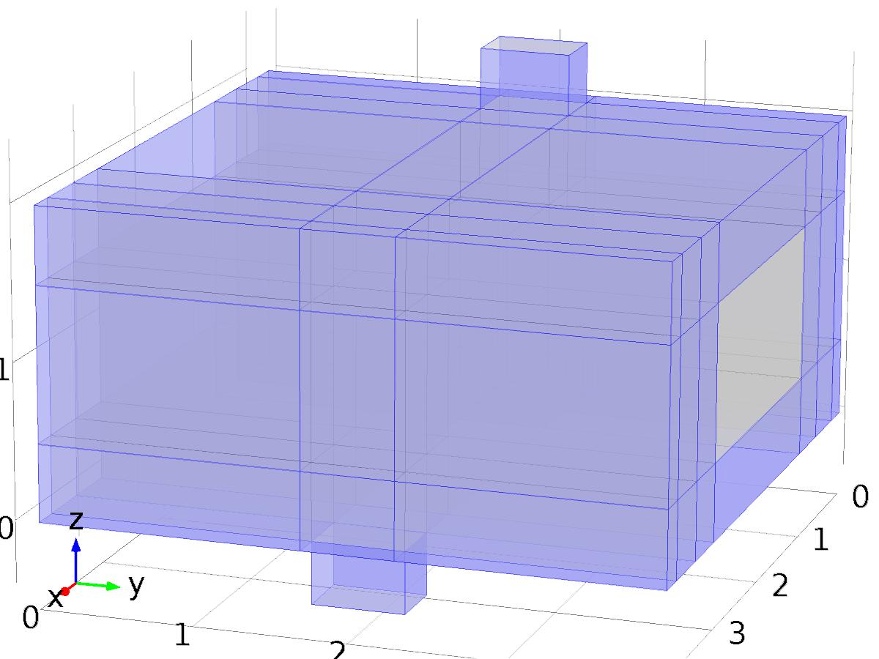

Thermal Insulation 1

Selection

|  |  |
| --- | --- |
| Geometric entity level | Boundary |
| Selection | Boundaries 1–5, 7–8, 10–11, 13–14, 17, 20–21, 23–24, 27, 30–33, 35–36, 38, 41, 43, 46, 53–54, 59, 66–70, 72–73, 75, 78, 80, 83, 90–91, 94, 101–104, 106–107, 109, 112, 114, 117, 124, 127, 134–135, 137, 139–140, 142, 145, 147, 150, 157, 160, 167–170, 172–173, 175, 178, 180–182, 193–194, 197, 204–207, 209–210, 212, 215, 217–218, 221, 228, 231, 238–250 |

Equations

#### Variables

| **Name** | **Expression** | **Unit** | **Description** | **Selection** |
| --- | --- | --- | --- | --- |
| X_T.ins1.ntfluxInt | X_T.ins1.intExtBnd(X_T.ntflux*X_T.ins1.varIntSpa) | W | Total net heat rate | Global |
| X_T.ins1.ntefluxInt | X_T.ins1.intExtBnd(X_T.nteflux*X_T.ins1.varIntSpa) | W | Total net energy rate | Global |
| X_T.ins1.ntfluxInt_u | X_T.ins1.intIntBnd(X_T.ntflux_u*X_T.ins1.varIntSpa) | W | Total net heat rate, upside | Global |
| X_T.ins1.ntefluxInt_u | X_T.ins1.intIntBnd(X_T.nteflux_u*X_T.ins1.varIntSpa) | W | Total net energy rate, upside | Global |
| X_T.ins1.ntfluxInt_d | X_T.ins1.intIntBnd(X_T.ntflux_d*X_T.ins1.varIntSpa) | W | Total net heat rate, downside | Global |
| X_T.ins1.ntefluxInt_d | X_T.ins1.intIntBnd(X_T.nteflux_d*X_T.ins1.varIntSpa) | W | Total net energy rate, downside | Global |
| X_T.ins1.Tave | if(X_T.ins1.intBnd(X_T.ins1.varIntSpa*X_T.rho*X_T.Cp*(X_T.ux*X_T.nx+X_T.uy*X_T.ny+X_T.uz*X_T.nz))==0,X_T.ins1.intBnd(X_T.ins1.varIntSpa*X_T)/X_T.ins1.intBnd(X_T.ins1.varIntSpa),X_T.ins1.intBnd(X_T.ins1.varIntSpa*X_T.rho*X_T.Cp*X_T*(X_T.ux*X_T.nx+X_T.uy*X_T.ny+X_T.uz*X_T.nz))/X_T.ins1.intBnd(X_T.ins1.varIntSpa*X_T.rho*X_T.Cp*(X_T.ux*X_T.nx+X_T.uy*X_T.ny+X_T.uz*X_T.nz))) | K | Weighted average temperature | Global |

* + 1. Initial Values 1



Initial Values 1

Selection

|  |  |
| --- | --- |
| Geometric entity level | Domain |
| Selection | Domains 1–65 |

#### Variables

| **Name** | **Expression** | **Unit** | **Description** | **Selection** |
| --- | --- | --- | --- | --- |
| X_T.Tinit | 0 | K | Temperature | Domains 1–65 |

* + 1. Temperature 1

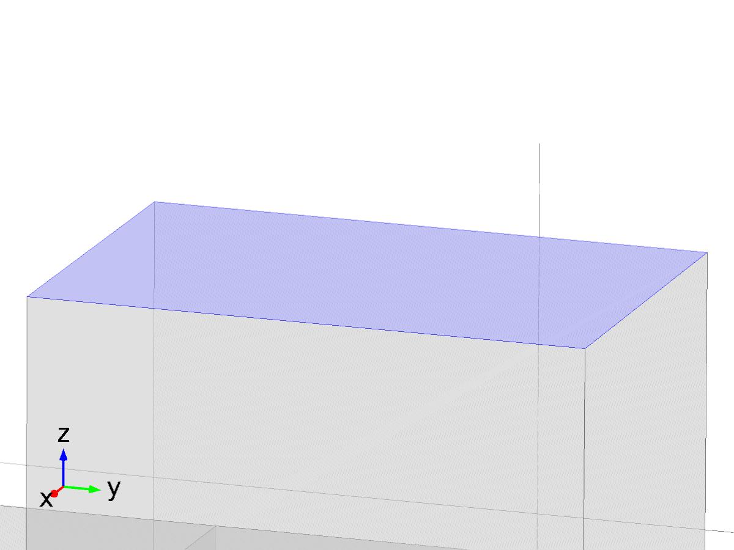

Temperature 1

Selection

|  |  |
| --- | --- |
| Geometric entity level | Boundary |
| Selection | Boundary 56 |

Equations

Settings

| **Description** | **Value** |
| --- | --- |
| Temperature | Bin*1 |
|  | Classic constraints |
| Apply reaction terms on | All physics (symmetric) |
| Use weak constraints | Off |
| Constraint method | Elemental |

#### Variables

| **Name** | **Expression** | **Unit** | **Description** | **Selection** |
| --- | --- | --- | --- | --- |
| X_T.Tvar | X_T | K | Temperature | Boundary 56 |
| X_T.T0 | Bin | K | Temperature | Boundary 56 |
| X_T.temp1.ntfluxInt | X_T.temp1.intExtBnd(X_T.ntflux*X_T.temp1.varIntSpa) | W | Total net heat rate | Global |
| X_T.temp1.ntefluxInt | X_T.temp1.intExtBnd(X_T.nteflux*X_T.temp1.varIntSpa) | W | Total net energy rate | Global |
| X_T.temp1.ntfluxInt_u | X_T.temp1.intIntBnd(X_T.ntflux_u*X_T.temp1.varIntSpa) | W | Total net heat rate, upside | Global |
| X_T.temp1.ntefluxInt_u | X_T.temp1.intIntBnd(X_T.nteflux_u*X_T.temp1.varIntSpa) | W | Total net energy rate, upside | Global |
| X_T.temp1.ntfluxInt_d | X_T.temp1.intIntBnd(X_T.ntflux_d*X_T.temp1.varIntSpa) | W | Total net heat rate, downside | Global |
| X_T.temp1.ntefluxInt_d | X_T.temp1.intIntBnd(X_T.nteflux_d*X_T.temp1.varIntSpa) | W | Total net energy rate, downside | Global |
| X_T.temp1.Tave | if(X_T.temp1.intBnd(X_T.temp1.varIntSpa*X_T.rho*X_T.Cp*(X_T.ux*X_T.nx+X_T.uy*X_T.ny+X_T.uz*X_T.nz))==0,X_T.temp1.intBnd(X_T.temp1.varIntSpa*X_T)/X_T.temp1.intBnd(X_T.temp1.varIntSpa),X_T.temp1.intBnd(X_T.temp1.varIntSpa*X_T.rho*X_T.Cp*X_T*(X_T.ux*X_T.nx+X_T.uy*X_T.ny+X_T.uz*X_T.nz))/X_T.temp1.intBnd(X_T.temp1.varIntSpa*X_T.rho*X_T.Cp*(X_T.ux*X_T.nx+X_T.uy*X_T.ny+X_T.uz*X_T.nz))) | K | Weighted average temperature | Global |

#### Shape functions

| **Constraint** | **Constraint force** | **Shape function** | **Selection** |
| --- | --- | --- | --- |
| X_T.T0-X_T.Tvar | test(X_T.T0-X_T.Tvar) | Lagrange (Linear) | Boundary 56 |

* + 1. Outflow 1

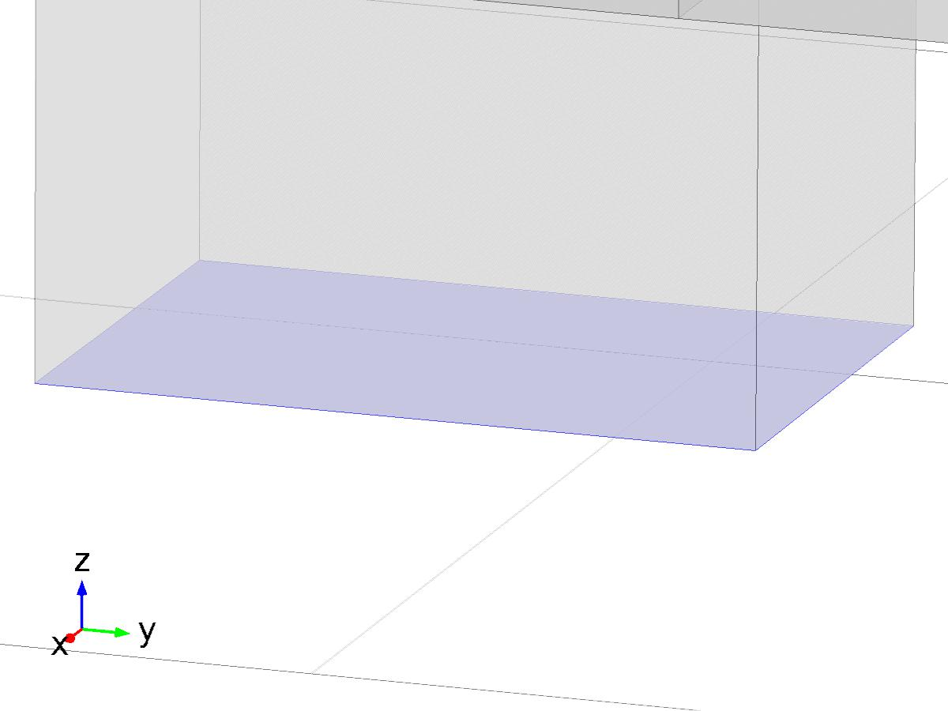

Outflow 1

Selection

|  |  |
| --- | --- |
| Geometric entity level | Boundary |
| Selection | Boundary 183 |

Equations

#### Variables

| **Name** | **Expression** | **Unit** | **Description** | **Selection** |
| --- | --- | --- | --- | --- |
| X_T.ofl1.ntfluxInt | X_T.ofl1.intExtBnd(X_T.ntflux*X_T.ofl1.varIntSpa) | W | Total net heat rate | Global |
| X_T.ofl1.ntefluxInt | X_T.ofl1.intExtBnd(X_T.nteflux*X_T.ofl1.varIntSpa) | W | Total net energy rate | Global |
| X_T.ofl1.ntfluxInt_u | X_T.ofl1.intIntBnd(X_T.ntflux_u*X_T.ofl1.varIntSpa) | W | Total net heat rate, upside | Global |
| X_T.ofl1.ntefluxInt_u | X_T.ofl1.intIntBnd(X_T.nteflux_u*X_T.ofl1.varIntSpa) | W | Total net energy rate, upside | Global |
| X_T.ofl1.ntfluxInt_d | X_T.ofl1.intIntBnd(X_T.ntflux_d*X_T.ofl1.varIntSpa) | W | Total net heat rate, downside | Global |
| X_T.ofl1.ntefluxInt_d | X_T.ofl1.intIntBnd(X_T.nteflux_d*X_T.ofl1.varIntSpa) | W | Total net energy rate, downside | Global |
| X_T.ofl1.Tave | if(X_T.ofl1.intBnd(X_T.ofl1.varIntSpa*X_T.rho*X_T.Cp*(X_T.ux*X_T.nx+X_T.uy*X_T.ny+X_T.uz*X_T.nz))==0,X_T.ofl1.intBnd(X_T.ofl1.varIntSpa*X_T)/X_T.ofl1.intBnd(X_T.ofl1.varIntSpa),X_T.ofl1.intBnd(X_T.ofl1.varIntSpa*X_T.rho*X_T.Cp*X_T*(X_T.ux*X_T.nx+X_T.uy*X_T.ny+X_T.uz*X_T.nz))/X_T.ofl1.intBnd(X_T.ofl1.varIntSpa*X_T.rho*X_T.Cp*(X_T.ux*X_T.nx+X_T.uy*X_T.ny+X_T.uz*X_T.nz))) | K | Weighted average temperature | Global |

* + 1. Heat Flux 1

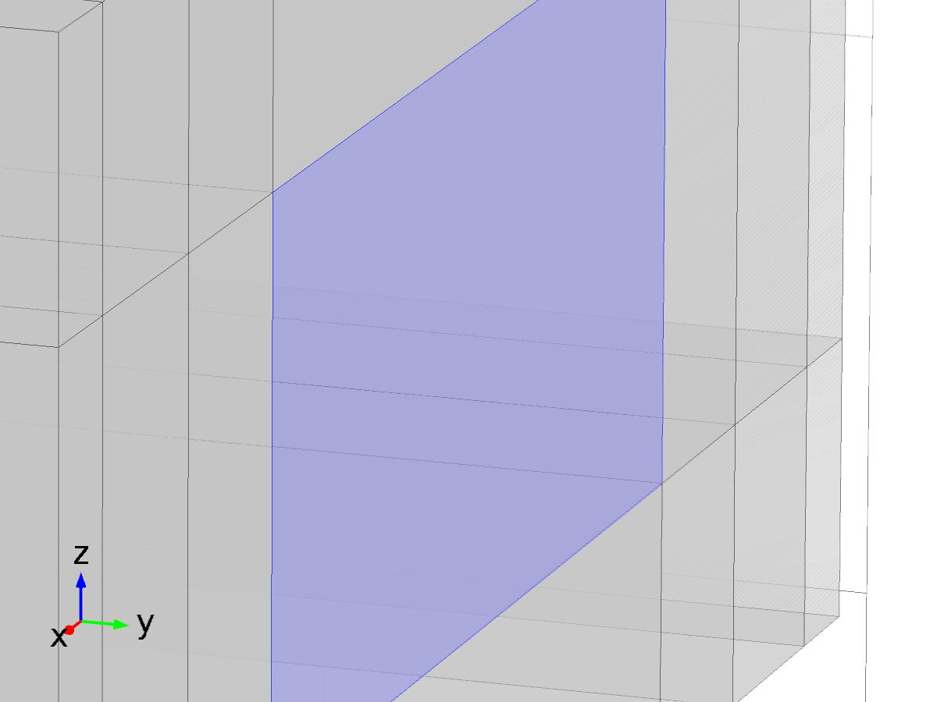

Heat Flux 1

Selection

|  |  |
| --- | --- |
| Geometric entity level | Boundary |
| Selection | Boundary 136 |

Equations

Settings

| **Description** | **Value** |
| --- | --- |
| Heat flux | Convective heat flux |
| Heat transfer coefficient | 0.01 |
| External temperature | 0[K] |
| Heat transfer coefficient | User defined |

#### Variables

| **Name** | **Expression** | **Unit** | **Description** | **Selection** |
| --- | --- | --- | --- | --- |
| X_T.q0 | X_T.hf1.q0 | W/m^2 | Inward heat flux | Boundary 136 |
| X_T.Tvar | X_T.Tu | K | Temperature | Boundary 136 |
| X_T.hf1.h | 0.01 | W/(m^2*K) | Heat transfer coefficient | Boundary 136 |
| X_T.hf1.Text | 0[K] | K | External temperature | Boundary 136 |
| X_T.hf1.q0 | X_T.hf1.h*(X_T.hf1.Text-X_T.Tvar) | W/m^2 | Boundary convective heat flux | Boundary 136 |
| X_T.hf1.ntfluxInt | X_T.hf1.intExtBnd(X_T.ntflux*X_T.hf1.varIntSpa) | W | Total net heat rate | Global |
| X_T.hf1.ntefluxInt | X_T.hf1.intExtBnd(X_T.nteflux*X_T.hf1.varIntSpa) | W | Total net energy rate | Global |
| X_T.hf1.ntfluxInt_u | X_T.hf1.intIntBnd(X_T.ntflux_u*X_T.hf1.varIntSpa) | W | Total net heat rate, upside | Global |
| X_T.hf1.ntefluxInt_u | X_T.hf1.intIntBnd(X_T.nteflux_u*X_T.hf1.varIntSpa) | W | Total net energy rate, upside | Global |
| X_T.hf1.ntfluxInt_d | X_T.hf1.intIntBnd(X_T.ntflux_d*X_T.hf1.varIntSpa) | W | Total net heat rate, downside | Global |
| X_T.hf1.ntefluxInt_d | X_T.hf1.intIntBnd(X_T.nteflux_d*X_T.hf1.varIntSpa) | W | Total net energy rate, downside | Global |
| X_T.hf1.Tave | if(X_T.hf1.intBnd(X_T.hf1.varIntSpa*X_T.rho*X_T.Cp*(X_T.ux*X_T.nx+X_T.uy*X_T.ny+X_T.uz*X_T.nz))==0,X_T.hf1.intBnd(X_T.hf1.varIntSpa*X_T)/X_T.hf1.intBnd(X_T.hf1.varIntSpa),X_T.hf1.intBnd(X_T.hf1.varIntSpa*X_T.rho*X_T.Cp*X_T*(X_T.ux*X_T.nx+X_T.uy*X_T.ny+X_T.uz*X_T.nz))/X_T.hf1.intBnd(X_T.hf1.varIntSpa*X_T.rho*X_T.Cp*(X_T.ux*X_T.nx+X_T.uy*X_T.ny+X_T.uz*X_T.nz))) | K | Weighted average temperature | Global |

#### Weak expressions

| **Weak expression** | **Integration frame** | **Selection** |
| --- | --- | --- |
| X_T.hf1.q0*test(X_T.Tvar)*X_T.d | Material | Boundary 136 |

* 1. Heat Transfer in Fluids 2



Heat Transfer in Fluids 2

Selection

|  |  |
| --- | --- |
| Geometric entity level | Domain |
| Selection | Domains 1–65 |

Equations





Settings

| **Description** | **Value** |
| --- | --- |
| Temperature | Linear |
| Compute boundary fluxes | On |
| Apply smoothing to boundary fluxes | On |
| Value type when using splitting of complex variables | Real |
| Streamline diffusion | On |
| Crosswind diffusion | On |
| Lower gradient limit | (0.01[K])/ht2.helem |
| Isotropic diffusion | Off |

Used products

|  |
| --- |
| COMSOL Multiphysics |

Variables

| **Name** | **Expression** | **Unit** | **Description** | **Selection** |
| --- | --- | --- | --- | --- |
| z1_T.q0 | 0 | W/m^2 | Inward heat flux | Boundaries 1–250 |
| z1_T.Tu | z1_T | K | Temperature | Boundaries 1–250 |
| z1_T.Td | z1_T | K | Temperature | Boundaries 1–250 |
| z1_T.opaqueLayer | 1 |  | Thin layer opacity | Boundaries 1–250 |
| z1_T.Tvar | z1_T | K | Temperature | Domains 1–65 |
| z1_T.d | 1 | 1 | Thickness | Domains 1–65 |
| z1_T.nx | nx | 1 | Normal vector, x component | Boundaries 6, 9, 12, 15–16, 18–19, 22, 25–26, 28–29, 34, 37, 39–40, 42, 44–45, 47–52, 55, 57–58, 60–65, 71, 74, 76–77, 79, 81–82, 84–89, 92–93, 95–100, 105, 108, 110–111, 113, 115–116, 118–123, 125–126, 128–133, 138, 141, 143–144, 146, 148–149, 151–156, 158–159, 161–166, 171, 174, 176–177, 179, 184–192, 195–196, 198–203, 208, 211, 213–214, 216, 219–220, 222–227, 229–230, 232–237 |
| z1_T.ny | ny | 1 | Normal vector, y component | Boundaries 6, 9, 12, 15–16, 18–19, 22, 25–26, 28–29, 34, 37, 39–40, 42, 44–45, 47–52, 55, 57–58, 60–65, 71, 74, 76–77, 79, 81–82, 84–89, 92–93, 95–100, 105, 108, 110–111, 113, 115–116, 118–123, 125–126, 128–133, 138, 141, 143–144, 146, 148–149, 151–156, 158–159, 161–166, 171, 174, 176–177, 179, 184–192, 195–196, 198–203, 208, 211, 213–214, 216, 219–220, 222–227, 229–230, 232–237 |
| z1_T.nz | nz | 1 | Normal vector, z component | Boundaries 6, 9, 12, 15–16, 18–19, 22, 25–26, 28–29, 34, 37, 39–40, 42, 44–45, 47–52, 55, 57–58, 60–65, 71, 74, 76–77, 79, 81–82, 84–89, 92–93, 95–100, 105, 108, 110–111, 113, 115–116, 118–123, 125–126, 128–133, 138, 141, 143–144, 146, 148–149, 151–156, 158–159, 161–166, 171, 174, 176–177, 179, 184–192, 195–196, 198–203, 208, 211, 213–214, 216, 219–220, 222–227, 229–230, 232–237 |
| z1_T.nx | dnx | 1 | Normal vector, x component | Boundaries 1–5, 7–8, 10–11, 13–14, 17, 20–21, 23–24, 27, 30–33, 35–36, 38, 41, 43, 46, 53–54, 56, 59, 66–70, 72–73, 75, 78, 80, 83, 90–91, 94, 101–104, 106–107, 109, 112, 114, 117, 124, 127, 134–137, 139–140, 142, 145, 147, 150, 157, 160, 167–170, 172–173, 175, 178, 180–183, 193–194, 197, 204–207, 209–210, 212, 215, 217–218, 221, 228, 231, 238–250 |
| z1_T.ny | dny | 1 | Normal vector, y component | Boundaries 1–5, 7–8, 10–11, 13–14, 17, 20–21, 23–24, 27, 30–33, 35–36, 38, 41, 43, 46, 53–54, 56, 59, 66–70, 72–73, 75, 78, 80, 83, 90–91, 94, 101–104, 106–107, 109, 112, 114, 117, 124, 127, 134–137, 139–140, 142, 145, 147, 150, 157, 160, 167–170, 172–173, 175, 178, 180–183, 193–194, 197, 204–207, 209–210, 212, 215, 217–218, 221, 228, 231, 238–250 |
| z1_T.nz | dnz | 1 | Normal vector, z component | Boundaries 1–5, 7–8, 10–11, 13–14, 17, 20–21, 23–24, 27, 30–33, 35–36, 38, 41, 43, 46, 53–54, 56, 59, 66–70, 72–73, 75, 78, 80, 83, 90–91, 94, 101–104, 106–107, 109, 112, 114, 117, 124, 127, 134–137, 139–140, 142, 145, 147, 150, 157, 160, 167–170, 172–173, 175, 178, 180–183, 193–194, 197, 204–207, 209–210, 212, 215, 217–218, 221, 228, 231, 238–250 |
| z1_T.nxmesh | root.nxmesh | 1 | Normal vector (mesh), x component | Boundaries 6, 9, 12, 15–16, 18–19, 22, 25–26, 28–29, 34, 37, 39–40, 42, 44–45, 47–52, 55, 57–58, 60–65, 71, 74, 76–77, 79, 81–82, 84–89, 92–93, 95–100, 105, 108, 110–111, 113, 115–116, 118–123, 125–126, 128–133, 138, 141, 143–144, 146, 148–149, 151–156, 158–159, 161–166, 171, 174, 176–177, 179, 184–192, 195–196, 198–203, 208, 211, 213–214, 216, 219–220, 222–227, 229–230, 232–237 |
| z1_T.nymesh | root.nymesh | 1 | Normal vector (mesh), y component | Boundaries 6, 9, 12, 15–16, 18–19, 22, 25–26, 28–29, 34, 37, 39–40, 42, 44–45, 47–52, 55, 57–58, 60–65, 71, 74, 76–77, 79, 81–82, 84–89, 92–93, 95–100, 105, 108, 110–111, 113, 115–116, 118–123, 125–126, 128–133, 138, 141, 143–144, 146, 148–149, 151–156, 158–159, 161–166, 171, 174, 176–177, 179, 184–192, 195–196, 198–203, 208, 211, 213–214, 216, 219–220, 222–227, 229–230, 232–237 |
| z1_T.nzmesh | root.nzmesh | 1 | Normal vector (mesh), z component | Boundaries 6, 9, 12, 15–16, 18–19, 22, 25–26, 28–29, 34, 37, 39–40, 42, 44–45, 47–52, 55, 57–58, 60–65, 71, 74, 76–77, 79, 81–82, 84–89, 92–93, 95–100, 105, 108, 110–111, 113, 115–116, 118–123, 125–126, 128–133, 138, 141, 143–144, 146, 148–149, 151–156, 158–159, 161–166, 171, 174, 176–177, 179, 184–192, 195–196, 198–203, 208, 211, 213–214, 216, 219–220, 222–227, 229–230, 232–237 |
| z1_T.nxmesh | root.dnxmesh | 1 | Normal vector (mesh), x component | Boundaries 1–5, 7–8, 10–11, 13–14, 17, 20–21, 23–24, 27, 30–33, 35–36, 38, 41, 43, 46, 53–54, 56, 59, 66–70, 72–73, 75, 78, 80, 83, 90–91, 94, 101–104, 106–107, 109, 112, 114, 117, 124, 127, 134–137, 139–140, 142, 145, 147, 150, 157, 160, 167–170, 172–173, 175, 178, 180–183, 193–194, 197, 204–207, 209–210, 212, 215, 217–218, 221, 228, 231, 238–250 |
| z1_T.nymesh | root.dnymesh | 1 | Normal vector (mesh), y component | Boundaries 1–5, 7–8, 10–11, 13–14, 17, 20–21, 23–24, 27, 30–33, 35–36, 38, 41, 43, 46, 53–54, 56, 59, 66–70, 72–73, 75, 78, 80, 83, 90–91, 94, 101–104, 106–107, 109, 112, 114, 117, 124, 127, 134–137, 139–140, 142, 145, 147, 150, 157, 160, 167–170, 172–173, 175, 178, 180–183, 193–194, 197, 204–207, 209–210, 212, 215, 217–218, 221, 228, 231, 238–250 |
| z1_T.nzmesh | root.dnzmesh | 1 | Normal vector (mesh), z component | Boundaries 1–5, 7–8, 10–11, 13–14, 17, 20–21, 23–24, 27, 30–33, 35–36, 38, 41, 43, 46, 53–54, 56, 59, 66–70, 72–73, 75, 78, 80, 83, 90–91, 94, 101–104, 106–107, 109, 112, 114, 117, 124, 127, 134–137, 139–140, 142, 145, 147, 150, 157, 160, 167–170, 172–173, 175, 178, 180–183, 193–194, 197, 204–207, 209–210, 212, 215, 217–218, 221, 228, 231, 238–250 |
| z1_T.dnx | dnx | 1 | Normal vector down direction, x component | Boundaries 1–250 |
| z1_T.dny | dny | 1 | Normal vector down direction, y component | Boundaries 1–250 |
| z1_T.dnz | dnz | 1 | Normal vector down direction, z component | Boundaries 1–250 |
| z1_T.unx | unx | 1 | Normal vector up direction, x component | Boundaries 1–250 |
| z1_T.uny | uny | 1 | Normal vector up direction, y component | Boundaries 1–250 |
| z1_T.unz | unz | 1 | Normal vector up direction, z component | Boundaries 1–250 |
| z1_T.dEiInt | z1_T.intDom(d(z1_T.rho*z1_T.Ei,t)*z1_T.varIntSpa) | W | Total accumulated heat rate | Global |
| z1_T.dEi0Int | z1_T.intDom(d(z1_T.rho*z1_T.Ei0,t)*z1_T.varIntSpa) | W | Total accumulated energy rate | Global |
| z1_T.ntfluxInt | z1_T.intExtBnd(z1_T.ntflux*z1_T.varIntSpa) | W | Total net heat rate | Global |
| z1_T.ntefluxInt | z1_T.intExtBnd(z1_T.nteflux*z1_T.varIntSpa) | W | Total net energy rate | Global |
| z1_T.QInt | z1_T.intDom(z1_T.Qtot*z1_T.varIntSpa)-z1_T.intIntBnd((z1_T.ndflux_u+z1_T.ndflux_d)*z1_T.varIntSpa) | W | Total heat source | Global |
| z1_T.WnsInt | 0 | W | Total work source | Global |
| z1_T.WInt | 0 | W | Total work source | Global |

* + 1. Heat Transfer in Fluids 1



Heat Transfer in Fluids 1

Selection

|  |  |
| --- | --- |
| Geometric entity level | Domain |
| Selection | Domains 1–65 |

Equations

Settings

| **Description** | **Value** |
| --- | --- |
| Fluid type | Gas/Liquid |
| Thermal conductivity | User defined |
| Thermal conductivity | {{K, 0, 0}, {0, K, 0}, {0, 0, K}} |
| Density | User defined |
| Density | rho |
| Heat capacity at constant pressure | User defined |
| Heat capacity at constant pressure | cp |
| Ratio of specific heats | User defined |
| Ratio of specific heats | 1 |
| Equivalent conductivity for convection | Off |

#### Variables

| **Name** | **Expression** | **Unit** | **Description** | **Selection** |
| --- | --- | --- | --- | --- |
| domflux.z1_Tx | -z1_T.k_effxx*z1_Tx-z1_T.k_effxy*z1_Ty-z1_T.k_effxz*z1_Tz | W/m^2 | Domain flux, x component | Domains 1–65 |
| domflux.z1_Ty | -z1_T.k_effyx*z1_Tx-z1_T.k_effyy*z1_Ty-z1_T.k_effyz*z1_Tz | W/m^2 | Domain flux, y component | Domains 1–65 |
| domflux.z1_Tz | -z1_T.k_effzx*z1_Tx-z1_T.k_effzy*z1_Ty-z1_T.k_effzz*z1_Tz | W/m^2 | Domain flux, z component | Domains 1–65 |
| z1_T.WnsInt | z1_T.fluid1.intDom(z1_T.pA*(d(z1_T.ux,x)+d(z1_T.uy,y)+d(z1_T.uz,z))*z1_T.fluid1.varIntSpa) | W | Total work source | Global |
| z1_T.Q | 0 | W/m^3 | Heat source | Domains 1–65 |
| z1_T.Qtot | 0 | W/m^3 | Total heat source | Domains 1–65 |
| z1_T.kxx | K | W/(m*K) | Thermal conductivity, xx component | Domains 1–65 |
| z1_T.kyx | 0 | W/(m*K) | Thermal conductivity, yx component | Domains 1–65 |
| z1_T.kzx | 0 | W/(m*K) | Thermal conductivity, zx component | Domains 1–65 |
| z1_T.kxy | 0 | W/(m*K) | Thermal conductivity, xy component | Domains 1–65 |
| z1_T.kyy | K | W/(m*K) | Thermal conductivity, yy component | Domains 1–65 |
| z1_T.kzy | 0 | W/(m*K) | Thermal conductivity, zy component | Domains 1–65 |
| z1_T.kxz | 0 | W/(m*K) | Thermal conductivity, xz component | Domains 1–65 |
| z1_T.kyz | 0 | W/(m*K) | Thermal conductivity, yz component | Domains 1–65 |
| z1_T.kzz | K | W/(m*K) | Thermal conductivity, zz component | Domains 1–65 |
| z1_T.rho | material.rho | kg/m^3 | Density | Domains 1–65 |
| z1_T.Cp | cp | J/(kg*K) | Heat capacity at constant pressure | Domains 1–65 |
| z1_T.gamma | 1 | 1 | Ratio of specific heats | Domains 1–65 |
| z1_T.fluid1.pRef | model.input.pRef | Pa | Reference pressure level | Domains 1–65 |
| z1_T.T | model.input.minput_temperature | K | Temperature | Domains 1–65 |
| z1_T.alphap | -d(z1_T.rho,z1_T)/(z1_T.rho+eps) | 1/K | Isobaric compressibility coefficient | Domains 1–65 |
| z1_T.pA | model.input.minput_pressure | Pa | Absolute pressure | Domains 1–65 |
| z1_T.gradTmag | sqrt(z1_T.gradTx^2+z1_T.gradTy^2+z1_T.gradTz^2) | K/m | Temperature gradient magnitude | Domains 1–65 |
| z1_T.kmean | (z1_T.k_effxx+z1_T.k_effyy+z1_T.k_effzz)/3 | W/(m*K) | Mean effective thermal conductivity | Domains 1–65 |
| z1_T.qs | 0 | W/(m^3*K) | Production/absorption coefficient | Domains 1–65 |
| z1_T.Qmet | 0 | W/m^3 | Metabolic heat source | Domains 1–65 |
| z1_T.rhoInt | subst(z1_T.rho,root.mod1.z1_T.fluid1.minput_pressure,z1_T.pA) | kg/m^3 | Density for integration | Domains 1–65 |
| z1_T.CpInt | subst(z1_T.Cp,root.mod1.z1_T.fluid1.minput_pressure,z1_T.pA) | J/(kg*K) | Specific heat capacity for integration | Domains 1–65 |
| z1_T.gammaInt | subst(z1_T.gamma,root.mod1.z1_T.fluid1.minput_pressure,z1_T.pA) | 1 | Ratio of specific heats for integration | Domains 1–65 |
| z1_T.TRef | 298.15[K] | K | Reference temperature | Domains 1–65 |
| z1_T.pRef | z1_T.fluid1.pRef | Pa | Reference pressure level | Domains 1–65 |
| z1_T.HRef | 0 | J/kg | Reference enthalpy | Domains 1–65 |
| z1_T.DeltaH | integrate((1+z1_T*d(z1_T.rhoInt,z1_T)/z1_T.rhoInt)/z1_T.rhoInt,z1_T.pA,z1_T.pRef,z1_T.pA)+integrate(subst(z1_T.CpInt,z1_T.pA,z1_T.pRef),z1_T,z1_T.TRef,z1_T) | J/kg | Sensible enthalpy | Domains 1–65 |
| z1_T.H | z1_T.HRef+z1_T.DeltaH | J/kg | Enthalpy | Domains 1–65 |
| z1_T.H0 | z1_T.H+0.5*(z1_T.ux^2+z1_T.uy^2+z1_T.uz^2) | J/kg | Total enthalpy | Domains 1–65 |
| z1_T.Ei | z1_T.H-z1_T.pA/z1_T.rho | J/kg | Internal energy | Domains 1–65 |
| z1_T.Ei0 | z1_T.Ei+0.5*(z1_T.ux^2+z1_T.uy^2+z1_T.uz^2) | J/kg | Total internal energy | Domains 1–65 |
| z1_T.Qbtot | 0 | W/m^2 | Total boundary heat source | Boundaries 1–250 |
| z1_T.k_effxx | z1_T.kxx | W/(m*K) | Effective thermal conductivity, xx component | Domains 1–65 |
| z1_T.k_effyx | z1_T.kyx | W/(m*K) | Effective thermal conductivity, yx component | Domains 1–65 |
| z1_T.k_effzx | z1_T.kzx | W/(m*K) | Effective thermal conductivity, zx component | Domains 1–65 |
| z1_T.k_effxy | z1_T.kxy | W/(m*K) | Effective thermal conductivity, xy component | Domains 1–65 |
| z1_T.k_effyy | z1_T.kyy | W/(m*K) | Effective thermal conductivity, yy component | Domains 1–65 |
| z1_T.k_effzy | z1_T.kzy | W/(m*K) | Effective thermal conductivity, zy component | Domains 1–65 |
| z1_T.k_effxz | z1_T.kxz | W/(m*K) | Effective thermal conductivity, xz component | Domains 1–65 |
| z1_T.k_effyz | z1_T.kyz | W/(m*K) | Effective thermal conductivity, yz component | Domains 1–65 |
| z1_T.k_effzz | z1_T.kzz | W/(m*K) | Effective thermal conductivity, zz component | Domains 1–65 |
| z1_T.C_eff | z1_T.rho*z1_T.Cp | J/(m^3*K) | Effective volumetric heat capacity | Domains 1–65 |
| z1_T.ux | model.input.minput_velocity1 | m/s | Velocity field, x component | Domains 1–65 |
| z1_T.uy | model.input.minput_velocity2 | m/s | Velocity field, y component | Domains 1–65 |
| z1_T.uz | model.input.minput_velocity3 | m/s | Velocity field, z component | Domains 1–65 |
| z1_T.gradTx | z1_Tx | K/m | Temperature gradient, x component | Domains 1–65 |
| z1_T.gradTy | z1_Ty | K/m | Temperature gradient, y component | Domains 1–65 |
| z1_T.gradTz | z1_Tz | K/m | Temperature gradient, z component | Domains 1–65 |
| z1_T.Qltot | 0 | W/m | Total line heat source | Edges 1–320 |
| z1_T.Qptot | 0 | W | Total point heat source | Points 1–136 |
| z1_T.alphaTdxx | z1_T.k_effxx/z1_T.C_eff | m^2/s | Thermal diffusivity, xx component | Domains 1–65 |
| z1_T.alphaTdyx | z1_T.k_effyx/z1_T.C_eff | m^2/s | Thermal diffusivity, yx component | Domains 1–65 |
| z1_T.alphaTdzx | z1_T.k_effzx/z1_T.C_eff | m^2/s | Thermal diffusivity, zx component | Domains 1–65 |
| z1_T.alphaTdxy | z1_T.k_effxy/z1_T.C_eff | m^2/s | Thermal diffusivity, xy component | Domains 1–65 |
| z1_T.alphaTdyy | z1_T.k_effyy/z1_T.C_eff | m^2/s | Thermal diffusivity, yy component | Domains 1–65 |
| z1_T.alphaTdzy | z1_T.k_effzy/z1_T.C_eff | m^2/s | Thermal diffusivity, zy component | Domains 1–65 |
| z1_T.alphaTdxz | z1_T.k_effxz/z1_T.C_eff | m^2/s | Thermal diffusivity, xz component | Domains 1–65 |
| z1_T.alphaTdyz | z1_T.k_effyz/z1_T.C_eff | m^2/s | Thermal diffusivity, yz component | Domains 1–65 |
| z1_T.alphaTdzz | z1_T.k_effzz/z1_T.C_eff | m^2/s | Thermal diffusivity, zz component | Domains 1–65 |
| z1_T.alphaTdMean | z1_T.kmean/z1_T.C_eff | m^2/s | Mean thermal diffusivity | Domains 1–65 |
| z1_T.dfluxx | -z1_T.k_effxx*z1_Tx-z1_T.k_effxy*z1_Ty-z1_T.k_effxz*z1_Tz | W/m^2 | Conductive heat flux, x component | Domains 1–65 |
| z1_T.dfluxy | -z1_T.k_effyx*z1_Tx-z1_T.k_effyy*z1_Ty-z1_T.k_effyz*z1_Tz | W/m^2 | Conductive heat flux, y component | Domains 1–65 |
| z1_T.dfluxz | -z1_T.k_effzx*z1_Tx-z1_T.k_effzy*z1_Ty-z1_T.k_effzz*z1_Tz | W/m^2 | Conductive heat flux, z component | Domains 1–65 |
| z1_T.dfluxMag | sqrt(z1_T.dfluxx^2+z1_T.dfluxy^2+z1_T.dfluxz^2) | W/m^2 | Conductive heat flux magnitude | Domains 1–65 |
| z1_T.trlfluxx | 0 | W/m^2 | Translational heat flux, x component | Domains 1–65 |
| z1_T.trlfluxy | 0 | W/m^2 | Translational heat flux, y component | Domains 1–65 |
| z1_T.trlfluxz | 0 | W/m^2 | Translational heat flux, z component | Domains 1–65 |
| z1_T.trlfluxMag | sqrt(z1_T.trlfluxx^2+z1_T.trlfluxy^2+z1_T.trlfluxz^2) | W/m^2 | Translational heat flux magnitude | Domains 1–65 |
| z1_T.cfluxx | z1_T.rho*z1_T.ux*z1_T.Ei | W/m^2 | Convective heat flux, x component | Domains 1–65 |
| z1_T.cfluxy | z1_T.rho*z1_T.uy*z1_T.Ei | W/m^2 | Convective heat flux, y component | Domains 1–65 |
| z1_T.cfluxz | z1_T.rho*z1_T.uz*z1_T.Ei | W/m^2 | Convective heat flux, z component | Domains 1–65 |
| z1_T.cfluxMag | sqrt(z1_T.cfluxx^2+z1_T.cfluxy^2+z1_T.cfluxz^2) | W/m^2 | Convective heat flux magnitude | Domains 1–65 |
| z1_T.tfluxx | z1_T.dfluxx+z1_T.trlfluxx+z1_T.cfluxx | W/m^2 | Total heat flux, x component | Domains 1–65 |
| z1_T.tfluxy | z1_T.dfluxy+z1_T.trlfluxy+z1_T.cfluxy | W/m^2 | Total heat flux, y component | Domains 1–65 |
| z1_T.tfluxz | z1_T.dfluxz+z1_T.trlfluxz+z1_T.cfluxz | W/m^2 | Total heat flux, z component | Domains 1–65 |
| z1_T.tfluxMag | sqrt(z1_T.tfluxx^2+z1_T.tfluxy^2+z1_T.tfluxz^2) | W/m^2 | Total heat flux magnitude | Domains 1–65 |
| z1_T.tefluxx | z1_T.dfluxx+z1_T.rho*z1_T.ux*z1_T.H0 | W/m^2 | Total energy flux, x component | Domains 1–65 |
| z1_T.tefluxy | z1_T.dfluxy+z1_T.rho*z1_T.uy*z1_T.H0 | W/m^2 | Total energy flux, y component | Domains 1–65 |
| z1_T.tefluxz | z1_T.dfluxz+z1_T.rho*z1_T.uz*z1_T.H0 | W/m^2 | Total energy flux, z component | Domains 1–65 |
| z1_T.tefluxMag | sqrt(z1_T.tefluxx^2+z1_T.tefluxy^2+z1_T.tefluxz^2) | W/m^2 | Total energy flux magnitude | Domains 1–65 |
| z1_T.rflux | 0 | W/m^2 | Radiative heat flux | Boundaries 1–250 |
| z1_T.chflux | 0 | W/m^2 | Boundary convective heat flux | Boundaries 1–250 |
| z1_T.ntrlflux | mean(z1_T.trlfluxx)*z1_T.nx+mean(z1_T.trlfluxy)*z1_T.ny+mean(z1_T.trlfluxz)*z1_T.nz | W/m^2 | Normal translational heat flux | Boundaries 1–250 |
| z1_T.ntrlflux_u | up(z1_T.trlfluxx)*z1_T.unx+up(z1_T.trlfluxy)*z1_T.uny+up(z1_T.trlfluxz)*z1_T.unz | W/m^2 | Internal normal translational heat flux, upside | Boundaries 6, 9, 12, 15–16, 18–19, 22, 25–26, 28–29, 34, 37, 39–40, 42, 44–45, 47–52, 55, 57–58, 60–65, 71, 74, 76–77, 79, 81–82, 84–89, 92–93, 95–100, 105, 108, 110–111, 113, 115–116, 118–123, 125–126, 128–133, 138, 141, 143–144, 146, 148–149, 151–156, 158–159, 161–166, 171, 174, 176–177, 179, 184–192, 195–196, 198–203, 208, 211, 213–214, 216, 219–220, 222–227, 229–230, 232–237 |
| z1_T.ntrlflux_d | down(z1_T.trlfluxx)*z1_T.dnx+down(z1_T.trlfluxy)*z1_T.dny+down(z1_T.trlfluxz)*z1_T.dnz | W/m^2 | Internal normal translational heat flux, downside | Boundaries 6, 9, 12, 15–16, 18–19, 22, 25–26, 28–29, 34, 37, 39–40, 42, 44–45, 47–52, 55, 57–58, 60–65, 71, 74, 76–77, 79, 81–82, 84–89, 92–93, 95–100, 105, 108, 110–111, 113, 115–116, 118–123, 125–126, 128–133, 138, 141, 143–144, 146, 148–149, 151–156, 158–159, 161–166, 171, 174, 176–177, 179, 184–192, 195–196, 198–203, 208, 211, 213–214, 216, 219–220, 222–227, 229–230, 232–237 |
| z1_T.ncflux | mean(z1_T.cfluxx)*z1_T.nx+mean(z1_T.cfluxy)*z1_T.ny+mean(z1_T.cfluxz)*z1_T.nz | W/m^2 | Normal convective heat flux | Boundaries 1–250 |
| z1_T.ncflux_u | up(z1_T.cfluxx)*z1_T.unx+up(z1_T.cfluxy)*z1_T.uny+up(z1_T.cfluxz)*z1_T.unz | W/m^2 | Internal normal convective heat flux, upside | Boundaries 6, 9, 12, 15–16, 18–19, 22, 25–26, 28–29, 34, 37, 39–40, 42, 44–45, 47–52, 55, 57–58, 60–65, 71, 74, 76–77, 79, 81–82, 84–89, 92–93, 95–100, 105, 108, 110–111, 113, 115–116, 118–123, 125–126, 128–133, 138, 141, 143–144, 146, 148–149, 151–156, 158–159, 161–166, 171, 174, 176–177, 179, 184–192, 195–196, 198–203, 208, 211, 213–214, 216, 219–220, 222–227, 229–230, 232–237 |
| z1_T.ncflux_d | down(z1_T.cfluxx)*z1_T.dnx+down(z1_T.cfluxy)*z1_T.dny+down(z1_T.cfluxz)*z1_T.dnz | W/m^2 | Internal normal convective heat flux, downside | Boundaries 6, 9, 12, 15–16, 18–19, 22, 25–26, 28–29, 34, 37, 39–40, 42, 44–45, 47–52, 55, 57–58, 60–65, 71, 74, 76–77, 79, 81–82, 84–89, 92–93, 95–100, 105, 108, 110–111, 113, 115–116, 118–123, 125–126, 128–133, 138, 141, 143–144, 146, 148–149, 151–156, 158–159, 161–166, 171, 174, 176–177, 179, 184–192, 195–196, 198–203, 208, 211, 213–214, 216, 219–220, 222–227, 229–230, 232–237 |
| z1_T.ndflux | -dflux_spatial(z1_T) | W/m^2 | Normal conductive heat flux | Boundaries 1–5, 7–8, 10–11, 13–14, 17, 20–21, 23–24, 27, 30–33, 35–36, 38, 41, 43, 46, 53–54, 56, 59, 66–70, 72–73, 75, 78, 80, 83, 90–91, 94, 101–104, 106–107, 109, 112, 114, 117, 124, 127, 134–137, 139–140, 142, 145, 147, 150, 157, 160, 167–170, 172–173, 175, 178, 180–183, 193–194, 197, 204–207, 209–210, 212, 215, 217–218, 221, 228, 231, 238–250 |
| z1_T.ndflux | 0.5*(uflux_spatial(z1_T)-dflux_spatial(z1_T)) | W/m^2 | Normal conductive heat flux | Boundaries 6, 9, 12, 15–16, 18–19, 22, 25–26, 28–29, 34, 37, 39–40, 42, 44–45, 47–52, 55, 57–58, 60–65, 71, 74, 76–77, 79, 81–82, 84–89, 92–93, 95–100, 105, 108, 110–111, 113, 115–116, 118–123, 125–126, 128–133, 138, 141, 143–144, 146, 148–149, 151–156, 158–159, 161–166, 171, 174, 176–177, 179, 184–192, 195–196, 198–203, 208, 211, 213–214, 216, 219–220, 222–227, 229–230, 232–237 |
| z1_T.ndflux_u | -uflux_spatial(z1_T) | W/m^2 | Internal normal conductive heat flux, upside | Boundaries 6, 9, 12, 15–16, 18–19, 22, 25–26, 28–29, 34, 37, 39–40, 42, 44–45, 47–52, 55, 57–58, 60–65, 71, 74, 76–77, 79, 81–82, 84–89, 92–93, 95–100, 105, 108, 110–111, 113, 115–116, 118–123, 125–126, 128–133, 138, 141, 143–144, 146, 148–149, 151–156, 158–159, 161–166, 171, 174, 176–177, 179, 184–192, 195–196, 198–203, 208, 211, 213–214, 216, 219–220, 222–227, 229–230, 232–237 |
| z1_T.ndflux_d | -dflux_spatial(z1_T) | W/m^2 | Internal normal conductive heat flux, downside | Boundaries 6, 9, 12, 15–16, 18–19, 22, 25–26, 28–29, 34, 37, 39–40, 42, 44–45, 47–52, 55, 57–58, 60–65, 71, 74, 76–77, 79, 81–82, 84–89, 92–93, 95–100, 105, 108, 110–111, 113, 115–116, 118–123, 125–126, 128–133, 138, 141, 143–144, 146, 148–149, 151–156, 158–159, 161–166, 171, 174, 176–177, 179, 184–192, 195–196, 198–203, 208, 211, 213–214, 216, 219–220, 222–227, 229–230, 232–237 |
| z1_T.ntflux | z1_T.ndflux+z1_T.ntrlflux+z1_T.ncflux | W/m^2 | Normal total heat flux | Boundaries 1–250 |
| z1_T.ntflux_u | z1_T.ndflux_u+z1_T.ntrlflux_u+z1_T.ncflux_u | W/m^2 | Internal normal total flux, upside | Boundaries 6, 9, 12, 15–16, 18–19, 22, 25–26, 28–29, 34, 37, 39–40, 42, 44–45, 47–52, 55, 57–58, 60–65, 71, 74, 76–77, 79, 81–82, 84–89, 92–93, 95–100, 105, 108, 110–111, 113, 115–116, 118–123, 125–126, 128–133, 138, 141, 143–144, 146, 148–149, 151–156, 158–159, 161–166, 171, 174, 176–177, 179, 184–192, 195–196, 198–203, 208, 211, 213–214, 216, 219–220, 222–227, 229–230, 232–237 |
| z1_T.ntflux_d | z1_T.ndflux_d+z1_T.ntrlflux_d+z1_T.ncflux_d | W/m^2 | Internal normal total flux, downside | Boundaries 6, 9, 12, 15–16, 18–19, 22, 25–26, 28–29, 34, 37, 39–40, 42, 44–45, 47–52, 55, 57–58, 60–65, 71, 74, 76–77, 79, 81–82, 84–89, 92–93, 95–100, 105, 108, 110–111, 113, 115–116, 118–123, 125–126, 128–133, 138, 141, 143–144, 146, 148–149, 151–156, 158–159, 161–166, 171, 174, 176–177, 179, 184–192, 195–196, 198–203, 208, 211, 213–214, 216, 219–220, 222–227, 229–230, 232–237 |
| z1_T.nteflux | mean(z1_T.tefluxx)*z1_T.nx+mean(z1_T.tefluxy)*z1_T.ny+mean(z1_T.tefluxz)*z1_T.nz-mean(z1_T.dfluxx)*z1_T.nx-mean(z1_T.dfluxy)*z1_T.ny-mean(z1_T.dfluxz)*z1_T.nz+z1_T.ndflux | W/m^2 | Normal total energy flux | Boundaries 1–250 |
| z1_T.nteflux_u | up(z1_T.tefluxx)*z1_T.unx+up(z1_T.tefluxy)*z1_T.uny+up(z1_T.tefluxz)*z1_T.unz-up(z1_T.dfluxx)*z1_T.unx-up(z1_T.dfluxy)*z1_T.uny-up(z1_T.dfluxz)*z1_T.unz+z1_T.ndflux_u | W/m^2 | Internal normal total energy flux, upside | Boundaries 6, 9, 12, 15–16, 18–19, 22, 25–26, 28–29, 34, 37, 39–40, 42, 44–45, 47–52, 55, 57–58, 60–65, 71, 74, 76–77, 79, 81–82, 84–89, 92–93, 95–100, 105, 108, 110–111, 113, 115–116, 118–123, 125–126, 128–133, 138, 141, 143–144, 146, 148–149, 151–156, 158–159, 161–166, 171, 174, 176–177, 179, 184–192, 195–196, 198–203, 208, 211, 213–214, 216, 219–220, 222–227, 229–230, 232–237 |
| z1_T.nteflux_d | down(z1_T.tefluxx)*z1_T.dnx+down(z1_T.tefluxy)*z1_T.dny+down(z1_T.tefluxz)*z1_T.dnz-down(z1_T.dfluxx)*z1_T.dnx-down(z1_T.dfluxy)*z1_T.dny-down(z1_T.dfluxz)*z1_T.dnz+z1_T.ndflux_d | W/m^2 | Internal normal total energy flux, downside | Boundaries 6, 9, 12, 15–16, 18–19, 22, 25–26, 28–29, 34, 37, 39–40, 42, 44–45, 47–52, 55, 57–58, 60–65, 71, 74, 76–77, 79, 81–82, 84–89, 92–93, 95–100, 105, 108, 110–111, 113, 115–116, 118–123, 125–126, 128–133, 138, 141, 143–144, 146, 148–149, 151–156, 158–159, 161–166, 171, 174, 176–177, 179, 184–192, 195–196, 198–203, 208, 211, 213–214, 216, 219–220, 222–227, 229–230, 232–237 |
| z1_T.fluid1.dEiInt | z1_T.fluid1.intDom(d(z1_T.rho*z1_T.Ei,t)*z1_T.fluid1.varIntSpa) | W | Total accumulated heat rate | Global |
| z1_T.fluid1.dEi0Int | z1_T.fluid1.intDom(d(z1_T.rho*z1_T.Ei0,t)*z1_T.fluid1.varIntSpa) | W | Total accumulated energy rate | Global |
| z1_T.fluid1.ntfluxInt | z1_T.fluid1.intExtBnd(z1_T.ntflux*z1_T.fluid1.varIntSpa)+z1_T.fluid1.intExtBndUp(z1_T.ntflux_u*z1_T.fluid1.varIntSpa)+z1_T.fluid1.intExtBndDown(z1_T.ntflux_d*z1_T.fluid1.varIntSpa) | W | Total net heat rate | Global |
| z1_T.fluid1.ntefluxInt | z1_T.fluid1.intExtBnd(z1_T.nteflux*z1_T.fluid1.varIntSpa)+z1_T.fluid1.intExtBndUp(z1_T.nteflux_u*z1_T.fluid1.varIntSpa)+z1_T.fluid1.intExtBndDown(z1_T.nteflux_d*z1_T.fluid1.varIntSpa) | W | Total net energy rate | Global |
| z1_T.fluid1.QInt | z1_T.fluid1.intDom(z1_T.Qtot*z1_T.fluid1.varIntSpa)-z1_T.fluid1.intIntBnd((z1_T.ndflux_u+z1_T.ndflux_d)*z1_T.fluid1.varIntSpa) | W | Total heat source | Global |
| z1_T.fluid1.WnsInt | z1_T.fluid1.intDom(z1_T.pA*(d(z1_T.ux,x)+d(z1_T.uy,y)+d(z1_T.uz,z))*z1_T.fluid1.varIntSpa) | W | Total work source | Global |
| z1_T.fluid1.WInt | 0 | W | Total work source | Global |
| z1_T.c_s | sqrt(z1_T.gamma/max(subst(d(z1_T.rhoInt,z1_T.pA),z1_T.pA,model.input.minput_pressure),eps)) | m/s | Speed of sound | Domains 1–65 |
| z1_T.Ma | sqrt(model.input.minput_velocity1^2+model.input.minput_velocity2^2+model.input.minput_velocity3^2)/z1_T.c_s | 1 | Mach number | Domains 1–65 |
| z1_T.cellPe | 0.5*z1_T.rho*z1_T.Cp*h*sqrt(z1_T.ux^2+z1_T.uy^2+z1_T.uz^2)/z1_T.kmean | 1 | Cell Péclet number | Domains 1–65 |
| z1_T.helem | h | m | Element size | Domains 1–65 |
| z1_T.res_T | -z1_T.k_effxx*z1_Txx-z1_T.k_effxy*z1_Txy-z1_T.k_effxz*z1_Txz-z1_T.k_effyx*z1_Tyx-z1_T.k_effyy*z1_Tyy-z1_T.k_effyz*z1_Tyz-z1_T.k_effzx*z1_Tzx-z1_T.k_effzy*z1_Tzy-z1_T.k_effzz*z1_Tzz-(z1_T.qs+z1_T.qs_oop)*z1_T+z1_T.rho*z1_T.Cp*(z1_T.ux*z1_Tx+z1_T.uy*z1_Ty+z1_T.uz*z1_Tz)-z1_T.Q-z1_T.Qoop | W/m^3 | Equation residual | Domains 1–65 |

#### Shape functions

| **Name** | **Shape function** | **Unit** | **Description** | **Shape frame** | **Selection** |
| --- | --- | --- | --- | --- | --- |
| z1_T | Lagrange (Linear) | K | Temperature | Material | Domains 1–65 |

#### Weak expressions

| **Weak expression** | **Integration frame** | **Selection** |
| --- | --- | --- |
| (-(z1_T.k_effxx*z1_Tx+z1_T.k_effxy*z1_Ty+z1_T.k_effxz*z1_Tz)*test(z1_Tx)-(z1_T.k_effyx*z1_Tx+z1_T.k_effyy*z1_Ty+z1_T.k_effyz*z1_Tz)*test(z1_Ty)-(z1_T.k_effzx*z1_Tx+z1_T.k_effzy*z1_Ty+z1_T.k_effzz*z1_Tz)*test(z1_Tz))*z1_T.d | Material | Domains 1–65 |
| -z1_T.rho*z1_T.Cp*(z1_T.ux*z1_Tx+z1_T.uy*z1_Ty+z1_T.uz*z1_Tz)*test(z1_T)*z1_T.d | Material | Domains 1–65 |
| z1_T.crosswind | Material | Domains 1–65 |
| z1_T.streamline | Material | Domains 1–65 |

* + 1. Thermal Insulation 1



Thermal Insulation 1

Selection

|  |  |
| --- | --- |
| Geometric entity level | Boundary |
| Selection | Boundaries 1–5, 7–8, 10–11, 13–14, 17, 20–21, 23–24, 27, 30–33, 35–36, 38, 41, 43, 46, 53–54, 59, 66–70, 72–73, 75, 78, 80, 83, 90–91, 94, 101–104, 106–107, 109, 112, 114, 117, 124, 127, 134–135, 137, 139–140, 142, 145, 147, 150, 157, 160, 167–170, 172–173, 175, 178, 180–182, 193–194, 197, 204–207, 209–210, 212, 215, 217–218, 221, 228, 231, 238–250 |

Equations

#### Variables

| **Name** | **Expression** | **Unit** | **Description** | **Selection** |
| --- | --- | --- | --- | --- |
| z1_T.ins1.ntfluxInt | z1_T.ins1.intExtBnd(z1_T.ntflux*z1_T.ins1.varIntSpa) | W | Total net heat rate | Global |
| z1_T.ins1.ntefluxInt | z1_T.ins1.intExtBnd(z1_T.nteflux*z1_T.ins1.varIntSpa) | W | Total net energy rate | Global |
| z1_T.ins1.ntfluxInt_u | z1_T.ins1.intIntBnd(z1_T.ntflux_u*z1_T.ins1.varIntSpa) | W | Total net heat rate, upside | Global |
| z1_T.ins1.ntefluxInt_u | z1_T.ins1.intIntBnd(z1_T.nteflux_u*z1_T.ins1.varIntSpa) | W | Total net energy rate, upside | Global |
| z1_T.ins1.ntfluxInt_d | z1_T.ins1.intIntBnd(z1_T.ntflux_d*z1_T.ins1.varIntSpa) | W | Total net heat rate, downside | Global |
| z1_T.ins1.ntefluxInt_d | z1_T.ins1.intIntBnd(z1_T.nteflux_d*z1_T.ins1.varIntSpa) | W | Total net energy rate, downside | Global |
| z1_T.ins1.Tave | if(z1_T.ins1.intBnd(z1_T.ins1.varIntSpa*z1_T.rho*z1_T.Cp*(z1_T.ux*z1_T.nx+z1_T.uy*z1_T.ny+z1_T.uz*z1_T.nz))==0,z1_T.ins1.intBnd(z1_T.ins1.varIntSpa*z1_T)/z1_T.ins1.intBnd(z1_T.ins1.varIntSpa),z1_T.ins1.intBnd(z1_T.ins1.varIntSpa*z1_T.rho*z1_T.Cp*z1_T*(z1_T.ux*z1_T.nx+z1_T.uy*z1_T.ny+z1_T.uz*z1_T.nz))/z1_T.ins1.intBnd(z1_T.ins1.varIntSpa*z1_T.rho*z1_T.Cp*(z1_T.ux*z1_T.nx+z1_T.uy*z1_T.ny+z1_T.uz*z1_T.nz))) | K | Weighted average temperature | Global |

* + 1. Initial Values 1



Initial Values 1

Selection

|  |  |
| --- | --- |
| Geometric entity level | Domain |
| Selection | Domains 1–65 |

#### Variables

| **Name** | **Expression** | **Unit** | **Description** | **Selection** |
| --- | --- | --- | --- | --- |
| z1_T.Tinit | 0 | K | Temperature | Domains 1–65 |

* + 1. Temperature 1



Temperature 1

Selection

|  |  |
| --- | --- |
| Geometric entity level | Boundary |
| Selection | Boundary 56 |

Equations

Settings

| **Description** | **Value** |
| --- | --- |
| Temperature | Bin*Gammac |
|  | Classic constraints |
| Apply reaction terms on | All physics (symmetric) |
| Use weak constraints | Off |
| Constraint method | Elemental |

#### Variables

| **Name** | **Expression** | **Unit** | **Description** | **Selection** |
| --- | --- | --- | --- | --- |
| z1_T.Tvar | z1_T | K | Temperature | Boundary 56 |
| z1_T.T0 | Bin*Gammac | K | Temperature | Boundary 56 |
| z1_T.temp1.ntfluxInt | z1_T.temp1.intExtBnd(z1_T.ntflux*z1_T.temp1.varIntSpa) | W | Total net heat rate | Global |
| z1_T.temp1.ntefluxInt | z1_T.temp1.intExtBnd(z1_T.nteflux*z1_T.temp1.varIntSpa) | W | Total net energy rate | Global |
| z1_T.temp1.ntfluxInt_u | z1_T.temp1.intIntBnd(z1_T.ntflux_u*z1_T.temp1.varIntSpa) | W | Total net heat rate, upside | Global |
| z1_T.temp1.ntefluxInt_u | z1_T.temp1.intIntBnd(z1_T.nteflux_u*z1_T.temp1.varIntSpa) | W | Total net energy rate, upside | Global |
| z1_T.temp1.ntfluxInt_d | z1_T.temp1.intIntBnd(z1_T.ntflux_d*z1_T.temp1.varIntSpa) | W | Total net heat rate, downside | Global |
| z1_T.temp1.ntefluxInt_d | z1_T.temp1.intIntBnd(z1_T.nteflux_d*z1_T.temp1.varIntSpa) | W | Total net energy rate, downside | Global |
| z1_T.temp1.Tave | if(z1_T.temp1.intBnd(z1_T.temp1.varIntSpa*z1_T.rho*z1_T.Cp*(z1_T.ux*z1_T.nx+z1_T.uy*z1_T.ny+z1_T.uz*z1_T.nz))==0,z1_T.temp1.intBnd(z1_T.temp1.varIntSpa*z1_T)/z1_T.temp1.intBnd(z1_T.temp1.varIntSpa),z1_T.temp1.intBnd(z1_T.temp1.varIntSpa*z1_T.rho*z1_T.Cp*z1_T*(z1_T.ux*z1_T.nx+z1_T.uy*z1_T.ny+z1_T.uz*z1_T.nz))/z1_T.temp1.intBnd(z1_T.temp1.varIntSpa*z1_T.rho*z1_T.Cp*(z1_T.ux*z1_T.nx+z1_T.uy*z1_T.ny+z1_T.uz*z1_T.nz))) | K | Weighted average temperature | Global |

#### Shape functions

| **Constraint** | **Constraint force** | **Shape function** | **Selection** |
| --- | --- | --- | --- |
| z1_T.T0-z1_T.Tvar | test(z1_T.T0-z1_T.Tvar) | Lagrange (Linear) | Boundary 56 |

* + 1. Outflow 1



Outflow 1

Selection

|  |  |
| --- | --- |
| Geometric entity level | Boundary |
| Selection | Boundary 183 |

Equations

#### Variables

| **Name** | **Expression** | **Unit** | **Description** | **Selection** |
| --- | --- | --- | --- | --- |
| z1_T.ofl1.ntfluxInt | z1_T.ofl1.intExtBnd(z1_T.ntflux*z1_T.ofl1.varIntSpa) | W | Total net heat rate | Global |
| z1_T.ofl1.ntefluxInt | z1_T.ofl1.intExtBnd(z1_T.nteflux*z1_T.ofl1.varIntSpa) | W | Total net energy rate | Global |
| z1_T.ofl1.ntfluxInt_u | z1_T.ofl1.intIntBnd(z1_T.ntflux_u*z1_T.ofl1.varIntSpa) | W | Total net heat rate, upside | Global |
| z1_T.ofl1.ntefluxInt_u | z1_T.ofl1.intIntBnd(z1_T.nteflux_u*z1_T.ofl1.varIntSpa) | W | Total net energy rate, upside | Global |
| z1_T.ofl1.ntfluxInt_d | z1_T.ofl1.intIntBnd(z1_T.ntflux_d*z1_T.ofl1.varIntSpa) | W | Total net heat rate, downside | Global |
| z1_T.ofl1.ntefluxInt_d | z1_T.ofl1.intIntBnd(z1_T.nteflux_d*z1_T.ofl1.varIntSpa) | W | Total net energy rate, downside | Global |
| z1_T.ofl1.Tave | if(z1_T.ofl1.intBnd(z1_T.ofl1.varIntSpa*z1_T.rho*z1_T.Cp*(z1_T.ux*z1_T.nx+z1_T.uy*z1_T.ny+z1_T.uz*z1_T.nz))==0,z1_T.ofl1.intBnd(z1_T.ofl1.varIntSpa*z1_T)/z1_T.ofl1.intBnd(z1_T.ofl1.varIntSpa),z1_T.ofl1.intBnd(z1_T.ofl1.varIntSpa*z1_T.rho*z1_T.Cp*z1_T*(z1_T.ux*z1_T.nx+z1_T.uy*z1_T.ny+z1_T.uz*z1_T.nz))/z1_T.ofl1.intBnd(z1_T.ofl1.varIntSpa*z1_T.rho*z1_T.Cp*(z1_T.ux*z1_T.nx+z1_T.uy*z1_T.ny+z1_T.uz*z1_T.nz))) | K | Weighted average temperature | Global |

* + 1. Heat Flux 1



Heat Flux 1

Selection

|  |  |
| --- | --- |
| Geometric entity level | Boundary |
| Selection | Boundary 136 |

Equations

Settings

| **Description** | **Value** |
| --- | --- |
| Heat flux | Convective heat flux |
| Heat transfer coefficient | 0.01 |
| External temperature | dc(k) |
| Heat transfer coefficient | User defined |

#### Variables

| **Name** | **Expression** | **Unit** | **Description** | **Selection** |
| --- | --- | --- | --- | --- |
| z1_T.q0 | z1_T.hf1.q0 | W/m^2 | Inward heat flux | Boundary 136 |
| z1_T.Tvar | z1_T.Tu | K | Temperature | Boundary 136 |
| z1_T.hf1.h | 0.01 | W/(m^2*K) | Heat transfer coefficient | Boundary 136 |
| z1_T.hf1.Text | dc(k) | K | External temperature | Boundary 136 |
| z1_T.hf1.q0 | z1_T.hf1.h*(z1_T.hf1.Text-z1_T.Tvar) | W/m^2 | Boundary convective heat flux | Boundary 136 |
| z1_T.hf1.ntfluxInt | z1_T.hf1.intExtBnd(z1_T.ntflux*z1_T.hf1.varIntSpa) | W | Total net heat rate | Global |
| z1_T.hf1.ntefluxInt | z1_T.hf1.intExtBnd(z1_T.nteflux*z1_T.hf1.varIntSpa) | W | Total net energy rate | Global |
| z1_T.hf1.ntfluxInt_u | z1_T.hf1.intIntBnd(z1_T.ntflux_u*z1_T.hf1.varIntSpa) | W | Total net heat rate, upside | Global |
| z1_T.hf1.ntefluxInt_u | z1_T.hf1.intIntBnd(z1_T.nteflux_u*z1_T.hf1.varIntSpa) | W | Total net energy rate, upside | Global |
| z1_T.hf1.ntfluxInt_d | z1_T.hf1.intIntBnd(z1_T.ntflux_d*z1_T.hf1.varIntSpa) | W | Total net heat rate, downside | Global |
| z1_T.hf1.ntefluxInt_d | z1_T.hf1.intIntBnd(z1_T.nteflux_d*z1_T.hf1.varIntSpa) | W | Total net energy rate, downside | Global |
| z1_T.hf1.Tave | if(z1_T.hf1.intBnd(z1_T.hf1.varIntSpa*z1_T.rho*z1_T.Cp*(z1_T.ux*z1_T.nx+z1_T.uy*z1_T.ny+z1_T.uz*z1_T.nz))==0,z1_T.hf1.intBnd(z1_T.hf1.varIntSpa*z1_T)/z1_T.hf1.intBnd(z1_T.hf1.varIntSpa),z1_T.hf1.intBnd(z1_T.hf1.varIntSpa*z1_T.rho*z1_T.Cp*z1_T*(z1_T.ux*z1_T.nx+z1_T.uy*z1_T.ny+z1_T.uz*z1_T.nz))/z1_T.hf1.intBnd(z1_T.hf1.varIntSpa*z1_T.rho*z1_T.Cp*(z1_T.ux*z1_T.nx+z1_T.uy*z1_T.ny+z1_T.uz*z1_T.nz))) | K | Weighted average temperature | Global |

#### Weak expressions

| **Weak expression** | **Integration frame** | **Selection** |
| --- | --- | --- |
| z1_T.hf1.q0*test(z1_T.Tvar)*z1_T.d | Material | Boundary 136 |

* + 1. Heat Source 1



Heat Source 1

Selection

|  |  |
| --- | --- |
| Geometric entity level | Domain |
| Selection | Domains 1–65 |

Equations

Settings

| **Description** | **Value** |
| --- | --- |
| Heat source | General source |
| Heat source | User defined |
| Heat source | -alpha(k)*rho*cp*z2_T |

#### Variables

| **Name** | **Expression** | **Unit** | **Description** | **Selection** |
| --- | --- | --- | --- | --- |
| z1_T.Q | z1_T.hs1.Q | W/m^3 | Heat source | Domains 1–65 |
| z1_T.Qtot | z1_T.hs1.Q | W/m^3 | Total heat source | Domains 1–65 |
| z1_T.hs1.Q | -alpha(k)*rho*cp*z2_T | W/m^3 | Heat source | Domains 1–65 |

#### Weak expressions

| **Weak expression** | **Integration frame** | **Selection** |
| --- | --- | --- |
| z1_T.hs1.Q*test(z1_T)*z1_T.d | Material | Domains 1–65 |

* 1. Heat Transfer in Fluids 3



Heat Transfer in Fluids 3

Selection

|  |  |
| --- | --- |
| Geometric entity level | Domain |
| Selection | Domains 1–65 |

Equations





Settings

| **Description** | **Value** |
| --- | --- |
| Temperature | Linear |
| Compute boundary fluxes | On |
| Apply smoothing to boundary fluxes | On |
| Value type when using splitting of complex variables | Real |
| Streamline diffusion | On |
| Crosswind diffusion | On |
| Lower gradient limit | (0.01[K])/ht3.helem |
| Isotropic diffusion | Off |

Used products

|  |
| --- |
| COMSOL Multiphysics |

Variables

| **Name** | **Expression** | **Unit** | **Description** | **Selection** |
| --- | --- | --- | --- | --- |
| z1t_T.q0 | 0 | W/m^2 | Inward heat flux | Boundaries 1–250 |
| z1t_T.Tu | z1t_T | K | Temperature | Boundaries 1–250 |
| z1t_T.Td | z1t_T | K | Temperature | Boundaries 1–250 |
| z1t_T.opaqueLayer | 1 |  | Thin layer opacity | Boundaries 1–250 |
| z1t_T.Tvar | z1t_T | K | Temperature | Domains 1–65 |
| z1t_T.d | 1 | 1 | Thickness | Domains 1–65 |
| z1t_T.nx | nx | 1 | Normal vector, x component | Boundaries 6, 9, 12, 15–16, 18–19, 22, 25–26, 28–29, 34, 37, 39–40, 42, 44–45, 47–52, 55, 57–58, 60–65, 71, 74, 76–77, 79, 81–82, 84–89, 92–93, 95–100, 105, 108, 110–111, 113, 115–116, 118–123, 125–126, 128–133, 138, 141, 143–144, 146, 148–149, 151–156, 158–159, 161–166, 171, 174, 176–177, 179, 184–192, 195–196, 198–203, 208, 211, 213–214, 216, 219–220, 222–227, 229–230, 232–237 |
| z1t_T.ny | ny | 1 | Normal vector, y component | Boundaries 6, 9, 12, 15–16, 18–19, 22, 25–26, 28–29, 34, 37, 39–40, 42, 44–45, 47–52, 55, 57–58, 60–65, 71, 74, 76–77, 79, 81–82, 84–89, 92–93, 95–100, 105, 108, 110–111, 113, 115–116, 118–123, 125–126, 128–133, 138, 141, 143–144, 146, 148–149, 151–156, 158–159, 161–166, 171, 174, 176–177, 179, 184–192, 195–196, 198–203, 208, 211, 213–214, 216, 219–220, 222–227, 229–230, 232–237 |
| z1t_T.nz | nz | 1 | Normal vector, z component | Boundaries 6, 9, 12, 15–16, 18–19, 22, 25–26, 28–29, 34, 37, 39–40, 42, 44–45, 47–52, 55, 57–58, 60–65, 71, 74, 76–77, 79, 81–82, 84–89, 92–93, 95–100, 105, 108, 110–111, 113, 115–116, 118–123, 125–126, 128–133, 138, 141, 143–144, 146, 148–149, 151–156, 158–159, 161–166, 171, 174, 176–177, 179, 184–192, 195–196, 198–203, 208, 211, 213–214, 216, 219–220, 222–227, 229–230, 232–237 |
| z1t_T.nx | dnx | 1 | Normal vector, x component | Boundaries 1–5, 7–8, 10–11, 13–14, 17, 20–21, 23–24, 27, 30–33, 35–36, 38, 41, 43, 46, 53–54, 56, 59, 66–70, 72–73, 75, 78, 80, 83, 90–91, 94, 101–104, 106–107, 109, 112, 114, 117, 124, 127, 134–137, 139–140, 142, 145, 147, 150, 157, 160, 167–170, 172–173, 175, 178, 180–183, 193–194, 197, 204–207, 209–210, 212, 215, 217–218, 221, 228, 231, 238–250 |
| z1t_T.ny | dny | 1 | Normal vector, y component | Boundaries 1–5, 7–8, 10–11, 13–14, 17, 20–21, 23–24, 27, 30–33, 35–36, 38, 41, 43, 46, 53–54, 56, 59, 66–70, 72–73, 75, 78, 80, 83, 90–91, 94, 101–104, 106–107, 109, 112, 114, 117, 124, 127, 134–137, 139–140, 142, 145, 147, 150, 157, 160, 167–170, 172–173, 175, 178, 180–183, 193–194, 197, 204–207, 209–210, 212, 215, 217–218, 221, 228, 231, 238–250 |
| z1t_T.nz | dnz | 1 | Normal vector, z component | Boundaries 1–5, 7–8, 10–11, 13–14, 17, 20–21, 23–24, 27, 30–33, 35–36, 38, 41, 43, 46, 53–54, 56, 59, 66–70, 72–73, 75, 78, 80, 83, 90–91, 94, 101–104, 106–107, 109, 112, 114, 117, 124, 127, 134–137, 139–140, 142, 145, 147, 150, 157, 160, 167–170, 172–173, 175, 178, 180–183, 193–194, 197, 204–207, 209–210, 212, 215, 217–218, 221, 228, 231, 238–250 |
| z1t_T.nxmesh | root.nxmesh | 1 | Normal vector (mesh), x component | Boundaries 6, 9, 12, 15–16, 18–19, 22, 25–26, 28–29, 34, 37, 39–40, 42, 44–45, 47–52, 55, 57–58, 60–65, 71, 74, 76–77, 79, 81–82, 84–89, 92–93, 95–100, 105, 108, 110–111, 113, 115–116, 118–123, 125–126, 128–133, 138, 141, 143–144, 146, 148–149, 151–156, 158–159, 161–166, 171, 174, 176–177, 179, 184–192, 195–196, 198–203, 208, 211, 213–214, 216, 219–220, 222–227, 229–230, 232–237 |
| z1t_T.nymesh | root.nymesh | 1 | Normal vector (mesh), y component | Boundaries 6, 9, 12, 15–16, 18–19, 22, 25–26, 28–29, 34, 37, 39–40, 42, 44–45, 47–52, 55, 57–58, 60–65, 71, 74, 76–77, 79, 81–82, 84–89, 92–93, 95–100, 105, 108, 110–111, 113, 115–116, 118–123, 125–126, 128–133, 138, 141, 143–144, 146, 148–149, 151–156, 158–159, 161–166, 171, 174, 176–177, 179, 184–192, 195–196, 198–203, 208, 211, 213–214, 216, 219–220, 222–227, 229–230, 232–237 |
| z1t_T.nzmesh | root.nzmesh | 1 | Normal vector (mesh), z component | Boundaries 6, 9, 12, 15–16, 18–19, 22, 25–26, 28–29, 34, 37, 39–40, 42, 44–45, 47–52, 55, 57–58, 60–65, 71, 74, 76–77, 79, 81–82, 84–89, 92–93, 95–100, 105, 108, 110–111, 113, 115–116, 118–123, 125–126, 128–133, 138, 141, 143–144, 146, 148–149, 151–156, 158–159, 161–166, 171, 174, 176–177, 179, 184–192, 195–196, 198–203, 208, 211, 213–214, 216, 219–220, 222–227, 229–230, 232–237 |
| z1t_T.nxmesh | root.dnxmesh | 1 | Normal vector (mesh), x component | Boundaries 1–5, 7–8, 10–11, 13–14, 17, 20–21, 23–24, 27, 30–33, 35–36, 38, 41, 43, 46, 53–54, 56, 59, 66–70, 72–73, 75, 78, 80, 83, 90–91, 94, 101–104, 106–107, 109, 112, 114, 117, 124, 127, 134–137, 139–140, 142, 145, 147, 150, 157, 160, 167–170, 172–173, 175, 178, 180–183, 193–194, 197, 204–207, 209–210, 212, 215, 217–218, 221, 228, 231, 238–250 |
| z1t_T.nymesh | root.dnymesh | 1 | Normal vector (mesh), y component | Boundaries 1–5, 7–8, 10–11, 13–14, 17, 20–21, 23–24, 27, 30–33, 35–36, 38, 41, 43, 46, 53–54, 56, 59, 66–70, 72–73, 75, 78, 80, 83, 90–91, 94, 101–104, 106–107, 109, 112, 114, 117, 124, 127, 134–137, 139–140, 142, 145, 147, 150, 157, 160, 167–170, 172–173, 175, 178, 180–183, 193–194, 197, 204–207, 209–210, 212, 215, 217–218, 221, 228, 231, 238–250 |
| z1t_T.nzmesh | root.dnzmesh | 1 | Normal vector (mesh), z component | Boundaries 1–5, 7–8, 10–11, 13–14, 17, 20–21, 23–24, 27, 30–33, 35–36, 38, 41, 43, 46, 53–54, 56, 59, 66–70, 72–73, 75, 78, 80, 83, 90–91, 94, 101–104, 106–107, 109, 112, 114, 117, 124, 127, 134–137, 139–140, 142, 145, 147, 150, 157, 160, 167–170, 172–173, 175, 178, 180–183, 193–194, 197, 204–207, 209–210, 212, 215, 217–218, 221, 228, 231, 238–250 |
| z1t_T.dnx | dnx | 1 | Normal vector down direction, x component | Boundaries 1–250 |
| z1t_T.dny | dny | 1 | Normal vector down direction, y component | Boundaries 1–250 |
| z1t_T.dnz | dnz | 1 | Normal vector down direction, z component | Boundaries 1–250 |
| z1t_T.unx | unx | 1 | Normal vector up direction, x component | Boundaries 1–250 |
| z1t_T.uny | uny | 1 | Normal vector up direction, y component | Boundaries 1–250 |
| z1t_T.unz | unz | 1 | Normal vector up direction, z component | Boundaries 1–250 |
| z1t_T.dEiInt | z1t_T.intDom(d(z1t_T.rho*z1t_T.Ei,t)*z1t_T.varIntSpa) | W | Total accumulated heat rate | Global |
| z1t_T.dEi0Int | z1t_T.intDom(d(z1t_T.rho*z1t_T.Ei0,t)*z1t_T.varIntSpa) | W | Total accumulated energy rate | Global |
| z1t_T.ntfluxInt | z1t_T.intExtBnd(z1t_T.ntflux*z1t_T.varIntSpa) | W | Total net heat rate | Global |
| z1t_T.ntefluxInt | z1t_T.intExtBnd(z1t_T.nteflux*z1t_T.varIntSpa) | W | Total net energy rate | Global |
| z1t_T.QInt | z1t_T.intDom(z1t_T.Qtot*z1t_T.varIntSpa)-z1t_T.intIntBnd((z1t_T.ndflux_u+z1t_T.ndflux_d)*z1t_T.varIntSpa) | W | Total heat source | Global |
| z1t_T.WnsInt | 0 | W | Total work source | Global |
| z1t_T.WInt | 0 | W | Total work source | Global |

* + 1. Heat Transfer in Fluids 1



Heat Transfer in Fluids 1

Selection

|  |  |
| --- | --- |
| Geometric entity level | Domain |
| Selection | Domains 1–65 |

Equations

Settings

| **Description** | **Value** |
| --- | --- |
| Fluid type | Gas/Liquid |
| Thermal conductivity | User defined |
| Thermal conductivity | {{K, 0, 0}, {0, K, 0}, {0, 0, K}} |
| Density | User defined |
| Density | rho |
| Heat capacity at constant pressure | User defined |
| Heat capacity at constant pressure | cp |
| Ratio of specific heats | User defined |
| Ratio of specific heats | 1 |
| Equivalent conductivity for convection | Off |

#### Variables

| **Name** | **Expression** | **Unit** | **Description** | **Selection** |
| --- | --- | --- | --- | --- |
| domflux.z1t_Tx | -z1t_T.k_effxx*z1t_Tx-z1t_T.k_effxy*z1t_Ty-z1t_T.k_effxz*z1t_Tz | W/m^2 | Domain flux, x component | Domains 1–65 |
| domflux.z1t_Ty | -z1t_T.k_effyx*z1t_Tx-z1t_T.k_effyy*z1t_Ty-z1t_T.k_effyz*z1t_Tz | W/m^2 | Domain flux, y component | Domains 1–65 |
| domflux.z1t_Tz | -z1t_T.k_effzx*z1t_Tx-z1t_T.k_effzy*z1t_Ty-z1t_T.k_effzz*z1t_Tz | W/m^2 | Domain flux, z component | Domains 1–65 |
| z1t_T.WnsInt | z1t_T.fluid1.intDom(z1t_T.pA*(d(z1t_T.ux,x)+d(z1t_T.uy,y)+d(z1t_T.uz,z))*z1t_T.fluid1.varIntSpa) | W | Total work source | Global |
| z1t_T.Q | 0 | W/m^3 | Heat source | Domains 1–65 |
| z1t_T.Qtot | 0 | W/m^3 | Total heat source | Domains 1–65 |
| z1t_T.kxx | K | W/(m*K) | Thermal conductivity, xx component | Domains 1–65 |
| z1t_T.kyx | 0 | W/(m*K) | Thermal conductivity, yx component | Domains 1–65 |
| z1t_T.kzx | 0 | W/(m*K) | Thermal conductivity, zx component | Domains 1–65 |
| z1t_T.kxy | 0 | W/(m*K) | Thermal conductivity, xy component | Domains 1–65 |
| z1t_T.kyy | K | W/(m*K) | Thermal conductivity, yy component | Domains 1–65 |
| z1t_T.kzy | 0 | W/(m*K) | Thermal conductivity, zy component | Domains 1–65 |
| z1t_T.kxz | 0 | W/(m*K) | Thermal conductivity, xz component | Domains 1–65 |
| z1t_T.kyz | 0 | W/(m*K) | Thermal conductivity, yz component | Domains 1–65 |
| z1t_T.kzz | K | W/(m*K) | Thermal conductivity, zz component | Domains 1–65 |
| z1t_T.rho | material.rho | kg/m^3 | Density | Domains 1–65 |
| z1t_T.Cp | cp | J/(kg*K) | Heat capacity at constant pressure | Domains 1–65 |
| z1t_T.gamma | 1 | 1 | Ratio of specific heats | Domains 1–65 |
| z1t_T.fluid1.pRef | model.input.pRef | Pa | Reference pressure level | Domains 1–65 |
| z1t_T.T | model.input.minput_temperature | K | Temperature | Domains 1–65 |
| z1t_T.alphap | -d(z1t_T.rho,z1t_T)/(z1t_T.rho+eps) | 1/K | Isobaric compressibility coefficient | Domains 1–65 |
| z1t_T.pA | model.input.minput_pressure | Pa | Absolute pressure | Domains 1–65 |
| z1t_T.gradTmag | sqrt(z1t_T.gradTx^2+z1t_T.gradTy^2+z1t_T.gradTz^2) | K/m | Temperature gradient magnitude | Domains 1–65 |
| z1t_T.kmean | (z1t_T.k_effxx+z1t_T.k_effyy+z1t_T.k_effzz)/3 | W/(m*K) | Mean effective thermal conductivity | Domains 1–65 |
| z1t_T.qs | 0 | W/(m^3*K) | Production/absorption coefficient | Domains 1–65 |
| z1t_T.Qmet | 0 | W/m^3 | Metabolic heat source | Domains 1–65 |
| z1t_T.rhoInt | subst(z1t_T.rho,root.mod1.z1t_T.fluid1.minput_pressure,z1t_T.pA) | kg/m^3 | Density for integration | Domains 1–65 |
| z1t_T.CpInt | subst(z1t_T.Cp,root.mod1.z1t_T.fluid1.minput_pressure,z1t_T.pA) | J/(kg*K) | Specific heat capacity for integration | Domains 1–65 |
| z1t_T.gammaInt | subst(z1t_T.gamma,root.mod1.z1t_T.fluid1.minput_pressure,z1t_T.pA) | 1 | Ratio of specific heats for integration | Domains 1–65 |
| z1t_T.TRef | 298.15[K] | K | Reference temperature | Domains 1–65 |
| z1t_T.pRef | z1t_T.fluid1.pRef | Pa | Reference pressure level | Domains 1–65 |
| z1t_T.HRef | 0 | J/kg | Reference enthalpy | Domains 1–65 |
| z1t_T.DeltaH | integrate((1+z1t_T*d(z1t_T.rhoInt,z1t_T)/z1t_T.rhoInt)/z1t_T.rhoInt,z1t_T.pA,z1t_T.pRef,z1t_T.pA)+integrate(subst(z1t_T.CpInt,z1t_T.pA,z1t_T.pRef),z1t_T,z1t_T.TRef,z1t_T) | J/kg | Sensible enthalpy | Domains 1–65 |
| z1t_T.H | z1t_T.HRef+z1t_T.DeltaH | J/kg | Enthalpy | Domains 1–65 |
| z1t_T.H0 | z1t_T.H+0.5*(z1t_T.ux^2+z1t_T.uy^2+z1t_T.uz^2) | J/kg | Total enthalpy | Domains 1–65 |
| z1t_T.Ei | z1t_T.H-z1t_T.pA/z1t_T.rho | J/kg | Internal energy | Domains 1–65 |
| z1t_T.Ei0 | z1t_T.Ei+0.5*(z1t_T.ux^2+z1t_T.uy^2+z1t_T.uz^2) | J/kg | Total internal energy | Domains 1–65 |
| z1t_T.Qbtot | 0 | W/m^2 | Total boundary heat source | Boundaries 1–250 |
| z1t_T.k_effxx | z1t_T.kxx | W/(m*K) | Effective thermal conductivity, xx component | Domains 1–65 |
| z1t_T.k_effyx | z1t_T.kyx | W/(m*K) | Effective thermal conductivity, yx component | Domains 1–65 |
| z1t_T.k_effzx | z1t_T.kzx | W/(m*K) | Effective thermal conductivity, zx component | Domains 1–65 |
| z1t_T.k_effxy | z1t_T.kxy | W/(m*K) | Effective thermal conductivity, xy component | Domains 1–65 |
| z1t_T.k_effyy | z1t_T.kyy | W/(m*K) | Effective thermal conductivity, yy component | Domains 1–65 |
| z1t_T.k_effzy | z1t_T.kzy | W/(m*K) | Effective thermal conductivity, zy component | Domains 1–65 |
| z1t_T.k_effxz | z1t_T.kxz | W/(m*K) | Effective thermal conductivity, xz component | Domains 1–65 |
| z1t_T.k_effyz | z1t_T.kyz | W/(m*K) | Effective thermal conductivity, yz component | Domains 1–65 |
| z1t_T.k_effzz | z1t_T.kzz | W/(m*K) | Effective thermal conductivity, zz component | Domains 1–65 |
| z1t_T.C_eff | z1t_T.rho*z1t_T.Cp | J/(m^3*K) | Effective volumetric heat capacity | Domains 1–65 |
| z1t_T.ux | model.input.minput_velocity1 | m/s | Velocity field, x component | Domains 1–65 |
| z1t_T.uy | model.input.minput_velocity2 | m/s | Velocity field, y component | Domains 1–65 |
| z1t_T.uz | model.input.minput_velocity3 | m/s | Velocity field, z component | Domains 1–65 |
| z1t_T.gradTx | z1t_Tx | K/m | Temperature gradient, x component | Domains 1–65 |
| z1t_T.gradTy | z1t_Ty | K/m | Temperature gradient, y component | Domains 1–65 |
| z1t_T.gradTz | z1t_Tz | K/m | Temperature gradient, z component | Domains 1–65 |
| z1t_T.Qltot | 0 | W/m | Total line heat source | Edges 1–320 |
| z1t_T.Qptot | 0 | W | Total point heat source | Points 1–136 |
| z1t_T.alphaTdxx | z1t_T.k_effxx/z1t_T.C_eff | m^2/s | Thermal diffusivity, xx component | Domains 1–65 |
| z1t_T.alphaTdyx | z1t_T.k_effyx/z1t_T.C_eff | m^2/s | Thermal diffusivity, yx component | Domains 1–65 |
| z1t_T.alphaTdzx | z1t_T.k_effzx/z1t_T.C_eff | m^2/s | Thermal diffusivity, zx component | Domains 1–65 |
| z1t_T.alphaTdxy | z1t_T.k_effxy/z1t_T.C_eff | m^2/s | Thermal diffusivity, xy component | Domains 1–65 |
| z1t_T.alphaTdyy | z1t_T.k_effyy/z1t_T.C_eff | m^2/s | Thermal diffusivity, yy component | Domains 1–65 |
| z1t_T.alphaTdzy | z1t_T.k_effzy/z1t_T.C_eff | m^2/s | Thermal diffusivity, zy component | Domains 1–65 |
| z1t_T.alphaTdxz | z1t_T.k_effxz/z1t_T.C_eff | m^2/s | Thermal diffusivity, xz component | Domains 1–65 |
| z1t_T.alphaTdyz | z1t_T.k_effyz/z1t_T.C_eff | m^2/s | Thermal diffusivity, yz component | Domains 1–65 |
| z1t_T.alphaTdzz | z1t_T.k_effzz/z1t_T.C_eff | m^2/s | Thermal diffusivity, zz component | Domains 1–65 |
| z1t_T.alphaTdMean | z1t_T.kmean/z1t_T.C_eff | m^2/s | Mean thermal diffusivity | Domains 1–65 |
| z1t_T.dfluxx | -z1t_T.k_effxx*z1t_Tx-z1t_T.k_effxy*z1t_Ty-z1t_T.k_effxz*z1t_Tz | W/m^2 | Conductive heat flux, x component | Domains 1–65 |
| z1t_T.dfluxy | -z1t_T.k_effyx*z1t_Tx-z1t_T.k_effyy*z1t_Ty-z1t_T.k_effyz*z1t_Tz | W/m^2 | Conductive heat flux, y component | Domains 1–65 |
| z1t_T.dfluxz | -z1t_T.k_effzx*z1t_Tx-z1t_T.k_effzy*z1t_Ty-z1t_T.k_effzz*z1t_Tz | W/m^2 | Conductive heat flux, z component | Domains 1–65 |
| z1t_T.dfluxMag | sqrt(z1t_T.dfluxx^2+z1t_T.dfluxy^2+z1t_T.dfluxz^2) | W/m^2 | Conductive heat flux magnitude | Domains 1–65 |
| z1t_T.trlfluxx | 0 | W/m^2 | Translational heat flux, x component | Domains 1–65 |
| z1t_T.trlfluxy | 0 | W/m^2 | Translational heat flux, y component | Domains 1–65 |
| z1t_T.trlfluxz | 0 | W/m^2 | Translational heat flux, z component | Domains 1–65 |
| z1t_T.trlfluxMag | sqrt(z1t_T.trlfluxx^2+z1t_T.trlfluxy^2+z1t_T.trlfluxz^2) | W/m^2 | Translational heat flux magnitude | Domains 1–65 |
| z1t_T.cfluxx | z1t_T.rho*z1t_T.ux*z1t_T.Ei | W/m^2 | Convective heat flux, x component | Domains 1–65 |
| z1t_T.cfluxy | z1t_T.rho*z1t_T.uy*z1t_T.Ei | W/m^2 | Convective heat flux, y component | Domains 1–65 |
| z1t_T.cfluxz | z1t_T.rho*z1t_T.uz*z1t_T.Ei | W/m^2 | Convective heat flux, z component | Domains 1–65 |
| z1t_T.cfluxMag | sqrt(z1t_T.cfluxx^2+z1t_T.cfluxy^2+z1t_T.cfluxz^2) | W/m^2 | Convective heat flux magnitude | Domains 1–65 |
| z1t_T.tfluxx | z1t_T.dfluxx+z1t_T.trlfluxx+z1t_T.cfluxx | W/m^2 | Total heat flux, x component | Domains 1–65 |
| z1t_T.tfluxy | z1t_T.dfluxy+z1t_T.trlfluxy+z1t_T.cfluxy | W/m^2 | Total heat flux, y component | Domains 1–65 |
| z1t_T.tfluxz | z1t_T.dfluxz+z1t_T.trlfluxz+z1t_T.cfluxz | W/m^2 | Total heat flux, z component | Domains 1–65 |
| z1t_T.tfluxMag | sqrt(z1t_T.tfluxx^2+z1t_T.tfluxy^2+z1t_T.tfluxz^2) | W/m^2 | Total heat flux magnitude | Domains 1–65 |
| z1t_T.tefluxx | z1t_T.dfluxx+z1t_T.rho*z1t_T.ux*z1t_T.H0 | W/m^2 | Total energy flux, x component | Domains 1–65 |
| z1t_T.tefluxy | z1t_T.dfluxy+z1t_T.rho*z1t_T.uy*z1t_T.H0 | W/m^2 | Total energy flux, y component | Domains 1–65 |
| z1t_T.tefluxz | z1t_T.dfluxz+z1t_T.rho*z1t_T.uz*z1t_T.H0 | W/m^2 | Total energy flux, z component | Domains 1–65 |
| z1t_T.tefluxMag | sqrt(z1t_T.tefluxx^2+z1t_T.tefluxy^2+z1t_T.tefluxz^2) | W/m^2 | Total energy flux magnitude | Domains 1–65 |
| z1t_T.rflux | 0 | W/m^2 | Radiative heat flux | Boundaries 1–250 |
| z1t_T.chflux | 0 | W/m^2 | Boundary convective heat flux | Boundaries 1–250 |
| z1t_T.ntrlflux | mean(z1t_T.trlfluxx)*z1t_T.nx+mean(z1t_T.trlfluxy)*z1t_T.ny+mean(z1t_T.trlfluxz)*z1t_T.nz | W/m^2 | Normal translational heat flux | Boundaries 1–250 |
| z1t_T.ntrlflux_u | up(z1t_T.trlfluxx)*z1t_T.unx+up(z1t_T.trlfluxy)*z1t_T.uny+up(z1t_T.trlfluxz)*z1t_T.unz | W/m^2 | Internal normal translational heat flux, upside | Boundaries 6, 9, 12, 15–16, 18–19, 22, 25–26, 28–29, 34, 37, 39–40, 42, 44–45, 47–52, 55, 57–58, 60–65, 71, 74, 76–77, 79, 81–82, 84–89, 92–93, 95–100, 105, 108, 110–111, 113, 115–116, 118–123, 125–126, 128–133, 138, 141, 143–144, 146, 148–149, 151–156, 158–159, 161–166, 171, 174, 176–177, 179, 184–192, 195–196, 198–203, 208, 211, 213–214, 216, 219–220, 222–227, 229–230, 232–237 |
| z1t_T.ntrlflux_d | down(z1t_T.trlfluxx)*z1t_T.dnx+down(z1t_T.trlfluxy)*z1t_T.dny+down(z1t_T.trlfluxz)*z1t_T.dnz | W/m^2 | Internal normal translational heat flux, downside | Boundaries 6, 9, 12, 15–16, 18–19, 22, 25–26, 28–29, 34, 37, 39–40, 42, 44–45, 47–52, 55, 57–58, 60–65, 71, 74, 76–77, 79, 81–82, 84–89, 92–93, 95–100, 105, 108, 110–111, 113, 115–116, 118–123, 125–126, 128–133, 138, 141, 143–144, 146, 148–149, 151–156, 158–159, 161–166, 171, 174, 176–177, 179, 184–192, 195–196, 198–203, 208, 211, 213–214, 216, 219–220, 222–227, 229–230, 232–237 |
| z1t_T.ncflux | mean(z1t_T.cfluxx)*z1t_T.nx+mean(z1t_T.cfluxy)*z1t_T.ny+mean(z1t_T.cfluxz)*z1t_T.nz | W/m^2 | Normal convective heat flux | Boundaries 1–250 |
| z1t_T.ncflux_u | up(z1t_T.cfluxx)*z1t_T.unx+up(z1t_T.cfluxy)*z1t_T.uny+up(z1t_T.cfluxz)*z1t_T.unz | W/m^2 | Internal normal convective heat flux, upside | Boundaries 6, 9, 12, 15–16, 18–19, 22, 25–26, 28–29, 34, 37, 39–40, 42, 44–45, 47–52, 55, 57–58, 60–65, 71, 74, 76–77, 79, 81–82, 84–89, 92–93, 95–100, 105, 108, 110–111, 113, 115–116, 118–123, 125–126, 128–133, 138, 141, 143–144, 146, 148–149, 151–156, 158–159, 161–166, 171, 174, 176–177, 179, 184–192, 195–196, 198–203, 208, 211, 213–214, 216, 219–220, 222–227, 229–230, 232–237 |
| z1t_T.ncflux_d | down(z1t_T.cfluxx)*z1t_T.dnx+down(z1t_T.cfluxy)*z1t_T.dny+down(z1t_T.cfluxz)*z1t_T.dnz | W/m^2 | Internal normal convective heat flux, downside | Boundaries 6, 9, 12, 15–16, 18–19, 22, 25–26, 28–29, 34, 37, 39–40, 42, 44–45, 47–52, 55, 57–58, 60–65, 71, 74, 76–77, 79, 81–82, 84–89, 92–93, 95–100, 105, 108, 110–111, 113, 115–116, 118–123, 125–126, 128–133, 138, 141, 143–144, 146, 148–149, 151–156, 158–159, 161–166, 171, 174, 176–177, 179, 184–192, 195–196, 198–203, 208, 211, 213–214, 216, 219–220, 222–227, 229–230, 232–237 |
| z1t_T.ndflux | -dflux_spatial(z1t_T) | W/m^2 | Normal conductive heat flux | Boundaries 1–5, 7–8, 10–11, 13–14, 17, 20–21, 23–24, 27, 30–33, 35–36, 38, 41, 43, 46, 53–54, 56, 59, 66–70, 72–73, 75, 78, 80, 83, 90–91, 94, 101–104, 106–107, 109, 112, 114, 117, 124, 127, 134–137, 139–140, 142, 145, 147, 150, 157, 160, 167–170, 172–173, 175, 178, 180–183, 193–194, 197, 204–207, 209–210, 212, 215, 217–218, 221, 228, 231, 238–250 |
| z1t_T.ndflux | 0.5*(uflux_spatial(z1t_T)-dflux_spatial(z1t_T)) | W/m^2 | Normal conductive heat flux | Boundaries 6, 9, 12, 15–16, 18–19, 22, 25–26, 28–29, 34, 37, 39–40, 42, 44–45, 47–52, 55, 57–58, 60–65, 71, 74, 76–77, 79, 81–82, 84–89, 92–93, 95–100, 105, 108, 110–111, 113, 115–116, 118–123, 125–126, 128–133, 138, 141, 143–144, 146, 148–149, 151–156, 158–159, 161–166, 171, 174, 176–177, 179, 184–192, 195–196, 198–203, 208, 211, 213–214, 216, 219–220, 222–227, 229–230, 232–237 |
| z1t_T.ndflux_u | -uflux_spatial(z1t_T) | W/m^2 | Internal normal conductive heat flux, upside | Boundaries 6, 9, 12, 15–16, 18–19, 22, 25–26, 28–29, 34, 37, 39–40, 42, 44–45, 47–52, 55, 57–58, 60–65, 71, 74, 76–77, 79, 81–82, 84–89, 92–93, 95–100, 105, 108, 110–111, 113, 115–116, 118–123, 125–126, 128–133, 138, 141, 143–144, 146, 148–149, 151–156, 158–159, 161–166, 171, 174, 176–177, 179, 184–192, 195–196, 198–203, 208, 211, 213–214, 216, 219–220, 222–227, 229–230, 232–237 |
| z1t_T.ndflux_d | -dflux_spatial(z1t_T) | W/m^2 | Internal normal conductive heat flux, downside | Boundaries 6, 9, 12, 15–16, 18–19, 22, 25–26, 28–29, 34, 37, 39–40, 42, 44–45, 47–52, 55, 57–58, 60–65, 71, 74, 76–77, 79, 81–82, 84–89, 92–93, 95–100, 105, 108, 110–111, 113, 115–116, 118–123, 125–126, 128–133, 138, 141, 143–144, 146, 148–149, 151–156, 158–159, 161–166, 171, 174, 176–177, 179, 184–192, 195–196, 198–203, 208, 211, 213–214, 216, 219–220, 222–227, 229–230, 232–237 |
| z1t_T.ntflux | z1t_T.ndflux+z1t_T.ntrlflux+z1t_T.ncflux | W/m^2 | Normal total heat flux | Boundaries 1–250 |
| z1t_T.ntflux_u | z1t_T.ndflux_u+z1t_T.ntrlflux_u+z1t_T.ncflux_u | W/m^2 | Internal normal total flux, upside | Boundaries 6, 9, 12, 15–16, 18–19, 22, 25–26, 28–29, 34, 37, 39–40, 42, 44–45, 47–52, 55, 57–58, 60–65, 71, 74, 76–77, 79, 81–82, 84–89, 92–93, 95–100, 105, 108, 110–111, 113, 115–116, 118–123, 125–126, 128–133, 138, 141, 143–144, 146, 148–149, 151–156, 158–159, 161–166, 171, 174, 176–177, 179, 184–192, 195–196, 198–203, 208, 211, 213–214, 216, 219–220, 222–227, 229–230, 232–237 |
| z1t_T.ntflux_d | z1t_T.ndflux_d+z1t_T.ntrlflux_d+z1t_T.ncflux_d | W/m^2 | Internal normal total flux, downside | Boundaries 6, 9, 12, 15–16, 18–19, 22, 25–26, 28–29, 34, 37, 39–40, 42, 44–45, 47–52, 55, 57–58, 60–65, 71, 74, 76–77, 79, 81–82, 84–89, 92–93, 95–100, 105, 108, 110–111, 113, 115–116, 118–123, 125–126, 128–133, 138, 141, 143–144, 146, 148–149, 151–156, 158–159, 161–166, 171, 174, 176–177, 179, 184–192, 195–196, 198–203, 208, 211, 213–214, 216, 219–220, 222–227, 229–230, 232–237 |
| z1t_T.nteflux | mean(z1t_T.tefluxx)*z1t_T.nx+mean(z1t_T.tefluxy)*z1t_T.ny+mean(z1t_T.tefluxz)*z1t_T.nz-mean(z1t_T.dfluxx)*z1t_T.nx-mean(z1t_T.dfluxy)*z1t_T.ny-mean(z1t_T.dfluxz)*z1t_T.nz+z1t_T.ndflux | W/m^2 | Normal total energy flux | Boundaries 1–250 |
| z1t_T.nteflux_u | up(z1t_T.tefluxx)*z1t_T.unx+up(z1t_T.tefluxy)*z1t_T.uny+up(z1t_T.tefluxz)*z1t_T.unz-up(z1t_T.dfluxx)*z1t_T.unx-up(z1t_T.dfluxy)*z1t_T.uny-up(z1t_T.dfluxz)*z1t_T.unz+z1t_T.ndflux_u | W/m^2 | Internal normal total energy flux, upside | Boundaries 6, 9, 12, 15–16, 18–19, 22, 25–26, 28–29, 34, 37, 39–40, 42, 44–45, 47–52, 55, 57–58, 60–65, 71, 74, 76–77, 79, 81–82, 84–89, 92–93, 95–100, 105, 108, 110–111, 113, 115–116, 118–123, 125–126, 128–133, 138, 141, 143–144, 146, 148–149, 151–156, 158–159, 161–166, 171, 174, 176–177, 179, 184–192, 195–196, 198–203, 208, 211, 213–214, 216, 219–220, 222–227, 229–230, 232–237 |
| z1t_T.nteflux_d | down(z1t_T.tefluxx)*z1t_T.dnx+down(z1t_T.tefluxy)*z1t_T.dny+down(z1t_T.tefluxz)*z1t_T.dnz-down(z1t_T.dfluxx)*z1t_T.dnx-down(z1t_T.dfluxy)*z1t_T.dny-down(z1t_T.dfluxz)*z1t_T.dnz+z1t_T.ndflux_d | W/m^2 | Internal normal total energy flux, downside | Boundaries 6, 9, 12, 15–16, 18–19, 22, 25–26, 28–29, 34, 37, 39–40, 42, 44–45, 47–52, 55, 57–58, 60–65, 71, 74, 76–77, 79, 81–82, 84–89, 92–93, 95–100, 105, 108, 110–111, 113, 115–116, 118–123, 125–126, 128–133, 138, 141, 143–144, 146, 148–149, 151–156, 158–159, 161–166, 171, 174, 176–177, 179, 184–192, 195–196, 198–203, 208, 211, 213–214, 216, 219–220, 222–227, 229–230, 232–237 |
| z1t_T.fluid1.dEiInt | z1t_T.fluid1.intDom(d(z1t_T.rho*z1t_T.Ei,t)*z1t_T.fluid1.varIntSpa) | W | Total accumulated heat rate | Global |
| z1t_T.fluid1.dEi0Int | z1t_T.fluid1.intDom(d(z1t_T.rho*z1t_T.Ei0,t)*z1t_T.fluid1.varIntSpa) | W | Total accumulated energy rate | Global |
| z1t_T.fluid1.ntfluxInt | z1t_T.fluid1.intExtBnd(z1t_T.ntflux*z1t_T.fluid1.varIntSpa)+z1t_T.fluid1.intExtBndUp(z1t_T.ntflux_u*z1t_T.fluid1.varIntSpa)+z1t_T.fluid1.intExtBndDown(z1t_T.ntflux_d*z1t_T.fluid1.varIntSpa) | W | Total net heat rate | Global |
| z1t_T.fluid1.ntefluxInt | z1t_T.fluid1.intExtBnd(z1t_T.nteflux*z1t_T.fluid1.varIntSpa)+z1t_T.fluid1.intExtBndUp(z1t_T.nteflux_u*z1t_T.fluid1.varIntSpa)+z1t_T.fluid1.intExtBndDown(z1t_T.nteflux_d*z1t_T.fluid1.varIntSpa) | W | Total net energy rate | Global |
| z1t_T.fluid1.QInt | z1t_T.fluid1.intDom(z1t_T.Qtot*z1t_T.fluid1.varIntSpa)-z1t_T.fluid1.intIntBnd((z1t_T.ndflux_u+z1t_T.ndflux_d)*z1t_T.fluid1.varIntSpa) | W | Total heat source | Global |
| z1t_T.fluid1.WnsInt | z1t_T.fluid1.intDom(z1t_T.pA*(d(z1t_T.ux,x)+d(z1t_T.uy,y)+d(z1t_T.uz,z))*z1t_T.fluid1.varIntSpa) | W | Total work source | Global |
| z1t_T.fluid1.WInt | 0 | W | Total work source | Global |
| z1t_T.c_s | sqrt(z1t_T.gamma/max(subst(d(z1t_T.rhoInt,z1t_T.pA),z1t_T.pA,model.input.minput_pressure),eps)) | m/s | Speed of sound | Domains 1–65 |
| z1t_T.Ma | sqrt(model.input.minput_velocity1^2+model.input.minput_velocity2^2+model.input.minput_velocity3^2)/z1t_T.c_s | 1 | Mach number | Domains 1–65 |
| z1t_T.cellPe | 0.5*z1t_T.rho*z1t_T.Cp*h*sqrt(z1t_T.ux^2+z1t_T.uy^2+z1t_T.uz^2)/z1t_T.kmean | 1 | Cell Péclet number | Domains 1–65 |
| z1t_T.helem | h | m | Element size | Domains 1–65 |
| z1t_T.res_T | -z1t_T.k_effxx*z1t_Txx-z1t_T.k_effxy*z1t_Txy-z1t_T.k_effxz*z1t_Txz-z1t_T.k_effyx*z1t_Tyx-z1t_T.k_effyy*z1t_Tyy-z1t_T.k_effyz*z1t_Tyz-z1t_T.k_effzx*z1t_Tzx-z1t_T.k_effzy*z1t_Tzy-z1t_T.k_effzz*z1t_Tzz-(z1t_T.qs+z1t_T.qs_oop)*z1t_T+z1t_T.rho*z1t_T.Cp*(z1t_T.ux*z1t_Tx+z1t_T.uy*z1t_Ty+z1t_T.uz*z1t_Tz)-z1t_T.Q-z1t_T.Qoop | W/m^3 | Equation residual | Domains 1–65 |

#### Shape functions

| **Name** | **Shape function** | **Unit** | **Description** | **Shape frame** | **Selection** |
| --- | --- | --- | --- | --- | --- |
| z1t_T | Lagrange (Linear) | K | Temperature | Material | Domains 1–65 |

#### Weak expressions

| **Weak expression** | **Integration frame** | **Selection** |
| --- | --- | --- |
| (-(z1t_T.k_effxx*z1t_Tx+z1t_T.k_effxy*z1t_Ty+z1t_T.k_effxz*z1t_Tz)*test(z1t_Tx)-(z1t_T.k_effyx*z1t_Tx+z1t_T.k_effyy*z1t_Ty+z1t_T.k_effyz*z1t_Tz)*test(z1t_Ty)-(z1t_T.k_effzx*z1t_Tx+z1t_T.k_effzy*z1t_Ty+z1t_T.k_effzz*z1t_Tz)*test(z1t_Tz))*z1t_T.d | Material | Domains 1–65 |
| -z1t_T.rho*z1t_T.Cp*(z1t_T.ux*z1t_Tx+z1t_T.uy*z1t_Ty+z1t_T.uz*z1t_Tz)*test(z1t_T)*z1t_T.d | Material | Domains 1–65 |
| z1t_T.crosswind | Material | Domains 1–65 |
| z1t_T.streamline | Material | Domains 1–65 |

* + 1. Thermal Insulation 1



Thermal Insulation 1

Selection

|  |  |
| --- | --- |
| Geometric entity level | Boundary |
| Selection | Boundaries 1–5, 7–8, 10–11, 13–14, 17, 20–21, 23–24, 27, 30–33, 35–36, 38, 41, 43, 46, 53–54, 59, 66–70, 72–73, 75, 78, 80, 83, 90–91, 94, 101–104, 106–107, 109, 112, 114, 117, 124, 127, 134–135, 137, 139–140, 142, 145, 147, 150, 157, 160, 167–170, 172–173, 175, 178, 180–182, 193–194, 197, 204–207, 209–210, 212, 215, 217–218, 221, 228, 231, 238–250 |

Equations

#### Variables

| **Name** | **Expression** | **Unit** | **Description** | **Selection** |
| --- | --- | --- | --- | --- |
| z1t_T.ins1.ntfluxInt | z1t_T.ins1.intExtBnd(z1t_T.ntflux*z1t_T.ins1.varIntSpa) | W | Total net heat rate | Global |
| z1t_T.ins1.ntefluxInt | z1t_T.ins1.intExtBnd(z1t_T.nteflux*z1t_T.ins1.varIntSpa) | W | Total net energy rate | Global |
| z1t_T.ins1.ntfluxInt_u | z1t_T.ins1.intIntBnd(z1t_T.ntflux_u*z1t_T.ins1.varIntSpa) | W | Total net heat rate, upside | Global |
| z1t_T.ins1.ntefluxInt_u | z1t_T.ins1.intIntBnd(z1t_T.nteflux_u*z1t_T.ins1.varIntSpa) | W | Total net energy rate, upside | Global |
| z1t_T.ins1.ntfluxInt_d | z1t_T.ins1.intIntBnd(z1t_T.ntflux_d*z1t_T.ins1.varIntSpa) | W | Total net heat rate, downside | Global |
| z1t_T.ins1.ntefluxInt_d | z1t_T.ins1.intIntBnd(z1t_T.nteflux_d*z1t_T.ins1.varIntSpa) | W | Total net energy rate, downside | Global |
| z1t_T.ins1.Tave | if(z1t_T.ins1.intBnd(z1t_T.ins1.varIntSpa*z1t_T.rho*z1t_T.Cp*(z1t_T.ux*z1t_T.nx+z1t_T.uy*z1t_T.ny+z1t_T.uz*z1t_T.nz))==0,z1t_T.ins1.intBnd(z1t_T.ins1.varIntSpa*z1t_T)/z1t_T.ins1.intBnd(z1t_T.ins1.varIntSpa),z1t_T.ins1.intBnd(z1t_T.ins1.varIntSpa*z1t_T.rho*z1t_T.Cp*z1t_T*(z1t_T.ux*z1t_T.nx+z1t_T.uy*z1t_T.ny+z1t_T.uz*z1t_T.nz))/z1t_T.ins1.intBnd(z1t_T.ins1.varIntSpa*z1t_T.rho*z1t_T.Cp*(z1t_T.ux*z1t_T.nx+z1t_T.uy*z1t_T.ny+z1t_T.uz*z1t_T.nz))) | K | Weighted average temperature | Global |

* + 1. Initial Values 1



Initial Values 1

Selection

|  |  |
| --- | --- |
| Geometric entity level | Domain |
| Selection | Domains 1–65 |

#### Variables

| **Name** | **Expression** | **Unit** | **Description** | **Selection** |
| --- | --- | --- | --- | --- |
| z1t_T.Tinit | 0 | K | Temperature | Domains 1–65 |

* + 1. Temperature 1



Temperature 1

Selection

|  |  |
| --- | --- |
| Geometric entity level | Boundary |
| Selection | Boundary 56 |

Equations

Settings

| **Description** | **Value** |
| --- | --- |
| Temperature | Bin*0 |
|  | Classic constraints |
| Apply reaction terms on | All physics (symmetric) |
| Use weak constraints | Off |
| Constraint method | Elemental |

#### Variables

| **Name** | **Expression** | **Unit** | **Description** | **Selection** |
| --- | --- | --- | --- | --- |
| z1t_T.Tvar | z1t_T | K | Temperature | Boundary 56 |
| z1t_T.T0 | 0 | K | Temperature | Boundary 56 |
| z1t_T.temp1.ntfluxInt | z1t_T.temp1.intExtBnd(z1t_T.ntflux*z1t_T.temp1.varIntSpa) | W | Total net heat rate | Global |
| z1t_T.temp1.ntefluxInt | z1t_T.temp1.intExtBnd(z1t_T.nteflux*z1t_T.temp1.varIntSpa) | W | Total net energy rate | Global |
| z1t_T.temp1.ntfluxInt_u | z1t_T.temp1.intIntBnd(z1t_T.ntflux_u*z1t_T.temp1.varIntSpa) | W | Total net heat rate, upside | Global |
| z1t_T.temp1.ntefluxInt_u | z1t_T.temp1.intIntBnd(z1t_T.nteflux_u*z1t_T.temp1.varIntSpa) | W | Total net energy rate, upside | Global |
| z1t_T.temp1.ntfluxInt_d | z1t_T.temp1.intIntBnd(z1t_T.ntflux_d*z1t_T.temp1.varIntSpa) | W | Total net heat rate, downside | Global |
| z1t_T.temp1.ntefluxInt_d | z1t_T.temp1.intIntBnd(z1t_T.nteflux_d*z1t_T.temp1.varIntSpa) | W | Total net energy rate, downside | Global |
| z1t_T.temp1.Tave | if(z1t_T.temp1.intBnd(z1t_T.temp1.varIntSpa*z1t_T.rho*z1t_T.Cp*(z1t_T.ux*z1t_T.nx+z1t_T.uy*z1t_T.ny+z1t_T.uz*z1t_T.nz))==0,z1t_T.temp1.intBnd(z1t_T.temp1.varIntSpa*z1t_T)/z1t_T.temp1.intBnd(z1t_T.temp1.varIntSpa),z1t_T.temp1.intBnd(z1t_T.temp1.varIntSpa*z1t_T.rho*z1t_T.Cp*z1t_T*(z1t_T.ux*z1t_T.nx+z1t_T.uy*z1t_T.ny+z1t_T.uz*z1t_T.nz))/z1t_T.temp1.intBnd(z1t_T.temp1.varIntSpa*z1t_T.rho*z1t_T.Cp*(z1t_T.ux*z1t_T.nx+z1t_T.uy*z1t_T.ny+z1t_T.uz*z1t_T.nz))) | K | Weighted average temperature | Global |

#### Shape functions

| **Constraint** | **Constraint force** | **Shape function** | **Selection** |
| --- | --- | --- | --- |
| z1t_T.T0-z1t_T.Tvar | test(z1t_T.T0-z1t_T.Tvar) | Lagrange (Linear) | Boundary 56 |

* + 1. Outflow 1



Outflow 1

Selection

|  |  |
| --- | --- |
| Geometric entity level | Boundary |
| Selection | Boundary 183 |

Equations

#### Variables

| **Name** | **Expression** | **Unit** | **Description** | **Selection** |
| --- | --- | --- | --- | --- |
| z1t_T.ofl1.ntfluxInt | z1t_T.ofl1.intExtBnd(z1t_T.ntflux*z1t_T.ofl1.varIntSpa) | W | Total net heat rate | Global |
| z1t_T.ofl1.ntefluxInt | z1t_T.ofl1.intExtBnd(z1t_T.nteflux*z1t_T.ofl1.varIntSpa) | W | Total net energy rate | Global |
| z1t_T.ofl1.ntfluxInt_u | z1t_T.ofl1.intIntBnd(z1t_T.ntflux_u*z1t_T.ofl1.varIntSpa) | W | Total net heat rate, upside | Global |
| z1t_T.ofl1.ntefluxInt_u | z1t_T.ofl1.intIntBnd(z1t_T.nteflux_u*z1t_T.ofl1.varIntSpa) | W | Total net energy rate, upside | Global |
| z1t_T.ofl1.ntfluxInt_d | z1t_T.ofl1.intIntBnd(z1t_T.ntflux_d*z1t_T.ofl1.varIntSpa) | W | Total net heat rate, downside | Global |
| z1t_T.ofl1.ntefluxInt_d | z1t_T.ofl1.intIntBnd(z1t_T.nteflux_d*z1t_T.ofl1.varIntSpa) | W | Total net energy rate, downside | Global |
| z1t_T.ofl1.Tave | if(z1t_T.ofl1.intBnd(z1t_T.ofl1.varIntSpa*z1t_T.rho*z1t_T.Cp*(z1t_T.ux*z1t_T.nx+z1t_T.uy*z1t_T.ny+z1t_T.uz*z1t_T.nz))==0,z1t_T.ofl1.intBnd(z1t_T.ofl1.varIntSpa*z1t_T)/z1t_T.ofl1.intBnd(z1t_T.ofl1.varIntSpa),z1t_T.ofl1.intBnd(z1t_T.ofl1.varIntSpa*z1t_T.rho*z1t_T.Cp*z1t_T*(z1t_T.ux*z1t_T.nx+z1t_T.uy*z1t_T.ny+z1t_T.uz*z1t_T.nz))/z1t_T.ofl1.intBnd(z1t_T.ofl1.varIntSpa*z1t_T.rho*z1t_T.Cp*(z1t_T.ux*z1t_T.nx+z1t_T.uy*z1t_T.ny+z1t_T.uz*z1t_T.nz))) | K | Weighted average temperature | Global |

* + 1. Heat Flux 1



Heat Flux 1

Selection

|  |  |
| --- | --- |
| Geometric entity level | Boundary |
| Selection | Boundary 136 |

Equations

Settings

| **Description** | **Value** |
| --- | --- |
| Heat flux | Convective heat flux |
| Heat transfer coefficient | 0.01 |
| External temperature | dc(k) |
| Heat transfer coefficient | User defined |

#### Variables

| **Name** | **Expression** | **Unit** | **Description** | **Selection** |
| --- | --- | --- | --- | --- |
| z1t_T.q0 | z1t_T.hf1.q0 | W/m^2 | Inward heat flux | Boundary 136 |
| z1t_T.Tvar | z1t_T.Tu | K | Temperature | Boundary 136 |
| z1t_T.hf1.h | 0.01 | W/(m^2*K) | Heat transfer coefficient | Boundary 136 |
| z1t_T.hf1.Text | dc(k) | K | External temperature | Boundary 136 |
| z1t_T.hf1.q0 | z1t_T.hf1.h*(z1t_T.hf1.Text-z1t_T.Tvar) | W/m^2 | Boundary convective heat flux | Boundary 136 |
| z1t_T.hf1.ntfluxInt | z1t_T.hf1.intExtBnd(z1t_T.ntflux*z1t_T.hf1.varIntSpa) | W | Total net heat rate | Global |
| z1t_T.hf1.ntefluxInt | z1t_T.hf1.intExtBnd(z1t_T.nteflux*z1t_T.hf1.varIntSpa) | W | Total net energy rate | Global |
| z1t_T.hf1.ntfluxInt_u | z1t_T.hf1.intIntBnd(z1t_T.ntflux_u*z1t_T.hf1.varIntSpa) | W | Total net heat rate, upside | Global |
| z1t_T.hf1.ntefluxInt_u | z1t_T.hf1.intIntBnd(z1t_T.nteflux_u*z1t_T.hf1.varIntSpa) | W | Total net energy rate, upside | Global |
| z1t_T.hf1.ntfluxInt_d | z1t_T.hf1.intIntBnd(z1t_T.ntflux_d*z1t_T.hf1.varIntSpa) | W | Total net heat rate, downside | Global |
| z1t_T.hf1.ntefluxInt_d | z1t_T.hf1.intIntBnd(z1t_T.nteflux_d*z1t_T.hf1.varIntSpa) | W | Total net energy rate, downside | Global |
| z1t_T.hf1.Tave | if(z1t_T.hf1.intBnd(z1t_T.hf1.varIntSpa*z1t_T.rho*z1t_T.Cp*(z1t_T.ux*z1t_T.nx+z1t_T.uy*z1t_T.ny+z1t_T.uz*z1t_T.nz))==0,z1t_T.hf1.intBnd(z1t_T.hf1.varIntSpa*z1t_T)/z1t_T.hf1.intBnd(z1t_T.hf1.varIntSpa),z1t_T.hf1.intBnd(z1t_T.hf1.varIntSpa*z1t_T.rho*z1t_T.Cp*z1t_T*(z1t_T.ux*z1t_T.nx+z1t_T.uy*z1t_T.ny+z1t_T.uz*z1t_T.nz))/z1t_T.hf1.intBnd(z1t_T.hf1.varIntSpa*z1t_T.rho*z1t_T.Cp*(z1t_T.ux*z1t_T.nx+z1t_T.uy*z1t_T.ny+z1t_T.uz*z1t_T.nz))) | K | Weighted average temperature | Global |

#### Weak expressions

| **Weak expression** | **Integration frame** | **Selection** |
| --- | --- | --- |
| z1t_T.hf1.q0*test(z1t_T.Tvar)*z1t_T.d | Material | Boundary 136 |

* + 1. Heat Source 1



Heat Source 1

Selection

|  |  |
| --- | --- |
| Geometric entity level | Domain |
| Selection | Domains 1–65 |

Equations

Settings

| **Description** | **Value** |
| --- | --- |
| Heat source | General source |
| Heat source | User defined |
| Heat source | -alpha(k)*rho*cp*z2_T |

#### Variables

| **Name** | **Expression** | **Unit** | **Description** | **Selection** |
| --- | --- | --- | --- | --- |
| z1t_T.Q | z1t_T.hs1.Q | W/m^3 | Heat source | Domains 1–65 |
| z1t_T.Qtot | z1t_T.hs1.Q | W/m^3 | Total heat source | Domains 1–65 |
| z1t_T.hs1.Q | -alpha(k)*rho*cp*z2_T | W/m^3 | Heat source | Domains 1–65 |

#### Weak expressions

| **Weak expression** | **Integration frame** | **Selection** |
| --- | --- | --- |
| z1t_T.hs1.Q*test(z1t_T)*z1t_T.d | Material | Domains 1–65 |

* 1. Heat Transfer in Fluids 1



Heat Transfer in Fluids 1

Selection

|  |  |
| --- | --- |
| Geometric entity level | Domain |
| Selection | Domains 1–65 |

Equations





Settings

| **Description** | **Value** |
| --- | --- |
| Temperature | Linear |
| Compute boundary fluxes | On |
| Apply smoothing to boundary fluxes | On |
| Value type when using splitting of complex variables | Real |
| Streamline diffusion | On |
| Crosswind diffusion | On |
| Lower gradient limit | (0.01[K])/ht2.helem |
| Isotropic diffusion | Off |

Used products

|  |
| --- |
| COMSOL Multiphysics |

Variables

| **Name** | **Expression** | **Unit** | **Description** | **Selection** |
| --- | --- | --- | --- | --- |
| z2_T.q0 | 0 | W/m^2 | Inward heat flux | Boundaries 1–250 |
| z2_T.Tu | z2_T | K | Temperature | Boundaries 1–250 |
| z2_T.Td | z2_T | K | Temperature | Boundaries 1–250 |
| z2_T.opaqueLayer | 1 |  | Thin layer opacity | Boundaries 1–250 |
| z2_T.Tvar | z2_T | K | Temperature | Domains 1–65 |
| z2_T.d | 1 | 1 | Thickness | Domains 1–65 |
| z2_T.nx | nx | 1 | Normal vector, x component | Boundaries 6, 9, 12, 15–16, 18–19, 22, 25–26, 28–29, 34, 37, 39–40, 42, 44–45, 47–52, 55, 57–58, 60–65, 71, 74, 76–77, 79, 81–82, 84–89, 92–93, 95–100, 105, 108, 110–111, 113, 115–116, 118–123, 125–126, 128–133, 138, 141, 143–144, 146, 148–149, 151–156, 158–159, 161–166, 171, 174, 176–177, 179, 184–192, 195–196, 198–203, 208, 211, 213–214, 216, 219–220, 222–227, 229–230, 232–237 |
| z2_T.ny | ny | 1 | Normal vector, y component | Boundaries 6, 9, 12, 15–16, 18–19, 22, 25–26, 28–29, 34, 37, 39–40, 42, 44–45, 47–52, 55, 57–58, 60–65, 71, 74, 76–77, 79, 81–82, 84–89, 92–93, 95–100, 105, 108, 110–111, 113, 115–116, 118–123, 125–126, 128–133, 138, 141, 143–144, 146, 148–149, 151–156, 158–159, 161–166, 171, 174, 176–177, 179, 184–192, 195–196, 198–203, 208, 211, 213–214, 216, 219–220, 222–227, 229–230, 232–237 |
| z2_T.nz | nz | 1 | Normal vector, z component | Boundaries 6, 9, 12, 15–16, 18–19, 22, 25–26, 28–29, 34, 37, 39–40, 42, 44–45, 47–52, 55, 57–58, 60–65, 71, 74, 76–77, 79, 81–82, 84–89, 92–93, 95–100, 105, 108, 110–111, 113, 115–116, 118–123, 125–126, 128–133, 138, 141, 143–144, 146, 148–149, 151–156, 158–159, 161–166, 171, 174, 176–177, 179, 184–192, 195–196, 198–203, 208, 211, 213–214, 216, 219–220, 222–227, 229–230, 232–237 |
| z2_T.nx | dnx | 1 | Normal vector, x component | Boundaries 1–5, 7–8, 10–11, 13–14, 17, 20–21, 23–24, 27, 30–33, 35–36, 38, 41, 43, 46, 53–54, 56, 59, 66–70, 72–73, 75, 78, 80, 83, 90–91, 94, 101–104, 106–107, 109, 112, 114, 117, 124, 127, 134–137, 139–140, 142, 145, 147, 150, 157, 160, 167–170, 172–173, 175, 178, 180–183, 193–194, 197, 204–207, 209–210, 212, 215, 217–218, 221, 228, 231, 238–250 |
| z2_T.ny | dny | 1 | Normal vector, y component | Boundaries 1–5, 7–8, 10–11, 13–14, 17, 20–21, 23–24, 27, 30–33, 35–36, 38, 41, 43, 46, 53–54, 56, 59, 66–70, 72–73, 75, 78, 80, 83, 90–91, 94, 101–104, 106–107, 109, 112, 114, 117, 124, 127, 134–137, 139–140, 142, 145, 147, 150, 157, 160, 167–170, 172–173, 175, 178, 180–183, 193–194, 197, 204–207, 209–210, 212, 215, 217–218, 221, 228, 231, 238–250 |
| z2_T.nz | dnz | 1 | Normal vector, z component | Boundaries 1–5, 7–8, 10–11, 13–14, 17, 20–21, 23–24, 27, 30–33, 35–36, 38, 41, 43, 46, 53–54, 56, 59, 66–70, 72–73, 75, 78, 80, 83, 90–91, 94, 101–104, 106–107, 109, 112, 114, 117, 124, 127, 134–137, 139–140, 142, 145, 147, 150, 157, 160, 167–170, 172–173, 175, 178, 180–183, 193–194, 197, 204–207, 209–210, 212, 215, 217–218, 221, 228, 231, 238–250 |
| z2_T.nxmesh | root.nxmesh | 1 | Normal vector (mesh), x component | Boundaries 6, 9, 12, 15–16, 18–19, 22, 25–26, 28–29, 34, 37, 39–40, 42, 44–45, 47–52, 55, 57–58, 60–65, 71, 74, 76–77, 79, 81–82, 84–89, 92–93, 95–100, 105, 108, 110–111, 113, 115–116, 118–123, 125–126, 128–133, 138, 141, 143–144, 146, 148–149, 151–156, 158–159, 161–166, 171, 174, 176–177, 179, 184–192, 195–196, 198–203, 208, 211, 213–214, 216, 219–220, 222–227, 229–230, 232–237 |
| z2_T.nymesh | root.nymesh | 1 | Normal vector (mesh), y component | Boundaries 6, 9, 12, 15–16, 18–19, 22, 25–26, 28–29, 34, 37, 39–40, 42, 44–45, 47–52, 55, 57–58, 60–65, 71, 74, 76–77, 79, 81–82, 84–89, 92–93, 95–100, 105, 108, 110–111, 113, 115–116, 118–123, 125–126, 128–133, 138, 141, 143–144, 146, 148–149, 151–156, 158–159, 161–166, 171, 174, 176–177, 179, 184–192, 195–196, 198–203, 208, 211, 213–214, 216, 219–220, 222–227, 229–230, 232–237 |
| z2_T.nzmesh | root.nzmesh | 1 | Normal vector (mesh), z component | Boundaries 6, 9, 12, 15–16, 18–19, 22, 25–26, 28–29, 34, 37, 39–40, 42, 44–45, 47–52, 55, 57–58, 60–65, 71, 74, 76–77, 79, 81–82, 84–89, 92–93, 95–100, 105, 108, 110–111, 113, 115–116, 118–123, 125–126, 128–133, 138, 141, 143–144, 146, 148–149, 151–156, 158–159, 161–166, 171, 174, 176–177, 179, 184–192, 195–196, 198–203, 208, 211, 213–214, 216, 219–220, 222–227, 229–230, 232–237 |
| z2_T.nxmesh | root.dnxmesh | 1 | Normal vector (mesh), x component | Boundaries 1–5, 7–8, 10–11, 13–14, 17, 20–21, 23–24, 27, 30–33, 35–36, 38, 41, 43, 46, 53–54, 56, 59, 66–70, 72–73, 75, 78, 80, 83, 90–91, 94, 101–104, 106–107, 109, 112, 114, 117, 124, 127, 134–137, 139–140, 142, 145, 147, 150, 157, 160, 167–170, 172–173, 175, 178, 180–183, 193–194, 197, 204–207, 209–210, 212, 215, 217–218, 221, 228, 231, 238–250 |
| z2_T.nymesh | root.dnymesh | 1 | Normal vector (mesh), y component | Boundaries 1–5, 7–8, 10–11, 13–14, 17, 20–21, 23–24, 27, 30–33, 35–36, 38, 41, 43, 46, 53–54, 56, 59, 66–70, 72–73, 75, 78, 80, 83, 90–91, 94, 101–104, 106–107, 109, 112, 114, 117, 124, 127, 134–137, 139–140, 142, 145, 147, 150, 157, 160, 167–170, 172–173, 175, 178, 180–183, 193–194, 197, 204–207, 209–210, 212, 215, 217–218, 221, 228, 231, 238–250 |
| z2_T.nzmesh | root.dnzmesh | 1 | Normal vector (mesh), z component | Boundaries 1–5, 7–8, 10–11, 13–14, 17, 20–21, 23–24, 27, 30–33, 35–36, 38, 41, 43, 46, 53–54, 56, 59, 66–70, 72–73, 75, 78, 80, 83, 90–91, 94, 101–104, 106–107, 109, 112, 114, 117, 124, 127, 134–137, 139–140, 142, 145, 147, 150, 157, 160, 167–170, 172–173, 175, 178, 180–183, 193–194, 197, 204–207, 209–210, 212, 215, 217–218, 221, 228, 231, 238–250 |
| z2_T.dnx | dnx | 1 | Normal vector down direction, x component | Boundaries 1–250 |
| z2_T.dny | dny | 1 | Normal vector down direction, y component | Boundaries 1–250 |
| z2_T.dnz | dnz | 1 | Normal vector down direction, z component | Boundaries 1–250 |
| z2_T.unx | unx | 1 | Normal vector up direction, x component | Boundaries 1–250 |
| z2_T.uny | uny | 1 | Normal vector up direction, y component | Boundaries 1–250 |
| z2_T.unz | unz | 1 | Normal vector up direction, z component | Boundaries 1–250 |
| z2_T.dEiInt | z2_T.intDom(d(z2_T.rho*z2_T.Ei,t)*z2_T.varIntSpa) | W | Total accumulated heat rate | Global |
| z2_T.dEi0Int | z2_T.intDom(d(z2_T.rho*z2_T.Ei0,t)*z2_T.varIntSpa) | W | Total accumulated energy rate | Global |
| z2_T.ntfluxInt | z2_T.intExtBnd(z2_T.ntflux*z2_T.varIntSpa) | W | Total net heat rate | Global |
| z2_T.ntefluxInt | z2_T.intExtBnd(z2_T.nteflux*z2_T.varIntSpa) | W | Total net energy rate | Global |
| z2_T.QInt | z2_T.intDom(z2_T.Qtot*z2_T.varIntSpa)-z2_T.intIntBnd((z2_T.ndflux_u+z2_T.ndflux_d)*z2_T.varIntSpa) | W | Total heat source | Global |
| z2_T.WnsInt | 0 | W | Total work source | Global |
| z2_T.WInt | 0 | W | Total work source | Global |

* + 1. Heat Transfer in Fluids 1



Heat Transfer in Fluids 1

Selection

|  |  |
| --- | --- |
| Geometric entity level | Domain |
| Selection | Domains 1–65 |

Equations

Settings

| **Description** | **Value** |
| --- | --- |
| Fluid type | Gas/Liquid |
| Thermal conductivity | User defined |
| Thermal conductivity | {{K, 0, 0}, {0, K, 0}, {0, 0, K}} |
| Density | User defined |
| Density | rho |
| Heat capacity at constant pressure | User defined |
| Heat capacity at constant pressure | cp |
| Ratio of specific heats | User defined |
| Ratio of specific heats | 1 |
| Equivalent conductivity for convection | Off |

#### Variables

| **Name** | **Expression** | **Unit** | **Description** | **Selection** |
| --- | --- | --- | --- | --- |
| domflux.z2_Tx | -z2_T.k_effxx*z2_Tx-z2_T.k_effxy*z2_Ty-z2_T.k_effxz*z2_Tz | W/m^2 | Domain flux, x component | Domains 1–65 |
| domflux.z2_Ty | -z2_T.k_effyx*z2_Tx-z2_T.k_effyy*z2_Ty-z2_T.k_effyz*z2_Tz | W/m^2 | Domain flux, y component | Domains 1–65 |
| domflux.z2_Tz | -z2_T.k_effzx*z2_Tx-z2_T.k_effzy*z2_Ty-z2_T.k_effzz*z2_Tz | W/m^2 | Domain flux, z component | Domains 1–65 |
| z2_T.WnsInt | z2_T.fluid1.intDom(z2_T.pA*(d(z2_T.ux,x)+d(z2_T.uy,y)+d(z2_T.uz,z))*z2_T.fluid1.varIntSpa) | W | Total work source | Global |
| z2_T.Q | 0 | W/m^3 | Heat source | Domains 1–65 |
| z2_T.Qtot | 0 | W/m^3 | Total heat source | Domains 1–65 |
| z2_T.kxx | K | W/(m*K) | Thermal conductivity, xx component | Domains 1–65 |
| z2_T.kyx | 0 | W/(m*K) | Thermal conductivity, yx component | Domains 1–65 |
| z2_T.kzx | 0 | W/(m*K) | Thermal conductivity, zx component | Domains 1–65 |
| z2_T.kxy | 0 | W/(m*K) | Thermal conductivity, xy component | Domains 1–65 |
| z2_T.kyy | K | W/(m*K) | Thermal conductivity, yy component | Domains 1–65 |
| z2_T.kzy | 0 | W/(m*K) | Thermal conductivity, zy component | Domains 1–65 |
| z2_T.kxz | 0 | W/(m*K) | Thermal conductivity, xz component | Domains 1–65 |
| z2_T.kyz | 0 | W/(m*K) | Thermal conductivity, yz component | Domains 1–65 |
| z2_T.kzz | K | W/(m*K) | Thermal conductivity, zz component | Domains 1–65 |
| z2_T.rho | material.rho | kg/m^3 | Density | Domains 1–65 |
| z2_T.Cp | cp | J/(kg*K) | Heat capacity at constant pressure | Domains 1–65 |
| z2_T.gamma | 1 | 1 | Ratio of specific heats | Domains 1–65 |
| z2_T.fluid1.pRef | model.input.pRef | Pa | Reference pressure level | Domains 1–65 |
| z2_T.T | model.input.minput_temperature | K | Temperature | Domains 1–65 |
| z2_T.alphap | -d(z2_T.rho,z2_T)/(z2_T.rho+eps) | 1/K | Isobaric compressibility coefficient | Domains 1–65 |
| z2_T.pA | model.input.minput_pressure | Pa | Absolute pressure | Domains 1–65 |
| z2_T.gradTmag | sqrt(z2_T.gradTx^2+z2_T.gradTy^2+z2_T.gradTz^2) | K/m | Temperature gradient magnitude | Domains 1–65 |
| z2_T.kmean | (z2_T.k_effxx+z2_T.k_effyy+z2_T.k_effzz)/3 | W/(m*K) | Mean effective thermal conductivity | Domains 1–65 |
| z2_T.qs | 0 | W/(m^3*K) | Production/absorption coefficient | Domains 1–65 |
| z2_T.Qmet | 0 | W/m^3 | Metabolic heat source | Domains 1–65 |
| z2_T.rhoInt | subst(z2_T.rho,root.mod1.z2_T.fluid1.minput_pressure,z2_T.pA) | kg/m^3 | Density for integration | Domains 1–65 |
| z2_T.CpInt | subst(z2_T.Cp,root.mod1.z2_T.fluid1.minput_pressure,z2_T.pA) | J/(kg*K) | Specific heat capacity for integration | Domains 1–65 |
| z2_T.gammaInt | subst(z2_T.gamma,root.mod1.z2_T.fluid1.minput_pressure,z2_T.pA) | 1 | Ratio of specific heats for integration | Domains 1–65 |
| z2_T.TRef | 298.15[K] | K | Reference temperature | Domains 1–65 |
| z2_T.pRef | z2_T.fluid1.pRef | Pa | Reference pressure level | Domains 1–65 |
| z2_T.HRef | 0 | J/kg | Reference enthalpy | Domains 1–65 |
| z2_T.DeltaH | integrate((1+z2_T*d(z2_T.rhoInt,z2_T)/z2_T.rhoInt)/z2_T.rhoInt,z2_T.pA,z2_T.pRef,z2_T.pA)+integrate(subst(z2_T.CpInt,z2_T.pA,z2_T.pRef),z2_T,z2_T.TRef,z2_T) | J/kg | Sensible enthalpy | Domains 1–65 |
| z2_T.H | z2_T.HRef+z2_T.DeltaH | J/kg | Enthalpy | Domains 1–65 |
| z2_T.H0 | z2_T.H+0.5*(z2_T.ux^2+z2_T.uy^2+z2_T.uz^2) | J/kg | Total enthalpy | Domains 1–65 |
| z2_T.Ei | z2_T.H-z2_T.pA/z2_T.rho | J/kg | Internal energy | Domains 1–65 |
| z2_T.Ei0 | z2_T.Ei+0.5*(z2_T.ux^2+z2_T.uy^2+z2_T.uz^2) | J/kg | Total internal energy | Domains 1–65 |
| z2_T.Qbtot | 0 | W/m^2 | Total boundary heat source | Boundaries 1–250 |
| z2_T.k_effxx | z2_T.kxx | W/(m*K) | Effective thermal conductivity, xx component | Domains 1–65 |
| z2_T.k_effyx | z2_T.kyx | W/(m*K) | Effective thermal conductivity, yx component | Domains 1–65 |
| z2_T.k_effzx | z2_T.kzx | W/(m*K) | Effective thermal conductivity, zx component | Domains 1–65 |
| z2_T.k_effxy | z2_T.kxy | W/(m*K) | Effective thermal conductivity, xy component | Domains 1–65 |
| z2_T.k_effyy | z2_T.kyy | W/(m*K) | Effective thermal conductivity, yy component | Domains 1–65 |
| z2_T.k_effzy | z2_T.kzy | W/(m*K) | Effective thermal conductivity, zy component | Domains 1–65 |
| z2_T.k_effxz | z2_T.kxz | W/(m*K) | Effective thermal conductivity, xz component | Domains 1–65 |
| z2_T.k_effyz | z2_T.kyz | W/(m*K) | Effective thermal conductivity, yz component | Domains 1–65 |
| z2_T.k_effzz | z2_T.kzz | W/(m*K) | Effective thermal conductivity, zz component | Domains 1–65 |
| z2_T.C_eff | z2_T.rho*z2_T.Cp | J/(m^3*K) | Effective volumetric heat capacity | Domains 1–65 |
| z2_T.ux | model.input.minput_velocity1 | m/s | Velocity field, x component | Domains 1–65 |
| z2_T.uy | model.input.minput_velocity2 | m/s | Velocity field, y component | Domains 1–65 |
| z2_T.uz | model.input.minput_velocity3 | m/s | Velocity field, z component | Domains 1–65 |
| z2_T.gradTx | z2_Tx | K/m | Temperature gradient, x component | Domains 1–65 |
| z2_T.gradTy | z2_Ty | K/m | Temperature gradient, y component | Domains 1–65 |
| z2_T.gradTz | z2_Tz | K/m | Temperature gradient, z component | Domains 1–65 |
| z2_T.Qltot | 0 | W/m | Total line heat source | Edges 1–320 |
| z2_T.Qptot | 0 | W | Total point heat source | Points 1–136 |
| z2_T.alphaTdxx | z2_T.k_effxx/z2_T.C_eff | m^2/s | Thermal diffusivity, xx component | Domains 1–65 |
| z2_T.alphaTdyx | z2_T.k_effyx/z2_T.C_eff | m^2/s | Thermal diffusivity, yx component | Domains 1–65 |
| z2_T.alphaTdzx | z2_T.k_effzx/z2_T.C_eff | m^2/s | Thermal diffusivity, zx component | Domains 1–65 |
| z2_T.alphaTdxy | z2_T.k_effxy/z2_T.C_eff | m^2/s | Thermal diffusivity, xy component | Domains 1–65 |
| z2_T.alphaTdyy | z2_T.k_effyy/z2_T.C_eff | m^2/s | Thermal diffusivity, yy component | Domains 1–65 |
| z2_T.alphaTdzy | z2_T.k_effzy/z2_T.C_eff | m^2/s | Thermal diffusivity, zy component | Domains 1–65 |
| z2_T.alphaTdxz | z2_T.k_effxz/z2_T.C_eff | m^2/s | Thermal diffusivity, xz component | Domains 1–65 |
| z2_T.alphaTdyz | z2_T.k_effyz/z2_T.C_eff | m^2/s | Thermal diffusivity, yz component | Domains 1–65 |
| z2_T.alphaTdzz | z2_T.k_effzz/z2_T.C_eff | m^2/s | Thermal diffusivity, zz component | Domains 1–65 |
| z2_T.alphaTdMean | z2_T.kmean/z2_T.C_eff | m^2/s | Mean thermal diffusivity | Domains 1–65 |
| z2_T.dfluxx | -z2_T.k_effxx*z2_Tx-z2_T.k_effxy*z2_Ty-z2_T.k_effxz*z2_Tz | W/m^2 | Conductive heat flux, x component | Domains 1–65 |
| z2_T.dfluxy | -z2_T.k_effyx*z2_Tx-z2_T.k_effyy*z2_Ty-z2_T.k_effyz*z2_Tz | W/m^2 | Conductive heat flux, y component | Domains 1–65 |
| z2_T.dfluxz | -z2_T.k_effzx*z2_Tx-z2_T.k_effzy*z2_Ty-z2_T.k_effzz*z2_Tz | W/m^2 | Conductive heat flux, z component | Domains 1–65 |
| z2_T.dfluxMag | sqrt(z2_T.dfluxx^2+z2_T.dfluxy^2+z2_T.dfluxz^2) | W/m^2 | Conductive heat flux magnitude | Domains 1–65 |
| z2_T.trlfluxx | 0 | W/m^2 | Translational heat flux, x component | Domains 1–65 |
| z2_T.trlfluxy | 0 | W/m^2 | Translational heat flux, y component | Domains 1–65 |
| z2_T.trlfluxz | 0 | W/m^2 | Translational heat flux, z component | Domains 1–65 |
| z2_T.trlfluxMag | sqrt(z2_T.trlfluxx^2+z2_T.trlfluxy^2+z2_T.trlfluxz^2) | W/m^2 | Translational heat flux magnitude | Domains 1–65 |
| z2_T.cfluxx | z2_T.rho*z2_T.ux*z2_T.Ei | W/m^2 | Convective heat flux, x component | Domains 1–65 |
| z2_T.cfluxy | z2_T.rho*z2_T.uy*z2_T.Ei | W/m^2 | Convective heat flux, y component | Domains 1–65 |
| z2_T.cfluxz | z2_T.rho*z2_T.uz*z2_T.Ei | W/m^2 | Convective heat flux, z component | Domains 1–65 |
| z2_T.cfluxMag | sqrt(z2_T.cfluxx^2+z2_T.cfluxy^2+z2_T.cfluxz^2) | W/m^2 | Convective heat flux magnitude | Domains 1–65 |
| z2_T.tfluxx | z2_T.dfluxx+z2_T.trlfluxx+z2_T.cfluxx | W/m^2 | Total heat flux, x component | Domains 1–65 |
| z2_T.tfluxy | z2_T.dfluxy+z2_T.trlfluxy+z2_T.cfluxy | W/m^2 | Total heat flux, y component | Domains 1–65 |
| z2_T.tfluxz | z2_T.dfluxz+z2_T.trlfluxz+z2_T.cfluxz | W/m^2 | Total heat flux, z component | Domains 1–65 |
| z2_T.tfluxMag | sqrt(z2_T.tfluxx^2+z2_T.tfluxy^2+z2_T.tfluxz^2) | W/m^2 | Total heat flux magnitude | Domains 1–65 |
| z2_T.tefluxx | z2_T.dfluxx+z2_T.rho*z2_T.ux*z2_T.H0 | W/m^2 | Total energy flux, x component | Domains 1–65 |
| z2_T.tefluxy | z2_T.dfluxy+z2_T.rho*z2_T.uy*z2_T.H0 | W/m^2 | Total energy flux, y component | Domains 1–65 |
| z2_T.tefluxz | z2_T.dfluxz+z2_T.rho*z2_T.uz*z2_T.H0 | W/m^2 | Total energy flux, z component | Domains 1–65 |
| z2_T.tefluxMag | sqrt(z2_T.tefluxx^2+z2_T.tefluxy^2+z2_T.tefluxz^2) | W/m^2 | Total energy flux magnitude | Domains 1–65 |
| z2_T.rflux | 0 | W/m^2 | Radiative heat flux | Boundaries 1–250 |
| z2_T.chflux | 0 | W/m^2 | Boundary convective heat flux | Boundaries 1–250 |
| z2_T.ntrlflux | mean(z2_T.trlfluxx)*z2_T.nx+mean(z2_T.trlfluxy)*z2_T.ny+mean(z2_T.trlfluxz)*z2_T.nz | W/m^2 | Normal translational heat flux | Boundaries 1–250 |
| z2_T.ntrlflux_u | up(z2_T.trlfluxx)*z2_T.unx+up(z2_T.trlfluxy)*z2_T.uny+up(z2_T.trlfluxz)*z2_T.unz | W/m^2 | Internal normal translational heat flux, upside | Boundaries 6, 9, 12, 15–16, 18–19, 22, 25–26, 28–29, 34, 37, 39–40, 42, 44–45, 47–52, 55, 57–58, 60–65, 71, 74, 76–77, 79, 81–82, 84–89, 92–93, 95–100, 105, 108, 110–111, 113, 115–116, 118–123, 125–126, 128–133, 138, 141, 143–144, 146, 148–149, 151–156, 158–159, 161–166, 171, 174, 176–177, 179, 184–192, 195–196, 198–203, 208, 211, 213–214, 216, 219–220, 222–227, 229–230, 232–237 |
| z2_T.ntrlflux_d | down(z2_T.trlfluxx)*z2_T.dnx+down(z2_T.trlfluxy)*z2_T.dny+down(z2_T.trlfluxz)*z2_T.dnz | W/m^2 | Internal normal translational heat flux, downside | Boundaries 6, 9, 12, 15–16, 18–19, 22, 25–26, 28–29, 34, 37, 39–40, 42, 44–45, 47–52, 55, 57–58, 60–65, 71, 74, 76–77, 79, 81–82, 84–89, 92–93, 95–100, 105, 108, 110–111, 113, 115–116, 118–123, 125–126, 128–133, 138, 141, 143–144, 146, 148–149, 151–156, 158–159, 161–166, 171, 174, 176–177, 179, 184–192, 195–196, 198–203, 208, 211, 213–214, 216, 219–220, 222–227, 229–230, 232–237 |
| z2_T.ncflux | mean(z2_T.cfluxx)*z2_T.nx+mean(z2_T.cfluxy)*z2_T.ny+mean(z2_T.cfluxz)*z2_T.nz | W/m^2 | Normal convective heat flux | Boundaries 1–250 |
| z2_T.ncflux_u | up(z2_T.cfluxx)*z2_T.unx+up(z2_T.cfluxy)*z2_T.uny+up(z2_T.cfluxz)*z2_T.unz | W/m^2 | Internal normal convective heat flux, upside | Boundaries 6, 9, 12, 15–16, 18–19, 22, 25–26, 28–29, 34, 37, 39–40, 42, 44–45, 47–52, 55, 57–58, 60–65, 71, 74, 76–77, 79, 81–82, 84–89, 92–93, 95–100, 105, 108, 110–111, 113, 115–116, 118–123, 125–126, 128–133, 138, 141, 143–144, 146, 148–149, 151–156, 158–159, 161–166, 171, 174, 176–177, 179, 184–192, 195–196, 198–203, 208, 211, 213–214, 216, 219–220, 222–227, 229–230, 232–237 |
| z2_T.ncflux_d | down(z2_T.cfluxx)*z2_T.dnx+down(z2_T.cfluxy)*z2_T.dny+down(z2_T.cfluxz)*z2_T.dnz | W/m^2 | Internal normal convective heat flux, downside | Boundaries 6, 9, 12, 15–16, 18–19, 22, 25–26, 28–29, 34, 37, 39–40, 42, 44–45, 47–52, 55, 57–58, 60–65, 71, 74, 76–77, 79, 81–82, 84–89, 92–93, 95–100, 105, 108, 110–111, 113, 115–116, 118–123, 125–126, 128–133, 138, 141, 143–144, 146, 148–149, 151–156, 158–159, 161–166, 171, 174, 176–177, 179, 184–192, 195–196, 198–203, 208, 211, 213–214, 216, 219–220, 222–227, 229–230, 232–237 |
| z2_T.ndflux | -dflux_spatial(z2_T) | W/m^2 | Normal conductive heat flux | Boundaries 1–5, 7–8, 10–11, 13–14, 17, 20–21, 23–24, 27, 30–33, 35–36, 38, 41, 43, 46, 53–54, 56, 59, 66–70, 72–73, 75, 78, 80, 83, 90–91, 94, 101–104, 106–107, 109, 112, 114, 117, 124, 127, 134–137, 139–140, 142, 145, 147, 150, 157, 160, 167–170, 172–173, 175, 178, 180–183, 193–194, 197, 204–207, 209–210, 212, 215, 217–218, 221, 228, 231, 238–250 |
| z2_T.ndflux | 0.5*(uflux_spatial(z2_T)-dflux_spatial(z2_T)) | W/m^2 | Normal conductive heat flux | Boundaries 6, 9, 12, 15–16, 18–19, 22, 25–26, 28–29, 34, 37, 39–40, 42, 44–45, 47–52, 55, 57–58, 60–65, 71, 74, 76–77, 79, 81–82, 84–89, 92–93, 95–100, 105, 108, 110–111, 113, 115–116, 118–123, 125–126, 128–133, 138, 141, 143–144, 146, 148–149, 151–156, 158–159, 161–166, 171, 174, 176–177, 179, 184–192, 195–196, 198–203, 208, 211, 213–214, 216, 219–220, 222–227, 229–230, 232–237 |
| z2_T.ndflux_u | -uflux_spatial(z2_T) | W/m^2 | Internal normal conductive heat flux, upside | Boundaries 6, 9, 12, 15–16, 18–19, 22, 25–26, 28–29, 34, 37, 39–40, 42, 44–45, 47–52, 55, 57–58, 60–65, 71, 74, 76–77, 79, 81–82, 84–89, 92–93, 95–100, 105, 108, 110–111, 113, 115–116, 118–123, 125–126, 128–133, 138, 141, 143–144, 146, 148–149, 151–156, 158–159, 161–166, 171, 174, 176–177, 179, 184–192, 195–196, 198–203, 208, 211, 213–214, 216, 219–220, 222–227, 229–230, 232–237 |
| z2_T.ndflux_d | -dflux_spatial(z2_T) | W/m^2 | Internal normal conductive heat flux, downside | Boundaries 6, 9, 12, 15–16, 18–19, 22, 25–26, 28–29, 34, 37, 39–40, 42, 44–45, 47–52, 55, 57–58, 60–65, 71, 74, 76–77, 79, 81–82, 84–89, 92–93, 95–100, 105, 108, 110–111, 113, 115–116, 118–123, 125–126, 128–133, 138, 141, 143–144, 146, 148–149, 151–156, 158–159, 161–166, 171, 174, 176–177, 179, 184–192, 195–196, 198–203, 208, 211, 213–214, 216, 219–220, 222–227, 229–230, 232–237 |
| z2_T.ntflux | z2_T.ndflux+z2_T.ntrlflux+z2_T.ncflux | W/m^2 | Normal total heat flux | Boundaries 1–250 |
| z2_T.ntflux_u | z2_T.ndflux_u+z2_T.ntrlflux_u+z2_T.ncflux_u | W/m^2 | Internal normal total flux, upside | Boundaries 6, 9, 12, 15–16, 18–19, 22, 25–26, 28–29, 34, 37, 39–40, 42, 44–45, 47–52, 55, 57–58, 60–65, 71, 74, 76–77, 79, 81–82, 84–89, 92–93, 95–100, 105, 108, 110–111, 113, 115–116, 118–123, 125–126, 128–133, 138, 141, 143–144, 146, 148–149, 151–156, 158–159, 161–166, 171, 174, 176–177, 179, 184–192, 195–196, 198–203, 208, 211, 213–214, 216, 219–220, 222–227, 229–230, 232–237 |
| z2_T.ntflux_d | z2_T.ndflux_d+z2_T.ntrlflux_d+z2_T.ncflux_d | W/m^2 | Internal normal total flux, downside | Boundaries 6, 9, 12, 15–16, 18–19, 22, 25–26, 28–29, 34, 37, 39–40, 42, 44–45, 47–52, 55, 57–58, 60–65, 71, 74, 76–77, 79, 81–82, 84–89, 92–93, 95–100, 105, 108, 110–111, 113, 115–116, 118–123, 125–126, 128–133, 138, 141, 143–144, 146, 148–149, 151–156, 158–159, 161–166, 171, 174, 176–177, 179, 184–192, 195–196, 198–203, 208, 211, 213–214, 216, 219–220, 222–227, 229–230, 232–237 |
| z2_T.nteflux | mean(z2_T.tefluxx)*z2_T.nx+mean(z2_T.tefluxy)*z2_T.ny+mean(z2_T.tefluxz)*z2_T.nz-mean(z2_T.dfluxx)*z2_T.nx-mean(z2_T.dfluxy)*z2_T.ny-mean(z2_T.dfluxz)*z2_T.nz+z2_T.ndflux | W/m^2 | Normal total energy flux | Boundaries 1–250 |
| z2_T.nteflux_u | up(z2_T.tefluxx)*z2_T.unx+up(z2_T.tefluxy)*z2_T.uny+up(z2_T.tefluxz)*z2_T.unz-up(z2_T.dfluxx)*z2_T.unx-up(z2_T.dfluxy)*z2_T.uny-up(z2_T.dfluxz)*z2_T.unz+z2_T.ndflux_u | W/m^2 | Internal normal total energy flux, upside | Boundaries 6, 9, 12, 15–16, 18–19, 22, 25–26, 28–29, 34, 37, 39–40, 42, 44–45, 47–52, 55, 57–58, 60–65, 71, 74, 76–77, 79, 81–82, 84–89, 92–93, 95–100, 105, 108, 110–111, 113, 115–116, 118–123, 125–126, 128–133, 138, 141, 143–144, 146, 148–149, 151–156, 158–159, 161–166, 171, 174, 176–177, 179, 184–192, 195–196, 198–203, 208, 211, 213–214, 216, 219–220, 222–227, 229–230, 232–237 |
| z2_T.nteflux_d | down(z2_T.tefluxx)*z2_T.dnx+down(z2_T.tefluxy)*z2_T.dny+down(z2_T.tefluxz)*z2_T.dnz-down(z2_T.dfluxx)*z2_T.dnx-down(z2_T.dfluxy)*z2_T.dny-down(z2_T.dfluxz)*z2_T.dnz+z2_T.ndflux_d | W/m^2 | Internal normal total energy flux, downside | Boundaries 6, 9, 12, 15–16, 18–19, 22, 25–26, 28–29, 34, 37, 39–40, 42, 44–45, 47–52, 55, 57–58, 60–65, 71, 74, 76–77, 79, 81–82, 84–89, 92–93, 95–100, 105, 108, 110–111, 113, 115–116, 118–123, 125–126, 128–133, 138, 141, 143–144, 146, 148–149, 151–156, 158–159, 161–166, 171, 174, 176–177, 179, 184–192, 195–196, 198–203, 208, 211, 213–214, 216, 219–220, 222–227, 229–230, 232–237 |
| z2_T.fluid1.dEiInt | z2_T.fluid1.intDom(d(z2_T.rho*z2_T.Ei,t)*z2_T.fluid1.varIntSpa) | W | Total accumulated heat rate | Global |
| z2_T.fluid1.dEi0Int | z2_T.fluid1.intDom(d(z2_T.rho*z2_T.Ei0,t)*z2_T.fluid1.varIntSpa) | W | Total accumulated energy rate | Global |
| z2_T.fluid1.ntfluxInt | z2_T.fluid1.intExtBnd(z2_T.ntflux*z2_T.fluid1.varIntSpa)+z2_T.fluid1.intExtBndUp(z2_T.ntflux_u*z2_T.fluid1.varIntSpa)+z2_T.fluid1.intExtBndDown(z2_T.ntflux_d*z2_T.fluid1.varIntSpa) | W | Total net heat rate | Global |
| z2_T.fluid1.ntefluxInt | z2_T.fluid1.intExtBnd(z2_T.nteflux*z2_T.fluid1.varIntSpa)+z2_T.fluid1.intExtBndUp(z2_T.nteflux_u*z2_T.fluid1.varIntSpa)+z2_T.fluid1.intExtBndDown(z2_T.nteflux_d*z2_T.fluid1.varIntSpa) | W | Total net energy rate | Global |
| z2_T.fluid1.QInt | z2_T.fluid1.intDom(z2_T.Qtot*z2_T.fluid1.varIntSpa)-z2_T.fluid1.intIntBnd((z2_T.ndflux_u+z2_T.ndflux_d)*z2_T.fluid1.varIntSpa) | W | Total heat source | Global |
| z2_T.fluid1.WnsInt | z2_T.fluid1.intDom(z2_T.pA*(d(z2_T.ux,x)+d(z2_T.uy,y)+d(z2_T.uz,z))*z2_T.fluid1.varIntSpa) | W | Total work source | Global |
| z2_T.fluid1.WInt | 0 | W | Total work source | Global |
| z2_T.c_s | sqrt(z2_T.gamma/max(subst(d(z2_T.rhoInt,z2_T.pA),z2_T.pA,model.input.minput_pressure),eps)) | m/s | Speed of sound | Domains 1–65 |
| z2_T.Ma | sqrt(model.input.minput_velocity1^2+model.input.minput_velocity2^2+model.input.minput_velocity3^2)/z2_T.c_s | 1 | Mach number | Domains 1–65 |
| z2_T.cellPe | 0.5*z2_T.rho*z2_T.Cp*h*sqrt(z2_T.ux^2+z2_T.uy^2+z2_T.uz^2)/z2_T.kmean | 1 | Cell Péclet number | Domains 1–65 |
| z2_T.helem | h | m | Element size | Domains 1–65 |
| z2_T.res_T | -z2_T.k_effxx*z2_Txx-z2_T.k_effxy*z2_Txy-z2_T.k_effxz*z2_Txz-z2_T.k_effyx*z2_Tyx-z2_T.k_effyy*z2_Tyy-z2_T.k_effyz*z2_Tyz-z2_T.k_effzx*z2_Tzx-z2_T.k_effzy*z2_Tzy-z2_T.k_effzz*z2_Tzz-(z2_T.qs+z2_T.qs_oop)*z2_T+z2_T.rho*z2_T.Cp*(z2_T.ux*z2_Tx+z2_T.uy*z2_Ty+z2_T.uz*z2_Tz)-z2_T.Q-z2_T.Qoop | W/m^3 | Equation residual | Domains 1–65 |

#### Shape functions

| **Name** | **Shape function** | **Unit** | **Description** | **Shape frame** | **Selection** |
| --- | --- | --- | --- | --- | --- |
| z2_T | Lagrange (Linear) | K | Temperature | Material | Domains 1–65 |

#### Weak expressions

| **Weak expression** | **Integration frame** | **Selection** |
| --- | --- | --- |
| (-(z2_T.k_effxx*z2_Tx+z2_T.k_effxy*z2_Ty+z2_T.k_effxz*z2_Tz)*test(z2_Tx)-(z2_T.k_effyx*z2_Tx+z2_T.k_effyy*z2_Ty+z2_T.k_effyz*z2_Tz)*test(z2_Ty)-(z2_T.k_effzx*z2_Tx+z2_T.k_effzy*z2_Ty+z2_T.k_effzz*z2_Tz)*test(z2_Tz))*z2_T.d | Material | Domains 1–65 |
| -z2_T.rho*z2_T.Cp*(z2_T.ux*z2_Tx+z2_T.uy*z2_Ty+z2_T.uz*z2_Tz)*test(z2_T)*z2_T.d | Material | Domains 1–65 |
| z2_T.crosswind | Material | Domains 1–65 |
| z2_T.streamline | Material | Domains 1–65 |

* + 1. Thermal Insulation 1



Thermal Insulation 1

Selection

|  |  |
| --- | --- |
| Geometric entity level | Boundary |
| Selection | Boundaries 1–5, 7–8, 10–11, 13–14, 17, 20–21, 23–24, 27, 30–33, 35–36, 38, 41, 43, 46, 53–54, 59, 66–70, 72–73, 75, 78, 80, 83, 90–91, 94, 101–104, 106–107, 109, 112, 114, 117, 124, 127, 134–135, 137, 139–140, 142, 145, 147, 150, 157, 160, 167–170, 172–173, 175, 178, 180–182, 193–194, 197, 204–207, 209–210, 212, 215, 217–218, 221, 228, 231, 238–250 |

Equations

#### Variables

| **Name** | **Expression** | **Unit** | **Description** | **Selection** |
| --- | --- | --- | --- | --- |
| z2_T.ins1.ntfluxInt | z2_T.ins1.intExtBnd(z2_T.ntflux*z2_T.ins1.varIntSpa) | W | Total net heat rate | Global |
| z2_T.ins1.ntefluxInt | z2_T.ins1.intExtBnd(z2_T.nteflux*z2_T.ins1.varIntSpa) | W | Total net energy rate | Global |
| z2_T.ins1.ntfluxInt_u | z2_T.ins1.intIntBnd(z2_T.ntflux_u*z2_T.ins1.varIntSpa) | W | Total net heat rate, upside | Global |
| z2_T.ins1.ntefluxInt_u | z2_T.ins1.intIntBnd(z2_T.nteflux_u*z2_T.ins1.varIntSpa) | W | Total net energy rate, upside | Global |
| z2_T.ins1.ntfluxInt_d | z2_T.ins1.intIntBnd(z2_T.ntflux_d*z2_T.ins1.varIntSpa) | W | Total net heat rate, downside | Global |
| z2_T.ins1.ntefluxInt_d | z2_T.ins1.intIntBnd(z2_T.nteflux_d*z2_T.ins1.varIntSpa) | W | Total net energy rate, downside | Global |
| z2_T.ins1.Tave | if(z2_T.ins1.intBnd(z2_T.ins1.varIntSpa*z2_T.rho*z2_T.Cp*(z2_T.ux*z2_T.nx+z2_T.uy*z2_T.ny+z2_T.uz*z2_T.nz))==0,z2_T.ins1.intBnd(z2_T.ins1.varIntSpa*z2_T)/z2_T.ins1.intBnd(z2_T.ins1.varIntSpa),z2_T.ins1.intBnd(z2_T.ins1.varIntSpa*z2_T.rho*z2_T.Cp*z2_T*(z2_T.ux*z2_T.nx+z2_T.uy*z2_T.ny+z2_T.uz*z2_T.nz))/z2_T.ins1.intBnd(z2_T.ins1.varIntSpa*z2_T.rho*z2_T.Cp*(z2_T.ux*z2_T.nx+z2_T.uy*z2_T.ny+z2_T.uz*z2_T.nz))) | K | Weighted average temperature | Global |

* + 1. Initial Values 1



Initial Values 1

Selection

|  |  |
| --- | --- |
| Geometric entity level | Domain |
| Selection | Domains 1–65 |

#### Variables

| **Name** | **Expression** | **Unit** | **Description** | **Selection** |
| --- | --- | --- | --- | --- |
| z2_T.Tinit | 0 | K | Temperature | Domains 1–65 |

* + 1. Temperature 1



Temperature 1

Selection

|  |  |
| --- | --- |
| Geometric entity level | Boundary |
| Selection | Boundary 56 |

Equations

Settings

| **Description** | **Value** |
| --- | --- |
| Temperature | Bin*Gammas |
|  | Classic constraints |
| Apply reaction terms on | All physics (symmetric) |
| Use weak constraints | Off |
| Constraint method | Elemental |

#### Variables

| **Name** | **Expression** | **Unit** | **Description** | **Selection** |
| --- | --- | --- | --- | --- |
| z2_T.Tvar | z2_T | K | Temperature | Boundary 56 |
| z2_T.T0 | Bin*Gammas | K | Temperature | Boundary 56 |
| z2_T.temp1.ntfluxInt | z2_T.temp1.intExtBnd(z2_T.ntflux*z2_T.temp1.varIntSpa) | W | Total net heat rate | Global |
| z2_T.temp1.ntefluxInt | z2_T.temp1.intExtBnd(z2_T.nteflux*z2_T.temp1.varIntSpa) | W | Total net energy rate | Global |
| z2_T.temp1.ntfluxInt_u | z2_T.temp1.intIntBnd(z2_T.ntflux_u*z2_T.temp1.varIntSpa) | W | Total net heat rate, upside | Global |
| z2_T.temp1.ntefluxInt_u | z2_T.temp1.intIntBnd(z2_T.nteflux_u*z2_T.temp1.varIntSpa) | W | Total net energy rate, upside | Global |
| z2_T.temp1.ntfluxInt_d | z2_T.temp1.intIntBnd(z2_T.ntflux_d*z2_T.temp1.varIntSpa) | W | Total net heat rate, downside | Global |
| z2_T.temp1.ntefluxInt_d | z2_T.temp1.intIntBnd(z2_T.nteflux_d*z2_T.temp1.varIntSpa) | W | Total net energy rate, downside | Global |
| z2_T.temp1.Tave | if(z2_T.temp1.intBnd(z2_T.temp1.varIntSpa*z2_T.rho*z2_T.Cp*(z2_T.ux*z2_T.nx+z2_T.uy*z2_T.ny+z2_T.uz*z2_T.nz))==0,z2_T.temp1.intBnd(z2_T.temp1.varIntSpa*z2_T)/z2_T.temp1.intBnd(z2_T.temp1.varIntSpa),z2_T.temp1.intBnd(z2_T.temp1.varIntSpa*z2_T.rho*z2_T.Cp*z2_T*(z2_T.ux*z2_T.nx+z2_T.uy*z2_T.ny+z2_T.uz*z2_T.nz))/z2_T.temp1.intBnd(z2_T.temp1.varIntSpa*z2_T.rho*z2_T.Cp*(z2_T.ux*z2_T.nx+z2_T.uy*z2_T.ny+z2_T.uz*z2_T.nz))) | K | Weighted average temperature | Global |

#### Shape functions

| **Constraint** | **Constraint force** | **Shape function** | **Selection** |
| --- | --- | --- | --- |
| z2_T.T0-z2_T.Tvar | test(z2_T.T0-z2_T.Tvar) | Lagrange (Linear) | Boundary 56 |

* + 1. Outflow 1



Outflow 1

Selection

|  |  |
| --- | --- |
| Geometric entity level | Boundary |
| Selection | Boundary 183 |

Equations

#### Variables

| **Name** | **Expression** | **Unit** | **Description** | **Selection** |
| --- | --- | --- | --- | --- |
| z2_T.ofl1.ntfluxInt | z2_T.ofl1.intExtBnd(z2_T.ntflux*z2_T.ofl1.varIntSpa) | W | Total net heat rate | Global |
| z2_T.ofl1.ntefluxInt | z2_T.ofl1.intExtBnd(z2_T.nteflux*z2_T.ofl1.varIntSpa) | W | Total net energy rate | Global |
| z2_T.ofl1.ntfluxInt_u | z2_T.ofl1.intIntBnd(z2_T.ntflux_u*z2_T.ofl1.varIntSpa) | W | Total net heat rate, upside | Global |
| z2_T.ofl1.ntefluxInt_u | z2_T.ofl1.intIntBnd(z2_T.nteflux_u*z2_T.ofl1.varIntSpa) | W | Total net energy rate, upside | Global |
| z2_T.ofl1.ntfluxInt_d | z2_T.ofl1.intIntBnd(z2_T.ntflux_d*z2_T.ofl1.varIntSpa) | W | Total net heat rate, downside | Global |
| z2_T.ofl1.ntefluxInt_d | z2_T.ofl1.intIntBnd(z2_T.nteflux_d*z2_T.ofl1.varIntSpa) | W | Total net energy rate, downside | Global |
| z2_T.ofl1.Tave | if(z2_T.ofl1.intBnd(z2_T.ofl1.varIntSpa*z2_T.rho*z2_T.Cp*(z2_T.ux*z2_T.nx+z2_T.uy*z2_T.ny+z2_T.uz*z2_T.nz))==0,z2_T.ofl1.intBnd(z2_T.ofl1.varIntSpa*z2_T)/z2_T.ofl1.intBnd(z2_T.ofl1.varIntSpa),z2_T.ofl1.intBnd(z2_T.ofl1.varIntSpa*z2_T.rho*z2_T.Cp*z2_T*(z2_T.ux*z2_T.nx+z2_T.uy*z2_T.ny+z2_T.uz*z2_T.nz))/z2_T.ofl1.intBnd(z2_T.ofl1.varIntSpa*z2_T.rho*z2_T.Cp*(z2_T.ux*z2_T.nx+z2_T.uy*z2_T.ny+z2_T.uz*z2_T.nz))) | K | Weighted average temperature | Global |

* + 1. Heat Flux 1



Heat Flux 1

Selection

|  |  |
| --- | --- |
| Geometric entity level | Boundary |
| Selection | Boundary 136 |

Equations

Settings

| **Description** | **Value** |
| --- | --- |
| Heat flux | Convective heat flux |
| Heat transfer coefficient | 0.01 |
| External temperature | ds(k) |
| Heat transfer coefficient | User defined |

#### Variables

| **Name** | **Expression** | **Unit** | **Description** | **Selection** |
| --- | --- | --- | --- | --- |
| z2_T.q0 | z2_T.hf1.q0 | W/m^2 | Inward heat flux | Boundary 136 |
| z2_T.Tvar | z2_T.Tu | K | Temperature | Boundary 136 |
| z2_T.hf1.h | 0.01 | W/(m^2*K) | Heat transfer coefficient | Boundary 136 |
| z2_T.hf1.Text | ds(k) | K | External temperature | Boundary 136 |
| z2_T.hf1.q0 | z2_T.hf1.h*(z2_T.hf1.Text-z2_T.Tvar) | W/m^2 | Boundary convective heat flux | Boundary 136 |
| z2_T.hf1.ntfluxInt | z2_T.hf1.intExtBnd(z2_T.ntflux*z2_T.hf1.varIntSpa) | W | Total net heat rate | Global |
| z2_T.hf1.ntefluxInt | z2_T.hf1.intExtBnd(z2_T.nteflux*z2_T.hf1.varIntSpa) | W | Total net energy rate | Global |
| z2_T.hf1.ntfluxInt_u | z2_T.hf1.intIntBnd(z2_T.ntflux_u*z2_T.hf1.varIntSpa) | W | Total net heat rate, upside | Global |
| z2_T.hf1.ntefluxInt_u | z2_T.hf1.intIntBnd(z2_T.nteflux_u*z2_T.hf1.varIntSpa) | W | Total net energy rate, upside | Global |
| z2_T.hf1.ntfluxInt_d | z2_T.hf1.intIntBnd(z2_T.ntflux_d*z2_T.hf1.varIntSpa) | W | Total net heat rate, downside | Global |
| z2_T.hf1.ntefluxInt_d | z2_T.hf1.intIntBnd(z2_T.nteflux_d*z2_T.hf1.varIntSpa) | W | Total net energy rate, downside | Global |
| z2_T.hf1.Tave | if(z2_T.hf1.intBnd(z2_T.hf1.varIntSpa*z2_T.rho*z2_T.Cp*(z2_T.ux*z2_T.nx+z2_T.uy*z2_T.ny+z2_T.uz*z2_T.nz))==0,z2_T.hf1.intBnd(z2_T.hf1.varIntSpa*z2_T)/z2_T.hf1.intBnd(z2_T.hf1.varIntSpa),z2_T.hf1.intBnd(z2_T.hf1.varIntSpa*z2_T.rho*z2_T.Cp*z2_T*(z2_T.ux*z2_T.nx+z2_T.uy*z2_T.ny+z2_T.uz*z2_T.nz))/z2_T.hf1.intBnd(z2_T.hf1.varIntSpa*z2_T.rho*z2_T.Cp*(z2_T.ux*z2_T.nx+z2_T.uy*z2_T.ny+z2_T.uz*z2_T.nz))) | K | Weighted average temperature | Global |

#### Weak expressions

| **Weak expression** | **Integration frame** | **Selection** |
| --- | --- | --- |
| z2_T.hf1.q0*test(z2_T.Tvar)*z2_T.d | Material | Boundary 136 |

* + 1. Heat Source 1



Heat Source 1

Selection

|  |  |
| --- | --- |
| Geometric entity level | Domain |
| Selection | Domains 1–65 |

Equations

Settings

| **Description** | **Value** |
| --- | --- |
| Heat source | General source |
| Heat source | User defined |
| Heat source | alpha(k)*rho*cp*z1_T |

#### Variables

| **Name** | **Expression** | **Unit** | **Description** | **Selection** |
| --- | --- | --- | --- | --- |
| z2_T.Q | z2_T.hs1.Q | W/m^3 | Heat source | Domains 1–65 |
| z2_T.Qtot | z2_T.hs1.Q | W/m^3 | Total heat source | Domains 1–65 |
| z2_T.hs1.Q | alpha(k)*rho*cp*z1_T | W/m^3 | Heat source | Domains 1–65 |

#### Weak expressions

| **Weak expression** | **Integration frame** | **Selection** |
| --- | --- | --- |
| z2_T.hs1.Q*test(z2_T)*z2_T.d | Material | Domains 1–65 |

* 1. Heat Transfer in Fluids 2a



Heat Transfer in Fluids 2a

Selection

|  |  |
| --- | --- |
| Geometric entity level | Domain |
| Selection | Domains 1–65 |

Equations





Settings

| **Description** | **Value** |
| --- | --- |
| Temperature | Linear |
| Compute boundary fluxes | On |
| Apply smoothing to boundary fluxes | On |
| Value type when using splitting of complex variables | Real |
| Streamline diffusion | On |
| Crosswind diffusion | On |
| Lower gradient limit | (0.01[K])/ht2.helem |
| Isotropic diffusion | Off |

Used products

|  |
| --- |
| COMSOL Multiphysics |

Variables

| **Name** | **Expression** | **Unit** | **Description** | **Selection** |
| --- | --- | --- | --- | --- |
| z2t_T.q0 | 0 | W/m^2 | Inward heat flux | Boundaries 1–250 |
| z2t_T.Tu | z2t_T | K | Temperature | Boundaries 1–250 |
| z2t_T.Td | z2t_T | K | Temperature | Boundaries 1–250 |
| z2t_T.opaqueLayer | 1 |  | Thin layer opacity | Boundaries 1–250 |
| z2t_T.Tvar | z2t_T | K | Temperature | Domains 1–65 |
| z2t_T.d | 1 | 1 | Thickness | Domains 1–65 |
| z2t_T.nx | nx | 1 | Normal vector, x component | Boundaries 6, 9, 12, 15–16, 18–19, 22, 25–26, 28–29, 34, 37, 39–40, 42, 44–45, 47–52, 55, 57–58, 60–65, 71, 74, 76–77, 79, 81–82, 84–89, 92–93, 95–100, 105, 108, 110–111, 113, 115–116, 118–123, 125–126, 128–133, 138, 141, 143–144, 146, 148–149, 151–156, 158–159, 161–166, 171, 174, 176–177, 179, 184–192, 195–196, 198–203, 208, 211, 213–214, 216, 219–220, 222–227, 229–230, 232–237 |
| z2t_T.ny | ny | 1 | Normal vector, y component | Boundaries 6, 9, 12, 15–16, 18–19, 22, 25–26, 28–29, 34, 37, 39–40, 42, 44–45, 47–52, 55, 57–58, 60–65, 71, 74, 76–77, 79, 81–82, 84–89, 92–93, 95–100, 105, 108, 110–111, 113, 115–116, 118–123, 125–126, 128–133, 138, 141, 143–144, 146, 148–149, 151–156, 158–159, 161–166, 171, 174, 176–177, 179, 184–192, 195–196, 198–203, 208, 211, 213–214, 216, 219–220, 222–227, 229–230, 232–237 |
| z2t_T.nz | nz | 1 | Normal vector, z component | Boundaries 6, 9, 12, 15–16, 18–19, 22, 25–26, 28–29, 34, 37, 39–40, 42, 44–45, 47–52, 55, 57–58, 60–65, 71, 74, 76–77, 79, 81–82, 84–89, 92–93, 95–100, 105, 108, 110–111, 113, 115–116, 118–123, 125–126, 128–133, 138, 141, 143–144, 146, 148–149, 151–156, 158–159, 161–166, 171, 174, 176–177, 179, 184–192, 195–196, 198–203, 208, 211, 213–214, 216, 219–220, 222–227, 229–230, 232–237 |
| z2t_T.nx | dnx | 1 | Normal vector, x component | Boundaries 1–5, 7–8, 10–11, 13–14, 17, 20–21, 23–24, 27, 30–33, 35–36, 38, 41, 43, 46, 53–54, 56, 59, 66–70, 72–73, 75, 78, 80, 83, 90–91, 94, 101–104, 106–107, 109, 112, 114, 117, 124, 127, 134–137, 139–140, 142, 145, 147, 150, 157, 160, 167–170, 172–173, 175, 178, 180–183, 193–194, 197, 204–207, 209–210, 212, 215, 217–218, 221, 228, 231, 238–250 |
| z2t_T.ny | dny | 1 | Normal vector, y component | Boundaries 1–5, 7–8, 10–11, 13–14, 17, 20–21, 23–24, 27, 30–33, 35–36, 38, 41, 43, 46, 53–54, 56, 59, 66–70, 72–73, 75, 78, 80, 83, 90–91, 94, 101–104, 106–107, 109, 112, 114, 117, 124, 127, 134–137, 139–140, 142, 145, 147, 150, 157, 160, 167–170, 172–173, 175, 178, 180–183, 193–194, 197, 204–207, 209–210, 212, 215, 217–218, 221, 228, 231, 238–250 |
| z2t_T.nz | dnz | 1 | Normal vector, z component | Boundaries 1–5, 7–8, 10–11, 13–14, 17, 20–21, 23–24, 27, 30–33, 35–36, 38, 41, 43, 46, 53–54, 56, 59, 66–70, 72–73, 75, 78, 80, 83, 90–91, 94, 101–104, 106–107, 109, 112, 114, 117, 124, 127, 134–137, 139–140, 142, 145, 147, 150, 157, 160, 167–170, 172–173, 175, 178, 180–183, 193–194, 197, 204–207, 209–210, 212, 215, 217–218, 221, 228, 231, 238–250 |
| z2t_T.nxmesh | root.nxmesh | 1 | Normal vector (mesh), x component | Boundaries 6, 9, 12, 15–16, 18–19, 22, 25–26, 28–29, 34, 37, 39–40, 42, 44–45, 47–52, 55, 57–58, 60–65, 71, 74, 76–77, 79, 81–82, 84–89, 92–93, 95–100, 105, 108, 110–111, 113, 115–116, 118–123, 125–126, 128–133, 138, 141, 143–144, 146, 148–149, 151–156, 158–159, 161–166, 171, 174, 176–177, 179, 184–192, 195–196, 198–203, 208, 211, 213–214, 216, 219–220, 222–227, 229–230, 232–237 |
| z2t_T.nymesh | root.nymesh | 1 | Normal vector (mesh), y component | Boundaries 6, 9, 12, 15–16, 18–19, 22, 25–26, 28–29, 34, 37, 39–40, 42, 44–45, 47–52, 55, 57–58, 60–65, 71, 74, 76–77, 79, 81–82, 84–89, 92–93, 95–100, 105, 108, 110–111, 113, 115–116, 118–123, 125–126, 128–133, 138, 141, 143–144, 146, 148–149, 151–156, 158–159, 161–166, 171, 174, 176–177, 179, 184–192, 195–196, 198–203, 208, 211, 213–214, 216, 219–220, 222–227, 229–230, 232–237 |
| z2t_T.nzmesh | root.nzmesh | 1 | Normal vector (mesh), z component | Boundaries 6, 9, 12, 15–16, 18–19, 22, 25–26, 28–29, 34, 37, 39–40, 42, 44–45, 47–52, 55, 57–58, 60–65, 71, 74, 76–77, 79, 81–82, 84–89, 92–93, 95–100, 105, 108, 110–111, 113, 115–116, 118–123, 125–126, 128–133, 138, 141, 143–144, 146, 148–149, 151–156, 158–159, 161–166, 171, 174, 176–177, 179, 184–192, 195–196, 198–203, 208, 211, 213–214, 216, 219–220, 222–227, 229–230, 232–237 |
| z2t_T.nxmesh | root.dnxmesh | 1 | Normal vector (mesh), x component | Boundaries 1–5, 7–8, 10–11, 13–14, 17, 20–21, 23–24, 27, 30–33, 35–36, 38, 41, 43, 46, 53–54, 56, 59, 66–70, 72–73, 75, 78, 80, 83, 90–91, 94, 101–104, 106–107, 109, 112, 114, 117, 124, 127, 134–137, 139–140, 142, 145, 147, 150, 157, 160, 167–170, 172–173, 175, 178, 180–183, 193–194, 197, 204–207, 209–210, 212, 215, 217–218, 221, 228, 231, 238–250 |
| z2t_T.nymesh | root.dnymesh | 1 | Normal vector (mesh), y component | Boundaries 1–5, 7–8, 10–11, 13–14, 17, 20–21, 23–24, 27, 30–33, 35–36, 38, 41, 43, 46, 53–54, 56, 59, 66–70, 72–73, 75, 78, 80, 83, 90–91, 94, 101–104, 106–107, 109, 112, 114, 117, 124, 127, 134–137, 139–140, 142, 145, 147, 150, 157, 160, 167–170, 172–173, 175, 178, 180–183, 193–194, 197, 204–207, 209–210, 212, 215, 217–218, 221, 228, 231, 238–250 |
| z2t_T.nzmesh | root.dnzmesh | 1 | Normal vector (mesh), z component | Boundaries 1–5, 7–8, 10–11, 13–14, 17, 20–21, 23–24, 27, 30–33, 35–36, 38, 41, 43, 46, 53–54, 56, 59, 66–70, 72–73, 75, 78, 80, 83, 90–91, 94, 101–104, 106–107, 109, 112, 114, 117, 124, 127, 134–137, 139–140, 142, 145, 147, 150, 157, 160, 167–170, 172–173, 175, 178, 180–183, 193–194, 197, 204–207, 209–210, 212, 215, 217–218, 221, 228, 231, 238–250 |
| z2t_T.dnx | dnx | 1 | Normal vector down direction, x component | Boundaries 1–250 |
| z2t_T.dny | dny | 1 | Normal vector down direction, y component | Boundaries 1–250 |
| z2t_T.dnz | dnz | 1 | Normal vector down direction, z component | Boundaries 1–250 |
| z2t_T.unx | unx | 1 | Normal vector up direction, x component | Boundaries 1–250 |
| z2t_T.uny | uny | 1 | Normal vector up direction, y component | Boundaries 1–250 |
| z2t_T.unz | unz | 1 | Normal vector up direction, z component | Boundaries 1–250 |
| z2t_T.dEiInt | z2t_T.intDom(d(z2t_T.rho*z2t_T.Ei,t)*z2t_T.varIntSpa) | W | Total accumulated heat rate | Global |
| z2t_T.dEi0Int | z2t_T.intDom(d(z2t_T.rho*z2t_T.Ei0,t)*z2t_T.varIntSpa) | W | Total accumulated energy rate | Global |
| z2t_T.ntfluxInt | z2t_T.intExtBnd(z2t_T.ntflux*z2t_T.varIntSpa) | W | Total net heat rate | Global |
| z2t_T.ntefluxInt | z2t_T.intExtBnd(z2t_T.nteflux*z2t_T.varIntSpa) | W | Total net energy rate | Global |
| z2t_T.QInt | z2t_T.intDom(z2t_T.Qtot*z2t_T.varIntSpa)-z2t_T.intIntBnd((z2t_T.ndflux_u+z2t_T.ndflux_d)*z2t_T.varIntSpa) | W | Total heat source | Global |
| z2t_T.WnsInt | 0 | W | Total work source | Global |
| z2t_T.WInt | 0 | W | Total work source | Global |

* + 1. Heat Transfer in Fluids 1



Heat Transfer in Fluids 1

Selection

|  |  |
| --- | --- |
| Geometric entity level | Domain |
| Selection | Domains 1–65 |

Equations

Settings

| **Description** | **Value** |
| --- | --- |
| Fluid type | Gas/Liquid |
| Thermal conductivity | User defined |
| Thermal conductivity | {{K, 0, 0}, {0, K, 0}, {0, 0, K}} |
| Density | User defined |
| Density | rho |
| Heat capacity at constant pressure | User defined |
| Heat capacity at constant pressure | cp |
| Ratio of specific heats | User defined |
| Ratio of specific heats | 1 |
| Equivalent conductivity for convection | Off |

#### Variables

| **Name** | **Expression** | **Unit** | **Description** | **Selection** |
| --- | --- | --- | --- | --- |
| domflux.z2t_Tx | -z2t_T.k_effxx*z2t_Tx-z2t_T.k_effxy*z2t_Ty-z2t_T.k_effxz*z2t_Tz | W/m^2 | Domain flux, x component | Domains 1–65 |
| domflux.z2t_Ty | -z2t_T.k_effyx*z2t_Tx-z2t_T.k_effyy*z2t_Ty-z2t_T.k_effyz*z2t_Tz | W/m^2 | Domain flux, y component | Domains 1–65 |
| domflux.z2t_Tz | -z2t_T.k_effzx*z2t_Tx-z2t_T.k_effzy*z2t_Ty-z2t_T.k_effzz*z2t_Tz | W/m^2 | Domain flux, z component | Domains 1–65 |
| z2t_T.WnsInt | z2t_T.fluid1.intDom(z2t_T.pA*(d(z2t_T.ux,x)+d(z2t_T.uy,y)+d(z2t_T.uz,z))*z2t_T.fluid1.varIntSpa) | W | Total work source | Global |
| z2t_T.Q | 0 | W/m^3 | Heat source | Domains 1–65 |
| z2t_T.Qtot | 0 | W/m^3 | Total heat source | Domains 1–65 |
| z2t_T.kxx | K | W/(m*K) | Thermal conductivity, xx component | Domains 1–65 |
| z2t_T.kyx | 0 | W/(m*K) | Thermal conductivity, yx component | Domains 1–65 |
| z2t_T.kzx | 0 | W/(m*K) | Thermal conductivity, zx component | Domains 1–65 |
| z2t_T.kxy | 0 | W/(m*K) | Thermal conductivity, xy component | Domains 1–65 |
| z2t_T.kyy | K | W/(m*K) | Thermal conductivity, yy component | Domains 1–65 |
| z2t_T.kzy | 0 | W/(m*K) | Thermal conductivity, zy component | Domains 1–65 |
| z2t_T.kxz | 0 | W/(m*K) | Thermal conductivity, xz component | Domains 1–65 |
| z2t_T.kyz | 0 | W/(m*K) | Thermal conductivity, yz component | Domains 1–65 |
| z2t_T.kzz | K | W/(m*K) | Thermal conductivity, zz component | Domains 1–65 |
| z2t_T.rho | material.rho | kg/m^3 | Density | Domains 1–65 |
| z2t_T.Cp | cp | J/(kg*K) | Heat capacity at constant pressure | Domains 1–65 |
| z2t_T.gamma | 1 | 1 | Ratio of specific heats | Domains 1–65 |
| z2t_T.fluid1.pRef | model.input.pRef | Pa | Reference pressure level | Domains 1–65 |
| z2t_T.T | model.input.minput_temperature | K | Temperature | Domains 1–65 |
| z2t_T.alphap | -d(z2t_T.rho,z2t_T)/(z2t_T.rho+eps) | 1/K | Isobaric compressibility coefficient | Domains 1–65 |
| z2t_T.pA | model.input.minput_pressure | Pa | Absolute pressure | Domains 1–65 |
| z2t_T.gradTmag | sqrt(z2t_T.gradTx^2+z2t_T.gradTy^2+z2t_T.gradTz^2) | K/m | Temperature gradient magnitude | Domains 1–65 |
| z2t_T.kmean | (z2t_T.k_effxx+z2t_T.k_effyy+z2t_T.k_effzz)/3 | W/(m*K) | Mean effective thermal conductivity | Domains 1–65 |
| z2t_T.qs | 0 | W/(m^3*K) | Production/absorption coefficient | Domains 1–65 |
| z2t_T.Qmet | 0 | W/m^3 | Metabolic heat source | Domains 1–65 |
| z2t_T.rhoInt | subst(z2t_T.rho,root.mod1.z2t_T.fluid1.minput_pressure,z2t_T.pA) | kg/m^3 | Density for integration | Domains 1–65 |
| z2t_T.CpInt | subst(z2t_T.Cp,root.mod1.z2t_T.fluid1.minput_pressure,z2t_T.pA) | J/(kg*K) | Specific heat capacity for integration | Domains 1–65 |
| z2t_T.gammaInt | subst(z2t_T.gamma,root.mod1.z2t_T.fluid1.minput_pressure,z2t_T.pA) | 1 | Ratio of specific heats for integration | Domains 1–65 |
| z2t_T.TRef | 298.15[K] | K | Reference temperature | Domains 1–65 |
| z2t_T.pRef | z2t_T.fluid1.pRef | Pa | Reference pressure level | Domains 1–65 |
| z2t_T.HRef | 0 | J/kg | Reference enthalpy | Domains 1–65 |
| z2t_T.DeltaH | integrate((1+z2t_T*d(z2t_T.rhoInt,z2t_T)/z2t_T.rhoInt)/z2t_T.rhoInt,z2t_T.pA,z2t_T.pRef,z2t_T.pA)+integrate(subst(z2t_T.CpInt,z2t_T.pA,z2t_T.pRef),z2t_T,z2t_T.TRef,z2t_T) | J/kg | Sensible enthalpy | Domains 1–65 |
| z2t_T.H | z2t_T.HRef+z2t_T.DeltaH | J/kg | Enthalpy | Domains 1–65 |
| z2t_T.H0 | z2t_T.H+0.5*(z2t_T.ux^2+z2t_T.uy^2+z2t_T.uz^2) | J/kg | Total enthalpy | Domains 1–65 |
| z2t_T.Ei | z2t_T.H-z2t_T.pA/z2t_T.rho | J/kg | Internal energy | Domains 1–65 |
| z2t_T.Ei0 | z2t_T.Ei+0.5*(z2t_T.ux^2+z2t_T.uy^2+z2t_T.uz^2) | J/kg | Total internal energy | Domains 1–65 |
| z2t_T.Qbtot | 0 | W/m^2 | Total boundary heat source | Boundaries 1–250 |
| z2t_T.k_effxx | z2t_T.kxx | W/(m*K) | Effective thermal conductivity, xx component | Domains 1–65 |
| z2t_T.k_effyx | z2t_T.kyx | W/(m*K) | Effective thermal conductivity, yx component | Domains 1–65 |
| z2t_T.k_effzx | z2t_T.kzx | W/(m*K) | Effective thermal conductivity, zx component | Domains 1–65 |
| z2t_T.k_effxy | z2t_T.kxy | W/(m*K) | Effective thermal conductivity, xy component | Domains 1–65 |
| z2t_T.k_effyy | z2t_T.kyy | W/(m*K) | Effective thermal conductivity, yy component | Domains 1–65 |
| z2t_T.k_effzy | z2t_T.kzy | W/(m*K) | Effective thermal conductivity, zy component | Domains 1–65 |
| z2t_T.k_effxz | z2t_T.kxz | W/(m*K) | Effective thermal conductivity, xz component | Domains 1–65 |
| z2t_T.k_effyz | z2t_T.kyz | W/(m*K) | Effective thermal conductivity, yz component | Domains 1–65 |
| z2t_T.k_effzz | z2t_T.kzz | W/(m*K) | Effective thermal conductivity, zz component | Domains 1–65 |
| z2t_T.C_eff | z2t_T.rho*z2t_T.Cp | J/(m^3*K) | Effective volumetric heat capacity | Domains 1–65 |
| z2t_T.ux | model.input.minput_velocity1 | m/s | Velocity field, x component | Domains 1–65 |
| z2t_T.uy | model.input.minput_velocity2 | m/s | Velocity field, y component | Domains 1–65 |
| z2t_T.uz | model.input.minput_velocity3 | m/s | Velocity field, z component | Domains 1–65 |
| z2t_T.gradTx | z2t_Tx | K/m | Temperature gradient, x component | Domains 1–65 |
| z2t_T.gradTy | z2t_Ty | K/m | Temperature gradient, y component | Domains 1–65 |
| z2t_T.gradTz | z2t_Tz | K/m | Temperature gradient, z component | Domains 1–65 |
| z2t_T.Qltot | 0 | W/m | Total line heat source | Edges 1–320 |
| z2t_T.Qptot | 0 | W | Total point heat source | Points 1–136 |
| z2t_T.alphaTdxx | z2t_T.k_effxx/z2t_T.C_eff | m^2/s | Thermal diffusivity, xx component | Domains 1–65 |
| z2t_T.alphaTdyx | z2t_T.k_effyx/z2t_T.C_eff | m^2/s | Thermal diffusivity, yx component | Domains 1–65 |
| z2t_T.alphaTdzx | z2t_T.k_effzx/z2t_T.C_eff | m^2/s | Thermal diffusivity, zx component | Domains 1–65 |
| z2t_T.alphaTdxy | z2t_T.k_effxy/z2t_T.C_eff | m^2/s | Thermal diffusivity, xy component | Domains 1–65 |
| z2t_T.alphaTdyy | z2t_T.k_effyy/z2t_T.C_eff | m^2/s | Thermal diffusivity, yy component | Domains 1–65 |
| z2t_T.alphaTdzy | z2t_T.k_effzy/z2t_T.C_eff | m^2/s | Thermal diffusivity, zy component | Domains 1–65 |
| z2t_T.alphaTdxz | z2t_T.k_effxz/z2t_T.C_eff | m^2/s | Thermal diffusivity, xz component | Domains 1–65 |
| z2t_T.alphaTdyz | z2t_T.k_effyz/z2t_T.C_eff | m^2/s | Thermal diffusivity, yz component | Domains 1–65 |
| z2t_T.alphaTdzz | z2t_T.k_effzz/z2t_T.C_eff | m^2/s | Thermal diffusivity, zz component | Domains 1–65 |
| z2t_T.alphaTdMean | z2t_T.kmean/z2t_T.C_eff | m^2/s | Mean thermal diffusivity | Domains 1–65 |
| z2t_T.dfluxx | -z2t_T.k_effxx*z2t_Tx-z2t_T.k_effxy*z2t_Ty-z2t_T.k_effxz*z2t_Tz | W/m^2 | Conductive heat flux, x component | Domains 1–65 |
| z2t_T.dfluxy | -z2t_T.k_effyx*z2t_Tx-z2t_T.k_effyy*z2t_Ty-z2t_T.k_effyz*z2t_Tz | W/m^2 | Conductive heat flux, y component | Domains 1–65 |
| z2t_T.dfluxz | -z2t_T.k_effzx*z2t_Tx-z2t_T.k_effzy*z2t_Ty-z2t_T.k_effzz*z2t_Tz | W/m^2 | Conductive heat flux, z component | Domains 1–65 |
| z2t_T.dfluxMag | sqrt(z2t_T.dfluxx^2+z2t_T.dfluxy^2+z2t_T.dfluxz^2) | W/m^2 | Conductive heat flux magnitude | Domains 1–65 |
| z2t_T.trlfluxx | 0 | W/m^2 | Translational heat flux, x component | Domains 1–65 |
| z2t_T.trlfluxy | 0 | W/m^2 | Translational heat flux, y component | Domains 1–65 |
| z2t_T.trlfluxz | 0 | W/m^2 | Translational heat flux, z component | Domains 1–65 |
| z2t_T.trlfluxMag | sqrt(z2t_T.trlfluxx^2+z2t_T.trlfluxy^2+z2t_T.trlfluxz^2) | W/m^2 | Translational heat flux magnitude | Domains 1–65 |
| z2t_T.cfluxx | z2t_T.rho*z2t_T.ux*z2t_T.Ei | W/m^2 | Convective heat flux, x component | Domains 1–65 |
| z2t_T.cfluxy | z2t_T.rho*z2t_T.uy*z2t_T.Ei | W/m^2 | Convective heat flux, y component | Domains 1–65 |
| z2t_T.cfluxz | z2t_T.rho*z2t_T.uz*z2t_T.Ei | W/m^2 | Convective heat flux, z component | Domains 1–65 |
| z2t_T.cfluxMag | sqrt(z2t_T.cfluxx^2+z2t_T.cfluxy^2+z2t_T.cfluxz^2) | W/m^2 | Convective heat flux magnitude | Domains 1–65 |
| z2t_T.tfluxx | z2t_T.dfluxx+z2t_T.trlfluxx+z2t_T.cfluxx | W/m^2 | Total heat flux, x component | Domains 1–65 |
| z2t_T.tfluxy | z2t_T.dfluxy+z2t_T.trlfluxy+z2t_T.cfluxy | W/m^2 | Total heat flux, y component | Domains 1–65 |
| z2t_T.tfluxz | z2t_T.dfluxz+z2t_T.trlfluxz+z2t_T.cfluxz | W/m^2 | Total heat flux, z component | Domains 1–65 |
| z2t_T.tfluxMag | sqrt(z2t_T.tfluxx^2+z2t_T.tfluxy^2+z2t_T.tfluxz^2) | W/m^2 | Total heat flux magnitude | Domains 1–65 |
| z2t_T.tefluxx | z2t_T.dfluxx+z2t_T.rho*z2t_T.ux*z2t_T.H0 | W/m^2 | Total energy flux, x component | Domains 1–65 |
| z2t_T.tefluxy | z2t_T.dfluxy+z2t_T.rho*z2t_T.uy*z2t_T.H0 | W/m^2 | Total energy flux, y component | Domains 1–65 |
| z2t_T.tefluxz | z2t_T.dfluxz+z2t_T.rho*z2t_T.uz*z2t_T.H0 | W/m^2 | Total energy flux, z component | Domains 1–65 |
| z2t_T.tefluxMag | sqrt(z2t_T.tefluxx^2+z2t_T.tefluxy^2+z2t_T.tefluxz^2) | W/m^2 | Total energy flux magnitude | Domains 1–65 |
| z2t_T.rflux | 0 | W/m^2 | Radiative heat flux | Boundaries 1–250 |
| z2t_T.chflux | 0 | W/m^2 | Boundary convective heat flux | Boundaries 1–250 |
| z2t_T.ntrlflux | mean(z2t_T.trlfluxx)*z2t_T.nx+mean(z2t_T.trlfluxy)*z2t_T.ny+mean(z2t_T.trlfluxz)*z2t_T.nz | W/m^2 | Normal translational heat flux | Boundaries 1–250 |
| z2t_T.ntrlflux_u | up(z2t_T.trlfluxx)*z2t_T.unx+up(z2t_T.trlfluxy)*z2t_T.uny+up(z2t_T.trlfluxz)*z2t_T.unz | W/m^2 | Internal normal translational heat flux, upside | Boundaries 6, 9, 12, 15–16, 18–19, 22, 25–26, 28–29, 34, 37, 39–40, 42, 44–45, 47–52, 55, 57–58, 60–65, 71, 74, 76–77, 79, 81–82, 84–89, 92–93, 95–100, 105, 108, 110–111, 113, 115–116, 118–123, 125–126, 128–133, 138, 141, 143–144, 146, 148–149, 151–156, 158–159, 161–166, 171, 174, 176–177, 179, 184–192, 195–196, 198–203, 208, 211, 213–214, 216, 219–220, 222–227, 229–230, 232–237 |
| z2t_T.ntrlflux_d | down(z2t_T.trlfluxx)*z2t_T.dnx+down(z2t_T.trlfluxy)*z2t_T.dny+down(z2t_T.trlfluxz)*z2t_T.dnz | W/m^2 | Internal normal translational heat flux, downside | Boundaries 6, 9, 12, 15–16, 18–19, 22, 25–26, 28–29, 34, 37, 39–40, 42, 44–45, 47–52, 55, 57–58, 60–65, 71, 74, 76–77, 79, 81–82, 84–89, 92–93, 95–100, 105, 108, 110–111, 113, 115–116, 118–123, 125–126, 128–133, 138, 141, 143–144, 146, 148–149, 151–156, 158–159, 161–166, 171, 174, 176–177, 179, 184–192, 195–196, 198–203, 208, 211, 213–214, 216, 219–220, 222–227, 229–230, 232–237 |
| z2t_T.ncflux | mean(z2t_T.cfluxx)*z2t_T.nx+mean(z2t_T.cfluxy)*z2t_T.ny+mean(z2t_T.cfluxz)*z2t_T.nz | W/m^2 | Normal convective heat flux | Boundaries 1–250 |
| z2t_T.ncflux_u | up(z2t_T.cfluxx)*z2t_T.unx+up(z2t_T.cfluxy)*z2t_T.uny+up(z2t_T.cfluxz)*z2t_T.unz | W/m^2 | Internal normal convective heat flux, upside | Boundaries 6, 9, 12, 15–16, 18–19, 22, 25–26, 28–29, 34, 37, 39–40, 42, 44–45, 47–52, 55, 57–58, 60–65, 71, 74, 76–77, 79, 81–82, 84–89, 92–93, 95–100, 105, 108, 110–111, 113, 115–116, 118–123, 125–126, 128–133, 138, 141, 143–144, 146, 148–149, 151–156, 158–159, 161–166, 171, 174, 176–177, 179, 184–192, 195–196, 198–203, 208, 211, 213–214, 216, 219–220, 222–227, 229–230, 232–237 |
| z2t_T.ncflux_d | down(z2t_T.cfluxx)*z2t_T.dnx+down(z2t_T.cfluxy)*z2t_T.dny+down(z2t_T.cfluxz)*z2t_T.dnz | W/m^2 | Internal normal convective heat flux, downside | Boundaries 6, 9, 12, 15–16, 18–19, 22, 25–26, 28–29, 34, 37, 39–40, 42, 44–45, 47–52, 55, 57–58, 60–65, 71, 74, 76–77, 79, 81–82, 84–89, 92–93, 95–100, 105, 108, 110–111, 113, 115–116, 118–123, 125–126, 128–133, 138, 141, 143–144, 146, 148–149, 151–156, 158–159, 161–166, 171, 174, 176–177, 179, 184–192, 195–196, 198–203, 208, 211, 213–214, 216, 219–220, 222–227, 229–230, 232–237 |
| z2t_T.ndflux | -dflux_spatial(z2t_T) | W/m^2 | Normal conductive heat flux | Boundaries 1–5, 7–8, 10–11, 13–14, 17, 20–21, 23–24, 27, 30–33, 35–36, 38, 41, 43, 46, 53–54, 56, 59, 66–70, 72–73, 75, 78, 80, 83, 90–91, 94, 101–104, 106–107, 109, 112, 114, 117, 124, 127, 134–137, 139–140, 142, 145, 147, 150, 157, 160, 167–170, 172–173, 175, 178, 180–183, 193–194, 197, 204–207, 209–210, 212, 215, 217–218, 221, 228, 231, 238–250 |
| z2t_T.ndflux | 0.5*(uflux_spatial(z2t_T)-dflux_spatial(z2t_T)) | W/m^2 | Normal conductive heat flux | Boundaries 6, 9, 12, 15–16, 18–19, 22, 25–26, 28–29, 34, 37, 39–40, 42, 44–45, 47–52, 55, 57–58, 60–65, 71, 74, 76–77, 79, 81–82, 84–89, 92–93, 95–100, 105, 108, 110–111, 113, 115–116, 118–123, 125–126, 128–133, 138, 141, 143–144, 146, 148–149, 151–156, 158–159, 161–166, 171, 174, 176–177, 179, 184–192, 195–196, 198–203, 208, 211, 213–214, 216, 219–220, 222–227, 229–230, 232–237 |
| z2t_T.ndflux_u | -uflux_spatial(z2t_T) | W/m^2 | Internal normal conductive heat flux, upside | Boundaries 6, 9, 12, 15–16, 18–19, 22, 25–26, 28–29, 34, 37, 39–40, 42, 44–45, 47–52, 55, 57–58, 60–65, 71, 74, 76–77, 79, 81–82, 84–89, 92–93, 95–100, 105, 108, 110–111, 113, 115–116, 118–123, 125–126, 128–133, 138, 141, 143–144, 146, 148–149, 151–156, 158–159, 161–166, 171, 174, 176–177, 179, 184–192, 195–196, 198–203, 208, 211, 213–214, 216, 219–220, 222–227, 229–230, 232–237 |
| z2t_T.ndflux_d | -dflux_spatial(z2t_T) | W/m^2 | Internal normal conductive heat flux, downside | Boundaries 6, 9, 12, 15–16, 18–19, 22, 25–26, 28–29, 34, 37, 39–40, 42, 44–45, 47–52, 55, 57–58, 60–65, 71, 74, 76–77, 79, 81–82, 84–89, 92–93, 95–100, 105, 108, 110–111, 113, 115–116, 118–123, 125–126, 128–133, 138, 141, 143–144, 146, 148–149, 151–156, 158–159, 161–166, 171, 174, 176–177, 179, 184–192, 195–196, 198–203, 208, 211, 213–214, 216, 219–220, 222–227, 229–230, 232–237 |
| z2t_T.ntflux | z2t_T.ndflux+z2t_T.ntrlflux+z2t_T.ncflux | W/m^2 | Normal total heat flux | Boundaries 1–250 |
| z2t_T.ntflux_u | z2t_T.ndflux_u+z2t_T.ntrlflux_u+z2t_T.ncflux_u | W/m^2 | Internal normal total flux, upside | Boundaries 6, 9, 12, 15–16, 18–19, 22, 25–26, 28–29, 34, 37, 39–40, 42, 44–45, 47–52, 55, 57–58, 60–65, 71, 74, 76–77, 79, 81–82, 84–89, 92–93, 95–100, 105, 108, 110–111, 113, 115–116, 118–123, 125–126, 128–133, 138, 141, 143–144, 146, 148–149, 151–156, 158–159, 161–166, 171, 174, 176–177, 179, 184–192, 195–196, 198–203, 208, 211, 213–214, 216, 219–220, 222–227, 229–230, 232–237 |
| z2t_T.ntflux_d | z2t_T.ndflux_d+z2t_T.ntrlflux_d+z2t_T.ncflux_d | W/m^2 | Internal normal total flux, downside | Boundaries 6, 9, 12, 15–16, 18–19, 22, 25–26, 28–29, 34, 37, 39–40, 42, 44–45, 47–52, 55, 57–58, 60–65, 71, 74, 76–77, 79, 81–82, 84–89, 92–93, 95–100, 105, 108, 110–111, 113, 115–116, 118–123, 125–126, 128–133, 138, 141, 143–144, 146, 148–149, 151–156, 158–159, 161–166, 171, 174, 176–177, 179, 184–192, 195–196, 198–203, 208, 211, 213–214, 216, 219–220, 222–227, 229–230, 232–237 |
| z2t_T.nteflux | mean(z2t_T.tefluxx)*z2t_T.nx+mean(z2t_T.tefluxy)*z2t_T.ny+mean(z2t_T.tefluxz)*z2t_T.nz-mean(z2t_T.dfluxx)*z2t_T.nx-mean(z2t_T.dfluxy)*z2t_T.ny-mean(z2t_T.dfluxz)*z2t_T.nz+z2t_T.ndflux | W/m^2 | Normal total energy flux | Boundaries 1–250 |
| z2t_T.nteflux_u | up(z2t_T.tefluxx)*z2t_T.unx+up(z2t_T.tefluxy)*z2t_T.uny+up(z2t_T.tefluxz)*z2t_T.unz-up(z2t_T.dfluxx)*z2t_T.unx-up(z2t_T.dfluxy)*z2t_T.uny-up(z2t_T.dfluxz)*z2t_T.unz+z2t_T.ndflux_u | W/m^2 | Internal normal total energy flux, upside | Boundaries 6, 9, 12, 15–16, 18–19, 22, 25–26, 28–29, 34, 37, 39–40, 42, 44–45, 47–52, 55, 57–58, 60–65, 71, 74, 76–77, 79, 81–82, 84–89, 92–93, 95–100, 105, 108, 110–111, 113, 115–116, 118–123, 125–126, 128–133, 138, 141, 143–144, 146, 148–149, 151–156, 158–159, 161–166, 171, 174, 176–177, 179, 184–192, 195–196, 198–203, 208, 211, 213–214, 216, 219–220, 222–227, 229–230, 232–237 |
| z2t_T.nteflux_d | down(z2t_T.tefluxx)*z2t_T.dnx+down(z2t_T.tefluxy)*z2t_T.dny+down(z2t_T.tefluxz)*z2t_T.dnz-down(z2t_T.dfluxx)*z2t_T.dnx-down(z2t_T.dfluxy)*z2t_T.dny-down(z2t_T.dfluxz)*z2t_T.dnz+z2t_T.ndflux_d | W/m^2 | Internal normal total energy flux, downside | Boundaries 6, 9, 12, 15–16, 18–19, 22, 25–26, 28–29, 34, 37, 39–40, 42, 44–45, 47–52, 55, 57–58, 60–65, 71, 74, 76–77, 79, 81–82, 84–89, 92–93, 95–100, 105, 108, 110–111, 113, 115–116, 118–123, 125–126, 128–133, 138, 141, 143–144, 146, 148–149, 151–156, 158–159, 161–166, 171, 174, 176–177, 179, 184–192, 195–196, 198–203, 208, 211, 213–214, 216, 219–220, 222–227, 229–230, 232–237 |
| z2t_T.fluid1.dEiInt | z2t_T.fluid1.intDom(d(z2t_T.rho*z2t_T.Ei,t)*z2t_T.fluid1.varIntSpa) | W | Total accumulated heat rate | Global |
| z2t_T.fluid1.dEi0Int | z2t_T.fluid1.intDom(d(z2t_T.rho*z2t_T.Ei0,t)*z2t_T.fluid1.varIntSpa) | W | Total accumulated energy rate | Global |
| z2t_T.fluid1.ntfluxInt | z2t_T.fluid1.intExtBnd(z2t_T.ntflux*z2t_T.fluid1.varIntSpa)+z2t_T.fluid1.intExtBndUp(z2t_T.ntflux_u*z2t_T.fluid1.varIntSpa)+z2t_T.fluid1.intExtBndDown(z2t_T.ntflux_d*z2t_T.fluid1.varIntSpa) | W | Total net heat rate | Global |
| z2t_T.fluid1.ntefluxInt | z2t_T.fluid1.intExtBnd(z2t_T.nteflux*z2t_T.fluid1.varIntSpa)+z2t_T.fluid1.intExtBndUp(z2t_T.nteflux_u*z2t_T.fluid1.varIntSpa)+z2t_T.fluid1.intExtBndDown(z2t_T.nteflux_d*z2t_T.fluid1.varIntSpa) | W | Total net energy rate | Global |
| z2t_T.fluid1.QInt | z2t_T.fluid1.intDom(z2t_T.Qtot*z2t_T.fluid1.varIntSpa)-z2t_T.fluid1.intIntBnd((z2t_T.ndflux_u+z2t_T.ndflux_d)*z2t_T.fluid1.varIntSpa) | W | Total heat source | Global |
| z2t_T.fluid1.WnsInt | z2t_T.fluid1.intDom(z2t_T.pA*(d(z2t_T.ux,x)+d(z2t_T.uy,y)+d(z2t_T.uz,z))*z2t_T.fluid1.varIntSpa) | W | Total work source | Global |
| z2t_T.fluid1.WInt | 0 | W | Total work source | Global |
| z2t_T.c_s | sqrt(z2t_T.gamma/max(subst(d(z2t_T.rhoInt,z2t_T.pA),z2t_T.pA,model.input.minput_pressure),eps)) | m/s | Speed of sound | Domains 1–65 |
| z2t_T.Ma | sqrt(model.input.minput_velocity1^2+model.input.minput_velocity2^2+model.input.minput_velocity3^2)/z2t_T.c_s | 1 | Mach number | Domains 1–65 |
| z2t_T.cellPe | 0.5*z2t_T.rho*z2t_T.Cp*h*sqrt(z2t_T.ux^2+z2t_T.uy^2+z2t_T.uz^2)/z2t_T.kmean | 1 | Cell Péclet number | Domains 1–65 |
| z2t_T.helem | h | m | Element size | Domains 1–65 |
| z2t_T.res_T | -z2t_T.k_effxx*z2t_Txx-z2t_T.k_effxy*z2t_Txy-z2t_T.k_effxz*z2t_Txz-z2t_T.k_effyx*z2t_Tyx-z2t_T.k_effyy*z2t_Tyy-z2t_T.k_effyz*z2t_Tyz-z2t_T.k_effzx*z2t_Tzx-z2t_T.k_effzy*z2t_Tzy-z2t_T.k_effzz*z2t_Tzz-(z2t_T.qs+z2t_T.qs_oop)*z2t_T+z2t_T.rho*z2t_T.Cp*(z2t_T.ux*z2t_Tx+z2t_T.uy*z2t_Ty+z2t_T.uz*z2t_Tz)-z2t_T.Q-z2t_T.Qoop | W/m^3 | Equation residual | Domains 1–65 |

#### Shape functions

| **Name** | **Shape function** | **Unit** | **Description** | **Shape frame** | **Selection** |
| --- | --- | --- | --- | --- | --- |
| z2t_T | Lagrange (Linear) | K | Temperature | Material | Domains 1–65 |

#### Weak expressions

| **Weak expression** | **Integration frame** | **Selection** |
| --- | --- | --- |
| (-(z2t_T.k_effxx*z2t_Tx+z2t_T.k_effxy*z2t_Ty+z2t_T.k_effxz*z2t_Tz)*test(z2t_Tx)-(z2t_T.k_effyx*z2t_Tx+z2t_T.k_effyy*z2t_Ty+z2t_T.k_effyz*z2t_Tz)*test(z2t_Ty)-(z2t_T.k_effzx*z2t_Tx+z2t_T.k_effzy*z2t_Ty+z2t_T.k_effzz*z2t_Tz)*test(z2t_Tz))*z2t_T.d | Material | Domains 1–65 |
| -z2t_T.rho*z2t_T.Cp*(z2t_T.ux*z2t_Tx+z2t_T.uy*z2t_Ty+z2t_T.uz*z2t_Tz)*test(z2t_T)*z2t_T.d | Material | Domains 1–65 |
| z2t_T.crosswind | Material | Domains 1–65 |
| z2t_T.streamline | Material | Domains 1–65 |

* + 1. Thermal Insulation 1



Thermal Insulation 1

Selection

|  |  |
| --- | --- |
| Geometric entity level | Boundary |
| Selection | Boundaries 1–5, 7–8, 10–11, 13–14, 17, 20–21, 23–24, 27, 30–33, 35–36, 38, 41, 43, 46, 53–54, 59, 66–70, 72–73, 75, 78, 80, 83, 90–91, 94, 101–104, 106–107, 109, 112, 114, 117, 124, 127, 134–135, 137, 139–140, 142, 145, 147, 150, 157, 160, 167–170, 172–173, 175, 178, 180–182, 193–194, 197, 204–207, 209–210, 212, 215, 217–218, 221, 228, 231, 238–250 |

Equations

#### Variables

| **Name** | **Expression** | **Unit** | **Description** | **Selection** |
| --- | --- | --- | --- | --- |
| z2t_T.ins1.ntfluxInt | z2t_T.ins1.intExtBnd(z2t_T.ntflux*z2t_T.ins1.varIntSpa) | W | Total net heat rate | Global |
| z2t_T.ins1.ntefluxInt | z2t_T.ins1.intExtBnd(z2t_T.nteflux*z2t_T.ins1.varIntSpa) | W | Total net energy rate | Global |
| z2t_T.ins1.ntfluxInt_u | z2t_T.ins1.intIntBnd(z2t_T.ntflux_u*z2t_T.ins1.varIntSpa) | W | Total net heat rate, upside | Global |
| z2t_T.ins1.ntefluxInt_u | z2t_T.ins1.intIntBnd(z2t_T.nteflux_u*z2t_T.ins1.varIntSpa) | W | Total net energy rate, upside | Global |
| z2t_T.ins1.ntfluxInt_d | z2t_T.ins1.intIntBnd(z2t_T.ntflux_d*z2t_T.ins1.varIntSpa) | W | Total net heat rate, downside | Global |
| z2t_T.ins1.ntefluxInt_d | z2t_T.ins1.intIntBnd(z2t_T.nteflux_d*z2t_T.ins1.varIntSpa) | W | Total net energy rate, downside | Global |
| z2t_T.ins1.Tave | if(z2t_T.ins1.intBnd(z2t_T.ins1.varIntSpa*z2t_T.rho*z2t_T.Cp*(z2t_T.ux*z2t_T.nx+z2t_T.uy*z2t_T.ny+z2t_T.uz*z2t_T.nz))==0,z2t_T.ins1.intBnd(z2t_T.ins1.varIntSpa*z2t_T)/z2t_T.ins1.intBnd(z2t_T.ins1.varIntSpa),z2t_T.ins1.intBnd(z2t_T.ins1.varIntSpa*z2t_T.rho*z2t_T.Cp*z2t_T*(z2t_T.ux*z2t_T.nx+z2t_T.uy*z2t_T.ny+z2t_T.uz*z2t_T.nz))/z2t_T.ins1.intBnd(z2t_T.ins1.varIntSpa*z2t_T.rho*z2t_T.Cp*(z2t_T.ux*z2t_T.nx+z2t_T.uy*z2t_T.ny+z2t_T.uz*z2t_T.nz))) | K | Weighted average temperature | Global |

* + 1. Initial Values 1



Initial Values 1

Selection

|  |  |
| --- | --- |
| Geometric entity level | Domain |
| Selection | Domains 1–65 |

#### Variables

| **Name** | **Expression** | **Unit** | **Description** | **Selection** |
| --- | --- | --- | --- | --- |
| z2t_T.Tinit | 0 | K | Temperature | Domains 1–65 |

* + 1. Temperature 1



Temperature 1

Selection

|  |  |
| --- | --- |
| Geometric entity level | Boundary |
| Selection | Boundary 56 |

Equations

Settings

| **Description** | **Value** |
| --- | --- |
| Temperature | Bin*0 |
|  | Classic constraints |
| Apply reaction terms on | All physics (symmetric) |
| Use weak constraints | Off |
| Constraint method | Elemental |

#### Variables

| **Name** | **Expression** | **Unit** | **Description** | **Selection** |
| --- | --- | --- | --- | --- |
| z2t_T.Tvar | z2t_T | K | Temperature | Boundary 56 |
| z2t_T.T0 | 0 | K | Temperature | Boundary 56 |
| z2t_T.temp1.ntfluxInt | z2t_T.temp1.intExtBnd(z2t_T.ntflux*z2t_T.temp1.varIntSpa) | W | Total net heat rate | Global |
| z2t_T.temp1.ntefluxInt | z2t_T.temp1.intExtBnd(z2t_T.nteflux*z2t_T.temp1.varIntSpa) | W | Total net energy rate | Global |
| z2t_T.temp1.ntfluxInt_u | z2t_T.temp1.intIntBnd(z2t_T.ntflux_u*z2t_T.temp1.varIntSpa) | W | Total net heat rate, upside | Global |
| z2t_T.temp1.ntefluxInt_u | z2t_T.temp1.intIntBnd(z2t_T.nteflux_u*z2t_T.temp1.varIntSpa) | W | Total net energy rate, upside | Global |
| z2t_T.temp1.ntfluxInt_d | z2t_T.temp1.intIntBnd(z2t_T.ntflux_d*z2t_T.temp1.varIntSpa) | W | Total net heat rate, downside | Global |
| z2t_T.temp1.ntefluxInt_d | z2t_T.temp1.intIntBnd(z2t_T.nteflux_d*z2t_T.temp1.varIntSpa) | W | Total net energy rate, downside | Global |
| z2t_T.temp1.Tave | if(z2t_T.temp1.intBnd(z2t_T.temp1.varIntSpa*z2t_T.rho*z2t_T.Cp*(z2t_T.ux*z2t_T.nx+z2t_T.uy*z2t_T.ny+z2t_T.uz*z2t_T.nz))==0,z2t_T.temp1.intBnd(z2t_T.temp1.varIntSpa*z2t_T)/z2t_T.temp1.intBnd(z2t_T.temp1.varIntSpa),z2t_T.temp1.intBnd(z2t_T.temp1.varIntSpa*z2t_T.rho*z2t_T.Cp*z2t_T*(z2t_T.ux*z2t_T.nx+z2t_T.uy*z2t_T.ny+z2t_T.uz*z2t_T.nz))/z2t_T.temp1.intBnd(z2t_T.temp1.varIntSpa*z2t_T.rho*z2t_T.Cp*(z2t_T.ux*z2t_T.nx+z2t_T.uy*z2t_T.ny+z2t_T.uz*z2t_T.nz))) | K | Weighted average temperature | Global |

#### Shape functions

| **Constraint** | **Constraint force** | **Shape function** | **Selection** |
| --- | --- | --- | --- |
| z2t_T.T0-z2t_T.Tvar | test(z2t_T.T0-z2t_T.Tvar) | Lagrange (Linear) | Boundary 56 |

* + 1. Outflow 1



Outflow 1

Selection

|  |  |
| --- | --- |
| Geometric entity level | Boundary |
| Selection | Boundary 183 |

Equations

#### Variables

| **Name** | **Expression** | **Unit** | **Description** | **Selection** |
| --- | --- | --- | --- | --- |
| z2t_T.ofl1.ntfluxInt | z2t_T.ofl1.intExtBnd(z2t_T.ntflux*z2t_T.ofl1.varIntSpa) | W | Total net heat rate | Global |
| z2t_T.ofl1.ntefluxInt | z2t_T.ofl1.intExtBnd(z2t_T.nteflux*z2t_T.ofl1.varIntSpa) | W | Total net energy rate | Global |
| z2t_T.ofl1.ntfluxInt_u | z2t_T.ofl1.intIntBnd(z2t_T.ntflux_u*z2t_T.ofl1.varIntSpa) | W | Total net heat rate, upside | Global |
| z2t_T.ofl1.ntefluxInt_u | z2t_T.ofl1.intIntBnd(z2t_T.nteflux_u*z2t_T.ofl1.varIntSpa) | W | Total net energy rate, upside | Global |
| z2t_T.ofl1.ntfluxInt_d | z2t_T.ofl1.intIntBnd(z2t_T.ntflux_d*z2t_T.ofl1.varIntSpa) | W | Total net heat rate, downside | Global |
| z2t_T.ofl1.ntefluxInt_d | z2t_T.ofl1.intIntBnd(z2t_T.nteflux_d*z2t_T.ofl1.varIntSpa) | W | Total net energy rate, downside | Global |
| z2t_T.ofl1.Tave | if(z2t_T.ofl1.intBnd(z2t_T.ofl1.varIntSpa*z2t_T.rho*z2t_T.Cp*(z2t_T.ux*z2t_T.nx+z2t_T.uy*z2t_T.ny+z2t_T.uz*z2t_T.nz))==0,z2t_T.ofl1.intBnd(z2t_T.ofl1.varIntSpa*z2t_T)/z2t_T.ofl1.intBnd(z2t_T.ofl1.varIntSpa),z2t_T.ofl1.intBnd(z2t_T.ofl1.varIntSpa*z2t_T.rho*z2t_T.Cp*z2t_T*(z2t_T.ux*z2t_T.nx+z2t_T.uy*z2t_T.ny+z2t_T.uz*z2t_T.nz))/z2t_T.ofl1.intBnd(z2t_T.ofl1.varIntSpa*z2t_T.rho*z2t_T.Cp*(z2t_T.ux*z2t_T.nx+z2t_T.uy*z2t_T.ny+z2t_T.uz*z2t_T.nz))) | K | Weighted average temperature | Global |

* + 1. Heat Flux 1



Heat Flux 1

Selection

|  |  |
| --- | --- |
| Geometric entity level | Boundary |
| Selection | Boundary 136 |

Equations

Settings

| **Description** | **Value** |
| --- | --- |
| Heat flux | Convective heat flux |
| Heat transfer coefficient | 0.01 |
| External temperature | ds(k) |
| Heat transfer coefficient | User defined |

#### Variables

| **Name** | **Expression** | **Unit** | **Description** | **Selection** |
| --- | --- | --- | --- | --- |
| z2t_T.q0 | z2t_T.hf1.q0 | W/m^2 | Inward heat flux | Boundary 136 |
| z2t_T.Tvar | z2t_T.Tu | K | Temperature | Boundary 136 |
| z2t_T.hf1.h | 0.01 | W/(m^2*K) | Heat transfer coefficient | Boundary 136 |
| z2t_T.hf1.Text | ds(k) | K | External temperature | Boundary 136 |
| z2t_T.hf1.q0 | z2t_T.hf1.h*(z2t_T.hf1.Text-z2t_T.Tvar) | W/m^2 | Boundary convective heat flux | Boundary 136 |
| z2t_T.hf1.ntfluxInt | z2t_T.hf1.intExtBnd(z2t_T.ntflux*z2t_T.hf1.varIntSpa) | W | Total net heat rate | Global |
| z2t_T.hf1.ntefluxInt | z2t_T.hf1.intExtBnd(z2t_T.nteflux*z2t_T.hf1.varIntSpa) | W | Total net energy rate | Global |
| z2t_T.hf1.ntfluxInt_u | z2t_T.hf1.intIntBnd(z2t_T.ntflux_u*z2t_T.hf1.varIntSpa) | W | Total net heat rate, upside | Global |
| z2t_T.hf1.ntefluxInt_u | z2t_T.hf1.intIntBnd(z2t_T.nteflux_u*z2t_T.hf1.varIntSpa) | W | Total net energy rate, upside | Global |
| z2t_T.hf1.ntfluxInt_d | z2t_T.hf1.intIntBnd(z2t_T.ntflux_d*z2t_T.hf1.varIntSpa) | W | Total net heat rate, downside | Global |
| z2t_T.hf1.ntefluxInt_d | z2t_T.hf1.intIntBnd(z2t_T.nteflux_d*z2t_T.hf1.varIntSpa) | W | Total net energy rate, downside | Global |
| z2t_T.hf1.Tave | if(z2t_T.hf1.intBnd(z2t_T.hf1.varIntSpa*z2t_T.rho*z2t_T.Cp*(z2t_T.ux*z2t_T.nx+z2t_T.uy*z2t_T.ny+z2t_T.uz*z2t_T.nz))==0,z2t_T.hf1.intBnd(z2t_T.hf1.varIntSpa*z2t_T)/z2t_T.hf1.intBnd(z2t_T.hf1.varIntSpa),z2t_T.hf1.intBnd(z2t_T.hf1.varIntSpa*z2t_T.rho*z2t_T.Cp*z2t_T*(z2t_T.ux*z2t_T.nx+z2t_T.uy*z2t_T.ny+z2t_T.uz*z2t_T.nz))/z2t_T.hf1.intBnd(z2t_T.hf1.varIntSpa*z2t_T.rho*z2t_T.Cp*(z2t_T.ux*z2t_T.nx+z2t_T.uy*z2t_T.ny+z2t_T.uz*z2t_T.nz))) | K | Weighted average temperature | Global |

#### Weak expressions

| **Weak expression** | **Integration frame** | **Selection** |
| --- | --- | --- |
| z2t_T.hf1.q0*test(z2t_T.Tvar)*z2t_T.d | Material | Boundary 136 |

* + 1. Heat Source 1



Heat Source 1

Selection

|  |  |
| --- | --- |
| Geometric entity level | Domain |
| Selection | Domains 1–65 |

Equations

Settings

| **Description** | **Value** |
| --- | --- |
| Heat source | General source |
| Heat source | User defined |
| Heat source | alpha(k)*rho*cp*z1_T |

#### Variables

| **Name** | **Expression** | **Unit** | **Description** | **Selection** |
| --- | --- | --- | --- | --- |
| z2t_T.Q | z2t_T.hs1.Q | W/m^3 | Heat source | Domains 1–65 |
| z2t_T.Qtot | z2t_T.hs1.Q | W/m^3 | Total heat source | Domains 1–65 |
| z2t_T.hs1.Q | alpha(k)*rho*cp*z1_T | W/m^3 | Heat source | Domains 1–65 |

#### Weak expressions

| **Weak expression** | **Integration frame** | **Selection** |
| --- | --- | --- |
| z2t_T.hs1.Q*test(z2t_T)*z2t_T.d | Material | Domains 1–65 |

* 1. Heat Transfer in Fluids 3a



Heat Transfer in Fluids 3a

Selection

|  |  |
| --- | --- |
| Geometric entity level | Domain |
| Selection | Domains 1–65 |

Equations





Settings

| **Description** | **Value** |
| --- | --- |
| Temperature | Linear |
| Compute boundary fluxes | On |
| Apply smoothing to boundary fluxes | On |
| Value type when using splitting of complex variables | Real |
| Streamline diffusion | On |
| Crosswind diffusion | On |
| Lower gradient limit | (0.01[K])/ht2.helem |
| Isotropic diffusion | Off |

Used products

|  |
| --- |
| COMSOL Multiphysics |

Variables

| **Name** | **Expression** | **Unit** | **Description** | **Selection** |
| --- | --- | --- | --- | --- |
| CloseLoopSystem.q0 | 0 | W/m^2 | Inward heat flux | Boundaries 1–250 |
| CloseLoopSystem.Tu | T | K | Temperature | Boundaries 1–250 |
| CloseLoopSystem.Td | T | K | Temperature | Boundaries 1–250 |
| CloseLoopSystem.opaqueLayer | 1 |  | Thin layer opacity | Boundaries 1–250 |
| CloseLoopSystem.Tvar | T | K | Temperature | Domains 1–65 |
| CloseLoopSystem.d | 1 | 1 | Thickness | Domains 1–65 |
| CloseLoopSystem.nx | nx | 1 | Normal vector, x component | Boundaries 6, 9, 12, 15–16, 18–19, 22, 25–26, 28–29, 34, 37, 39–40, 42, 44–45, 47–52, 55, 57–58, 60–65, 71, 74, 76–77, 79, 81–82, 84–89, 92–93, 95–100, 105, 108, 110–111, 113, 115–116, 118–123, 125–126, 128–133, 138, 141, 143–144, 146, 148–149, 151–156, 158–159, 161–166, 171, 174, 176–177, 179, 184–192, 195–196, 198–203, 208, 211, 213–214, 216, 219–220, 222–227, 229–230, 232–237 |
| CloseLoopSystem.ny | ny | 1 | Normal vector, y component | Boundaries 6, 9, 12, 15–16, 18–19, 22, 25–26, 28–29, 34, 37, 39–40, 42, 44–45, 47–52, 55, 57–58, 60–65, 71, 74, 76–77, 79, 81–82, 84–89, 92–93, 95–100, 105, 108, 110–111, 113, 115–116, 118–123, 125–126, 128–133, 138, 141, 143–144, 146, 148–149, 151–156, 158–159, 161–166, 171, 174, 176–177, 179, 184–192, 195–196, 198–203, 208, 211, 213–214, 216, 219–220, 222–227, 229–230, 232–237 |
| CloseLoopSystem.nz | nz | 1 | Normal vector, z component | Boundaries 6, 9, 12, 15–16, 18–19, 22, 25–26, 28–29, 34, 37, 39–40, 42, 44–45, 47–52, 55, 57–58, 60–65, 71, 74, 76–77, 79, 81–82, 84–89, 92–93, 95–100, 105, 108, 110–111, 113, 115–116, 118–123, 125–126, 128–133, 138, 141, 143–144, 146, 148–149, 151–156, 158–159, 161–166, 171, 174, 176–177, 179, 184–192, 195–196, 198–203, 208, 211, 213–214, 216, 219–220, 222–227, 229–230, 232–237 |
| CloseLoopSystem.nx | dnx | 1 | Normal vector, x component | Boundaries 1–5, 7–8, 10–11, 13–14, 17, 20–21, 23–24, 27, 30–33, 35–36, 38, 41, 43, 46, 53–54, 56, 59, 66–70, 72–73, 75, 78, 80, 83, 90–91, 94, 101–104, 106–107, 109, 112, 114, 117, 124, 127, 134–137, 139–140, 142, 145, 147, 150, 157, 160, 167–170, 172–173, 175, 178, 180–183, 193–194, 197, 204–207, 209–210, 212, 215, 217–218, 221, 228, 231, 238–250 |
| CloseLoopSystem.ny | dny | 1 | Normal vector, y component | Boundaries 1–5, 7–8, 10–11, 13–14, 17, 20–21, 23–24, 27, 30–33, 35–36, 38, 41, 43, 46, 53–54, 56, 59, 66–70, 72–73, 75, 78, 80, 83, 90–91, 94, 101–104, 106–107, 109, 112, 114, 117, 124, 127, 134–137, 139–140, 142, 145, 147, 150, 157, 160, 167–170, 172–173, 175, 178, 180–183, 193–194, 197, 204–207, 209–210, 212, 215, 217–218, 221, 228, 231, 238–250 |
| CloseLoopSystem.nz | dnz | 1 | Normal vector, z component | Boundaries 1–5, 7–8, 10–11, 13–14, 17, 20–21, 23–24, 27, 30–33, 35–36, 38, 41, 43, 46, 53–54, 56, 59, 66–70, 72–73, 75, 78, 80, 83, 90–91, 94, 101–104, 106–107, 109, 112, 114, 117, 124, 127, 134–137, 139–140, 142, 145, 147, 150, 157, 160, 167–170, 172–173, 175, 178, 180–183, 193–194, 197, 204–207, 209–210, 212, 215, 217–218, 221, 228, 231, 238–250 |
| CloseLoopSystem.nxmesh | root.nxmesh | 1 | Normal vector (mesh), x component | Boundaries 6, 9, 12, 15–16, 18–19, 22, 25–26, 28–29, 34, 37, 39–40, 42, 44–45, 47–52, 55, 57–58, 60–65, 71, 74, 76–77, 79, 81–82, 84–89, 92–93, 95–100, 105, 108, 110–111, 113, 115–116, 118–123, 125–126, 128–133, 138, 141, 143–144, 146, 148–149, 151–156, 158–159, 161–166, 171, 174, 176–177, 179, 184–192, 195–196, 198–203, 208, 211, 213–214, 216, 219–220, 222–227, 229–230, 232–237 |
| CloseLoopSystem.nymesh | root.nymesh | 1 | Normal vector (mesh), y component | Boundaries 6, 9, 12, 15–16, 18–19, 22, 25–26, 28–29, 34, 37, 39–40, 42, 44–45, 47–52, 55, 57–58, 60–65, 71, 74, 76–77, 79, 81–82, 84–89, 92–93, 95–100, 105, 108, 110–111, 113, 115–116, 118–123, 125–126, 128–133, 138, 141, 143–144, 146, 148–149, 151–156, 158–159, 161–166, 171, 174, 176–177, 179, 184–192, 195–196, 198–203, 208, 211, 213–214, 216, 219–220, 222–227, 229–230, 232–237 |
| CloseLoopSystem.nzmesh | root.nzmesh | 1 | Normal vector (mesh), z component | Boundaries 6, 9, 12, 15–16, 18–19, 22, 25–26, 28–29, 34, 37, 39–40, 42, 44–45, 47–52, 55, 57–58, 60–65, 71, 74, 76–77, 79, 81–82, 84–89, 92–93, 95–100, 105, 108, 110–111, 113, 115–116, 118–123, 125–126, 128–133, 138, 141, 143–144, 146, 148–149, 151–156, 158–159, 161–166, 171, 174, 176–177, 179, 184–192, 195–196, 198–203, 208, 211, 213–214, 216, 219–220, 222–227, 229–230, 232–237 |
| CloseLoopSystem.nxmesh | root.dnxmesh | 1 | Normal vector (mesh), x component | Boundaries 1–5, 7–8, 10–11, 13–14, 17, 20–21, 23–24, 27, 30–33, 35–36, 38, 41, 43, 46, 53–54, 56, 59, 66–70, 72–73, 75, 78, 80, 83, 90–91, 94, 101–104, 106–107, 109, 112, 114, 117, 124, 127, 134–137, 139–140, 142, 145, 147, 150, 157, 160, 167–170, 172–173, 175, 178, 180–183, 193–194, 197, 204–207, 209–210, 212, 215, 217–218, 221, 228, 231, 238–250 |
| CloseLoopSystem.nymesh | root.dnymesh | 1 | Normal vector (mesh), y component | Boundaries 1–5, 7–8, 10–11, 13–14, 17, 20–21, 23–24, 27, 30–33, 35–36, 38, 41, 43, 46, 53–54, 56, 59, 66–70, 72–73, 75, 78, 80, 83, 90–91, 94, 101–104, 106–107, 109, 112, 114, 117, 124, 127, 134–137, 139–140, 142, 145, 147, 150, 157, 160, 167–170, 172–173, 175, 178, 180–183, 193–194, 197, 204–207, 209–210, 212, 215, 217–218, 221, 228, 231, 238–250 |
| CloseLoopSystem.nzmesh | root.dnzmesh | 1 | Normal vector (mesh), z component | Boundaries 1–5, 7–8, 10–11, 13–14, 17, 20–21, 23–24, 27, 30–33, 35–36, 38, 41, 43, 46, 53–54, 56, 59, 66–70, 72–73, 75, 78, 80, 83, 90–91, 94, 101–104, 106–107, 109, 112, 114, 117, 124, 127, 134–137, 139–140, 142, 145, 147, 150, 157, 160, 167–170, 172–173, 175, 178, 180–183, 193–194, 197, 204–207, 209–210, 212, 215, 217–218, 221, 228, 231, 238–250 |
| CloseLoopSystem.dnx | dnx | 1 | Normal vector down direction, x component | Boundaries 1–250 |
| CloseLoopSystem.dny | dny | 1 | Normal vector down direction, y component | Boundaries 1–250 |
| CloseLoopSystem.dnz | dnz | 1 | Normal vector down direction, z component | Boundaries 1–250 |
| CloseLoopSystem.unx | unx | 1 | Normal vector up direction, x component | Boundaries 1–250 |
| CloseLoopSystem.uny | uny | 1 | Normal vector up direction, y component | Boundaries 1–250 |
| CloseLoopSystem.unz | unz | 1 | Normal vector up direction, z component | Boundaries 1–250 |
| CloseLoopSystem.dEiInt | CloseLoopSystem.intDom(d(CloseLoopSystem.rho*CloseLoopSystem.Ei,t)*CloseLoopSystem.varIntSpa) | W | Total accumulated heat rate | Global |
| CloseLoopSystem.dEi0Int | CloseLoopSystem.intDom(d(CloseLoopSystem.rho*CloseLoopSystem.Ei0,t)*CloseLoopSystem.varIntSpa) | W | Total accumulated energy rate | Global |
| CloseLoopSystem.ntfluxInt | CloseLoopSystem.intExtBnd(CloseLoopSystem.ntflux*CloseLoopSystem.varIntSpa) | W | Total net heat rate | Global |
| CloseLoopSystem.ntefluxInt | CloseLoopSystem.intExtBnd(CloseLoopSystem.nteflux*CloseLoopSystem.varIntSpa) | W | Total net energy rate | Global |
| CloseLoopSystem.QInt | CloseLoopSystem.intDom(CloseLoopSystem.Qtot*CloseLoopSystem.varIntSpa)-CloseLoopSystem.intIntBnd((CloseLoopSystem.ndflux_u+CloseLoopSystem.ndflux_d)*CloseLoopSystem.varIntSpa) | W | Total heat source | Global |
| CloseLoopSystem.WnsInt | 0 | W | Total work source | Global |
| CloseLoopSystem.WInt | 0 | W | Total work source | Global |

* + 1. Heat Transfer in Fluids 1



Heat Transfer in Fluids 1

Selection

|  |  |
| --- | --- |
| Geometric entity level | Domain |
| Selection | Domains 1–65 |

Equations

Settings

| **Description** | **Value** |
| --- | --- |
| Fluid type | Gas/Liquid |
| Thermal conductivity | User defined |
| Thermal conductivity | {{K, 0, 0}, {0, K, 0}, {0, 0, K}} |
| Density | User defined |
| Density | rho |
| Heat capacity at constant pressure | User defined |
| Heat capacity at constant pressure | cp |
| Ratio of specific heats | User defined |
| Ratio of specific heats | 1 |
| Equivalent conductivity for convection | Off |

#### Variables

| **Name** | **Expression** | **Unit** | **Description** | **Selection** |
| --- | --- | --- | --- | --- |
| domflux.Tx | -CloseLoopSystem.k_effxx*Tx-CloseLoopSystem.k_effxy*Ty-CloseLoopSystem.k_effxz*Tz | W/m^2 | Domain flux, x component | Domains 1–65 |
| domflux.Ty | -CloseLoopSystem.k_effyx*Tx-CloseLoopSystem.k_effyy*Ty-CloseLoopSystem.k_effyz*Tz | W/m^2 | Domain flux, y component | Domains 1–65 |
| domflux.Tz | -CloseLoopSystem.k_effzx*Tx-CloseLoopSystem.k_effzy*Ty-CloseLoopSystem.k_effzz*Tz | W/m^2 | Domain flux, z component | Domains 1–65 |
| CloseLoopSystem.WnsInt | CloseLoopSystem.fluid1.intDom(CloseLoopSystem.pA*(d(CloseLoopSystem.ux,x)+d(CloseLoopSystem.uy,y)+d(CloseLoopSystem.uz,z))*CloseLoopSystem.fluid1.varIntSpa) | W | Total work source | Global |
| CloseLoopSystem.kxx | K | W/(m*K) | Thermal conductivity, xx component | Domains 1–65 |
| CloseLoopSystem.kyx | 0 | W/(m*K) | Thermal conductivity, yx component | Domains 1–65 |
| CloseLoopSystem.kzx | 0 | W/(m*K) | Thermal conductivity, zx component | Domains 1–65 |
| CloseLoopSystem.kxy | 0 | W/(m*K) | Thermal conductivity, xy component | Domains 1–65 |
| CloseLoopSystem.kyy | K | W/(m*K) | Thermal conductivity, yy component | Domains 1–65 |
| CloseLoopSystem.kzy | 0 | W/(m*K) | Thermal conductivity, zy component | Domains 1–65 |
| CloseLoopSystem.kxz | 0 | W/(m*K) | Thermal conductivity, xz component | Domains 1–65 |
| CloseLoopSystem.kyz | 0 | W/(m*K) | Thermal conductivity, yz component | Domains 1–65 |
| CloseLoopSystem.kzz | K | W/(m*K) | Thermal conductivity, zz component | Domains 1–65 |
| CloseLoopSystem.rho | material.rho | kg/m^3 | Density | Domains 1–65 |
| CloseLoopSystem.Cp | cp | J/(kg*K) | Heat capacity at constant pressure | Domains 1–65 |
| CloseLoopSystem.gamma | 1 | 1 | Ratio of specific heats | Domains 1–65 |
| CloseLoopSystem.fluid1.pRef | model.input.pRef | Pa | Reference pressure level | Domains 1–65 |
| CloseLoopSystem.T | model.input.minput_temperature | K | Temperature | Domains 1–65 |
| CloseLoopSystem.alphap | -d(CloseLoopSystem.rho,T)/(CloseLoopSystem.rho+eps) | 1/K | Isobaric compressibility coefficient | Domains 1–65 |
| CloseLoopSystem.pA | model.input.minput_pressure | Pa | Absolute pressure | Domains 1–65 |
| CloseLoopSystem.gradTmag | sqrt(CloseLoopSystem.gradTx^2+CloseLoopSystem.gradTy^2+CloseLoopSystem.gradTz^2) | K/m | Temperature gradient magnitude | Domains 1–65 |
| CloseLoopSystem.kmean | (CloseLoopSystem.k_effxx+CloseLoopSystem.k_effyy+CloseLoopSystem.k_effzz)/3 | W/(m*K) | Mean effective thermal conductivity | Domains 1–65 |
| CloseLoopSystem.Q | 0 | W/m^3 | Heat source | Domains 1–65 |
| CloseLoopSystem.qs | 0 | W/(m^3*K) | Production/absorption coefficient | Domains 1–65 |
| CloseLoopSystem.Qmet | 0 | W/m^3 | Metabolic heat source | Domains 1–65 |
| CloseLoopSystem.Qtot | 0 | W/m^3 | Total heat source | Domains 1–65 |
| CloseLoopSystem.rhoInt | subst(CloseLoopSystem.rho,root.mod1.CloseLoopSystem.fluid1.minput_pressure,CloseLoopSystem.pA) | kg/m^3 | Density for integration | Domains 1–65 |
| CloseLoopSystem.CpInt | subst(CloseLoopSystem.Cp,root.mod1.CloseLoopSystem.fluid1.minput_pressure,CloseLoopSystem.pA) | J/(kg*K) | Specific heat capacity for integration | Domains 1–65 |
| CloseLoopSystem.gammaInt | subst(CloseLoopSystem.gamma,root.mod1.CloseLoopSystem.fluid1.minput_pressure,CloseLoopSystem.pA) | 1 | Ratio of specific heats for integration | Domains 1–65 |
| CloseLoopSystem.TRef | 298.15[K] | K | Reference temperature | Domains 1–65 |
| CloseLoopSystem.pRef | CloseLoopSystem.fluid1.pRef | Pa | Reference pressure level | Domains 1–65 |
| CloseLoopSystem.HRef | 0 | J/kg | Reference enthalpy | Domains 1–65 |
| CloseLoopSystem.DeltaH | integrate((1+T*d(CloseLoopSystem.rhoInt,T)/CloseLoopSystem.rhoInt)/CloseLoopSystem.rhoInt,CloseLoopSystem.pA,CloseLoopSystem.pRef,CloseLoopSystem.pA)+integrate(subst(CloseLoopSystem.CpInt,CloseLoopSystem.pA,CloseLoopSystem.pRef),T,CloseLoopSystem.TRef,T) | J/kg | Sensible enthalpy | Domains 1–65 |
| CloseLoopSystem.H | CloseLoopSystem.HRef+CloseLoopSystem.DeltaH | J/kg | Enthalpy | Domains 1–65 |
| CloseLoopSystem.H0 | CloseLoopSystem.H+0.5*(CloseLoopSystem.ux^2+CloseLoopSystem.uy^2+CloseLoopSystem.uz^2) | J/kg | Total enthalpy | Domains 1–65 |
| CloseLoopSystem.Ei | CloseLoopSystem.H-CloseLoopSystem.pA/CloseLoopSystem.rho | J/kg | Internal energy | Domains 1–65 |
| CloseLoopSystem.Ei0 | CloseLoopSystem.Ei+0.5*(CloseLoopSystem.ux^2+CloseLoopSystem.uy^2+CloseLoopSystem.uz^2) | J/kg | Total internal energy | Domains 1–65 |
| CloseLoopSystem.Qbtot | 0 | W/m^2 | Total boundary heat source | Boundaries 1–250 |
| CloseLoopSystem.k_effxx | CloseLoopSystem.kxx | W/(m*K) | Effective thermal conductivity, xx component | Domains 1–65 |
| CloseLoopSystem.k_effyx | CloseLoopSystem.kyx | W/(m*K) | Effective thermal conductivity, yx component | Domains 1–65 |
| CloseLoopSystem.k_effzx | CloseLoopSystem.kzx | W/(m*K) | Effective thermal conductivity, zx component | Domains 1–65 |
| CloseLoopSystem.k_effxy | CloseLoopSystem.kxy | W/(m*K) | Effective thermal conductivity, xy component | Domains 1–65 |
| CloseLoopSystem.k_effyy | CloseLoopSystem.kyy | W/(m*K) | Effective thermal conductivity, yy component | Domains 1–65 |
| CloseLoopSystem.k_effzy | CloseLoopSystem.kzy | W/(m*K) | Effective thermal conductivity, zy component | Domains 1–65 |
| CloseLoopSystem.k_effxz | CloseLoopSystem.kxz | W/(m*K) | Effective thermal conductivity, xz component | Domains 1–65 |
| CloseLoopSystem.k_effyz | CloseLoopSystem.kyz | W/(m*K) | Effective thermal conductivity, yz component | Domains 1–65 |
| CloseLoopSystem.k_effzz | CloseLoopSystem.kzz | W/(m*K) | Effective thermal conductivity, zz component | Domains 1–65 |
| CloseLoopSystem.C_eff | CloseLoopSystem.rho*CloseLoopSystem.Cp | J/(m^3*K) | Effective volumetric heat capacity | Domains 1–65 |
| CloseLoopSystem.ux | model.input.minput_velocity1 | m/s | Velocity field, x component | Domains 1–65 |
| CloseLoopSystem.uy | model.input.minput_velocity2 | m/s | Velocity field, y component | Domains 1–65 |
| CloseLoopSystem.uz | model.input.minput_velocity3 | m/s | Velocity field, z component | Domains 1–65 |
| CloseLoopSystem.gradTx | Tx | K/m | Temperature gradient, x component | Domains 1–65 |
| CloseLoopSystem.gradTy | Ty | K/m | Temperature gradient, y component | Domains 1–65 |
| CloseLoopSystem.gradTz | Tz | K/m | Temperature gradient, z component | Domains 1–65 |
| CloseLoopSystem.Qltot | 0 | W/m | Total line heat source | Edges 1–320 |
| CloseLoopSystem.Qptot | 0 | W | Total point heat source | Points 1–136 |
| CloseLoopSystem.alphaTdxx | CloseLoopSystem.k_effxx/CloseLoopSystem.C_eff | m^2/s | Thermal diffusivity, xx component | Domains 1–65 |
| CloseLoopSystem.alphaTdyx | CloseLoopSystem.k_effyx/CloseLoopSystem.C_eff | m^2/s | Thermal diffusivity, yx component | Domains 1–65 |
| CloseLoopSystem.alphaTdzx | CloseLoopSystem.k_effzx/CloseLoopSystem.C_eff | m^2/s | Thermal diffusivity, zx component | Domains 1–65 |
| CloseLoopSystem.alphaTdxy | CloseLoopSystem.k_effxy/CloseLoopSystem.C_eff | m^2/s | Thermal diffusivity, xy component | Domains 1–65 |
| CloseLoopSystem.alphaTdyy | CloseLoopSystem.k_effyy/CloseLoopSystem.C_eff | m^2/s | Thermal diffusivity, yy component | Domains 1–65 |
| CloseLoopSystem.alphaTdzy | CloseLoopSystem.k_effzy/CloseLoopSystem.C_eff | m^2/s | Thermal diffusivity, zy component | Domains 1–65 |
| CloseLoopSystem.alphaTdxz | CloseLoopSystem.k_effxz/CloseLoopSystem.C_eff | m^2/s | Thermal diffusivity, xz component | Domains 1–65 |
| CloseLoopSystem.alphaTdyz | CloseLoopSystem.k_effyz/CloseLoopSystem.C_eff | m^2/s | Thermal diffusivity, yz component | Domains 1–65 |
| CloseLoopSystem.alphaTdzz | CloseLoopSystem.k_effzz/CloseLoopSystem.C_eff | m^2/s | Thermal diffusivity, zz component | Domains 1–65 |
| CloseLoopSystem.alphaTdMean | CloseLoopSystem.kmean/CloseLoopSystem.C_eff | m^2/s | Mean thermal diffusivity | Domains 1–65 |
| CloseLoopSystem.dfluxx | -CloseLoopSystem.k_effxx*Tx-CloseLoopSystem.k_effxy*Ty-CloseLoopSystem.k_effxz*Tz | W/m^2 | Conductive heat flux, x component | Domains 1–65 |
| CloseLoopSystem.dfluxy | -CloseLoopSystem.k_effyx*Tx-CloseLoopSystem.k_effyy*Ty-CloseLoopSystem.k_effyz*Tz | W/m^2 | Conductive heat flux, y component | Domains 1–65 |
| CloseLoopSystem.dfluxz | -CloseLoopSystem.k_effzx*Tx-CloseLoopSystem.k_effzy*Ty-CloseLoopSystem.k_effzz*Tz | W/m^2 | Conductive heat flux, z component | Domains 1–65 |
| CloseLoopSystem.dfluxMag | sqrt(CloseLoopSystem.dfluxx^2+CloseLoopSystem.dfluxy^2+CloseLoopSystem.dfluxz^2) | W/m^2 | Conductive heat flux magnitude | Domains 1–65 |
| CloseLoopSystem.trlfluxx | 0 | W/m^2 | Translational heat flux, x component | Domains 1–65 |
| CloseLoopSystem.trlfluxy | 0 | W/m^2 | Translational heat flux, y component | Domains 1–65 |
| CloseLoopSystem.trlfluxz | 0 | W/m^2 | Translational heat flux, z component | Domains 1–65 |
| CloseLoopSystem.trlfluxMag | sqrt(CloseLoopSystem.trlfluxx^2+CloseLoopSystem.trlfluxy^2+CloseLoopSystem.trlfluxz^2) | W/m^2 | Translational heat flux magnitude | Domains 1–65 |
| CloseLoopSystem.cfluxx | CloseLoopSystem.rho*CloseLoopSystem.ux*CloseLoopSystem.Ei | W/m^2 | Convective heat flux, x component | Domains 1–65 |
| CloseLoopSystem.cfluxy | CloseLoopSystem.rho*CloseLoopSystem.uy*CloseLoopSystem.Ei | W/m^2 | Convective heat flux, y component | Domains 1–65 |
| CloseLoopSystem.cfluxz | CloseLoopSystem.rho*CloseLoopSystem.uz*CloseLoopSystem.Ei | W/m^2 | Convective heat flux, z component | Domains 1–65 |
| CloseLoopSystem.cfluxMag | sqrt(CloseLoopSystem.cfluxx^2+CloseLoopSystem.cfluxy^2+CloseLoopSystem.cfluxz^2) | W/m^2 | Convective heat flux magnitude | Domains 1–65 |
| CloseLoopSystem.tfluxx | CloseLoopSystem.dfluxx+CloseLoopSystem.trlfluxx+CloseLoopSystem.cfluxx | W/m^2 | Total heat flux, x component | Domains 1–65 |
| CloseLoopSystem.tfluxy | CloseLoopSystem.dfluxy+CloseLoopSystem.trlfluxy+CloseLoopSystem.cfluxy | W/m^2 | Total heat flux, y component | Domains 1–65 |
| CloseLoopSystem.tfluxz | CloseLoopSystem.dfluxz+CloseLoopSystem.trlfluxz+CloseLoopSystem.cfluxz | W/m^2 | Total heat flux, z component | Domains 1–65 |
| CloseLoopSystem.tfluxMag | sqrt(CloseLoopSystem.tfluxx^2+CloseLoopSystem.tfluxy^2+CloseLoopSystem.tfluxz^2) | W/m^2 | Total heat flux magnitude | Domains 1–65 |
| CloseLoopSystem.tefluxx | CloseLoopSystem.dfluxx+CloseLoopSystem.rho*CloseLoopSystem.ux*CloseLoopSystem.H0 | W/m^2 | Total energy flux, x component | Domains 1–65 |
| CloseLoopSystem.tefluxy | CloseLoopSystem.dfluxy+CloseLoopSystem.rho*CloseLoopSystem.uy*CloseLoopSystem.H0 | W/m^2 | Total energy flux, y component | Domains 1–65 |
| CloseLoopSystem.tefluxz | CloseLoopSystem.dfluxz+CloseLoopSystem.rho*CloseLoopSystem.uz*CloseLoopSystem.H0 | W/m^2 | Total energy flux, z component | Domains 1–65 |
| CloseLoopSystem.tefluxMag | sqrt(CloseLoopSystem.tefluxx^2+CloseLoopSystem.tefluxy^2+CloseLoopSystem.tefluxz^2) | W/m^2 | Total energy flux magnitude | Domains 1–65 |
| CloseLoopSystem.rflux | 0 | W/m^2 | Radiative heat flux | Boundaries 1–250 |
| CloseLoopSystem.chflux | 0 | W/m^2 | Boundary convective heat flux | Boundaries 1–250 |
| CloseLoopSystem.ntrlflux | mean(CloseLoopSystem.trlfluxx)*CloseLoopSystem.nx+mean(CloseLoopSystem.trlfluxy)*CloseLoopSystem.ny+mean(CloseLoopSystem.trlfluxz)*CloseLoopSystem.nz | W/m^2 | Normal translational heat flux | Boundaries 1–250 |
| CloseLoopSystem.ntrlflux_u | up(CloseLoopSystem.trlfluxx)*CloseLoopSystem.unx+up(CloseLoopSystem.trlfluxy)*CloseLoopSystem.uny+up(CloseLoopSystem.trlfluxz)*CloseLoopSystem.unz | W/m^2 | Internal normal translational heat flux, upside | Boundaries 6, 9, 12, 15–16, 18–19, 22, 25–26, 28–29, 34, 37, 39–40, 42, 44–45, 47–52, 55, 57–58, 60–65, 71, 74, 76–77, 79, 81–82, 84–89, 92–93, 95–100, 105, 108, 110–111, 113, 115–116, 118–123, 125–126, 128–133, 138, 141, 143–144, 146, 148–149, 151–156, 158–159, 161–166, 171, 174, 176–177, 179, 184–192, 195–196, 198–203, 208, 211, 213–214, 216, 219–220, 222–227, 229–230, 232–237 |
| CloseLoopSystem.ntrlflux_d | down(CloseLoopSystem.trlfluxx)*CloseLoopSystem.dnx+down(CloseLoopSystem.trlfluxy)*CloseLoopSystem.dny+down(CloseLoopSystem.trlfluxz)*CloseLoopSystem.dnz | W/m^2 | Internal normal translational heat flux, downside | Boundaries 6, 9, 12, 15–16, 18–19, 22, 25–26, 28–29, 34, 37, 39–40, 42, 44–45, 47–52, 55, 57–58, 60–65, 71, 74, 76–77, 79, 81–82, 84–89, 92–93, 95–100, 105, 108, 110–111, 113, 115–116, 118–123, 125–126, 128–133, 138, 141, 143–144, 146, 148–149, 151–156, 158–159, 161–166, 171, 174, 176–177, 179, 184–192, 195–196, 198–203, 208, 211, 213–214, 216, 219–220, 222–227, 229–230, 232–237 |
| CloseLoopSystem.ncflux | mean(CloseLoopSystem.cfluxx)*CloseLoopSystem.nx+mean(CloseLoopSystem.cfluxy)*CloseLoopSystem.ny+mean(CloseLoopSystem.cfluxz)*CloseLoopSystem.nz | W/m^2 | Normal convective heat flux | Boundaries 1–250 |
| CloseLoopSystem.ncflux_u | up(CloseLoopSystem.cfluxx)*CloseLoopSystem.unx+up(CloseLoopSystem.cfluxy)*CloseLoopSystem.uny+up(CloseLoopSystem.cfluxz)*CloseLoopSystem.unz | W/m^2 | Internal normal convective heat flux, upside | Boundaries 6, 9, 12, 15–16, 18–19, 22, 25–26, 28–29, 34, 37, 39–40, 42, 44–45, 47–52, 55, 57–58, 60–65, 71, 74, 76–77, 79, 81–82, 84–89, 92–93, 95–100, 105, 108, 110–111, 113, 115–116, 118–123, 125–126, 128–133, 138, 141, 143–144, 146, 148–149, 151–156, 158–159, 161–166, 171, 174, 176–177, 179, 184–192, 195–196, 198–203, 208, 211, 213–214, 216, 219–220, 222–227, 229–230, 232–237 |
| CloseLoopSystem.ncflux_d | down(CloseLoopSystem.cfluxx)*CloseLoopSystem.dnx+down(CloseLoopSystem.cfluxy)*CloseLoopSystem.dny+down(CloseLoopSystem.cfluxz)*CloseLoopSystem.dnz | W/m^2 | Internal normal convective heat flux, downside | Boundaries 6, 9, 12, 15–16, 18–19, 22, 25–26, 28–29, 34, 37, 39–40, 42, 44–45, 47–52, 55, 57–58, 60–65, 71, 74, 76–77, 79, 81–82, 84–89, 92–93, 95–100, 105, 108, 110–111, 113, 115–116, 118–123, 125–126, 128–133, 138, 141, 143–144, 146, 148–149, 151–156, 158–159, 161–166, 171, 174, 176–177, 179, 184–192, 195–196, 198–203, 208, 211, 213–214, 216, 219–220, 222–227, 229–230, 232–237 |
| CloseLoopSystem.ndflux | -dflux_spatial(T) | W/m^2 | Normal conductive heat flux | Boundaries 1–5, 7–8, 10–11, 13–14, 17, 20–21, 23–24, 27, 30–33, 35–36, 38, 41, 43, 46, 53–54, 56, 59, 66–70, 72–73, 75, 78, 80, 83, 90–91, 94, 101–104, 106–107, 109, 112, 114, 117, 124, 127, 134–137, 139–140, 142, 145, 147, 150, 157, 160, 167–170, 172–173, 175, 178, 180–183, 193–194, 197, 204–207, 209–210, 212, 215, 217–218, 221, 228, 231, 238–250 |
| CloseLoopSystem.ndflux | 0.5*(uflux_spatial(T)-dflux_spatial(T)) | W/m^2 | Normal conductive heat flux | Boundaries 6, 9, 12, 15–16, 18–19, 22, 25–26, 28–29, 34, 37, 39–40, 42, 44–45, 47–52, 55, 57–58, 60–65, 71, 74, 76–77, 79, 81–82, 84–89, 92–93, 95–100, 105, 108, 110–111, 113, 115–116, 118–123, 125–126, 128–133, 138, 141, 143–144, 146, 148–149, 151–156, 158–159, 161–166, 171, 174, 176–177, 179, 184–192, 195–196, 198–203, 208, 211, 213–214, 216, 219–220, 222–227, 229–230, 232–237 |
| CloseLoopSystem.ndflux_u | -uflux_spatial(T) | W/m^2 | Internal normal conductive heat flux, upside | Boundaries 6, 9, 12, 15–16, 18–19, 22, 25–26, 28–29, 34, 37, 39–40, 42, 44–45, 47–52, 55, 57–58, 60–65, 71, 74, 76–77, 79, 81–82, 84–89, 92–93, 95–100, 105, 108, 110–111, 113, 115–116, 118–123, 125–126, 128–133, 138, 141, 143–144, 146, 148–149, 151–156, 158–159, 161–166, 171, 174, 176–177, 179, 184–192, 195–196, 198–203, 208, 211, 213–214, 216, 219–220, 222–227, 229–230, 232–237 |
| CloseLoopSystem.ndflux_d | -dflux_spatial(T) | W/m^2 | Internal normal conductive heat flux, downside | Boundaries 6, 9, 12, 15–16, 18–19, 22, 25–26, 28–29, 34, 37, 39–40, 42, 44–45, 47–52, 55, 57–58, 60–65, 71, 74, 76–77, 79, 81–82, 84–89, 92–93, 95–100, 105, 108, 110–111, 113, 115–116, 118–123, 125–126, 128–133, 138, 141, 143–144, 146, 148–149, 151–156, 158–159, 161–166, 171, 174, 176–177, 179, 184–192, 195–196, 198–203, 208, 211, 213–214, 216, 219–220, 222–227, 229–230, 232–237 |
| CloseLoopSystem.ntflux | CloseLoopSystem.ndflux+CloseLoopSystem.ntrlflux+CloseLoopSystem.ncflux | W/m^2 | Normal total heat flux | Boundaries 1–250 |
| CloseLoopSystem.ntflux_u | CloseLoopSystem.ndflux_u+CloseLoopSystem.ntrlflux_u+CloseLoopSystem.ncflux_u | W/m^2 | Internal normal total flux, upside | Boundaries 6, 9, 12, 15–16, 18–19, 22, 25–26, 28–29, 34, 37, 39–40, 42, 44–45, 47–52, 55, 57–58, 60–65, 71, 74, 76–77, 79, 81–82, 84–89, 92–93, 95–100, 105, 108, 110–111, 113, 115–116, 118–123, 125–126, 128–133, 138, 141, 143–144, 146, 148–149, 151–156, 158–159, 161–166, 171, 174, 176–177, 179, 184–192, 195–196, 198–203, 208, 211, 213–214, 216, 219–220, 222–227, 229–230, 232–237 |
| CloseLoopSystem.ntflux_d | CloseLoopSystem.ndflux_d+CloseLoopSystem.ntrlflux_d+CloseLoopSystem.ncflux_d | W/m^2 | Internal normal total flux, downside | Boundaries 6, 9, 12, 15–16, 18–19, 22, 25–26, 28–29, 34, 37, 39–40, 42, 44–45, 47–52, 55, 57–58, 60–65, 71, 74, 76–77, 79, 81–82, 84–89, 92–93, 95–100, 105, 108, 110–111, 113, 115–116, 118–123, 125–126, 128–133, 138, 141, 143–144, 146, 148–149, 151–156, 158–159, 161–166, 171, 174, 176–177, 179, 184–192, 195–196, 198–203, 208, 211, 213–214, 216, 219–220, 222–227, 229–230, 232–237 |
| CloseLoopSystem.nteflux | mean(CloseLoopSystem.tefluxx)*CloseLoopSystem.nx+mean(CloseLoopSystem.tefluxy)*CloseLoopSystem.ny+mean(CloseLoopSystem.tefluxz)*CloseLoopSystem.nz-mean(CloseLoopSystem.dfluxx)*CloseLoopSystem.nx-mean(CloseLoopSystem.dfluxy)*CloseLoopSystem.ny-mean(CloseLoopSystem.dfluxz)*CloseLoopSystem.nz+CloseLoopSystem.ndflux | W/m^2 | Normal total energy flux | Boundaries 1–250 |
| CloseLoopSystem.nteflux_u | up(CloseLoopSystem.tefluxx)*CloseLoopSystem.unx+up(CloseLoopSystem.tefluxy)*CloseLoopSystem.uny+up(CloseLoopSystem.tefluxz)*CloseLoopSystem.unz-up(CloseLoopSystem.dfluxx)*CloseLoopSystem.unx-up(CloseLoopSystem.dfluxy)*CloseLoopSystem.uny-up(CloseLoopSystem.dfluxz)*CloseLoopSystem.unz+CloseLoopSystem.ndflux_u | W/m^2 | Internal normal total energy flux, upside | Boundaries 6, 9, 12, 15–16, 18–19, 22, 25–26, 28–29, 34, 37, 39–40, 42, 44–45, 47–52, 55, 57–58, 60–65, 71, 74, 76–77, 79, 81–82, 84–89, 92–93, 95–100, 105, 108, 110–111, 113, 115–116, 118–123, 125–126, 128–133, 138, 141, 143–144, 146, 148–149, 151–156, 158–159, 161–166, 171, 174, 176–177, 179, 184–192, 195–196, 198–203, 208, 211, 213–214, 216, 219–220, 222–227, 229–230, 232–237 |
| CloseLoopSystem.nteflux_d | down(CloseLoopSystem.tefluxx)*CloseLoopSystem.dnx+down(CloseLoopSystem.tefluxy)*CloseLoopSystem.dny+down(CloseLoopSystem.tefluxz)*CloseLoopSystem.dnz-down(CloseLoopSystem.dfluxx)*CloseLoopSystem.dnx-down(CloseLoopSystem.dfluxy)*CloseLoopSystem.dny-down(CloseLoopSystem.dfluxz)*CloseLoopSystem.dnz+CloseLoopSystem.ndflux_d | W/m^2 | Internal normal total energy flux, downside | Boundaries 6, 9, 12, 15–16, 18–19, 22, 25–26, 28–29, 34, 37, 39–40, 42, 44–45, 47–52, 55, 57–58, 60–65, 71, 74, 76–77, 79, 81–82, 84–89, 92–93, 95–100, 105, 108, 110–111, 113, 115–116, 118–123, 125–126, 128–133, 138, 141, 143–144, 146, 148–149, 151–156, 158–159, 161–166, 171, 174, 176–177, 179, 184–192, 195–196, 198–203, 208, 211, 213–214, 216, 219–220, 222–227, 229–230, 232–237 |
| CloseLoopSystem.fluid1.dEiInt | CloseLoopSystem.fluid1.intDom(d(CloseLoopSystem.rho*CloseLoopSystem.Ei,t)*CloseLoopSystem.fluid1.varIntSpa) | W | Total accumulated heat rate | Global |
| CloseLoopSystem.fluid1.dEi0Int | CloseLoopSystem.fluid1.intDom(d(CloseLoopSystem.rho*CloseLoopSystem.Ei0,t)*CloseLoopSystem.fluid1.varIntSpa) | W | Total accumulated energy rate | Global |
| CloseLoopSystem.fluid1.ntfluxInt | CloseLoopSystem.fluid1.intExtBnd(CloseLoopSystem.ntflux*CloseLoopSystem.fluid1.varIntSpa)+CloseLoopSystem.fluid1.intExtBndUp(CloseLoopSystem.ntflux_u*CloseLoopSystem.fluid1.varIntSpa)+CloseLoopSystem.fluid1.intExtBndDown(CloseLoopSystem.ntflux_d*CloseLoopSystem.fluid1.varIntSpa) | W | Total net heat rate | Global |
| CloseLoopSystem.fluid1.ntefluxInt | CloseLoopSystem.fluid1.intExtBnd(CloseLoopSystem.nteflux*CloseLoopSystem.fluid1.varIntSpa)+CloseLoopSystem.fluid1.intExtBndUp(CloseLoopSystem.nteflux_u*CloseLoopSystem.fluid1.varIntSpa)+CloseLoopSystem.fluid1.intExtBndDown(CloseLoopSystem.nteflux_d*CloseLoopSystem.fluid1.varIntSpa) | W | Total net energy rate | Global |
| CloseLoopSystem.fluid1.QInt | CloseLoopSystem.fluid1.intDom(CloseLoopSystem.Qtot*CloseLoopSystem.fluid1.varIntSpa)-CloseLoopSystem.fluid1.intIntBnd((CloseLoopSystem.ndflux_u+CloseLoopSystem.ndflux_d)*CloseLoopSystem.fluid1.varIntSpa) | W | Total heat source | Global |
| CloseLoopSystem.fluid1.WnsInt | CloseLoopSystem.fluid1.intDom(CloseLoopSystem.pA*(d(CloseLoopSystem.ux,x)+d(CloseLoopSystem.uy,y)+d(CloseLoopSystem.uz,z))*CloseLoopSystem.fluid1.varIntSpa) | W | Total work source | Global |
| CloseLoopSystem.fluid1.WInt | 0 | W | Total work source | Global |
| CloseLoopSystem.c_s | sqrt(CloseLoopSystem.gamma/max(subst(d(CloseLoopSystem.rhoInt,CloseLoopSystem.pA),CloseLoopSystem.pA,model.input.minput_pressure),eps)) | m/s | Speed of sound | Domains 1–65 |
| CloseLoopSystem.Ma | sqrt(model.input.minput_velocity1^2+model.input.minput_velocity2^2+model.input.minput_velocity3^2)/CloseLoopSystem.c_s | 1 | Mach number | Domains 1–65 |
| CloseLoopSystem.cellPe | 0.5*CloseLoopSystem.rho*CloseLoopSystem.Cp*h*sqrt(CloseLoopSystem.ux^2+CloseLoopSystem.uy^2+CloseLoopSystem.uz^2)/CloseLoopSystem.kmean | 1 | Cell Péclet number | Domains 1–65 |
| CloseLoopSystem.helem | h | m | Element size | Domains 1–65 |
| CloseLoopSystem.res_T | -CloseLoopSystem.k_effxx*Txx-CloseLoopSystem.k_effxy*Txy-CloseLoopSystem.k_effxz*Txz-CloseLoopSystem.k_effyx*Tyx-CloseLoopSystem.k_effyy*Tyy-CloseLoopSystem.k_effyz*Tyz-CloseLoopSystem.k_effzx*Tzx-CloseLoopSystem.k_effzy*Tzy-CloseLoopSystem.k_effzz*Tzz-(CloseLoopSystem.qs+CloseLoopSystem.qs_oop)*T+CloseLoopSystem.rho*CloseLoopSystem.Cp*(CloseLoopSystem.ux*Tx+CloseLoopSystem.uy*Ty+CloseLoopSystem.uz*Tz)-CloseLoopSystem.Q-CloseLoopSystem.Qoop | W/m^3 | Equation residual | Domains 1–65 |

#### Shape functions

| **Name** | **Shape function** | **Unit** | **Description** | **Shape frame** | **Selection** |
| --- | --- | --- | --- | --- | --- |
| T | Lagrange (Linear) | K | Temperature | Material | Domains 1–65 |

#### Weak expressions

| **Weak expression** | **Integration frame** | **Selection** |
| --- | --- | --- |
| (-(CloseLoopSystem.k_effxx*Tx+CloseLoopSystem.k_effxy*Ty+CloseLoopSystem.k_effxz*Tz)*test(Tx)-(CloseLoopSystem.k_effyx*Tx+CloseLoopSystem.k_effyy*Ty+CloseLoopSystem.k_effyz*Tz)*test(Ty)-(CloseLoopSystem.k_effzx*Tx+CloseLoopSystem.k_effzy*Ty+CloseLoopSystem.k_effzz*Tz)*test(Tz))*CloseLoopSystem.d | Material | Domains 1–65 |
| -CloseLoopSystem.rho*CloseLoopSystem.Cp*(CloseLoopSystem.ux*Tx+CloseLoopSystem.uy*Ty+CloseLoopSystem.uz*Tz)*test(T)*CloseLoopSystem.d | Material | Domains 1–65 |
| CloseLoopSystem.crosswind | Material | Domains 1–65 |
| CloseLoopSystem.streamline | Material | Domains 1–65 |

* + 1. Thermal Insulation 1



Thermal Insulation 1

Selection

|  |  |
| --- | --- |
| Geometric entity level | Boundary |
| Selection | Boundaries 1–5, 7–8, 10–11, 13–14, 17, 20–21, 23–24, 27, 30–33, 35–36, 38, 41, 43, 46, 53–54, 59, 66–70, 72–73, 75, 78, 80, 83, 90–91, 94, 101–104, 106–107, 109, 112, 114, 117, 124, 127, 134–135, 137, 139–140, 142, 145, 147, 150, 157, 160, 167–170, 172–173, 175, 178, 180–182, 193–194, 197, 204–207, 209–210, 212, 215, 217–218, 221, 228, 231, 238–250 |

Equations

#### Variables

| **Name** | **Expression** | **Unit** | **Description** | **Selection** |
| --- | --- | --- | --- | --- |
| CloseLoopSystem.ins1.ntfluxInt | CloseLoopSystem.ins1.intExtBnd(CloseLoopSystem.ntflux*CloseLoopSystem.ins1.varIntSpa) | W | Total net heat rate | Global |
| CloseLoopSystem.ins1.ntefluxInt | CloseLoopSystem.ins1.intExtBnd(CloseLoopSystem.nteflux*CloseLoopSystem.ins1.varIntSpa) | W | Total net energy rate | Global |
| CloseLoopSystem.ins1.ntfluxInt_u | CloseLoopSystem.ins1.intIntBnd(CloseLoopSystem.ntflux_u*CloseLoopSystem.ins1.varIntSpa) | W | Total net heat rate, upside | Global |
| CloseLoopSystem.ins1.ntefluxInt_u | CloseLoopSystem.ins1.intIntBnd(CloseLoopSystem.nteflux_u*CloseLoopSystem.ins1.varIntSpa) | W | Total net energy rate, upside | Global |
| CloseLoopSystem.ins1.ntfluxInt_d | CloseLoopSystem.ins1.intIntBnd(CloseLoopSystem.ntflux_d*CloseLoopSystem.ins1.varIntSpa) | W | Total net heat rate, downside | Global |
| CloseLoopSystem.ins1.ntefluxInt_d | CloseLoopSystem.ins1.intIntBnd(CloseLoopSystem.nteflux_d*CloseLoopSystem.ins1.varIntSpa) | W | Total net energy rate, downside | Global |
| CloseLoopSystem.ins1.Tave | if(CloseLoopSystem.ins1.intBnd(CloseLoopSystem.ins1.varIntSpa*CloseLoopSystem.rho*CloseLoopSystem.Cp*(CloseLoopSystem.ux*CloseLoopSystem.nx+CloseLoopSystem.uy*CloseLoopSystem.ny+CloseLoopSystem.uz*CloseLoopSystem.nz))==0,CloseLoopSystem.ins1.intBnd(CloseLoopSystem.ins1.varIntSpa*T)/CloseLoopSystem.ins1.intBnd(CloseLoopSystem.ins1.varIntSpa),CloseLoopSystem.ins1.intBnd(CloseLoopSystem.ins1.varIntSpa*CloseLoopSystem.rho*CloseLoopSystem.Cp*T*(CloseLoopSystem.ux*CloseLoopSystem.nx+CloseLoopSystem.uy*CloseLoopSystem.ny+CloseLoopSystem.uz*CloseLoopSystem.nz))/CloseLoopSystem.ins1.intBnd(CloseLoopSystem.ins1.varIntSpa*CloseLoopSystem.rho*CloseLoopSystem.Cp*(CloseLoopSystem.ux*CloseLoopSystem.nx+CloseLoopSystem.uy*CloseLoopSystem.ny+CloseLoopSystem.uz*CloseLoopSystem.nz))) | K | Weighted average temperature | Global |

* + 1. Initial Values 1



Initial Values 1

Selection

|  |  |
| --- | --- |
| Geometric entity level | Domain |
| Selection | Domains 1–65 |

#### Variables

| **Name** | **Expression** | **Unit** | **Description** | **Selection** |
| --- | --- | --- | --- | --- |
| CloseLoopSystem.Tinit | 15 | K | Temperature | Domains 1–65 |

* + 1. Temperature 1



Temperature 1

Selection

|  |  |
| --- | --- |
| Geometric entity level | Boundary |
| Selection | Boundary 56 |

Equations

Settings

| **Description** | **Value** |
| --- | --- |
| Temperature | Bin*Gamma |
|  | Classic constraints |
| Apply reaction terms on | All physics (symmetric) |
| Use weak constraints | Off |
| Constraint method | Elemental |

#### Variables

| **Name** | **Expression** | **Unit** | **Description** | **Selection** |
| --- | --- | --- | --- | --- |
| CloseLoopSystem.Tvar | T | K | Temperature | Boundary 56 |
| CloseLoopSystem.T0 | Bin*Gamma | K | Temperature | Boundary 56 |
| CloseLoopSystem.temp1.ntfluxInt | CloseLoopSystem.temp1.intExtBnd(CloseLoopSystem.ntflux*CloseLoopSystem.temp1.varIntSpa) | W | Total net heat rate | Global |
| CloseLoopSystem.temp1.ntefluxInt | CloseLoopSystem.temp1.intExtBnd(CloseLoopSystem.nteflux*CloseLoopSystem.temp1.varIntSpa) | W | Total net energy rate | Global |
| CloseLoopSystem.temp1.ntfluxInt_u | CloseLoopSystem.temp1.intIntBnd(CloseLoopSystem.ntflux_u*CloseLoopSystem.temp1.varIntSpa) | W | Total net heat rate, upside | Global |
| CloseLoopSystem.temp1.ntefluxInt_u | CloseLoopSystem.temp1.intIntBnd(CloseLoopSystem.nteflux_u*CloseLoopSystem.temp1.varIntSpa) | W | Total net energy rate, upside | Global |
| CloseLoopSystem.temp1.ntfluxInt_d | CloseLoopSystem.temp1.intIntBnd(CloseLoopSystem.ntflux_d*CloseLoopSystem.temp1.varIntSpa) | W | Total net heat rate, downside | Global |
| CloseLoopSystem.temp1.ntefluxInt_d | CloseLoopSystem.temp1.intIntBnd(CloseLoopSystem.nteflux_d*CloseLoopSystem.temp1.varIntSpa) | W | Total net energy rate, downside | Global |
| CloseLoopSystem.temp1.Tave | if(CloseLoopSystem.temp1.intBnd(CloseLoopSystem.temp1.varIntSpa*CloseLoopSystem.rho*CloseLoopSystem.Cp*(CloseLoopSystem.ux*CloseLoopSystem.nx+CloseLoopSystem.uy*CloseLoopSystem.ny+CloseLoopSystem.uz*CloseLoopSystem.nz))==0,CloseLoopSystem.temp1.intBnd(CloseLoopSystem.temp1.varIntSpa*T)/CloseLoopSystem.temp1.intBnd(CloseLoopSystem.temp1.varIntSpa),CloseLoopSystem.temp1.intBnd(CloseLoopSystem.temp1.varIntSpa*CloseLoopSystem.rho*CloseLoopSystem.Cp*T*(CloseLoopSystem.ux*CloseLoopSystem.nx+CloseLoopSystem.uy*CloseLoopSystem.ny+CloseLoopSystem.uz*CloseLoopSystem.nz))/CloseLoopSystem.temp1.intBnd(CloseLoopSystem.temp1.varIntSpa*CloseLoopSystem.rho*CloseLoopSystem.Cp*(CloseLoopSystem.ux*CloseLoopSystem.nx+CloseLoopSystem.uy*CloseLoopSystem.ny+CloseLoopSystem.uz*CloseLoopSystem.nz))) | K | Weighted average temperature | Global |

#### Shape functions

| **Constraint** | **Constraint force** | **Shape function** | **Selection** |
| --- | --- | --- | --- |
| CloseLoopSystem.T0-CloseLoopSystem.Tvar | test(CloseLoopSystem.T0-CloseLoopSystem.Tvar) | Lagrange (Linear) | Boundary 56 |

* + 1. Outflow 1



Outflow 1

Selection

|  |  |
| --- | --- |
| Geometric entity level | Boundary |
| Selection | Boundary 183 |

Equations

#### Variables

| **Name** | **Expression** | **Unit** | **Description** | **Selection** |
| --- | --- | --- | --- | --- |
| CloseLoopSystem.ofl1.ntfluxInt | CloseLoopSystem.ofl1.intExtBnd(CloseLoopSystem.ntflux*CloseLoopSystem.ofl1.varIntSpa) | W | Total net heat rate | Global |
| CloseLoopSystem.ofl1.ntefluxInt | CloseLoopSystem.ofl1.intExtBnd(CloseLoopSystem.nteflux*CloseLoopSystem.ofl1.varIntSpa) | W | Total net energy rate | Global |
| CloseLoopSystem.ofl1.ntfluxInt_u | CloseLoopSystem.ofl1.intIntBnd(CloseLoopSystem.ntflux_u*CloseLoopSystem.ofl1.varIntSpa) | W | Total net heat rate, upside | Global |
| CloseLoopSystem.ofl1.ntefluxInt_u | CloseLoopSystem.ofl1.intIntBnd(CloseLoopSystem.nteflux_u*CloseLoopSystem.ofl1.varIntSpa) | W | Total net energy rate, upside | Global |
| CloseLoopSystem.ofl1.ntfluxInt_d | CloseLoopSystem.ofl1.intIntBnd(CloseLoopSystem.ntflux_d*CloseLoopSystem.ofl1.varIntSpa) | W | Total net heat rate, downside | Global |
| CloseLoopSystem.ofl1.ntefluxInt_d | CloseLoopSystem.ofl1.intIntBnd(CloseLoopSystem.nteflux_d*CloseLoopSystem.ofl1.varIntSpa) | W | Total net energy rate, downside | Global |
| CloseLoopSystem.ofl1.Tave | if(CloseLoopSystem.ofl1.intBnd(CloseLoopSystem.ofl1.varIntSpa*CloseLoopSystem.rho*CloseLoopSystem.Cp*(CloseLoopSystem.ux*CloseLoopSystem.nx+CloseLoopSystem.uy*CloseLoopSystem.ny+CloseLoopSystem.uz*CloseLoopSystem.nz))==0,CloseLoopSystem.ofl1.intBnd(CloseLoopSystem.ofl1.varIntSpa*T)/CloseLoopSystem.ofl1.intBnd(CloseLoopSystem.ofl1.varIntSpa),CloseLoopSystem.ofl1.intBnd(CloseLoopSystem.ofl1.varIntSpa*CloseLoopSystem.rho*CloseLoopSystem.Cp*T*(CloseLoopSystem.ux*CloseLoopSystem.nx+CloseLoopSystem.uy*CloseLoopSystem.ny+CloseLoopSystem.uz*CloseLoopSystem.nz))/CloseLoopSystem.ofl1.intBnd(CloseLoopSystem.ofl1.varIntSpa*CloseLoopSystem.rho*CloseLoopSystem.Cp*(CloseLoopSystem.ux*CloseLoopSystem.nx+CloseLoopSystem.uy*CloseLoopSystem.ny+CloseLoopSystem.uz*CloseLoopSystem.nz))) | K | Weighted average temperature | Global |

* + 1. Heat Flux 1



Heat Flux 1

Selection

|  |  |
| --- | --- |
| Geometric entity level | Boundary |
| Selection | Boundary 136 |

Equations

Settings

| **Description** | **Value** |
| --- | --- |
| Heat flux | Convective heat flux |
| Heat transfer coefficient | 0.01 |
| External temperature | d |
| Heat transfer coefficient | User defined |

#### Variables

| **Name** | **Expression** | **Unit** | **Description** | **Selection** |
| --- | --- | --- | --- | --- |
| CloseLoopSystem.q0 | CloseLoopSystem.hf1.q0 | W/m^2 | Inward heat flux | Boundary 136 |
| CloseLoopSystem.Tvar | CloseLoopSystem.Tu | K | Temperature | Boundary 136 |
| CloseLoopSystem.hf1.h | 0.01 | W/(m^2*K) | Heat transfer coefficient | Boundary 136 |
| CloseLoopSystem.hf1.Text | d | K | External temperature | Boundary 136 |
| CloseLoopSystem.hf1.q0 | CloseLoopSystem.hf1.h*(CloseLoopSystem.hf1.Text-CloseLoopSystem.Tvar) | W/m^2 | Boundary convective heat flux | Boundary 136 |
| CloseLoopSystem.hf1.ntfluxInt | CloseLoopSystem.hf1.intExtBnd(CloseLoopSystem.ntflux*CloseLoopSystem.hf1.varIntSpa) | W | Total net heat rate | Global |
| CloseLoopSystem.hf1.ntefluxInt | CloseLoopSystem.hf1.intExtBnd(CloseLoopSystem.nteflux*CloseLoopSystem.hf1.varIntSpa) | W | Total net energy rate | Global |
| CloseLoopSystem.hf1.ntfluxInt_u | CloseLoopSystem.hf1.intIntBnd(CloseLoopSystem.ntflux_u*CloseLoopSystem.hf1.varIntSpa) | W | Total net heat rate, upside | Global |
| CloseLoopSystem.hf1.ntefluxInt_u | CloseLoopSystem.hf1.intIntBnd(CloseLoopSystem.nteflux_u*CloseLoopSystem.hf1.varIntSpa) | W | Total net energy rate, upside | Global |
| CloseLoopSystem.hf1.ntfluxInt_d | CloseLoopSystem.hf1.intIntBnd(CloseLoopSystem.ntflux_d*CloseLoopSystem.hf1.varIntSpa) | W | Total net heat rate, downside | Global |
| CloseLoopSystem.hf1.ntefluxInt_d | CloseLoopSystem.hf1.intIntBnd(CloseLoopSystem.nteflux_d*CloseLoopSystem.hf1.varIntSpa) | W | Total net energy rate, downside | Global |
| CloseLoopSystem.hf1.Tave | if(CloseLoopSystem.hf1.intBnd(CloseLoopSystem.hf1.varIntSpa*CloseLoopSystem.rho*CloseLoopSystem.Cp*(CloseLoopSystem.ux*CloseLoopSystem.nx+CloseLoopSystem.uy*CloseLoopSystem.ny+CloseLoopSystem.uz*CloseLoopSystem.nz))==0,CloseLoopSystem.hf1.intBnd(CloseLoopSystem.hf1.varIntSpa*T)/CloseLoopSystem.hf1.intBnd(CloseLoopSystem.hf1.varIntSpa),CloseLoopSystem.hf1.intBnd(CloseLoopSystem.hf1.varIntSpa*CloseLoopSystem.rho*CloseLoopSystem.Cp*T*(CloseLoopSystem.ux*CloseLoopSystem.nx+CloseLoopSystem.uy*CloseLoopSystem.ny+CloseLoopSystem.uz*CloseLoopSystem.nz))/CloseLoopSystem.hf1.intBnd(CloseLoopSystem.hf1.varIntSpa*CloseLoopSystem.rho*CloseLoopSystem.Cp*(CloseLoopSystem.ux*CloseLoopSystem.nx+CloseLoopSystem.uy*CloseLoopSystem.ny+CloseLoopSystem.uz*CloseLoopSystem.nz))) | K | Weighted average temperature | Global |

#### Weak expressions

| **Weak expression** | **Integration frame** | **Selection** |
| --- | --- | --- |
| CloseLoopSystem.hf1.q0*test(CloseLoopSystem.Tvar)*CloseLoopSystem.d | Material | Boundary 136 |

* 1. Mesh 1

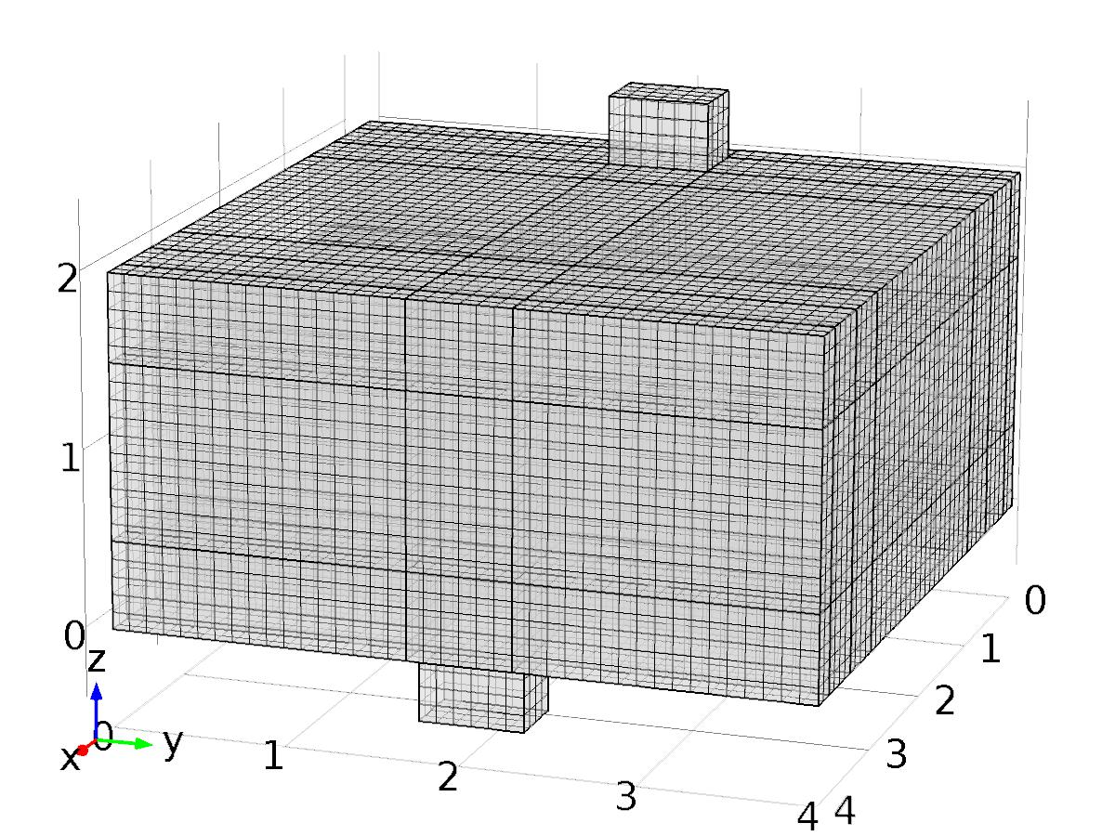

Mesh 1

* + 1. Size (size)

Settings

| **Description** | **Value** |
| --- | --- |
| Maximum element size | mesh_size |
| Minimum element size | mesh_size |
| Curvature factor | 0.6 |
| Resolution of narrow regions | 0.5 |
| Maximum element growth rate | 1.5 |
| Custom element size | Custom |

* + 1. Mapped 1 (map1)

Selection

|  |  |
| --- | --- |
| Geometric entity level | Domain |
| Selection | Geometry geom1 |

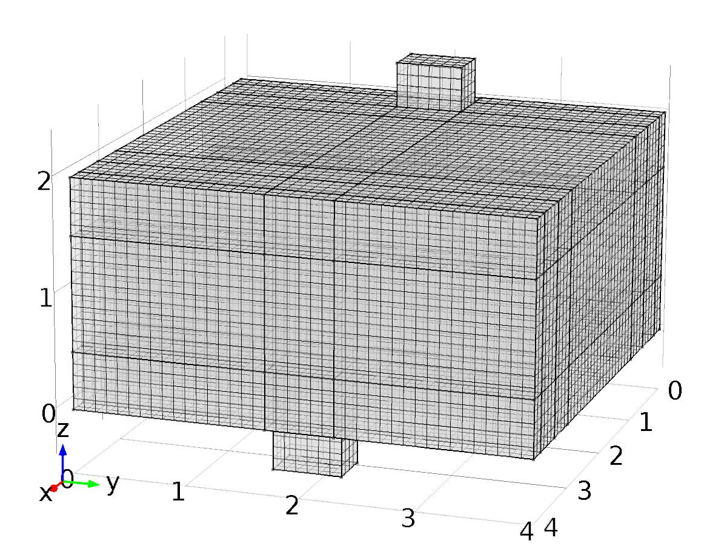

Mapped 1

* + 1. Swept 1 (swe1)

Selection

|  |  |
| --- | --- |
| Geometric entity level | Domain |
| Selection | Geometry geom1 |



Swept 1

1. Study 1
   1. Stationary

Study settings

| **Description** | **Value** |
| --- | --- |
| Include geometric nonlinearity | Off |

Physics and variables selection

| **Physics interface** | **Discretization** |
| --- | --- |
| Laminar Flow (spf) | physics |

Mesh selection

| **Geometry** | **Mesh** |
| --- | --- |
| Geometry 1 (geom1) | mesh1 |

* 1. Solver Configurations
     1. Solver 1

#### Compile Equations: Stationary (st1)

Study and step

| **Description** | **Value** |
| --- | --- |
| Use study | Study 1 |
| Use study step | Stationary |

#### Dependent Variables 1 (v1)

General

| **Description** | **Value** |
| --- | --- |
| Defined by study step | Stationary |
| Constant |  |

Initial values of variables solved for

| **Description** | **Value** |
| --- | --- |
| Solution | Zero |

Values of variables not solved for

| **Description** | **Value** |
| --- | --- |
| Solution | Zero |

##### Velocity field (mod1.u) (mod1_u)

General

| **Description** | **Value** |
| --- | --- |
| Field components | {mod1.u, mod1.v, mod1.w} |

##### Pressure (mod1.p) (mod1_p)

General

| **Description** | **Value** |
| --- | --- |
| Field components | mod1.p |

##### Temperature (mod1.X_T) (mod1_X_T)

General

| **Description** | **Value** |
| --- | --- |
| Field components | mod1.X_T |
| Solve for this field | Off |
| Field name | mod1_T |

##### Temperature (mod1.z1_T) (mod1_z1_T)

General

| **Description** | **Value** |
| --- | --- |
| Field components | mod1.z1_T |
| Solve for this field | Off |
| Field name | mod1_T |

##### Temperature (mod1.z1t_T) (mod1_z1t_T)

General

| **Description** | **Value** |
| --- | --- |
| Field components | mod1.z1t_T |
| Solve for this field | Off |
| Field name | mod1_T |

##### Temperature (mod1.z2_T) (mod1_z2_T)

General

| **Description** | **Value** |
| --- | --- |
| Field components | mod1.z2_T |
| Solve for this field | Off |
| Field name | mod1_T |

##### Temperature (mod1.z2t_T) (mod1_z2t_T)

General

| **Description** | **Value** |
| --- | --- |
| Field components | mod1.z2t_T |
| Solve for this field | Off |
| Field name | mod1_T |

##### Temperature (mod1.T) (mod1_T)

General

| **Description** | **Value** |
| --- | --- |
| Field components | mod1.T |
| Solve for this field | Off |

#### Stationary Solver 1 (s1)

General

| **Description** | **Value** |
| --- | --- |
| Defined by study step | Stationary |
| Relative tolerance | 0.0010 |

Log

| **Description** | **Value** |
| --- | --- |
| Constant |  |

##### Fully Coupled 1 (fc1)

General

| **Description** | **Value** |
| --- | --- |
| Linear solver | Direct |

Method and termination

| **Description** | **Value** |
| --- | --- |
| Initial damping factor | 0.01 |
| Minimum damping factor | 1.0E-6 |

1. Study 2
   1. Stationary

Study settings

| **Description** | **Value** |
| --- | --- |
| Include geometric nonlinearity | Off |

Physics and variables selection

| **Physics interface** | **Discretization** |
| --- | --- |
| Heat Transfer in Fluids (ht) | physics |

Mesh selection

| **Geometry** | **Mesh** |
| --- | --- |
| Geometry 1 (geom1) | mesh1 |

* 1. Solver Configurations
     1. Solver 2

#### Compile Equations: Stationary (st1)

Study and step

| **Description** | **Value** |
| --- | --- |
| Use study | Study 2 |
| Use study step | Stationary |

#### Dependent Variables 1 (v1)

General

| **Description** | **Value** |
| --- | --- |
| Defined by study step | Stationary |
| Constant |  |

Initial values of variables solved for

| **Description** | **Value** |
| --- | --- |
| Solution | Zero |

Values of variables not solved for

| **Description** | **Value** |
| --- | --- |
| Method | Solution |
| Solution | Solver 1 |

##### Temperature (mod1.X_T) (mod1_X_T)

General

| **Description** | **Value** |
| --- | --- |
| Field components | mod1.X_T |

##### Velocity field (mod1.u) (mod1_u)

General

| **Description** | **Value** |
| --- | --- |
| Field components | {mod1.u, mod1.v, mod1.w} |
| Solve for this field | Off |

##### Temperature (mod1.z1_T) (mod1_z1_T)

General

| **Description** | **Value** |
| --- | --- |
| Field components | mod1.z1_T |
| Solve for this field | Off |

##### Pressure (mod1.p) (mod1_p)

General

| **Description** | **Value** |
| --- | --- |
| Field components | mod1.p |
| Solve for this field | Off |

##### Temperature (mod1.z2t_T) (mod1_z2t_T)

General

| **Description** | **Value** |
| --- | --- |
| Field components | mod1.z2t_T |
| Solve for this field | Off |

##### Temperature (mod1.z2_T) (mod1_z2_T)

General

| **Description** | **Value** |
| --- | --- |
| Field components | mod1.z2_T |
| Solve for this field | Off |

##### Temperature (mod1.z1t_T) (mod1_z1t_T)

General

| **Description** | **Value** |
| --- | --- |
| Field components | mod1.z1t_T |
| Solve for this field | Off |

##### Temperature (mod1.T) (mod1_T)

General

| **Description** | **Value** |
| --- | --- |
| Field components | mod1.T |
| Solve for this field | Off |

#### Stationary Solver 1 (s1)

General

| **Description** | **Value** |
| --- | --- |
| Defined by study step | Stationary |
| Relative tolerance | 0.000010 |

Log

| **Description** | **Value** |
| --- | --- |
| Constant |  |

##### Fully Coupled 1 (fc1)

General

| **Description** | **Value** |
| --- | --- |
| Linear solver | Direct 1 |

Method and termination

| **Description** | **Value** |
| --- | --- |
| Initial damping factor | 0.01 |
| Minimum damping factor | 1.0E-6 |
| Maximum number of iterations | 50 |

##### Direct 1 (d1)

General

| **Description** | **Value** |
| --- | --- |
| Solver | PARDISO |

1. Study 3
   1. Parametric Sweep

| **Parameter name** | **Parameter value list** |
| --- | --- |
| k | 0,1,2,3 |

* 1. Stationary

Study settings

| **Description** | **Value** |
| --- | --- |
| Include geometric nonlinearity | Off |

Physics and variables selection

| **Physics interface** | **Discretization** |
| --- | --- |
| Heat Transfer in Fluids 2 (ht2) | physics |
| Heat Transfer in Fluids 3 (ht3) | physics |
| Heat Transfer in Fluids 1 (phys1) | physics |
| Heat Transfer in Fluids 2a (phys2) | physics |

Mesh selection

| **Geometry** | **Mesh** |
| --- | --- |
| Geometry 1 (geom1) | mesh1 |

* 1. Solver Configurations
     1. Solver 3

#### Compile Equations: Stationary (st1)

Study and step

| **Description** | **Value** |
| --- | --- |
| Use study | Study 3 |
| Use study step | Stationary |

#### Dependent Variables 1 (v1)

General

| **Description** | **Value** |
| --- | --- |
| Defined by study step | Stationary |
| Constant |  |

Initial values of variables solved for

| **Description** | **Value** |
| --- | --- |
| Solution | Zero |

Values of variables not solved for

| **Description** | **Value** |
| --- | --- |
| Method | Solution |
| Solution | Solver 2 |

##### Temperature (mod1.X_T) (mod1_X_T)

General

| **Description** | **Value** |
| --- | --- |
| Field components | mod1.X_T |
| Solve for this field | Off |

##### Velocity field (mod1.u) (mod1_u)

General

| **Description** | **Value** |
| --- | --- |
| Field components | {mod1.u, mod1.v, mod1.w} |
| Solve for this field | Off |

##### Temperature (mod1.z1_T) (mod1_z1_T)

General

| **Description** | **Value** |
| --- | --- |
| Field components | mod1.z1_T |
| Field name | mod1_z_T |

##### Pressure (mod1.p) (mod1_p)

General

| **Description** | **Value** |
| --- | --- |
| Field components | mod1.p |
| Solve for this field | Off |

##### Temperature (mod1.z1t_T) (mod1_z1t_T)

General

| **Description** | **Value** |
| --- | --- |
| Field components | mod1.z1t_T |
| Field name | mod1_zt_T |

##### Temperature (mod1.z2_T) (mod1_z2_T)

General

| **Description** | **Value** |
| --- | --- |
| Field components | mod1.z2_T |
| Field name | mod1_T |

##### Temperature (mod1.z2t_T) (mod1_z2t_T)

General

| **Description** | **Value** |
| --- | --- |
| Field components | mod1.z2t_T |
| Field name | mod1_T |

##### Temperature (mod1.T) (mod1_T)

General

| **Description** | **Value** |
| --- | --- |
| Field components | mod1.T |
| Solve for this field | Off |

#### Stationary Solver 1 (s1)

General

| **Description** | **Value** |
| --- | --- |
| Defined by study step | Stationary |
| Relative tolerance | 0.000010 |

Log

| **Description** | **Value** |
| --- | --- |
| Constant |  |

##### Fully Coupled 1 (fc1)

General

| **Description** | **Value** |
| --- | --- |
| Linear solver | Direct 1 |

##### Direct 1 (d1)

General

| **Description** | **Value** |
| --- | --- |
| Solver | PARDISO |

##### Parametric 1 (p1)

General

| **Description** | **Value** |
| --- | --- |
| Defined by study step | Parametric Sweep |
| Parameter value list | 0, 1, 2, 3 |

1. Study 4
   1. Time Dependent

Study settings

| **Description** | **Value** |
| --- | --- |
| Include geometric nonlinearity | Off |

| **Times** | **Unit** |
| --- | --- |
| range(0,hour,2*day) | s |

Physics and variables selection

| **Physics interface** | **Discretization** |
| --- | --- |
| Heat Transfer in Fluids 3a (phys3) | physics |

Mesh selection

| **Geometry** | **Mesh** |
| --- | --- |
| Geometry 1 (geom1) | mesh1 |

* 1. Solver Configurations
     1. Solver 4

#### Compile Equations: Time Dependent (st1)

Study and step

| **Description** | **Value** |
| --- | --- |
| Use study | Study 4 |
| Use study step | Time Dependent |

#### Dependent Variables 1 (v1)

General

| **Description** | **Value** |
| --- | --- |
| Defined by study step | Time Dependent |
| Constant |  |

Initial values of variables solved for

| **Description** | **Value** |
| --- | --- |
| Solution | Zero |

Values of variables not solved for

| **Description** | **Value** |
| --- | --- |
| Method | Solution |
| Solution | Solver 2 |

##### Temperature (mod1.X_T) (mod1_X_T)

General

| **Description** | **Value** |
| --- | --- |
| Field components | mod1.X_T |
| Solve for this field | Off |

##### Velocity field (mod1.u) (mod1_u)

General

| **Description** | **Value** |
| --- | --- |
| Field components | {mod1.u, mod1.v, mod1.w} |
| Solve for this field | Off |

##### Temperature (mod1.T) (mod1_T)

General

| **Description** | **Value** |
| --- | --- |
| Field components | mod1.T |

##### Temperature (mod1.z1_T) (mod1_z1_T)

General

| **Description** | **Value** |
| --- | --- |
| Field components | mod1.z1_T |
| Solve for this field | Off |

##### Pressure (mod1.p) (mod1_p)

General

| **Description** | **Value** |
| --- | --- |
| Field components | mod1.p |
| Solve for this field | Off |

##### Temperature (mod1.z2t_T) (mod1_z2t_T)

General

| **Description** | **Value** |
| --- | --- |
| Field components | mod1.z2t_T |
| Solve for this field | Off |

##### Temperature (mod1.z2_T) (mod1_z2_T)

General

| **Description** | **Value** |
| --- | --- |
| Field components | mod1.z2_T |
| Solve for this field | Off |

##### Temperature (mod1.z1t_T) (mod1_z1t_T)

General

| **Description** | **Value** |
| --- | --- |
| Field components | mod1.z1t_T |
| Solve for this field | Off |

#### Time-Dependent Solver 1 (t1)

General

| **Description** | **Value** |
| --- | --- |
| Defined by study step | Time Dependent |
| Time | {0, 3600, 7200, 10800, 14400, 18000, 21600, 25200, 28800, 32400, 36000, 39600, 43200, 46800, 50400, 54000, 57600, 61200, 64800, 68400, 72000, 75600, 79200, 82800, 86400, 90000, 93600, 97200, 100800, 104400, 108000, 111600, 115200, 118800, 122400, 126000, 129600, 133200, 136800, 140400, 144000, 147600, 151200, 154800, 158400, 162000, 165600, 169200, 172800} |
| Relative tolerance | 0.0001 |

Absolute tolerance

| **Description** | **Value** |
| --- | --- |
| Tolerance | 0.0010 |

Time stepping

| **Description** | **Value** |
| --- | --- |
| Initial step | 0.0010 |
| Maximum BDF order | 2 |

Results while solving

| **Description** | **Value** |
| --- | --- |
| Probes | None |

Advanced

| **Description** | **Value** |
| --- | --- |
| Fraction of initial step for Backward Euler | 0.0010 |

Log

| **Description** | **Value** |
| --- | --- |
| Constant |  |

##### Fully Coupled 1 (fc1)

General

| **Description** | **Value** |
| --- | --- |
| Linear solver | Direct 1 |

Method and termination

| **Description** | **Value** |
| --- | --- |
| Damping factor | 0.9 |
| Jacobian update | Once per time step |
| Maximum number of iterations | 5 |

##### Direct 1 (d1)

General

| **Description** | **Value** |
| --- | --- |
| Solver | PARDISO |

1. Results
   1. Data Sets
      1. Solution 1

Solution

| **Description** | **Value** |
| --- | --- |
| Solution | Solver 1 |
| Component | Save Point Geometry 1 |

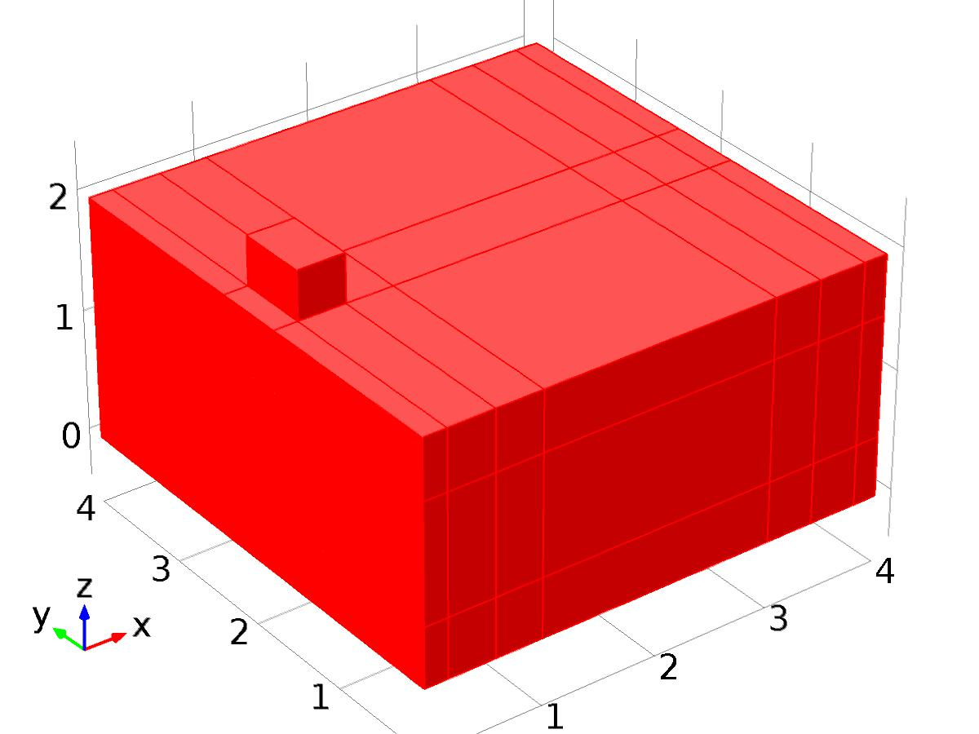

Data set: Solution 1

* + 1. Surface 1

Data

| **Description** | **Value** |
| --- | --- |
| Data set | Solution 1 |

Parameterization

| **Description** | **Value** |
| --- | --- |
| x- and y-axes | Surface parameters |

* + 1. Surface 2

Data

| **Description** | **Value** |
| --- | --- |
| Data set | Solution 1 |

Parameterization

| **Description** | **Value** |
| --- | --- |
| x- and y-axes | Surface parameters |

* + 1. Solution 2

Solution

| **Description** | **Value** |
| --- | --- |
| Solution | Solver 2 |
| Component | Save Point Geometry 1 |



Data set: Solution 2

* + 1. Solution 3

Solution

| **Description** | **Value** |
| --- | --- |
| Solution | Solver 3 |
| Component | Save Point Geometry 1 |



Data set: Solution 3

* + 1. Probe Solution 4

Solution

| **Description** | **Value** |
| --- | --- |
| Solution | Solver 3 |
| Component | Save Point Geometry 1 |



Data set: Probe Solution 4

* + 1. Solution 5

Solution

| **Description** | **Value** |
| --- | --- |
| Solution | Solver 4 |
| Component | Save Point Geometry 1 |



Data set: Solution 5

* 1. Derived Values
     1. Global Evaluation 1

Data

| **Description** | **Value** |
| --- | --- |
| Data set | Solution 3 |

Expression

| **Description** | **Value** |
| --- | --- |
| Expression | C(z1_T) |
| Unit | K |
| Description | C(z1_T) |

* + 1. Global Variable Probe 1

Data

| **Description** | **Value** |
| --- | --- |
| Data set | Probe Solution 4 |

Expression

| **Description** | **Value** |
| --- | --- |
| Expression | yrc |
| Unit | K |

* + 1. Global Variable Probe 2

Data

| **Description** | **Value** |
| --- | --- |
| Data set | Probe Solution 4 |

Expression

| **Description** | **Value** |
| --- | --- |
| Expression | yrs |
| Unit | K |

* + 1. Global Variable Probe 3

Data

| **Description** | **Value** |
| --- | --- |
| Data set | Probe Solution 4 |

Expression

| **Description** | **Value** |
| --- | --- |
| Expression | Gammac |
| Unit | 1 |

* + 1. Global Variable Probe 4

Data

| **Description** | **Value** |
| --- | --- |
| Data set | Probe Solution 4 |

Expression

| **Description** | **Value** |
| --- | --- |
| Expression | Gammas |
| Unit | 1 |

* + 1. Point Evaluation 1

Selection

|  |  |
| --- | --- |
| Geometric entity level | Point |
| Selection | Point 96 |

Data

| **Description** | **Value** |
| --- | --- |
| Data set | Solution 5 |

Expression

| **Description** | **Value** |
| --- | --- |
| Expression | Gamma |
| Unit | K |

* 1. Tables
     1. Table 1

Global Evaluation 1 (C(z_T))

Table 1

| **C(z_T) (K)** |
| --- |
| 295.00 |

* + 1. Table 2

Global Evaluation 1 (C(z1_T))

Table 2

| **C(z2_T) (K)** | **C(z1_T) (K)** |
| --- | --- |
| 25.000 | 24.994 |

* + 1. Probe Table 3
    2. Table 4

Point Evaluation 1 (C(T))

Table 4

| **Time** | **C(T) (K), Point: 96** | **yr (K), Point: 96** | **d (K), Point: 96** | **Gamma (K), Point: 96** |
| --- | --- | --- | --- | --- |
| 0.0000 | 15.000 | 22.000 | 5.0000 | 1.1375 |
| 3600.0 | 22.776 | 22.776 | 7.5882 | 1.1725 |
| 7200.0 | 23.493 | 23.500 | 10.000 | 1.2049 |
| 10800 | 24.115 | 24.121 | 12.071 | 1.2327 |
| 14400 | 24.591 | 24.598 | 13.660 | 1.2538 |
| 18000 | 24.892 | 24.898 | 14.659 | 1.2669 |
| 21600 | 24.999 | 25.000 | 15.000 | 1.2711 |
| 25200 | 24.900 | 24.898 | 14.659 | 1.2660 |
| 28800 | 24.602 | 24.598 | 13.660 | 1.2521 |
| 32400 | 24.127 | 24.121 | 12.071 | 1.2302 |
| 36000 | 23.505 | 23.500 | 10.000 | 1.2020 |
| 39600 | 22.778 | 22.776 | 7.5882 | 1.1692 |
| 43200 | 22.000 | 22.000 | 5.0000 | 1.1341 |
| 46800 | 21.224 | 21.224 | 2.4118 | 1.0992 |
| 50400 | 20.506 | 20.500 | 2.6645E-15 | 1.0667 |
| 54000 | 19.880 | 19.879 | -2.0711 | 1.0390 |
| 57600 | 19.403 | 19.402 | -3.6603 | 1.0178 |
| 61200 | 19.102 | 19.102 | -4.6593 | 1.0047 |
| 64800 | 19.000 | 19.000 | -5.0000 | 1.0006 |
| 68400 | 19.103 | 19.102 | -4.6593 | 1.0056 |
| 72000 | 19.401 | 19.402 | -3.6603 | 1.0195 |
| 75600 | 19.875 | 19.879 | -2.0711 | 1.0414 |
| 79200 | 20.495 | 20.500 | -4.4409E-15 | 1.0697 |
| 82800 | 21.221 | 21.224 | 2.4118 | 1.1025 |
| 86400 | 22.000 | 22.000 | 5.0000 | 1.1375 |
| 90000 | 22.776 | 22.776 | 7.5882 | 1.1725 |
| 93600 | 23.493 | 23.500 | 10.000 | 1.2049 |
| 97200 | 24.120 | 24.121 | 12.071 | 1.2327 |
| 1.0080E5 | 24.598 | 24.598 | 13.660 | 1.2538 |
| 1.0440E5 | 24.898 | 24.898 | 14.659 | 1.2669 |
| 1.0800E5 | 25.000 | 25.000 | 15.000 | 1.2711 |
| 1.1160E5 | 24.900 | 24.898 | 14.659 | 1.2660 |
| 1.1520E5 | 24.601 | 24.598 | 13.660 | 1.2521 |
| 1.1880E5 | 24.122 | 24.121 | 12.071 | 1.2302 |
| 1.2240E5 | 23.506 | 23.500 | 10.0000 | 1.2020 |
| 1.2600E5 | 22.783 | 22.776 | 7.5882 | 1.1692 |
| 1.2960E5 | 22.004 | 22.000 | 5.0000 | 1.1341 |
| 1.3320E5 | 21.231 | 21.224 | 2.4118 | 1.0992 |
| 1.3680E5 | 20.505 | 20.500 | 7.9936E-15 | 1.0667 |
| 1.4040E5 | 19.882 | 19.879 | -2.0711 | 1.0390 |
| 1.4400E5 | 19.406 | 19.402 | -3.6603 | 1.0178 |
| 1.4760E5 | 19.108 | 19.102 | -4.6593 | 1.0047 |
| 1.5120E5 | 19.001 | 19.000 | -5.0000 | 1.0006 |
| 1.5480E5 | 19.101 | 19.102 | -4.6593 | 1.0056 |
| 1.5840E5 | 19.400 | 19.402 | -3.6603 | 1.0195 |
| 1.6200E5 | 19.869 | 19.879 | -2.0711 | 1.0414 |
| 1.6560E5 | 20.498 | 20.500 | 8.8818E-16 | 1.0697 |
| 1.6920E5 | 21.218 | 21.224 | 2.4118 | 1.1025 |
| 1.7280E5 | 21.995 | 22.000 | 5.0000 | 1.1375 |

* 1. Plot Groups
     1. Velocity (spf)

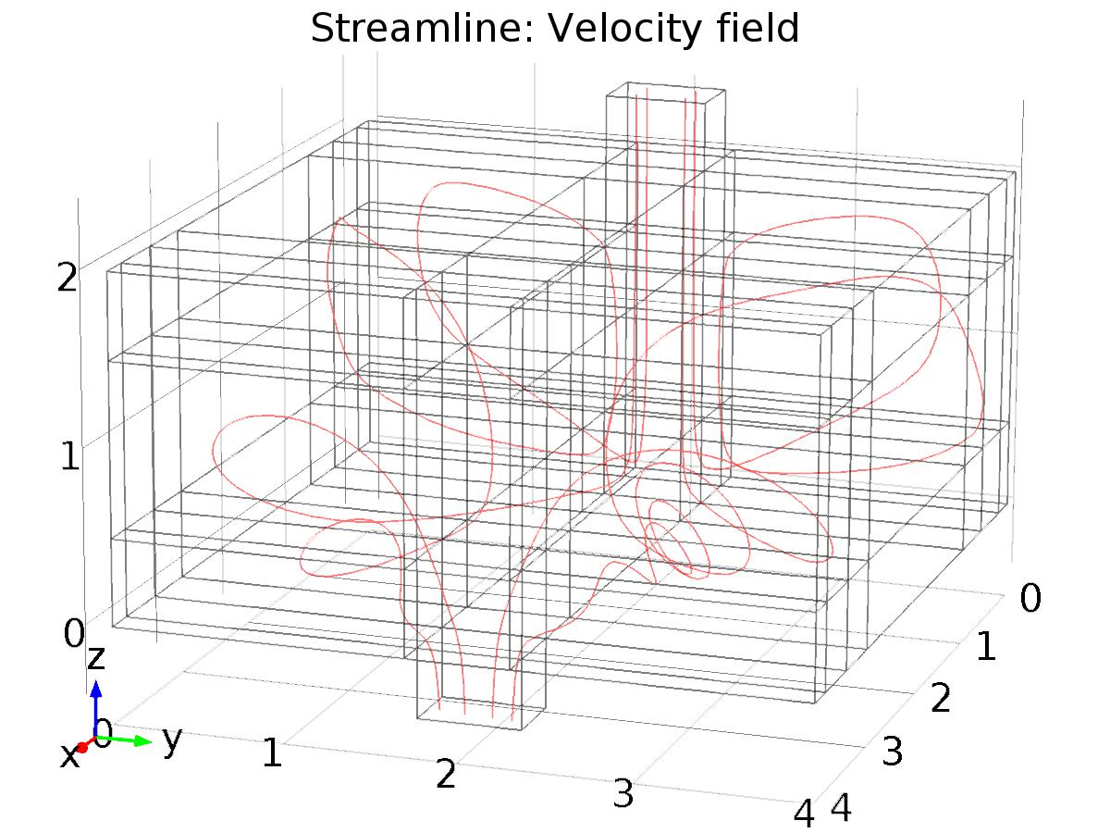

Streamline: Velocity field

* + 1. Pressure (spf)

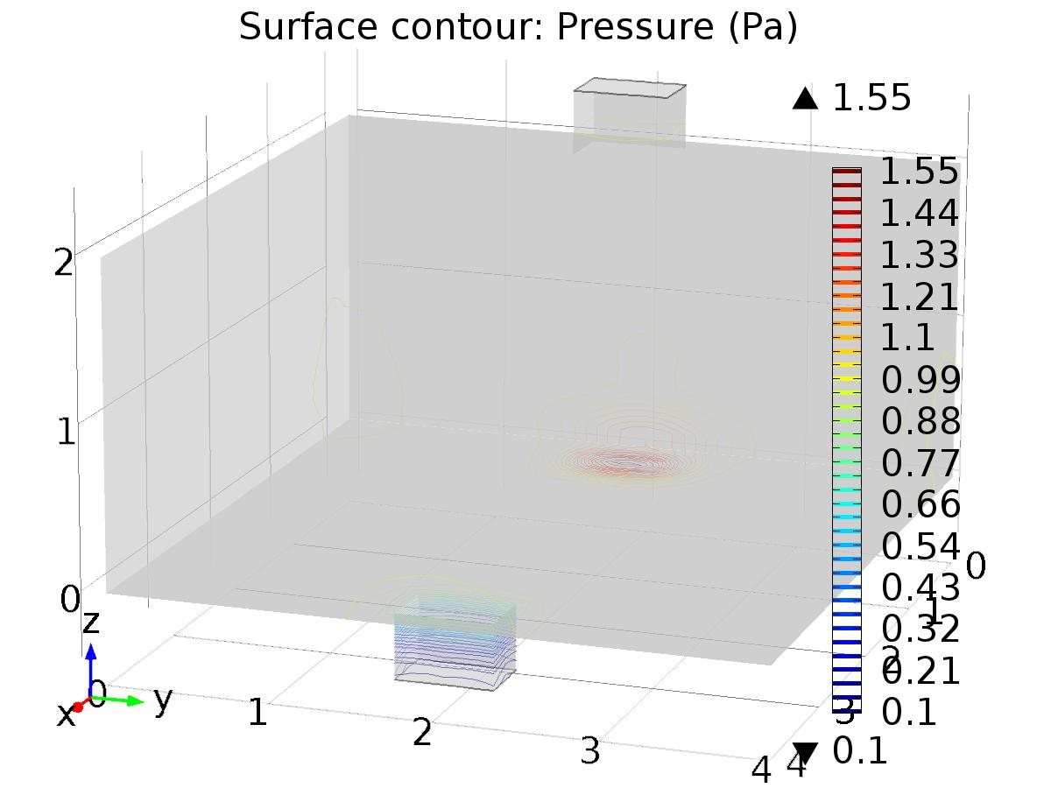

Surface contour: Pressure (Pa)

* + 1. Temperature (ht)

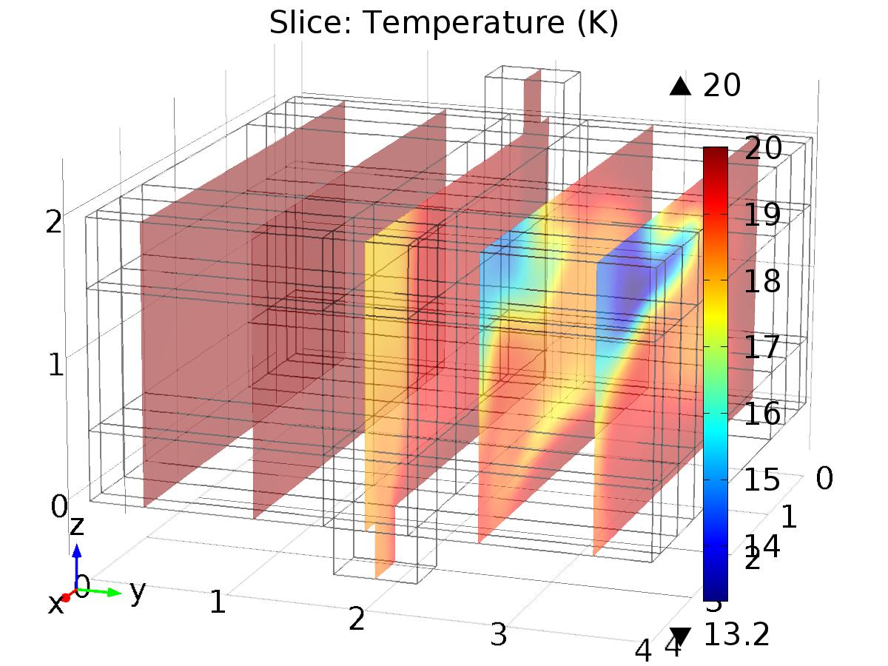

Slice: Temperature (K)

* + 1. Isothermal Contours (ht)
    2. Temperature (ht2)

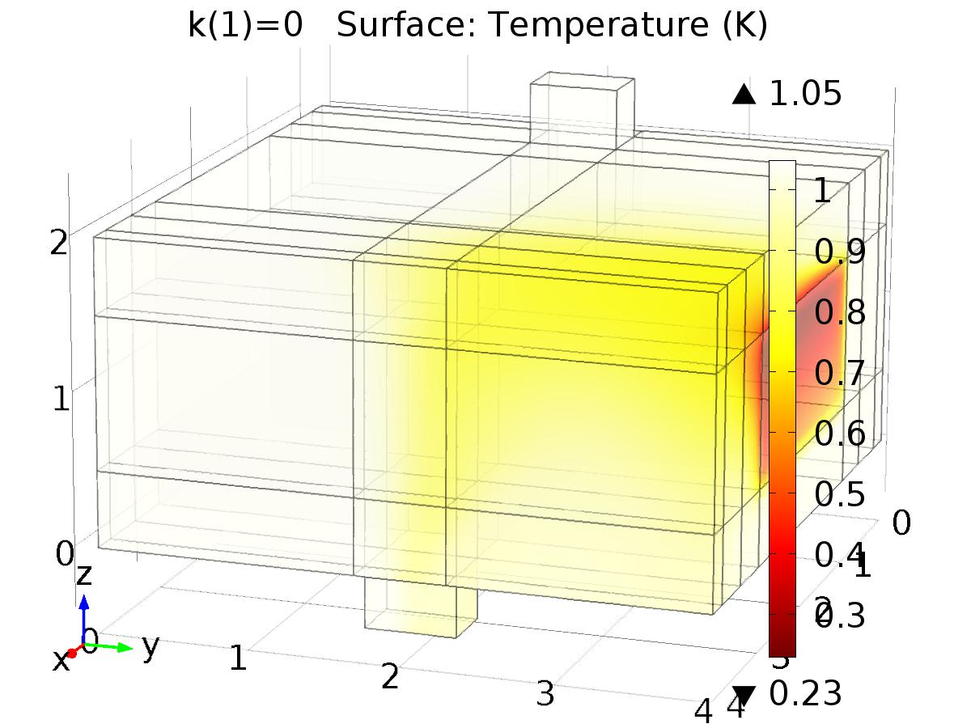

k(1)=0 Surface: Temperature (K)

* + 1. Isothermal Contours (ht2)

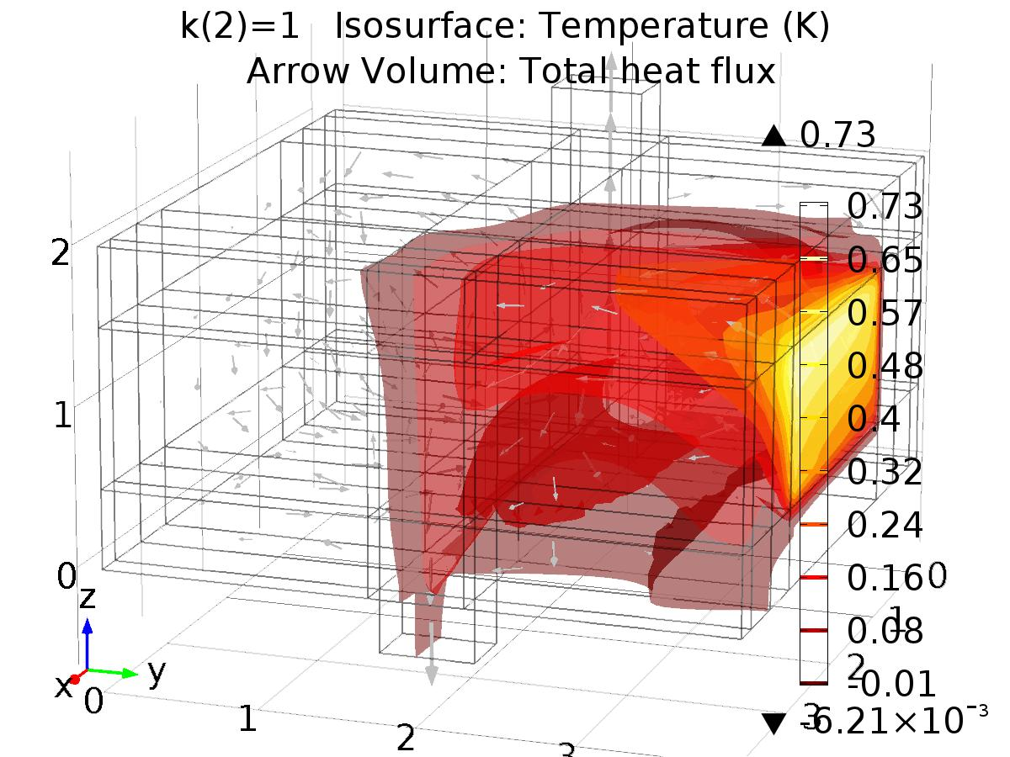

k(2)=1 Isosurface: Temperature (K) Arrow Volume: Total heat flux

* + 1. Temperature (ht3)

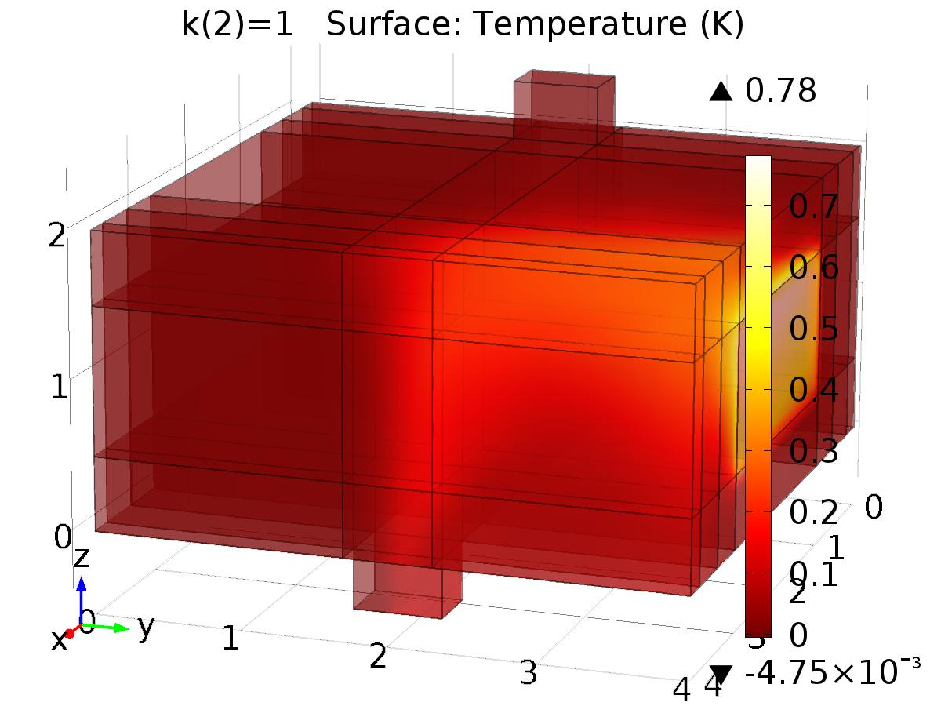

k(2)=1 Surface: Temperature (K)

* + 1. Isothermal Contours (ht3)

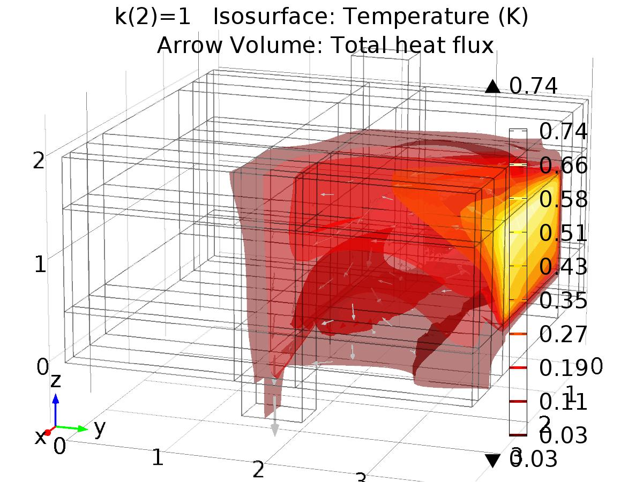

k(2)=1 Isosurface: Temperature (K) Arrow Volume: Total heat flux

* + 1. Probe 1D Plot Group 9

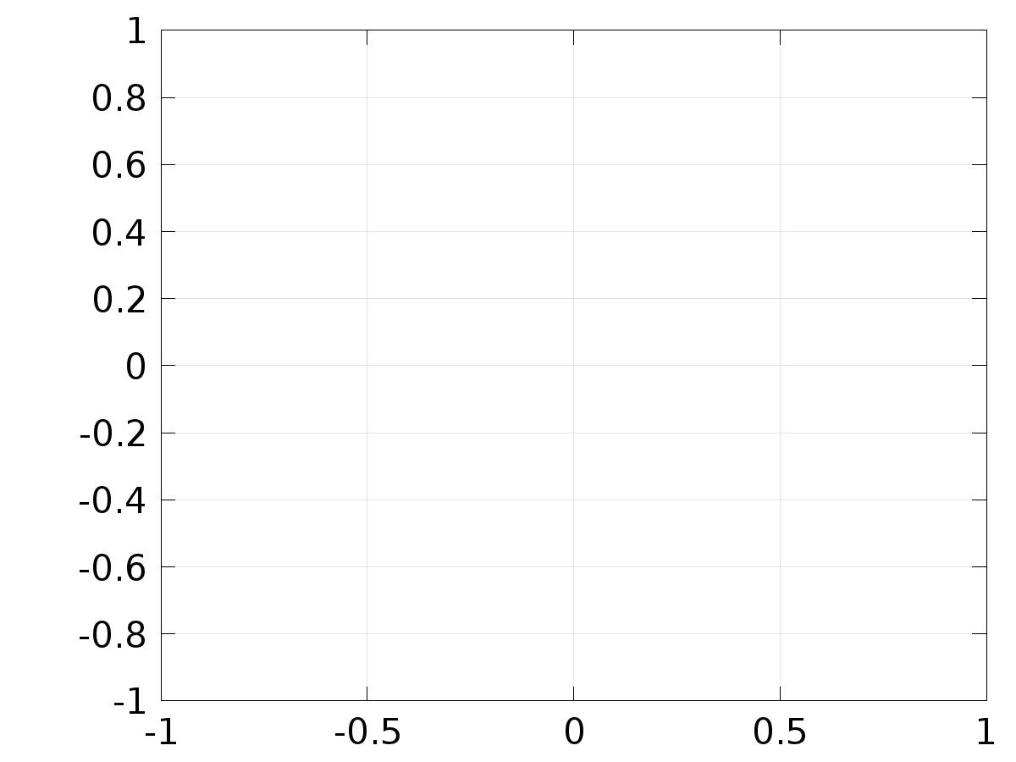

* + 1. Temperature (phys3)

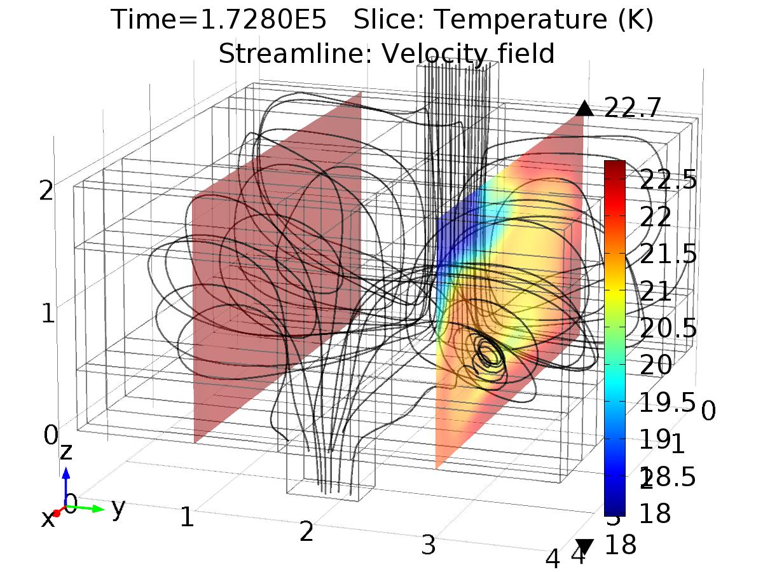

Time=1.7280E5 Slice: Temperature (K) Streamline: Velocity field

* + 1. Isothermal Contours (phys3)

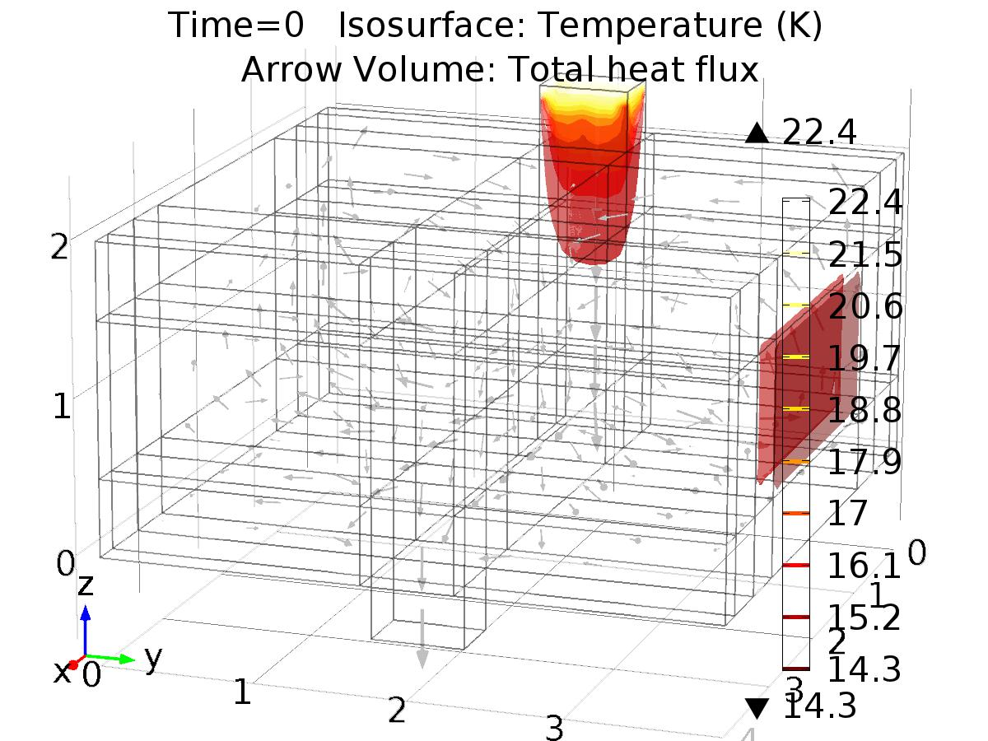

Time=0 Isosurface: Temperature (K) Arrow Volume: Total heat flux

* + 1. 1D Plot Group 12

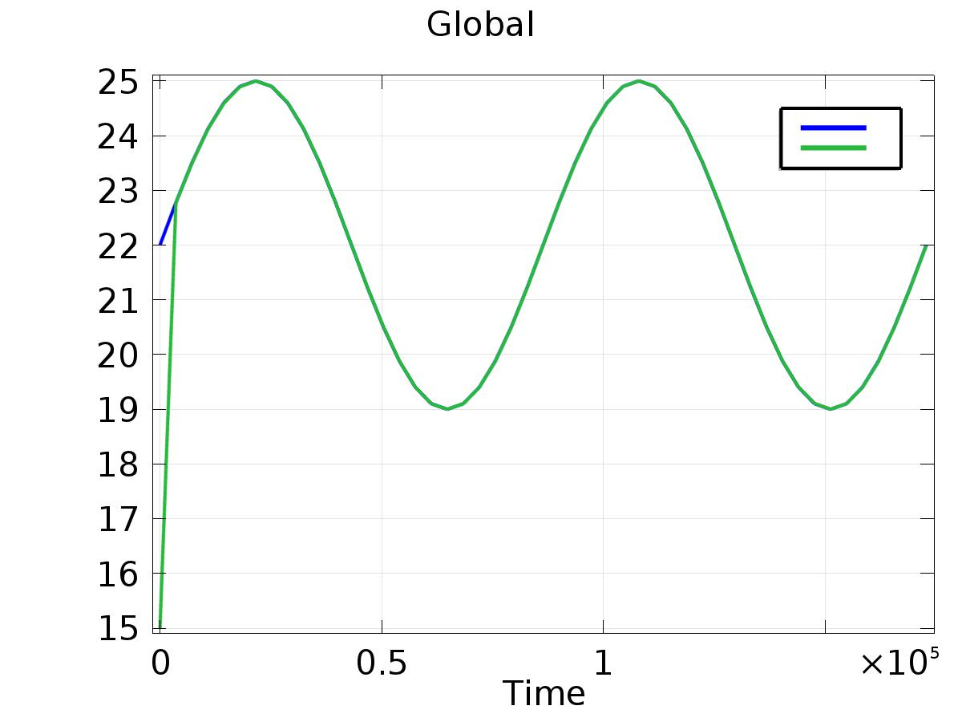

Global

* + 1. 1D Plot Group 13

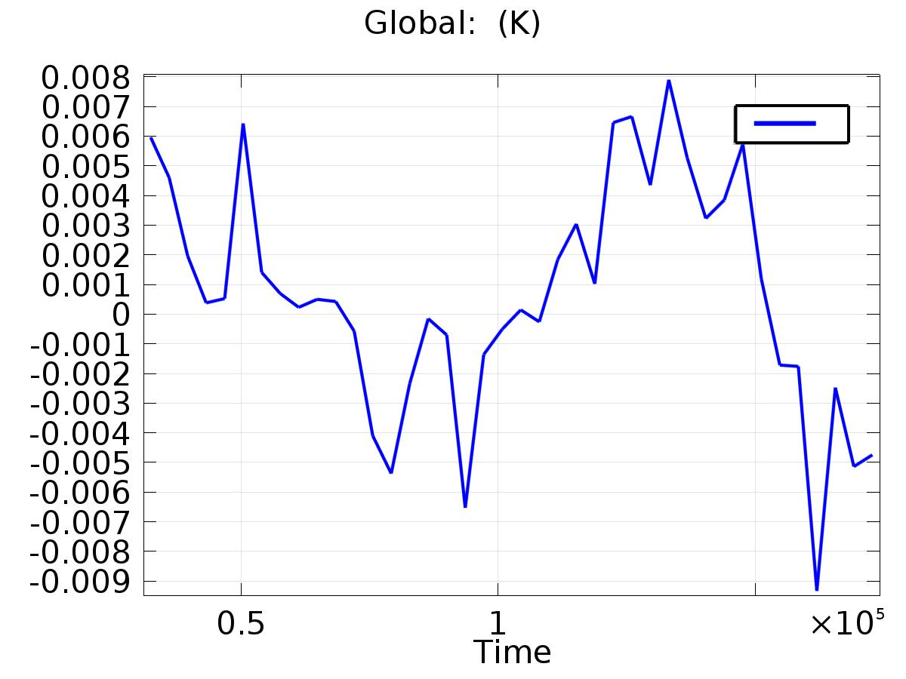

Global: (K)

* + 1. Temperature (phys3) 1

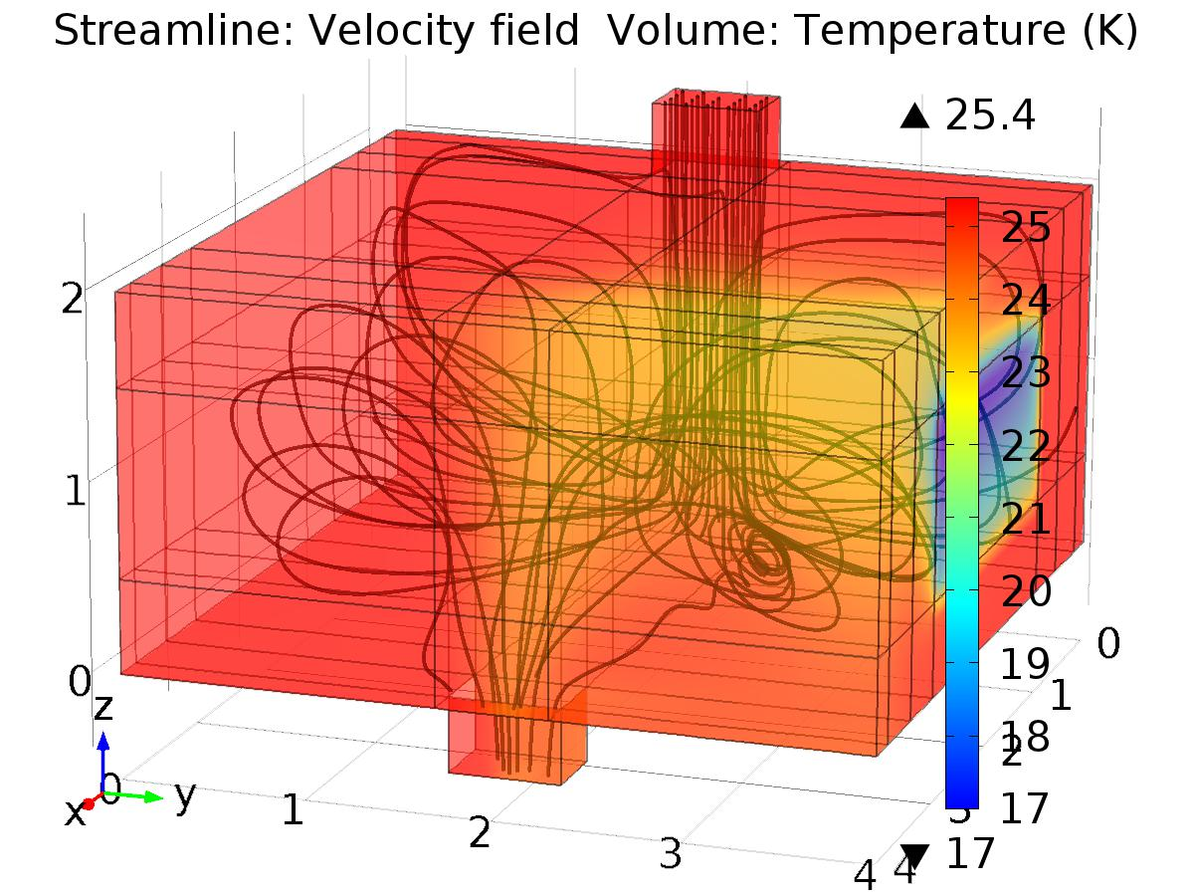

Streamline: Velocity field Volume: Temperature (K)